Button module, initial state is false, possible state can be true or false. If pressed by users it will transfer to true, if not pressed or reset by controller it will remain false, if not pressed can be any state.
--button

MODULE main

VAR
pressed : boolean;
reset : boolean;

ASSIGN
init(pressed) := FALSE;
next(pressed) := case
pressed & reset : FALSE;
pressed & !reset : TRUE;
!pressed : {FALSE,TRUE};
esac;

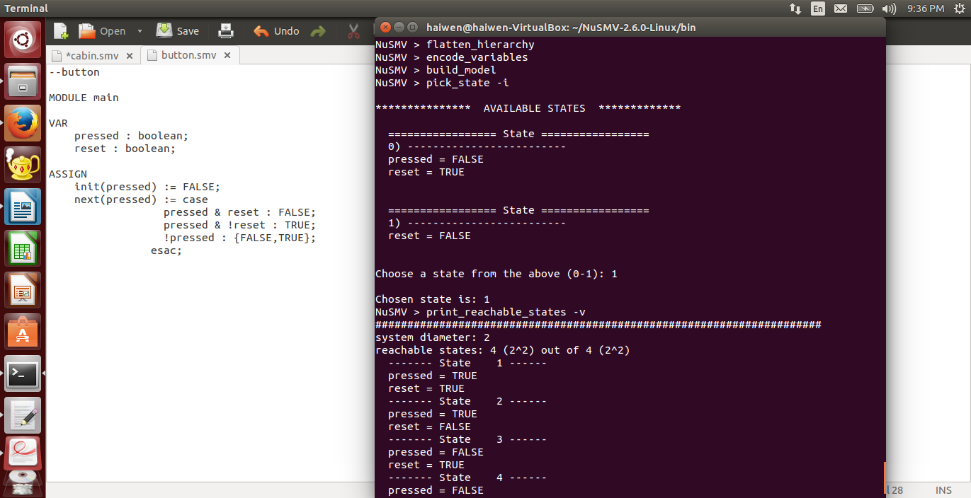
Elevator can reach floor from 1 to 3, the first variable should be floor. Each floor has one or two direction of moving up and down, the second variable should be direction. The elevator receives command from stop, go up and go down.

