The dchat system that we are going to develop will consist of processes communicating with each other. Each process can act as a client as well as a server, so the code for a client and a server will be the same and a flag will tell if the process will currently act as a server/sequencer or a client.

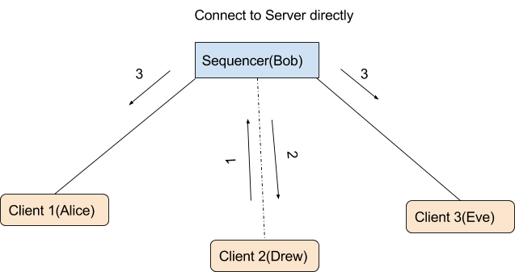

1. | Connect Message to the server
2. | ACK of the connect message
3. | Broadcast Updated Client List to all the clients

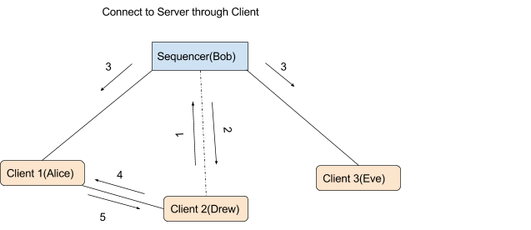

1. | Connect Message to the server
2. | ACK of the connect message
3. | Broadcast Updated Client List to all the clients
4. | Connect to Chat Group
5. | Give Server Info

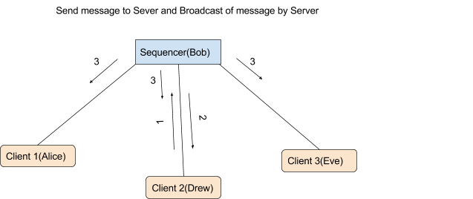

1. | Send Message to Server
2. | ACK from server for the received message to client
3. | Broadcast Message with Sequence #

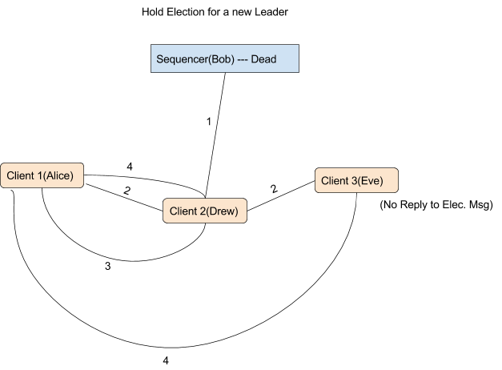

1. | Ping server to check if alive
2. | Election Message from Drew in case server dead
3. | Stop Election message from Alice
4. | Declare as Leader from Alice

