# INF 551 – Fall 2015

## Midterm Exam (100 points)

## Exam time: Oct. 10, 12pm – Oct. 11, 12pm (i.e., 24 hours)

**You are to work on this exam on your own. You are not to share, email or discuss in any way the contents of the exam prior to Oct 12, 2014. Failure to follow these rules will result in a failing grade for the *class*.**

**You can complete this exam by hand or electronically. If done by hand, please scan and generate a PDF. Result must be submitted via blackboard. Remember, if its hard for me to read, it will be hard for me to grade!!**

**Exam must be submitted to blackboard by 12 PM (Noon) on Sunday. We will deduct 10% from your total score for every 30 minutes after 12PM that your exam is late.**

**Please fill in below:**

**I certify that I the work on this exam is only mine and agree not do discuss the contents or answers with my classmates until Oct 12th. I understand that failure to follow these rules will result in me receiving a failing grade for the class.**

**Name, Date**

1. [RAID, 30 points] In this question, you are provided with **4** identical hard disks. The key parameters of each hard disk are as follows.

|  |  |
| --- | --- |
| **Capacity** | 1TB |
| **Rotational speed** | 10, 000RPM |
| **Maximum seek time** | 10ms |
| **Bandwidth** | 50MB/sec |
| **Block size** | 4KB |

You are asked to configure the 4 disks into RAID 0 (striping), RAID 1 (mirroring), RAID 10 (i.e., mirroring + striping), RAID 4 (striping + block-level parity), and RAID 5 (striping + distributed parity). For each configuration, answer the following questions.

* 1. What is the **maximum** capacity given by the configuration?
  2. What are the maximum and minimum time that it takes to **read** **2** blocks concurrently from the RAID? (**Note that concurrent reads/writes occur when two blocks to be read/written are located on different disks.)**
  3. What are the maximum and minimum time that it takes to **write** **2** blocks concurrently onto the RAID? For RAID 4 and RAID 5, assume that the subtractive method is used to compute the parity, and you may ignore the time to calculate the parity.

1. [File System, 30 points] Recall that we have seen a small file system stored in a disk of 64 blocks as shown below.

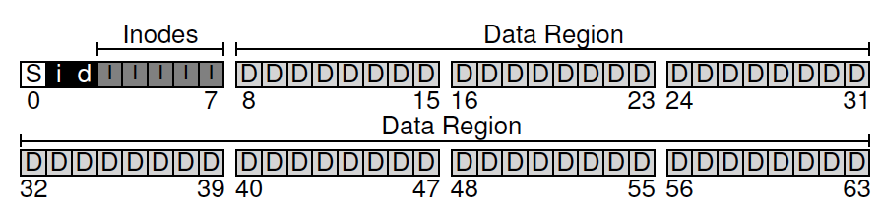

Now let us consider a new disk with 128 blocks, but the organization of file system on the disk remains the same. In other words, the new disk still has the first 8 blocks storing the superblock, two bitmaps (i-map and d-map) for tracking the free slots for inodes (i-map) and free data blocks (d-map). But the new disk now has additional 64 data blocks, numbered 64 to 127.

Suppose that the disk has the following parameters.

|  |  |
| --- | --- |
| **Block size** | 4KB |
| **# of blocks on disk** | 128 |
| **Sector size** | 512B |

Further suppose that the file system has the following parameters.

|  |  |
| --- | --- |
| **Inode size** | 512B |
| **# of inode blocks** | 5 (blocks #3 to #7) |

Please answer the following questions on the new disk and file system.

1. What is the capacity of the disk? (Note that this is NOT asking how much space is available to store the file content, rather the total storage space of the disk.)
2. How many files can the file system store on the disk?
3. How many bits are there in the two bitmaps, i-map and b-map?
4. If the inumber of a file is n, where is its corresponding inode located on the disk? Assume that the sector numbers start from zero and the blocks have contiguous sector numbers. Which sector is the inode located?
5. What is the maximum size of a file that can be stored in this file system?
6. Explain how you can increase the file size by introducing multi-level index.
7. Suppose the file system stores two files under its root directory: “foo” and “bar”. Each file occupies one block. Suppose that inumber of the root directory is 2. How many blocks need to be read in order to load the content of the files into the memory? Indicate the content of the blocks (e.g., holding content of “foo”, holding some directory, or holding inodes). Assume that superblock is not available in the main memory. Also assume that once a block is read into memory, it can be cached there and looked up by future operations.
8. [Network File System, 20 points] In Network File System (NFS), it is possible that a client never receives a response from the server, after it sends a message to the server.
   1. What are the possible reasons for this?
   2. To address this problem, the client may simply keep resending the message to the server for desired operations until the operations succeed. However, this requires that the operations satisfy certain property. What is the property?
   3. For each of the following operations, indicate whether it has the property as described in b.
      1. Lookup
      2. Read
      3. Write
      4. Create (file)
      5. Remove (file)
      6. Mkdir
      7. ReadDir
9. [ER Modeling, 20 points] Consider building an application for an electronic store chain (i.e., it has many stores in different locations), in order to manage the purchases made at the store.

The store needs to record, for each product, its serial number, brand, model, and price. It also needs to record operating system and hard drive, but for laptops only.

Each store has a unique store ID, name, and city where the store is located.

For each purchase, the application needs to record the name of buyer and seller (i.e., sales person), the store where the purchase was made, the products purchased, and the purchase date. Note that there can only be one buyer and one seller involved in a single purchase. Also each purchase can be made at a single store. However, multiple products may be purchased in the same sale.

It also records, for buyer and seller, his/her name, phone number, and residence city.

Please depict an ER diagram to model the application. For each entity set, **underline its key attributes.** Properly indicate the multiplicity (i.e., many-one, many-many, or one-one) of each relationship.

For your reference, here are notations for indicating the multiplicity and type (is-a) of relationships. (Note that hollow arrow represents exactly one, i.e., one and only one, as the example below shows.)

one-to-one

many-to-one

many-to-many

many-to-exactly one

