# INF 551 – Fall 2017 (Afternoon section)

## Quiz 6: XML & ER (10 points), **15 minutes**

1. 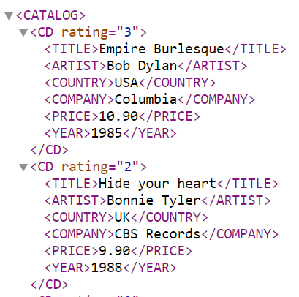[6 points] Consider an XML document containing a catalog of CD’s as shown on the right. Write an XPath expression for each of the following questions.
   1. Final all CDs (elements) by “Bob Dylan”.

/CATALOG/CD[ARTIST=”Bob Dylan”]

* 1. Find the titles of all CDs produced by “Columbia” and with price < 10, return values only.

/CATALOG/CD[COMPANY=”Columbia”][PRICE<10]/TITLE/text()

* 1. Find the artists of CDs produced after 1985 and rated 3 or above, return values only.

/CATALOG/CD[YEAR>1985][@rating>=3]/ARTIST/text()

1. [4 points] Draw an ER diagram to model the product-sale application with the following requirements.
   * For each product, record its id, name, and manufacturer.

store

StoreOf

product

ProductOf

purchase

Software product

isa

person

BuyerOf

* + For each person, record its SSN, name, and address.
  + For each store, record its id, name, and city.
  + If a product is a software product, record its operating system as well.
  + For each purchase, record its date.
  + Underline the key attributes.
  + Indicate the multiplicity and type of relationship.
  + *All relationships in the ER diagram should be* **binary**.