# INF 551 – Fall 2017 (Afternoon section)

## Quiz 2: SSD (10 points), **15 minutes**

Consider an SSD with the following specification on its read/write performance.

|  |  |
| --- | --- |
| **Operation** | **Time** |
| Read a page | 25 microseconds |
| Write a page | 250 microseconds |
| Erase a block | 2 milliseconds |

Consider the following block and requests in this order: (1) inserting two new pages at the same time; (2) update page 1; and (3) insert another new page.

State the read/write/erase operations needed to perform the above requests. How long does it take for them to complete?

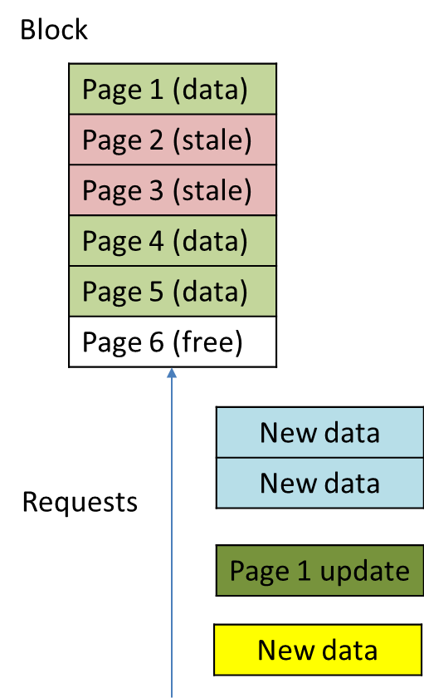

Answer:

(1) Inserting two new pages

1. Read 6 pages, rearrange page order and remove stale pages
2. Erase all pages
3. Write 5 new pages

(2) Update page 1

1. Write new page1 and mark original page1 as stale

(3) Insert another new page

1. Read 6 pages and rearrange page order and remove stale pages
2. Erase all pages
3. Write 6 new pages

So in total there are 12 reads, 12 writes and 2 erasures. It takes 12*25us+12*250us+2*2ms=7.3ms to complete.