EDUQUIZ

Author Details:
Name: Havish Gadey
Designation: Analyst
Organization: Capgemini
Program: SAP ABAP HANA & SD - AI Launchpad
Batch: 2

Technologies Used:
• Python
• Flask
• OpenAI SDK
• HTML
• CSS
• Jinja2
• Generative AI

Objective:
EDUQUIZ is an AI-powered educational quiz application developed using Flask and OpenAI-compatible Generative AI services. The primary aim of the application is to provide an interactive and personalized learning experience by dynamically generating multiple-choice questions (MCQs) based on a user-selected topic, difficulty level, and number of questions.

Features
- Generate quizzes dynamically using Generative AI
- Select any topic for quiz generation.
- Multiple difficulty levels (Easy, Medium, Hard)
- Configurable number of questions
- Support for programming-related questions
- Automatic answer evaluation
- Explanation for every question
- Session-based progress tracking
- Detailed review page after quiz completion
- Score and percentage calculation.

Technology Stack
Backend
- Python
- Flask
AI Integration
- OpenAI Python SDK
- OpenAI-Compatible Generative AI Endpoint
Frontend
- HTML
- CSS
- Jinja2 Templates

Configuration
- Python-dotenv
Session Management
- Flask Session

Project Architecture
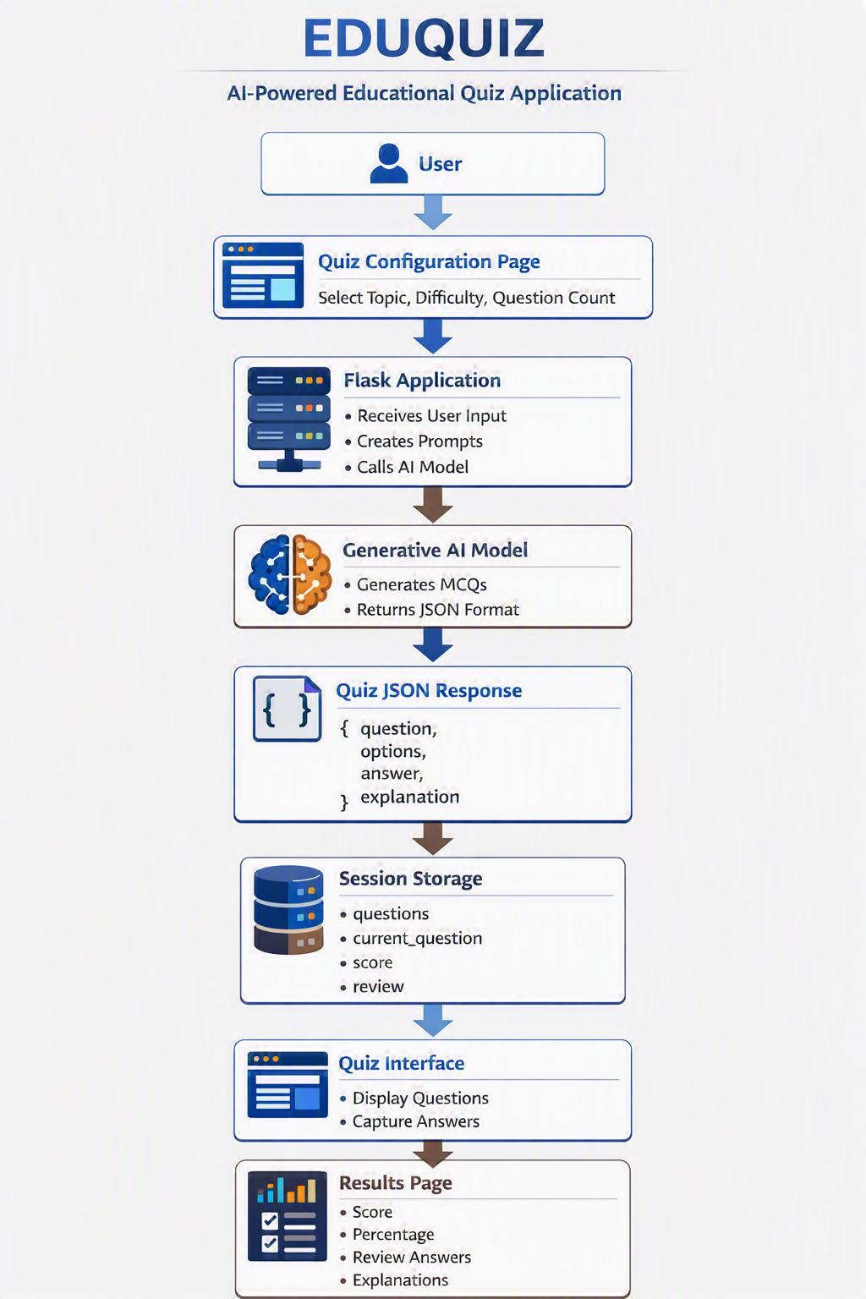

Application Workflow
Step 1: Create Quiz
The user enters:
- Topic
- Difficulty Level
- Number of Questions
Example:
Topic: Python
Difficulty: Easy
Questions: five

Step 2: Prompt Generation
The Flask application dynamically creates:
System Prompt
Defines:
- JSON output format
- MCQ structure
- Programming question rules
- Explanation generation rules
User Prompt
Has:
Topic: Python
Difficulty: Easy
Generate exactly 5 MCQs.

Step 3: Quiz Generation
The application sends prompts to the configured Generative AI model.
Example API call:
response = client.chat.completions.create(
model=os.getenv("GENAI_MODEL"),
messages= [
{"role": "system", "content": system_prompt},
{"role": "user", "content": user_prompt}
]
)
The model returns quiz questions in JSON format.
Example:
[
{
"question": "What is Python?",
"code": ,
"options": {
"A": "Programming Language",
"B": "Database",
"C": "Operating System",
"D": "Compiler"
},
"answer": "A",
"explanation": "Python is a high-level programming language."
}
]

Step 4: Store Quiz in Session
Generated quiz data is stored in Flask Session.
session["questions"]
session["current_question"]
session["score"]
session["review"]

Step 5: Quiz Attempt
The user answers each question.
For every submission:
- Selected answer is captured.
- Correct answer is validated.
- Score is updated.
- Review information is stored.

Step 6: Result Evaluation
Score percentage is calculated:
percentage = (score / total) * 100
Performance messages:
Percentage | Message
Eighty percent or above | Excellent!
Sixty percent to Seventy-Nine% | Good Job!
Below Sixty% | Keep Practicing!

Step 7: Review Answers
Users can view:
- Question
- Code snippet (if applicable)
- Selected answer
- Correct answer
- Explanation
- Result status

Configure Environment Variables
Create a .env file in the root directory.
GENAI_API_KEY=your_api_key
GENAI_BASE_URL=your_genai_endpoint
GENAI_MODEL=your_model_name

Environment Variables
Variable | Description
GENAI_API_KEY | API Key used to authenticate requests
GENAI_BASE_URL | Base URL of the AI endpoint
GENAI_MODEL | Model name used for quiz generation

Run Application
python app.py
Application URL:
http://localhost:4431

Session Management
The application uses Flask sessions to maintain quiz state.
Stored values:
session["questions"]
session["current_question"]
session["score"]
session["review"]
Purpose:
- Maintain quiz progress.
- Track user score.
- Store answer review data.
- Avoid database dependency.

Quiz JSON Structure
Each generated question follows the structure below:
{
"question": "Question text",
"code": ,
"options": {
"A": "Option A",
"B": "Option B",
"C": "Option C",
"D": "Option D"
},
"answer": "A",
"explanation": "Explanation text"
}

Programming Question Support
Programming questions are managed separately.
Example:
{
"question": "What is the output of the following code?",
"code": "print (type (3.14))",
"options": {
"A": "<class 'int'>",
"B": "<class 'float'>",
"C": "<class 'str'>",
"D": "Error"
},
"answer": "B",
"explanation": "3.14 is a floating-point value in Python."
}
Benefits:
- Clean question text
- Proper code rendering
- Better readability

Missing Environment Variables
Verify:
GENAI_API_KEY
GENAI_BASE_URL
GENAI_MODEL
are configured correctly.

Screenshots
Home Page
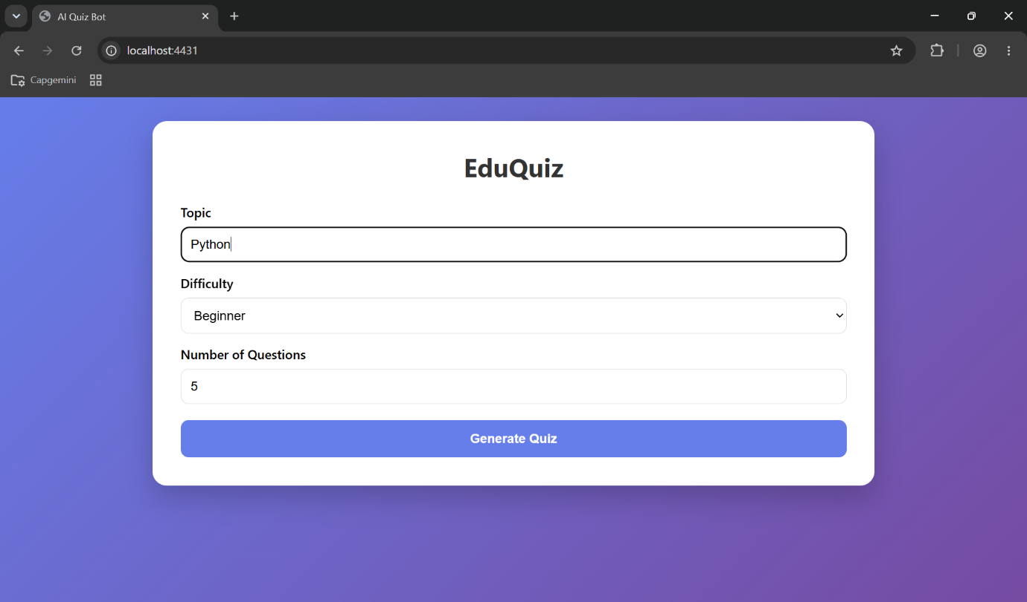
The landing page where users can select a topic, difficulty level, and the number of questions to generate.
Quiz Page
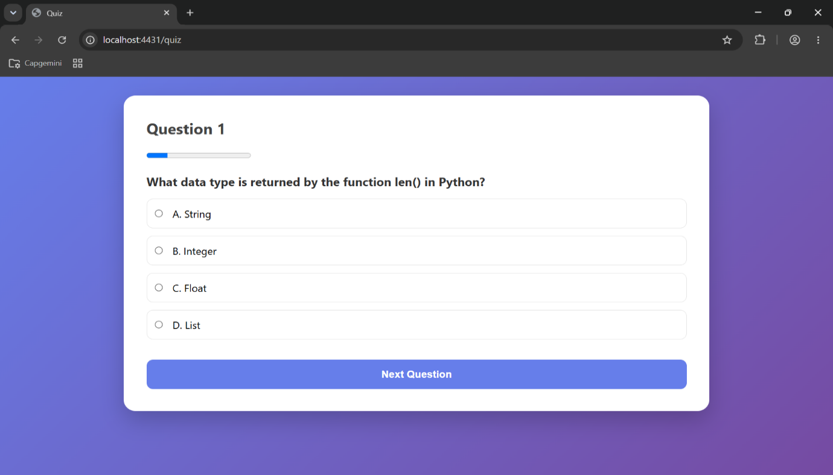
Displays AI-generated multiple-choice questions. Users can select an answer and navigate through the quiz.
Results Page
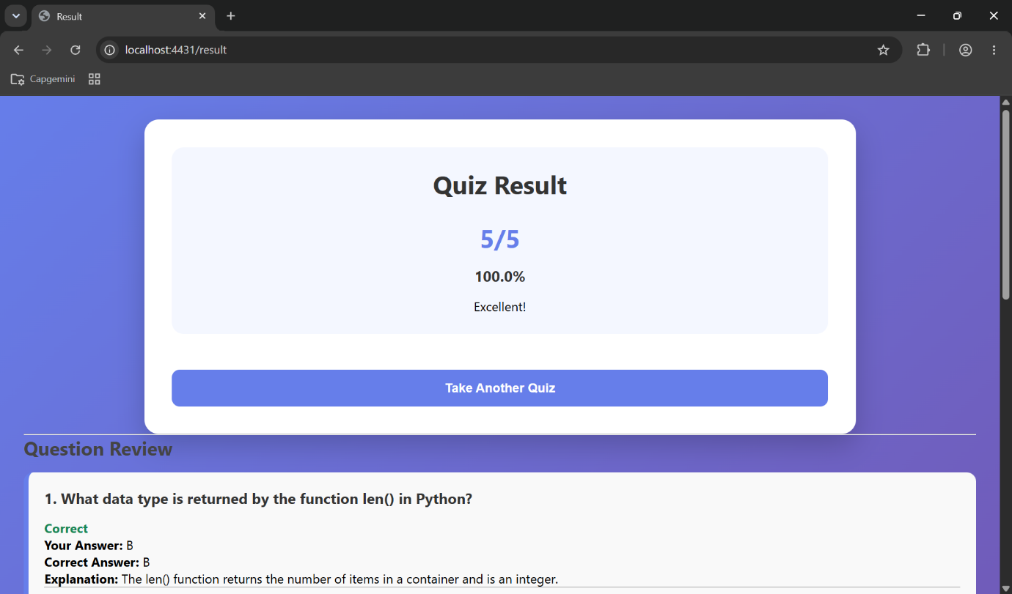
Shows the final score, percentage achieved, performance message, and answer review.
Answer Review & Explanation
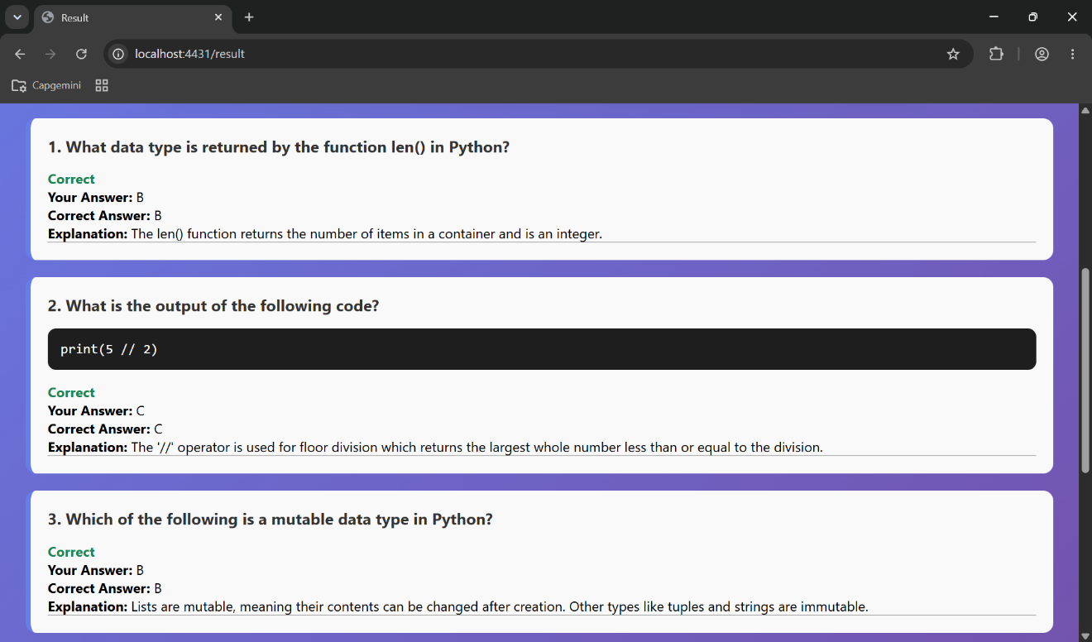
Provides a detailed review of each question, including the user's answer, correct answer, and AI-generated explanation.

