Data Visualization

graph visualizations for the  
undirected graph defined by the adjacency matrix.

Use D3’s force-directed layout function to visualize this graph. You may use your manually placed node locations as the starting positions. Users should be able to pick and drag nodes interactively.

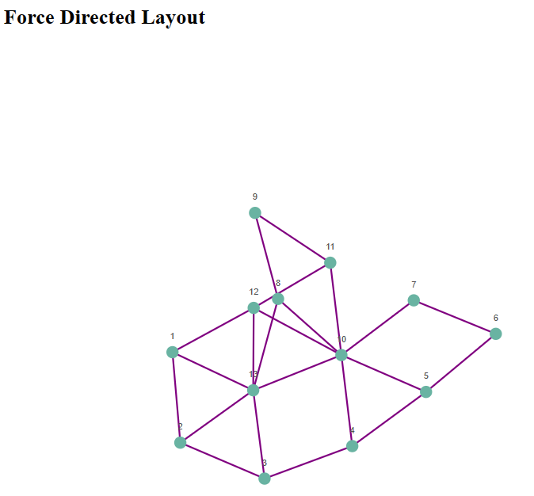

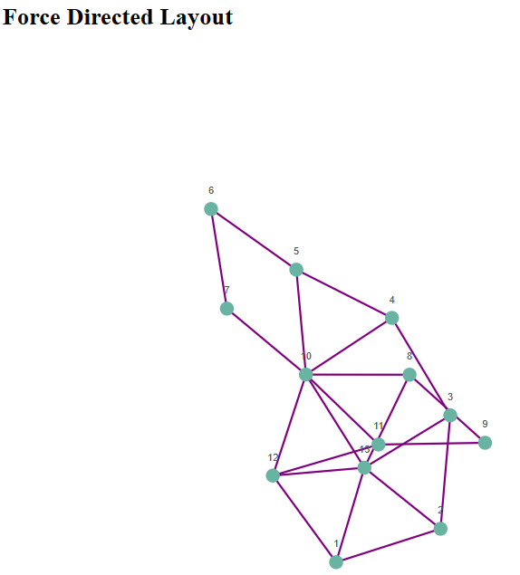

3. Draw an Arc Diagram of this graph using D3. Again, carefully order your nodes on the axis to avoid too many edge crossings and long edges.

4. Draw a Radial Network Diagram of this graph using D3. You may apply the same order as in the Arc Diagram to place the nodes on a circle.

