**Pizza Sale SQL Queries**

1. KPI’s
2. Total Revenue

SELECT SUM (total_price) AS Total_Revenue FROM [pizza_sales excel file.1]

1. Average Order Value

SELECT SUM (total_price) / COUNT (DISTINCT order_id) AS Avg_Order_Value FROM [pizza_sales excel file.1]

1. Total Pizzas Sold

SELECT SUM (quantity) AS Total_Pizza_Sold FROM [pizza_sales excel file.1]

1. Total Orders

SELECT COUNT (DISTINCT order_id) AS Total_Orders FROM [pizza_sales excel file.1]

1. Average Pizzas Per Order

SELECT CAST (SUM(quantity) AS DECIMAL(10,2)) /

CAST (COUNT(DISTINCT order_id) AS DECIMAL(10,2)) AS Avg_Pizzas_Per_Order FROM [pizza_sales excel file.1]

Charts

1. Daily Trend for Total Orders

SELECT DATENAME (DW, order_date) AS order_day, COUNT(DISTINCT order_id) AS Total_Orders FROM [pizza_sales excel file.1]

GROUP BY DATENAME(DW, order_date)

1. Hourly Trend for Total Orders

select DATEPART(HOUR, order_time) AS Order_Hours, COUNT(DISTINCT order_id) AS Total_Orders from [pizza_sales excel file.1]

GROUP BY DATEPART(HOUR, order_time)

ORDER BY DATEPART(HOUR, order_time)

1. Percentage of Sales by Pizza Category

SELECT pizza_category, SUM(total_price) AS Total_Sales, SUM(total_price) * 100 / (SELECT SUM (Total_Price) FROM [pizza_sales excel file.1]

WHERE MONTH(order_date) = 1) AS PCT_Sales

FROM [pizza_sales excel file.1]

WHERE MONTH(order_date) = 1

GROUP BY pizza_category

/* Here, MONTH(order_date) = 1 indicates that the output is for the month of January; MONTH(order_date) = 4 indicates the output is for the month of April.

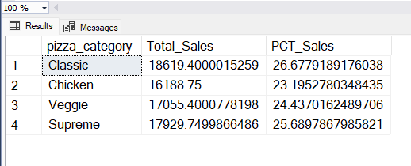

1. Percentage of Sales by Pizza Size

SELECT pizza_size, CAST(SUM(total_price) AS DECIMAL(10,2)) AS Total_Sales, CAST(SUM(total_price) * 100 / (SELECT SUM (Total_Price) FROM [pizza_sales excel file.1]

WHERE DATEPART(QUARTER, order_date) = 1) AS DECIMAL(10,2)) PCT_Sales

FROM [pizza_sales excel file.1]

WHERE DATEPART(QUARTER, order_date) = 1

GROUP BY Pizza_Size

ORDER BY PCT_Sales

1. Total Pizzas Sold by Category

SELECT pizza_category, SUM(quantity) AS Total_Pizzas_Sold

FROM [pizza_sales excel file.1]

GROUP BY pizza_category

1. Top 5 Best Sellers

SELECT TOP 5 pizza_name, SUM(quantity) AS Total_Pizzas_Sold

FROM [pizza_sales excel file.1]

GROUP BY pizza_name

ORDER BY SUM(quantity)

