AAI3001 · COMPUTER VISION AND DEEP LEARNING
PitchProfile
How each model works, how events and statistics are computed, and how the models were trained
Technical documentation of the PitchProfile video-analysis system, written from the code, the evaluation reports and the training logs in this repository. Every number comes from a stored result and says which test it was measured on.

Document
Scope | All models and algorithms in the full-match pipeline, event and statistic definitions, training methods, measured performance, limitations
Demo match used for examples | Chelsea v Manchester United, Premier League, 7 February 2016 (95:20 of SoccerNet 720p broadcast video, both halves)
Code | PitchProfile/football_profiler (pipeline), PitchProfile/scripts (training and evaluation), PitchProfile/evidence (reports, kept on the data drive)
Date | 8 October 2026
Status | Authors: [Team name · members]

Contents
1 Overview: what the system does and how the parts fit together
2 The models, one by one
3 How the system decides what is a pass, a shot, a carry and the other events
4 How distance, speed, sprints and positions are measured
5 How the models were trained
6 How well it works: all measured results
7 Limitations and how to read the numbers
8 Reproducing the results
A Appendix A: thresholds and constants
B Appendix B: glossary
C Appendix C: where things are in the code
D Appendix D: retired, removed and not adopted
Figures and tables are numbered in order. Terms in a grey code font, such as TOUCH_DV, are constant names in the code; Appendix A lists them with their values.

1. Overview: what the system does and how the parts fit together
PitchProfile takes the broadcast video of a football match and produces, for every player it can see, a set of statistics: where the player was, how far and how fast they moved, and what they did with the ball. The video is the only input. No tracking feed or event feed is used. A match line-up can optionally be connected to help name players (Section 2.9), but no number in this report uses one. Public annotations (SoccerNet, SoccerTrack, FOOTPASS) are used only to train models and to measure how well they work.
The system is a pipeline of nine stages. Some stages are learned neural networks, some are classical computer-vision methods, and some are hand-written rules. Figure 1 shows the order, and Table 1 lists what each stage does.
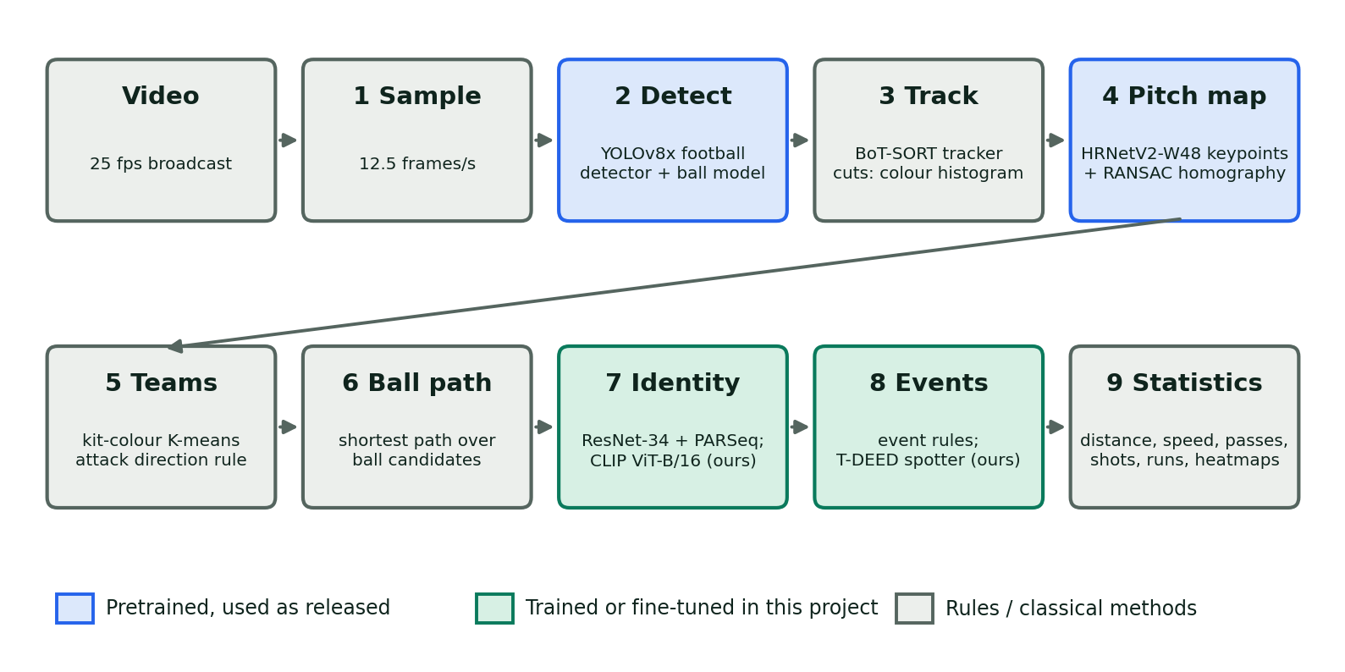
Figure 1. The pipeline. Blue stages use pretrained models as released, green stages use models trained or fine-tuned in this project, grey stages use rules and classical methods.
Stage | What it does | Method | Learned?
1 Sample | Reads every second frame of the 25 fps video, giving 12.5 samples per second | Frame stride | No
2 Detect | Finds players, goalkeepers, referees and the ball in each sample | YOLOv8x (football weights), plus a ball-only YOLOv8x | Pretrained
3 Track | Links detections into short tracks; finds camera cuts so identities are never carried across a cut by mistake | BoT-SORT; colour-histogram cut detector | No
4 Pitch map | Finds the pitch lines in the picture and converts image positions to metres on a 105 × 68 m pitch | HRNetV2-W48 keypoint network, RANSAC homography | Pretrained
5 Teams | Splits players into two teams by shirt colour; decides which way each team attacks | K-means on torso colour; positional rule | No
6 Ball path | Chooses one most-likely ball position per sample over the whole shot | Shortest-path search over detections | No
7 Identity | Reads shirt numbers and recognises players, so tracks across cuts become named players | ResNet-34, PARSeq, CLIP ViT-B/16 identity model | Fine-tuned here
8 Events | Finds touches, passes, carries, shots, tackles, headers and more | Rules over positions and the ball; T-DEED video model | Fine-tuned / trained here
9 Statistics | Totals everything per player and per team; computes distance, speed, heatmaps and rates | Arithmetic over the above | No
Table 1. The nine stages of the pipeline.

1.1 The idea in one paragraph
A player is first a box in a picture, then a track (the same box followed for a few seconds), then a dot on the pitch in metres, then a named player once the shirt number or appearance is recognised. The ball goes through the same journey. Once players and the ball are dots on the pitch with a time, simple geometry gives distance and speed, and rules over the ball and the nearest player give passes, carries and shots. A learned video model handles the actions that geometry cannot see, such as a tackle or a header.

1.2 Conventions used throughout
- Sampling. Detection runs on every second frame of the 25 fps video, so all times are in steps of 0.08 s (12.5 samples per second). The demo match has 71,500 samples.
- Pitch coordinates. Metres on a 105 × 68 m pitch. x runs along the length (0 to 105) and y across the width (0 to 68). The origin is the far-left corner as seen from the main camera.
- Attack-normalised coordinates. For statistics that depend on direction (forward passes, thirds, heatmaps), positions are flipped so that every team attacks towards x = 105. A team's direction is inferred per half from where its players stand.
- Shot. In this document a "shot" in the broadcast sense is one continuous camera view. Cutting to another camera, a close-up or a replay ends the shot. Tracking, ball path and event logic never cross a cut. (A football "shot" at goal is always written "shot at goal" or "shot event".)
- Segment. A stretch of one player inside one camera view, made by joining short tracks of the same person. Identity is a named player (for example "Man United #35") made of many segments across the match.
- Visible time. Seconds during which a player was on screen inside a calibrated pitch view. Distance, speed and the rates "per 90 on screen" use only visible time. A player the camera did not show contributes nothing for that time.
- Whole match. The app can merge the two halves into one dataset: the second half is shifted by the first half's length (2,700 s here) and mirrored so each team attacks the same way all match.

1.3 Which models are ours, which are borrowed
In this document a model is something whose weights were learned from data. Hand-written logic with fixed thresholds is called a rule, and anything else that is not learned (the tracker, K-means on shirt colour) is a method. Five pieces are pretrained models used as released: the football detector, the ball detector, the pitch keypoint network, the shirt-number legibility classifier and the PARSeq number reader. Two are fine-tuned in this project on public annotated data: the identity model and the action spotter. Fine-tuned means the model starts from published weights and keeps training on our data. The remaining stages are methods or rules whose numbers were set by hand and checked on held-out ground truth. Section 5 describes all training.
Why it matters. Because most of the pipeline is geometry and rules over detections, its accuracy is bounded by how often the camera shows the players and the ball. Section 7 returns to this.
Retired and not adopted. Several things were built and then retired (shot classifier, hand-written shot rule, re-identification head), removed (archetype profiler, short-clip analysis) or not adopted (fine-tuned ball detector). They are collected, with the measurements behind each decision, in Appendix D.

2. The models, one by one
Each entry says what the model is for, what goes in and out, how it works, where it is in the pipeline, and what was measured. Section 6 collects the full results.

2.1 Football detector: YOLOv8x
Job. Find every person and the ball in each sampled frame, and say whether each person is a player, a goalkeeper or a referee.
How it works. YOLOv8x is a single-stage object detector. The frame is resized to 1,280 pixels wide and passed once through a convolutional network that predicts, on grids at three scales, a box and a class score for each location. Overlapping boxes of one object are merged by non-maximum suppression (IoU 0.5). The pipeline keeps boxes with confidence of at least 0.1. The threshold is low on purpose: weak detections of distant players and the ball are kept, and later stages (tracking, ball path search, team assignment) remove the false ones. The weights come from the Roboflow football detector (four classes: player, goalkeeper, referee, ball) and are used without retraining.
What it feeds. Everything. The bottom centre of a player's box is the foot point that becomes a position on the pitch; the torso of the box gives the kit colour; the box is cut out as a thumbnail for the identity model; and the ball box, when present, is a ball candidate.
Measured. About 14 outfield players are detected per frame. On FOOTPASS ground truth (2.03 million true player-samples), 89.7% of visible player time had a detection with IoU of at least 0.5. Detection is weakest for very large close-up players: boxes over 150 px tall were detected 63.6% of the time, against 88–92% for boxes of 60–150 px.

2.2 Ball detector
Job. The ball is small (roughly 8–25 pixels across in 720p) and often hidden, so it gets its own detector. When the football detector finds no ball in a sample, a second YOLOv8x trained only on balls is run on that frame.
Measured. On 7,350 SoccerNet tracking frames (the ball visible in 6,766), the default ball model at confidence 0.1 found the ball in 47.2% of the frames where it was visible, and 72.1% of its detections were the real ball. The ball is the weakest link of the pipeline. A version fine-tuned in this project found more balls on its own but did not improve the full pipeline, so it was not adopted (Appendix D.3).

2.3 Tracker: BoT-SORT, and joining tracks into segments
Job. Give each person a track id that stays the same from frame to frame inside one camera view.
How it works. BoT-SORT predicts where each existing track should be in the next sample with a Kalman filter, then matches new detections to tracks by box overlap in two passes: confident boxes (score ≥ 0.25) first, weak ones (≥ 0.1) second, with a match threshold of 0.85. Because the broadcast camera pans and zooms constantly, the predicted positions are first corrected for camera motion using sparse optical flow between frames. Appearance re-identification inside the tracker is switched off; recognising who someone is happens later in the identity stage. A track lost for about a second is dropped. At every camera cut the tracker restarts.
Short tracks are then joined into segments by a motion rule: two tracks in the same view, of the same team and role, with a gap of at most 1.2 s, are joined if the distance between the end of one and the start of the next is at most 1.8 m + 7.5 m/s × gap. Joins are made greedily, nearest first, and never join overlapping tracks.
Measured. On FOOTPASS true boxes, 97.1% of tracked time sat in segments that contained only one player (segment purity), and 66.7% of visible time was in segments of 10 s or longer. Only 2.8% of detected player time was in no segment at all.

2.4 Camera-cut detector
Job. Tell when the broadcast switches camera, so that nothing is tracked or measured across the change.
How it works. Not a neural network. Each sampled frame is shrunk to 160 × 90 pixels and turned into a hue-and-saturation histogram (30 × 16 bins). A cut is declared when the Bhattacharyya distance to the previous sample's histogram exceeds 0.35. On 42 minutes of SoccerNet video this found 115 of 133 labelled hard cuts; the earlier rule (a change in mean grey level) found 19. The demo match has 730 cuts, roughly one every 7.8 seconds of video, and the median shot in the working set lasts about 3.5 s.

2.5 Pitch calibration: HRNetV2-W48 keypoints and a homography
Job. Convert a point in the picture into a point on the pitch in metres. Without this there would be no distance, no speed and no pitch positions.
How it works. The "No Bells Just Whistles" network (HRNetV2-W48) is given a frame at 960 × 540 and outputs 57 heat maps, one for each of 57 known pitch locations (corners, penalty-box corners, centre circle points, penalty spots and so on). The peak of each heat map, if confident (score ≥ 0.1486), gives the picture position of that pitch point. Four crossbar points are 2.44 m above the ground and are excluded; only ground points are used. From the matched pairs, RANSAC fits a 3 × 3 homography H, a mapping that carries any point of the pitch plane between the picture and the pitch (Figure 2). A fit is kept only if it has at least 5 inlier points within 6 px, a reprojection error under 4 px, and agrees with the painted white lines in the image.
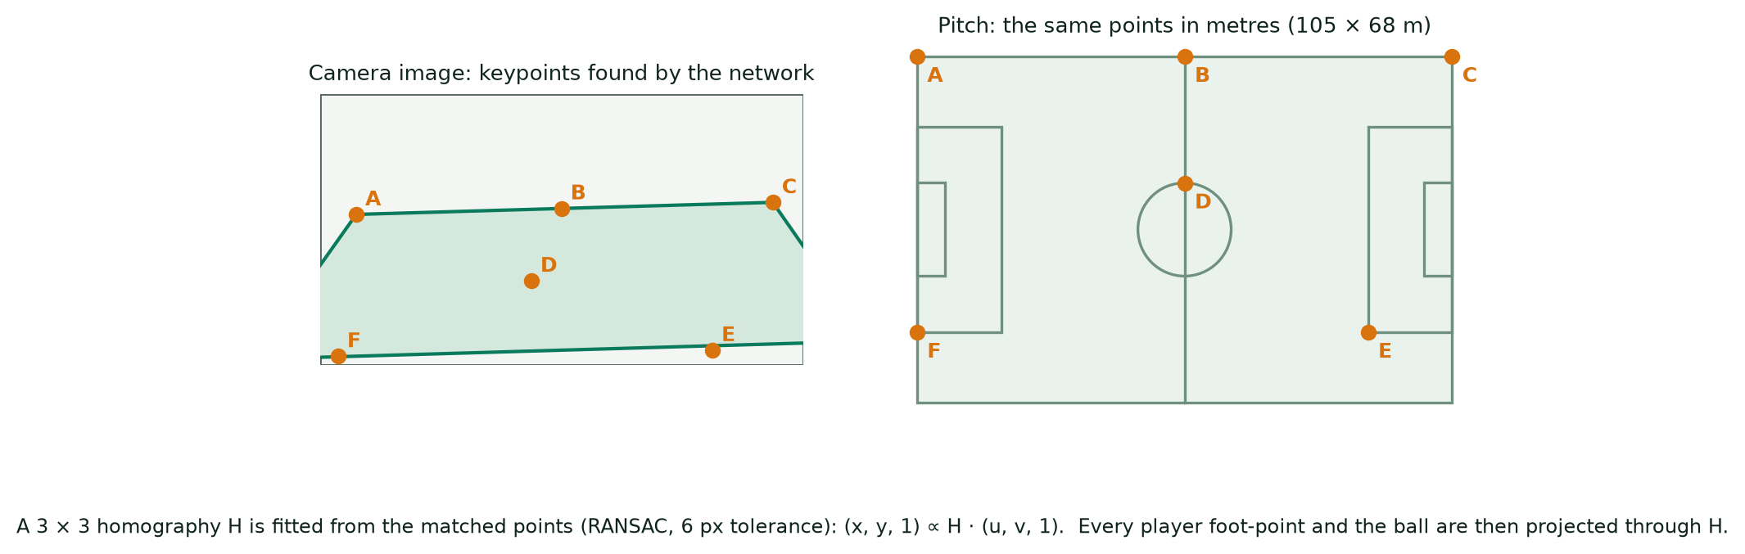
Figure 2. The idea of calibration. Matching keypoints between the camera image and the pitch fixes a homography; every foot point and the ball are then projected through it.
Calibration is tried on every second sample (and at the start of every shot). The raw fits are noisy, so they are cleaned before use: a fit more than 1 m away from the running median of its seven neighbours is rejected; gaps of up to 1.2 s inside a shot are filled by interpolation; the homographies are smoothed over 5 samples; and a sudden jump of the projected image centre of more than 12 m is treated as an undetected cut. A sample counts as "pitch view" only if at least half of the calibration attempts in its shot succeeded. Positions up to 3 m outside the lines are still accepted (throw-ins, goalkeepers).
Measured. On Chelsea v Burnley, the jitter of fixed image points projected to the pitch fell from 1.1 m to 0.18 m at the 90th percentile, and from 9–18 m to 0.5 m at the 99th, after this cleaning. In the demo match, 50.6% of the video was a usable pitch view.

2.6 Teams, attack direction and goalkeepers
Teams. Not learned. For each detected player the torso is sampled (the central 64% of the box width, from 15% to 50% of its height), grass-coloured pixels are masked out in HSV, and the median colour in CIELAB space is kept. Two-cluster K-means (12 random starts, observations weighted by the square root of their count, lightness down-weighted by half) groups the outfield tracks into two kits. Referees keep the detector's class.
Direction. Defenders stay between the ball and their own goal, so over a half the team with the smaller mean x defends the left goal. A gap of at least 1.5 m makes the direction "inferred". On the 8 halves where kick-off positions could be checked, the rule was right 8 times out of 8.
Goalkeepers. The detector labels goalkeepers; each is given to the team whose goal he stays near. The identity model's goalkeeper head adds a second opinion with safeguards (Section 2.9).
Naming the teams. The two kit clusters are anonymous ("Team A", "Team B"). In the demo they were named Manchester United (red) and Chelsea (blue) by looking at a frame with the broadcast scoreboard.

2.7 Ball path selection
Job. Detectors report zero, one or several ball candidates per sample, many of them wrong (boots, socks, advertising boards). Choose one ball per sample.
How it works. For each camera shot, a dynamic-programming search finds the cheapest path through the candidates over time. A candidate costs −0.5·ln(confidence); skipping a sample costs 1.0; starting a new trajectory piece costs 4.0; and a step is only allowed if the image motion is consistent (up to 90 px per sample, which allows for camera pan) and the implied pitch speed is below 38 m/s. Gaps of up to 8 samples are bridged inside the search, and up to 0.8 s are interpolated afterwards; interpolated points are marked and are not used as evidence of a touch. This is a global search, so one wrong high-confidence detection is outvoted by a consistent trajectory of weaker ones.
Measured. Across the 22 analysed halves the ball is located in a median of 64% of live play (range 47–80%); in the demo match it was 52.9%.

2.8 Shirt-number reading: legibility classifier and PARSeq
Job. Read the number on a player's back, when it is readable.
How it works. Two pretrained models from the SoccerNet jersey-number pipeline of Koshkina and Elder. A ResNet-34 legibility classifier decides whether a thumbnail shows a readable number at all (most do not: a player seen from the front, from far away or turned sideways shows nothing). PARSeq, a scene-text recogniser, reads digits from the torso band of the legible ones. On the official SoccerNet Jersey 2023 test split (1,211 tracklets) the pair gets 80.3% of tracklets right, counting "no number visible" as a correct answer; legible tracklets were read right 76.8% of the time.
The legibility classifier also tells the identity model which thumbnails may vote on a number (Section 2.9); PARSeq is a cross-check on every name.

2.9 Identity model: fine-tuned CLIP ViT-B/16
Job. Turn anonymous tracks into players. This is the model that makes per-player statistics possible, because the camera cuts every few seconds and a track never survives a cut.
Architecture. A CLIP ViT-B/16 vision transformer (OpenAI weights) takes a 224 × 224 thumbnail (the crop is scaled to fit and padded with grey, because players are tall and narrow). Four small output heads sit on top of the 768-dimensional image feature:
- Tens digit (10 classes: none, 1–9) and units digit (10 classes: 0–9). Reading two digits separately means a number never seen in training can still be read.
- Appearance embedding (768 → 512 → 256, normalised). Trained so thumbnails of the same player are close and thumbnails of any other player of the same game, team-mates included, are far.
- Goalkeeper probability. Goalkeepers wear a kit that matches neither team, so colour clustering alone often leaves them unassigned.
How the output is used. The pipeline cuts up to 24 thumbnails per track. For each segment, the digit probabilities of its legible thumbnails (legibility ≥ 0.5) are combined, each weighted by how sure that thumbnail is, so blurred or turned views count for almost nothing. Segments are then grouped into players by appearance, never joining two segments that are on screen together (up to 15 s of shared screen time is tolerated, because a tracker sometimes carries a box onto the wrong player for a moment). A group is named when one number has at least 85% of its votes. Segments that start where a team-mate's segment was heading are linked by pitch position when the gap is under 5 s. Groups with no reliable number stay as consistent "unnumbered" players, and their statistics are still kept. Goalkeeper calls are ignored for a team whose typical player scores above 0.3 or whose calls cover over 15% of its detections, and a called keeper must stay within 16.5 m of a goal line.
Measured. On three held-out FOOTPASS games (13,610 true tracklets, 406,205 crops): goalkeepers found with 89.9% recall at 99.0% precision; appearance matching of a tracklet to the right player 98.3%; the number reader, restricted to thumbnails where it is confident (≥ 0.5), right 94.2% of the time while reading 38% of tracklets. Through the whole pipeline, on 2.03 million true player-samples, 52.3% of visible player time was given the right player and 95% of the names given were right (Figure 7). The rest sits in consistent unnamed players or is not detected.
Optional line-up. If a reviewer connects the match line-up and confirms which kit group is which team, the shirt numbers that played check the naming. A number nobody in the line-up wore is treated as a misreading, and an unnamed group is named when one line-up number not yet taken holds at least 90% of its readable votes (and at least 20% of all its votes). In a test on the three held-out FOOTPASS games, with each team's true squad as the line-up, the share of visible time named right rose from 53.0% to 64.2% and wrong names went from 3.0% to 2.7%. That test was run before the later changes (today's video-only figure is 52.3%), without the 20% guard wrong names rose to 5.1%, and it has not been measured with real provider line-ups. None of the figures elsewhere in this report use a line-up.

2.10 Action spotter: T-DEED
Job. Find actions that positions and the ball path cannot reveal: tackles, blocks, headers, crosses, lofted passes, throw-ins and shots, and say which team did them.
How it works. T-DEED (Temporal Discriminability Enhancer Encoder-Decoder; the SoccerNet 2025 Team Ball Action Spotting baseline) watches an 8-second clip of 100 frames at 12.5 frames per second and 796 × 448 pixels. A small image network, RegNet-Y 200MF with gate-shift modules that mix information between neighbouring frames, makes a feature for every frame. A temporal encoder-decoder then sharpens the differences between neighbouring frames so that an action can be placed on the right frame. Three heads read the result: which of 12 actions happens at each frame (pass, drive, header, high pass, out of play, cross, throw-in, shot, block, successful tackle, free kick, goal), how far the true moment is from the frame (so timing is finer than the frame step), and which team (left or right of the screen) did it. Clips overlap by three quarters and overlapping predictions are merged with soft non-maximum suppression over a 12-frame window. Scores below 0.05 are discarded.
What it feeds. Each spot with a class, a time, a side and a score. The side "left" means the team defending the left goal, which the pipeline already knows. For tackles and blocks, the team is taken from the previous touch instead (the tackler is on the other side of the last on-ball spot), which was right 78–97% of the time against 65–78% from the model's own side output. A spot is credited to the player of that team whose picture box holds the ball at that moment, otherwise the nearest of that team within a radius; if neither exists, the event stays team-level. Statistics from the spotter are expected counts: the sum of scores, not a count of events above a threshold.
Measured. See Figures 8 and 9 and Section 6.3. Passes and drives are reliable (average precision 0.91 and 0.89 on FOOTPASS validation); tackles remain weak (0.06–0.10).

2.11 How the models depend on each other
Each stage needs the ones before it, so a weak early stage limits everything after it. Table 2 shows what each model contributes and what is lost if it fails.
Model / stage | Needs | Provides | If it fails
Football detector | Frames | Boxes of people and ball | No players at all
Tracker + cut detector | Boxes | Tracks inside a view | Players cannot be followed; wrong identity carried over a cut
Pitch keypoints + homography | Frames | Metres on the pitch | No distance, speed, positions or events (only picture boxes)
Team clustering, direction | Positions, colours | Team of each player; forward = towards goal | Passes and runs lose their direction; heatmaps are not comparable
Ball path | Ball candidates, homography | One ball per sample | Touches, passes, carries and shots cannot be found
Identity model | Thumbnails, segments | Named players | Statistics stay per track, not per player
T-DEED spotter | Frames, team directions | Tackles, blocks, headers, shots, crosses | Those actions are missing or far too low; a half without spotter output has no shots
Statistics | All of the above | The report
Table 2. What each stage needs, provides and risks.

3. How the system decides what is a pass, a shot, a carry and the other events
Most events are found by rules over two things the earlier stages provide: the positions of every player and the position of the ball, both in metres and in time. The rules are explicit and conservative. If the ball was not seen, or the camera was not on the pitch, the event is missed rather than invented. All thresholds were set on annotated ground truth (SoccerTrack and SoccerNet), and Appendix A lists every one.

3.1 Step 1: detecting a touch from the ball's motion
A football only changes direction or speed abruptly when something hits it. The system turns that into a measurement.
- Ball velocity before and after. For each sample, the ball's velocity is measured over the two samples before it and the two after it: v_in = (position − position two samples earlier) / 0.16 s and v_out = (position two samples later − position) / 0.16 s. Only observed ball positions inside one continuous piece of the ball path are used; interpolated points are straight lines and carry no touch evidence.
- Velocity change. dv = the length of the vector v_out − v_in, in m/s. A ball rolling smoothly past a player has a small dv. A kick, a trap or a deflection produces a spike (Figure 3).
- A kick is a spike with a player at the ball. A sample is a kick if dv is at least TOUCH_DV = 4 m/s, is the largest value within two samples either side, and a player is within TOUCH_RADIUS_M = 2.0 m of the ball just before the spike. Where the ball's position in the picture is known, it must also lie on that player's box (padded by 35% of the box width either side), because a lofted ball is projected onto the pitch far from where it really is. The kicker is the nearest such player, with a preference for whoever already had the ball if they are within half a metre of the nearest.
- Control is a touch without a spike. A dribbler keeps the ball close without sharp changes. If the ball stays within CONTROL_RADIUS_M = 1.2 m of the same player, moving slower than 9 m/s, for at least 3 consecutive samples (0.24 s), that player has control. A marker standing slightly closer does not take possession unless the current holder is further than 1.7 m.
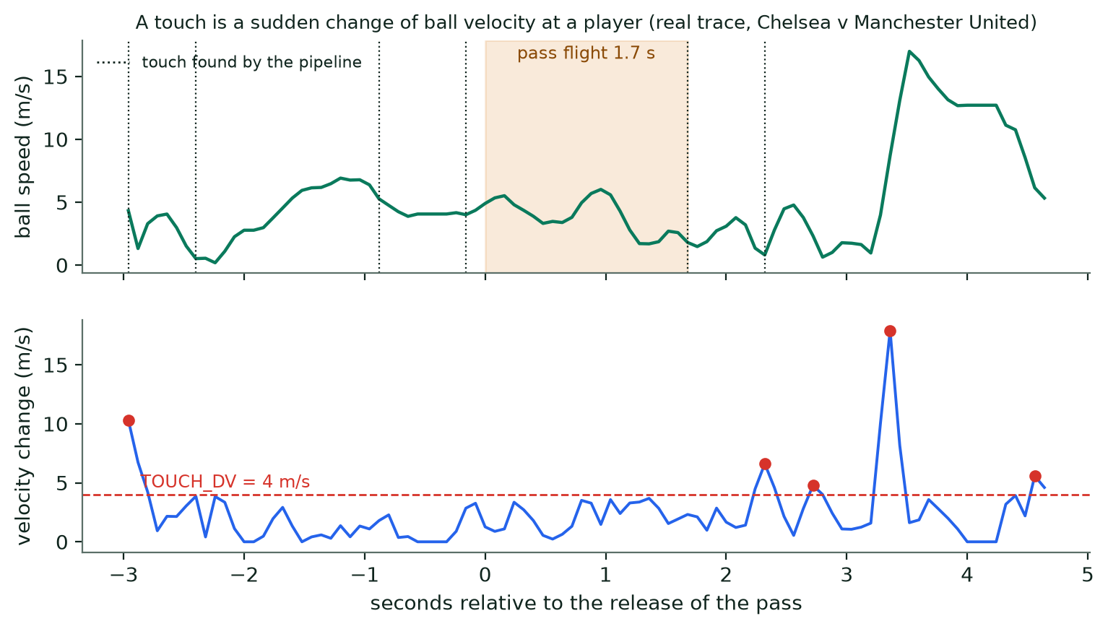
Figure 3. A real trace from the demo match. Top: ball speed in the seconds around a pass; dotted lines are touches found by the pipeline. Bottom: the velocity change. Spikes above 4 m/s that are local maxima (red) are candidate kicks.

3.2 Step 2: possession spells
Consecutive touches by one player, with no touch by anyone else in between and gaps of at most SPELL_MAX_GAP_S = 2.5 s, form a possession spell. A spell has a start, an end, a start and end position of the ball, and a duration (time on the ball).
Deflections. A very short spell (at most 2 samples) by one team, sandwiched between two spells of the other team in the same view within 2 s, is a deflection or contested touch, not a change of possession. Removing these halved the excess of possession changes over the annotated sequence on SoccerTrack (206 found against 172 annotated in the first half).

3.3 Step 3: passes
A pass is the gap between two spells. Take a spell and the next spell:
- They must be in the same camera view, with the next spell starting at most MAX_PASS_FLIGHT_S = 4 s after the first ends, and by a different player segment.
- The ball must have travelled plausibly: the distance between where the first spell ended and the second began, divided by the gap, must not exceed 35 m/s (a faster implied speed means the ball path broke).
- If the second player is on the same team, the first spell ends in a completed pass. Its length is the distance between the two positions, its forward distance is the difference in x measured towards the goal the team attacks, and its flight time is the gap.
- If the second player is on the other team, the pass is intercepted. It becomes a clearance instead if it was played from the team's own third and was at least 20 m long.
Each pass carries flags: progressive (forward distance of at least 10 m), long (at least 30 m), cross (Section 3.8), key pass (the receiver shoots within 5 s), and ball played in behind (received at least 1 m beyond the last opposing outfield player, moving forward). A pass whose receiver is not detected, or whose ball path breaks, is simply not found. The video model can add passes that tracking missed; those count as passes but have no outcome, length or direction, so every pass quality (completion, length, direction) is computed from tracked passes only.
Worked example (demo match, 2080 s). A Manchester United player releases the ball; the next touch is by a team-mate 1.52 s later and 22.7 m away, of which 18.4 m is towards goal. That is one completed, progressive pass with an implied ball speed of about 14.9 m/s (54 km/h).

3.4 Step 4: interceptions, recoveries, tackles and clearances
- Recovery. Every time possession passes from one team to the other, the receiving player gets a recovery.
- Interception. A recovery after an intercepted pass is an interception only if the pass was a moving ball: at least 3 m of flight, and the median ball speed over the three samples before the opponent's first touch at least 6 m/s. Collecting a slow or loose ball is only a recovery.
- Tackle. A tracking rule (possession changes team within 0.6 s with the two players within 2.2 m) exists, but on ground-truth positions it had 6–14% precision and 8–12% recall, because real tackles look like any other contact. Tackles, blocks and headers therefore come from the video action spotter (Section 2.10) and are reported as expected counts.

3.5 Step 5: carries
A spell is a carry if the ball moved at least CARRY_MIN_M = 2.0 m between the first and last touch of that player (SoccerTrack's "Drive" has a median of 2.9 m). Its length is the straight-line distance, and it is progressive if at least 10 m of that is towards goal. Total carry distance is the sum of carry lengths. Carries that tracking missed but the video model spotted are filled in as carries without a length.

3.6 Step 6: take-ons and dribbles
A take-on is an attempt to beat a defender. During a spell of at least 0.4 s, the carrier must be moving towards goal at 2 m/s or more (measured over ±3 samples) while an opponent is within 2.0 m ahead of him and within 1.2 m of his line. It is a successful dribble if his team still has the ball at the next spell. Following the defender until he is behind the carrier was tried first but a metre of position noise made it flip too often (only about 5% successes), so retention of the ball decides the outcome. The result is 7–9 attempts per team per half, in line with real-world rates, although there is no local ground truth to test it against.

3.7 Step 7: shots
Shots are decided by the video model. A half without spotter output has no shots.
- Video model (used). A spot of class SHOT above the class threshold (0.3 in the stored runs) becomes a shot. The shooter is the player of that team at the ball at that moment: the one whose picture box holds the ball, otherwise the nearest within 3 m; with nobody there the shot stays team-level.
- No fallback. There is no rule-based or classifier fallback; the earlier ones are described in Appendix D.1. A shot is stored with its distance to goal. A spell that ends in a confirmed shot is not also counted as a failed pass.
- The system does not decide whether a shot was on target, blocked or a goal. Those outcomes stay "unknown" until a person reviews them.
Worked example (demo match, 1021 s). The video model spots a SHOT by Manchester United. The ball is 21.2 m from the goal being attacked when the shot is spotted.

3.8 Step 8: crosses, pressures and the rest
- Cross. A pass or spotted delivery from the wide part of the attacking third (at least 18 m from the centre line and beyond x = 70 in attack-normalised coordinates) whose ball path or reception enters the penalty area (x ≥ 88.5 m, y from 13.8 to 54.2 m).
- Pressure. Whenever a defender comes within PRESSURE_RADIUS_M = 3.0 m of the ball carrier during a spell, that defender gets one pressure for that spell.
- Dispossessed and turnovers. A player dispossessed in a tackle, plus their intercepted passes, are turnovers.
- Headers, blocks, lofted passes, throw-ins. Spotted by the video model and credited like tackles.
- Touches in zones, box entries. Touches in the final third and penalty area; passes and carries that start outside and end inside the final third or box; switches (a completed pass moving the ball at least 30 m across the pitch).

3.9 Giving an event to a player
An event found by rules belongs to the segment that made the touch, and a segment belongs to an identity. Events from the video model carry a time and a team but not a player, so each is credited to the player of that team at the ball (Section 2.10). This is the weakest link: even with perfect identities, only 59% of labelled passes landed on the right player's track, and about a quarter of spotted passes and carries could not be credited at all, mostly because the ball was not found at that instant. Team-level totals do not have this problem, because every event counts for its team whether or not a player can be named.
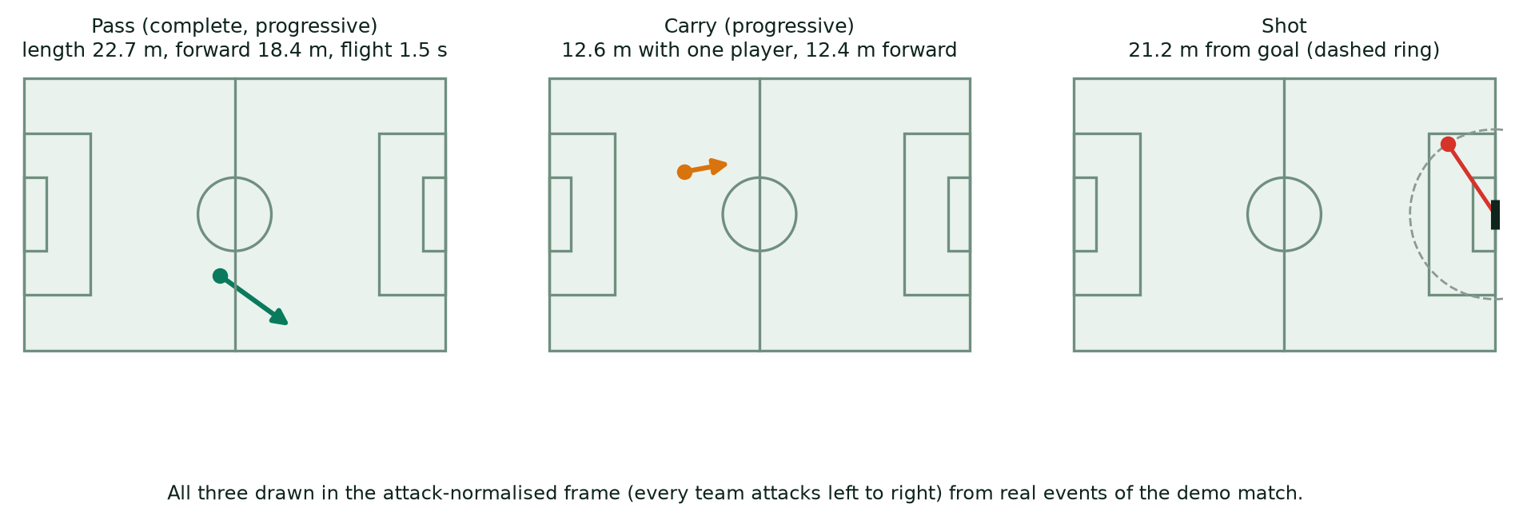
Figure 4. Three events from the demo match, drawn in attack-normalised coordinates: a completed progressive pass, a progressive carry and a shot at goal.

3.10 Summary of event definitions
Event | How it is detected | Key numbers
Touch | Ball velocity spike with a player at the ball, or close control | dv ≥ 4 m/s, ≤ 2.0 m; control ≤ 1.2 m for ≥ 3 samples
Spell | Consecutive touches by one player | gap ≤ 2.5 s
Pass (complete) | Next spell by a team-mate in the same view | gap ≤ 4 s, implied speed ≤ 35 m/s
Pass (intercepted) | Next spell by an opponent | same limits
Progressive pass / carry | At least 10 m towards goal | ≥ 10 m
Long pass | Length | ≥ 30 m
Carry | Ball moved with one player | ≥ 2.0 m
Take-on / dribble | Driving at an opponent; dribble if team keeps ball | ≤ 2.0 m ahead, ≤ 1.2 m across, ≥ 2 m/s
Interception | Opponent cuts out a moving pass | ≥ 3 m flight, ≥ 6 m/s
Recovery | Possession changes team
Clearance | Intercepted long ball from own third | ≥ 20 m
Pressure | Defender close to the carrier | ≤ 3.0 m
Shot | Video model | threshold 0.3
Tackle, block, header, cross, lofted pass, throw-in | Video model, team from the previous touch for tackles and blocks | class thresholds 0.3–0.475
Table 3. Event definitions at a glance.

4. How distance, speed, sprints and positions are measured
Physical statistics need no ball and no event logic. They use only where the player was and when. That is why they are the most reliable numbers in the report, subject to one condition: the player must be on screen.

4.1 From a box to a position on the pitch
For each sample, the bottom centre of a player's box (the feet) is passed through the homography of that frame (Section 2.5). The result is x and y in metres. Positions up to 3 m outside the lines are kept; anything further is dropped. The calibration cleaning of Section 2.5 matters here: without it, a wrong fit would make a player appear to jump 10 m between two samples and would be counted as running.

4.2 Smoothing, then distance
Even with good calibration, the box moves by a few decimetres from frame to frame, and at 12.5 samples per second that jitter would look like fast running. So positions are cleaned before they are turned into distance:
- Smooth. Each segment's positions are averaged over a centred window of 13 samples (about one second).
- Step. Take a position every 5 samples (0.4 s). Each pair of consecutive positions is a step with a length in metres and a duration of 0.4 s.
- Check. A step is used only if its two ends are exactly 5 samples apart (no gap) and its speed is at most 11 m/s (39.6 km/h). Faster steps are tracking or calibration errors.
- Add up. Distance is the sum of the lengths of all valid steps of all of the player's segments. The seconds in those steps are the player's moving seconds. Distance per minute is distance divided by moving seconds, times 60.
Because only visible time counts, a player seen for 20 minutes of a half has the distance of 20 minutes, not of 45. The report therefore shows distance next to time on screen, and the comparable measure across players is distance per minute on screen.

4.3 Speed, top speed and speed zones
The speed of a step is its length divided by 0.4 s. It is classed into zones, and the seconds in each zone are added up (Table 4). Top speed is the 98th percentile of a player's step speeds (when there are at least 10 steps), not the maximum, which resists single steps that survive the smoothing.
Zone | Speed (km/h) | Speed (m/s)
Walk | below 7.2 | below 2
Jog | 7.2 – 14.4 | 2 – 4
Run | 14.4 – 19.8 | 4 – 5.5
High speed | 19.8 – 25.2 | 5.5 – 7
Sprint | 25.2 and above | 7 and above
Table 4. Speed zones.

4.4 Sprints
A sprint is counted when a player's step speed stays at or above 25.2 km/h for at least three consecutive steps (about a second). It is counted once, when the third step is reached, so a long sprint is one sprint. Figure 5 shows a real track from the demo match with the raw speed (very noisy), the speed actually used, the zones, and the steps that count towards a sprint.
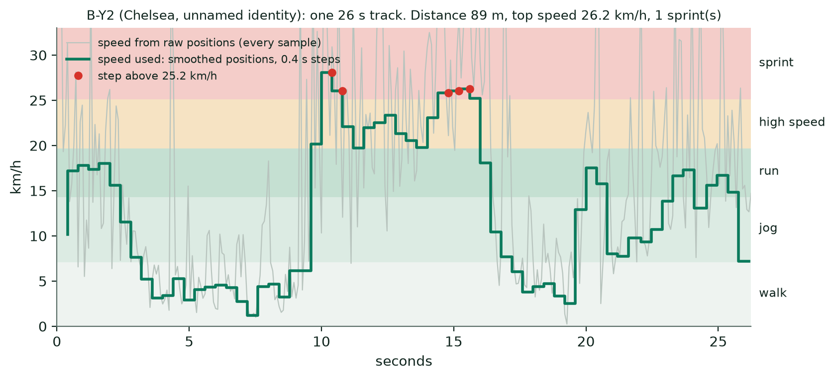
Figure 5. A real 26 s track of an unnamed Chelsea player ("B-Y2") from the demo match. Grey: speed computed straight from raw positions. Green: speed from smoothed positions in 0.4 s steps, which is what the statistics use. Distance 89 m, top speed 26.2 km/h, 1 sprint.
Worked example. In Figure 5, a step of 2.0 m in 0.4 s is 5 m/s, or 18 km/h: a run. A step of 2.9 m in 0.4 s is 7.25 m/s, or 26.1 km/h: above the sprint line. Three such steps in a row would be one sprint.

4.5 High-intensity runs and off-the-ball movement
Runs use a slightly different measurement designed for movement analysis. Speed is taken sample by sample from the smoothed attack-normalised positions (steps above 11 m/s and gaps over 2.5 samples are discarded). A high-intensity run is a stretch at or above RUN_MIN_SPEED = 5.5 m/s (19.8 km/h) lasting at least 1 s; dips below the threshold shorter than 0.4 s do not end a run. Each run is then classified using the team's possession (a team keeps possession for 4 s after its last touch) and the positions of the opposition:
Statistic | Definition
Runs in possession / out of possession | High-intensity runs while the player's team does / does not have the ball
Forward run | At least 70% of the displacement along the attack axis and at least 5 m
Run in behind | In possession, a forward run that starts level with or behind the last opposing outfielder and ends level with him (within 1 m) or beyond
Run into the box | In possession, a forward run that starts outside the penalty area and ends inside it
Overlap / underlap | A forward run, in possession, from behind a team-mate on the ball to ahead of him on the same flank, ending at least 2 m wider (overlap) or narrower (underlap) than him and within 15 m across
Pressing run | Out of possession, a run that ends (or whose following second ends) within 3 m of an opposing ball carrier
Recovery run | Out of possession, a run of at least 5 m back towards the team's own goal
Height, width, between the lines | Mean position relative to visible team-mates; distance from the centre line; share of possession time between the opposition's defensive and midfield lines (needs at least 6 opponents in view)
Table 5. Off-the-ball statistics.

4.6 Where a player was: heatmaps, thirds and lanes
Visible positions of a player (flipped so the team attacks left to right) are counted in a grid of 20 rows across the width by 32 columns along the length, and divided by the total so the grid sums to 1 (Figure 6). From the same positions the report gives the mean position and its spread, the share of time in the defensive, middle and attacking third, in the left, central and right lane (thirds of the width), and inside the opponent's penalty area.
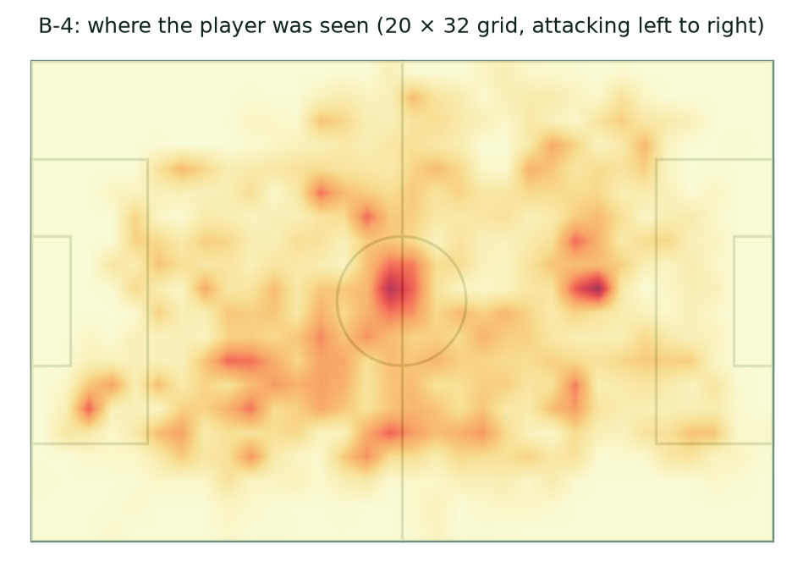
Figure 6. Heatmap of B-4 (Chelsea) over the demo match: where the player was seen, attacking left to right. It shows only what the camera showed, which is why some areas are empty.

4.7 Three ways to put counts on a common footing
Counts depend on how long a player was seen, which varies hugely between players. The report offers three rates:
- Per 90 minutes on screen. The count divided by the player's own visible time, times 5,400 s. Needs at least 60 s on screen. This is the default, because it does not depend on how much of the player could be identified. It describes involvement while the camera was on the player.
- Per 90 minutes of team live play. The count divided by the team's observed live time in calibrated view (2,894 s in the demo match), a single denominator for the whole team. Players seen for longer score higher.
- Per 100 touches. The mix of a player's on-ball actions (passes, carries, shots and so on) per 100 touches, independent of time and coverage; this shows how a player uses the ball.
Statistics from the video model (tackles, blocks, headers, lofted passes, crosses, throw-ins) are expected counts, the sum of the model's scores for the player, and so are shown with decimals and a dagger in the report.

5. How the models were trained
Two models in use were fine-tuned for this project: the identity model and the action spotter. The rest are pretrained or are not learned. Models that were trained and then retired or not adopted are described in Appendix D. All training followed the same rules:
- Annotations are for training and measurement only. SoccerNet, SoccerTrack and FOOTPASS labels teach or score a model; they are never an input when new footage is analysed.
- Held-out evaluation. Every reported number comes from games (or matches) the model did not train on. Official SoccerNet test games are scored once.
- Data stays on the data drive. Videos, frames and crops are kept on an external drive; SoccerNet NDA data was unpacked there after the user entered the password at a terminal.
- One GPU. All training ran on a single NVIDIA RTX 3090 (24 GB).
Model | Trained here? | Training data | What it learns | Cost
Identity model (CLIP ViT-B/16) | Fine-tuned | FOOTPASS 48 games (6.0 M thumbnails, 1,485 players) + SN-Jersey 2023 | Shirt digits, appearance embedding, goalkeeper | 10,000 steps
Action spotter (T-DEED) | Fine-tuned | SoccerNet BAS (5 games) + FOOTPASS (48 games) | 12 ball actions, timing, team | 3,000 steps, about 3 h
Table 6. The two models trained in this project, on what, and at what cost. The pretrained models are in Table 7; retired and not-adopted models are in Appendix D.

5.1 Pretrained models and where they come from
Model | Origin | Licence
Football detector, ball detector (YOLOv8x) | Roboflow sports repository | AGPL-3.0 (Ultralytics)
Pitch keypoints (HRNetV2-W48) | No-Bells-Just-Whistles (Gutiérrez-Pérez and Agudo) | GPL-2.0
Legibility classifier (ResNet-34), PARSeq | SoccerNet jersey-number pipeline (Koshkina and Elder); PARSeq by Bautista and Atienza | CC BY-NC 3.0 weights; Apache-2.0 code
CLIP ViT-B/16 | OpenAI weights through the timm library | MIT
T-DEED spotter (starting checkpoint) | SoccerNet 2025 team ball-action spotting baseline | GPL-3.0
Table 7. Pretrained components.
Several licences are non-commercial or copyleft. They suit research and teaching; any commercial use would need review (see THIRD_PARTY_NOTICES.md).

5.2 The identity model
Goal. One network that reads a shirt number, recognises a player and spots goalkeepers, from a 720p broadcast thumbnail.
Data. FOOTPASS (SoccerNet 2026, under the NDA) gives, for broadcast games, every player's true box, shirt number and team in every frame. Thumbnails were cut from these boxes (scripts/footpass_crops.py): from 48 training games, 6.0 million thumbnails of 1,485 players. SN-Jersey-2023 training tracklets add shirt numbers from other leagues and seasons. Three FOOTPASS games were held out for validation (13,610 true tracklets, 406,205 thumbnails). Each thumbnail carries three labels: tens and units digits of the true number, the player's identity within the game, and whether the player is a goalkeeper.
Batches. Each step takes 16 players from one game and 4 thumbnails of each (64 thumbnails). Because all come from one game, the other players in the batch include team-mates in the same kit, which makes the appearance task hard in the right way.
Augmentation. Thumbnails are shrunk at random to between 45% and 100% of their full-HD size and scaled back up, so the model sees the blur of 720p broadcasts (720p is two thirds of 1080p). They are never mirrored, because a mirrored digit reads differently.
Loss. Three terms are added:
- Digits: cross-entropy (label smoothing 0.05) on the tens head and on the units head.
- Appearance: supervised contrastive loss on the 256-dimensional embedding with temperature 0.1: thumbnails of the same player in the batch are pulled together and all others are pushed away.
- Goalkeeper: binary cross-entropy, weighted 0.5.
Optimisation. AdamW, learning rate 1e-5 for the CLIP backbone and 20 times that (2e-4) for the new heads, weight decay 0.05, 300 warm-up steps and a cosine decay to zero, bfloat16 precision, gradient clipping at 1.0, 10,000 steps for the 48-game model.
The most useful trick: learn digits only from legible thumbnails. In the training data every thumbnail of a player carries the player's true number, even when the back is turned and no number is visible. Learning those makes the digit heads guess from appearance. So with the "legible only" option the digit loss is applied only to thumbnails that the legibility classifier scores at 0.5 or more (about 28% of the crops); the appearance and goalkeeper heads still learn from every thumbnail. At analysis time the same rule applies: only legible thumbnails vote on a number. The legible vote picked the right number for 88% of grouped player time against 74% before the change, and for 73% against 42–53% on the hardest game (red-and-black stripes).
History. Version 1 used 19 games and all thumbnails (kept as model_v2_all_crops.pt); version 2 added legible-only digit learning on 19 games (6,000 steps, about 40 minutes); the adopted version trains that recipe on all 48 games. Moving from 19 to 48 games raised the right-name share from 48.9% to 53.0% of player time on FOOTPASS validation and from 71.8% to 75.7% on SoccerNet tracking clips, with wrong names unchanged (3.0% and 6.5%). These comparisons were measured when the model was retrained; the figure for the pipeline as it stands today is 52.3% (Section 6.2).

5.3 The action spotter
Goal. Make the published T-DEED baseline better at the actions that matter for player statistics (blocks, headers, tackles, shots, crosses), on 720p footage like ours.
Starting point. The published SoccerNet 2025 team ball-action checkpoint. Its class head, displacement head and team head continue training; the first backbone stages (stem, s1, s2: 16 thousand of 3.2 million backbone parameters) stay fixed so training fits in 24 GB.
Data. SoccerNet Ball Action Spotting training and validation games (5 games, exact labels for all 12 classes) and the 48 FOOTPASS training games (8 of the classes, as partial labels). Frames were packed once to the data drive (scripts/pack_spotter_frames.py). Two BAS test games and three FOOTPASS validation games were held out.
Training. Clips of 100 frames at 12.5 fps. The devkit's recipe: mixup (Beta(0.2, 0.2)), colour and blur augmentation, foreground classes weighted 5 times, and a loss of class + displacement + 2 × team. Changes made here: a partial-label class loss (the negative log of the summed probability of the classes a label allows, which equals ordinary cross-entropy for exact labels), a lower learning rate for fine-tuning, extra weight on tackles and blocks, and a share of clips centred on the rare actions (tackle, block, shot, cross, header, throw-in). AdamW with warm-up and cosine decay; the run used for the statistics was 3,000 steps (about three hours on one RTX 3090). The checkpoint with the lowest class loss on held-out FOOTPASS clips is kept: the loss fell from 3.39 to 1.80.
The model that counts tackles is the first fine-tune, and tackle statistics remain rough expected counts. A second run weighted further towards tackles did not help and was not adopted (Appendix D.5).

5.4 Hand-written parts: how their numbers were set
The camera-cut detector, team assignment, attack direction, ball path selection, the event rules, the distance and speed measures and the identity grouping rules have no gradient training. A person wrote each rule and set its numbers, and the numbers were then checked against annotated ground truth. Section 2 and Section 3 define each rule and Appendix A lists every constant. Table 8 says how the numbers were set and where the result is measured.
Rule | How its numbers were set or checked | Section
Touch and possession rules | Tuned on SoccerTrack v2 match 117092, the one local match where every player position, the ball track and every action are annotated | 3.1, 3.2
Pass, carry and the other event rules | Same match. Pass precision 0.68 and recall 0.70, and per-player pass counts correlate 0.89 with the annotated counts | 3.3 to 3.9, 6.4
Distance, speed and sprint measures | Constants listed in Appendix A. Positions are smoothed because raw jitter would look like fast running | 4.1 to 4.5
Camera-cut detector | Chosen on 42 minutes of SoccerNet video with labelled cuts: 115 of 133 hard cuts found | 2.4
Calibration cleaning | Outlier window, interpolation limit and smoothing chosen by the jitter of fixed image points projected onto the pitch | 2.5
Team assignment | Not learned; the two clusters are anonymous until a person names them. 97.0% of detected player time on the right team | 2.6
Attack direction | Right on all 8 halves where kick-off positions could be checked | 2.6
Ball path selection | Ball located in a median 64% of live play across 22 halves | 2.7
Identity grouping rules | Tuned on simulated 3-second pieces of 49 SoccerNet tracking clips (15 s overlap tolerance, 85% vote share, goalkeeper safeguards) and checked on FOOTPASS validation | 2.9
Table 8. How the numbers of the hand-written parts were set.
How to tell the two groups apart. A fine-tuned model is judged on games it never saw, and its recipe is a loss function and a dataset. A hand-written rule is judged the same way, but its recipe is a rule and its numbers were set by hand; changing one of them is a one-line edit, with no retraining.

6. How well it works: all measured results
Every figure below was measured on data the models did not train on, and the table says which. Where a result comes from an idealised test (for example event logic on annotated positions), that is stated.

6.1 Seeing, tracking and mapping the pitch
Component | Test | Result
Detection | FOOTPASS validation, 2.03 M true player-samples, IoU ≥ 0.5 | 89.7% of visible player time detected; 88.5% for boxes under 60 px, 91.8% for 60–100 px, 88.3% for 100–150 px, 63.6% above 150 px
Team assignment | FOOTPASS validation | 97.0% of detected player time given the right team
Tracking | FOOTPASS validation | 97.1% segment purity; 66.7% of visible time in segments of at least 10 s; 2.8% detected but in no segment
Camera cuts | 42 min of SoccerNet, 133 labelled hard cuts | 115 found (earlier rule: 19)
Pitch calibration | Chelsea v Burnley H1, jitter of fixed points | 90th percentile 1.1 m → 0.18 m; 99th 9–18 m → 0.5 m after cleaning
Attack direction | 8 halves with a calibrated kick-off view | 8 of 8 correct
Ball detection | 7,350 SoccerNet frames, ball visible in 6,766, confidence 0.1 | Recall 47.2%, precision 72.1%
Throughput | RTX 3090, 720p | About 22–25 sampled frames per second; demo match 3,044 s of detection for both halves
Table 9. Detection, tracking and calibration.

6.2 Naming players
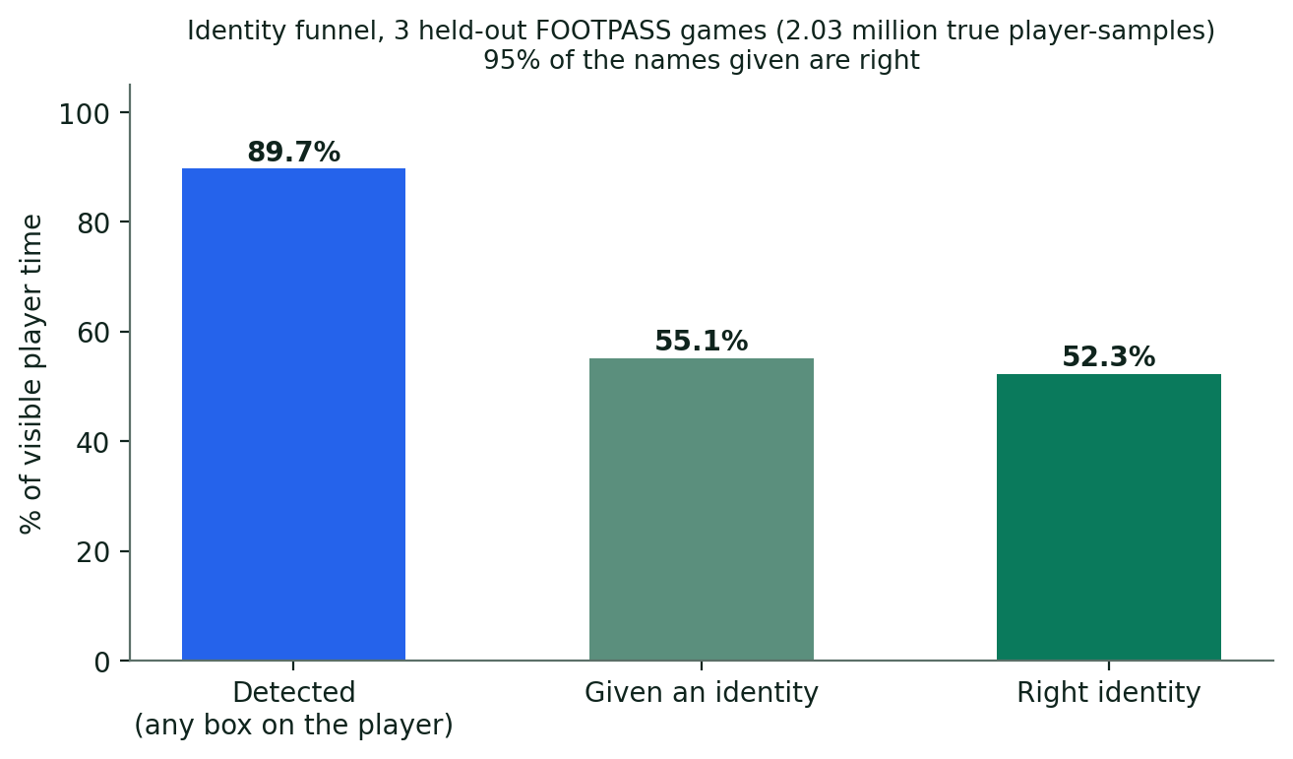
Figure 7. The identity funnel on three held-out FOOTPASS games: of all visible player time, 89.7% is detected, 55.1% is given an identity and 52.3% is given the right one. Of the identities given, 95.0% are right.
Measure | Result | Test
Names right / wrong (whole pipeline) | 52.3% of visible time right; 95.0% of names given right | FOOTPASS validation
By source | Shirt number: 95.9% right (21.0% of time); appearance: 94.0% right (31.7%) | FOOTPASS validation
Consistent unnamed players | 31.8% of visible time, 89.5% pure | FOOTPASS validation
Goalkeepers | Found for 88.5% of their time; 89.9% recall at 99.0% precision per tracklet | FOOTPASS validation
SoccerNet tracking clips | 75.7% named right, 6.5% wrong | 49 clips of 30 s
Number reader, confident (≥ 0.5) | Reads 38% of tracklets; right 94.2% of the time | FOOTPASS validation
Number reader, confident (≥ 0.7) | Reads 24.4%; right 99.6% | FOOTPASS validation
Shirt-number reader (ResNet-34 + PARSeq) | 80.3% of tracklets correct incl. "no number" | SoccerNet Jersey 2023 test, 1,211 tracklets
Appearance matching of a tracklet | 98.3% right | FOOTPASS validation
Table 10. Identity results.
Crediting events to players is lower than naming, because it also needs the ball. On FOOTPASS validation, 34.3% of labelled passes and 35.1% of carries were credited to the right named player (58–59% to the right track), and 84–90% were right when a credit was given.

6.3 Finding actions: the T-DEED spotter
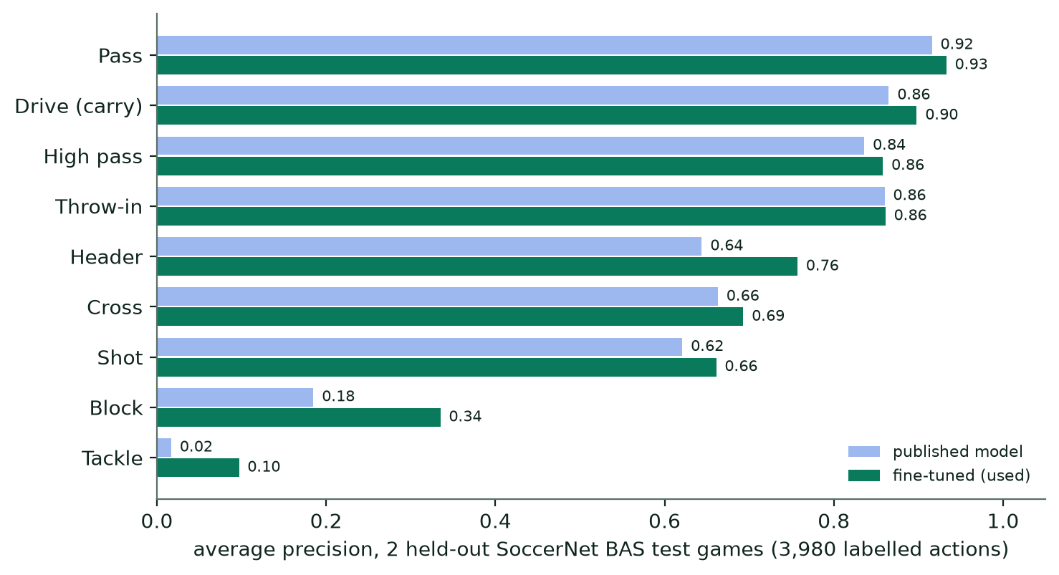
Figure 8. Average precision per action on two held-out SoccerNet BAS test games, for the published model and the fine-tuned model that the pipeline uses.
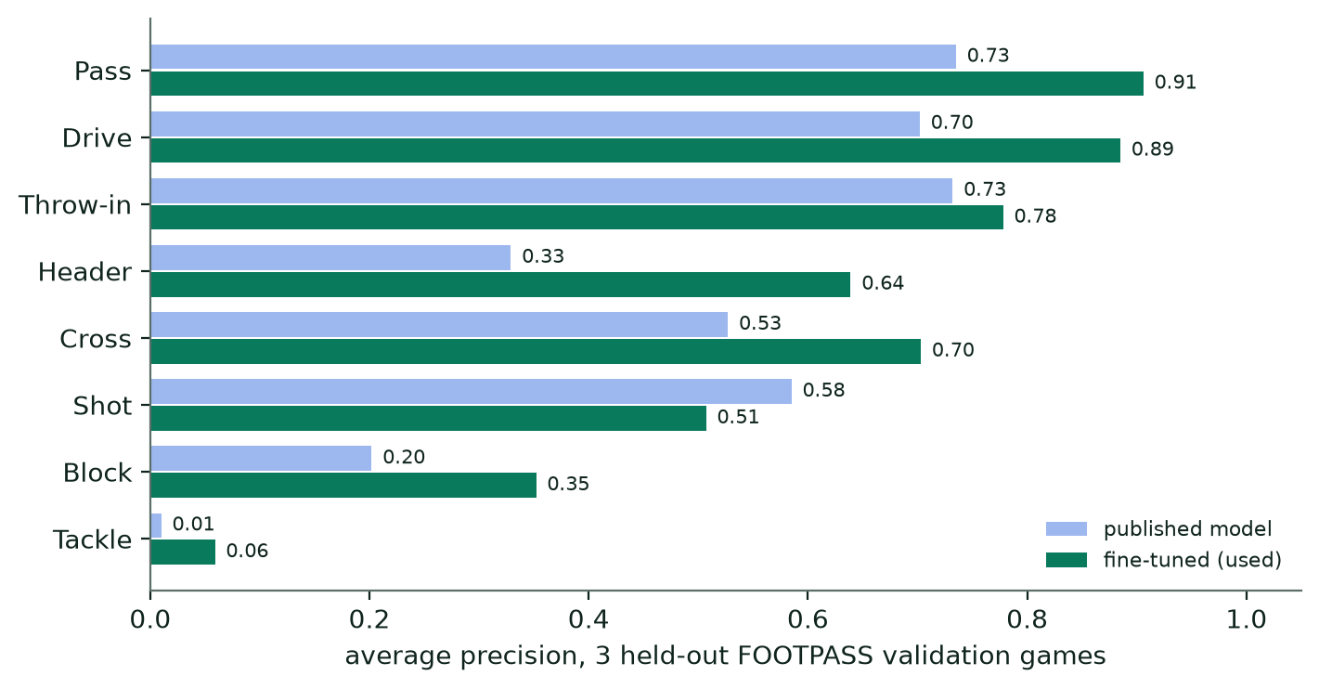
Figure 9. The same on three held-out FOOTPASS validation games, where fine-tuning helped most.
Test | Mean average precision (published → fine-tuned)
SoccerNet BAS test, 2 games, 3,980 labelled actions | 0.606 → 0.628
FOOTPASS validation, 3 games | 0.478 → 0.604
Table 11. Action spotter, mean over classes.
Passes, drives (carries), high passes and throw-ins are found reliably (average precision 0.78–0.93). Headers and crosses are moderate (0.64–0.76 and 0.69–0.70). Shots are 0.51–0.66. Blocks (0.34–0.35) and especially tackles (0.06–0.10) remain weak: the best tackle precision was 0.11–0.23 at recall 0.25–0.31. The team of a spotted action is right for 89–90% of passes and carries and 97–100% of shots and crosses.
Action | Labels | Found | Right team when found | Credited to the right player
Pass | 3,059 | 90.0% | 89.4% | 34.3%
Drive (carry) | 2,470 | 87.2% | 90.5% | 35.1%
Header | 162 | 63.6% | 76.7% | 9.3%
Shot | 67 | 52.2% | 100% | 17.9%
Block | 78 | 51.3% | 95.0% | 10.3%
Cross | 111 | 45.0% | 98.0% | 12.6%
Throw-in | 97 | 68.0% | 75.8% | 6.2%
Tackle | 26 | 3.8% | 100% | 3.8%
Table 12. From spot to player, FOOTPASS validation, whole pipeline.
The spotter's scores behave like probabilities, which is why statistics sum them. Summed throw-in scores were 166 against 171 labelled throw-ins; after fine-tuning, summed block scores were 72 against 67 labelled.

6.4 Event logic on annotated positions
This test isolates the event rules from vision. SoccerTrack v2 match 117092 has every player position and the ball track annotated, so the rules are run on perfect inputs and compared with the annotated actions (tolerance 1 s, 2 s for tackles).
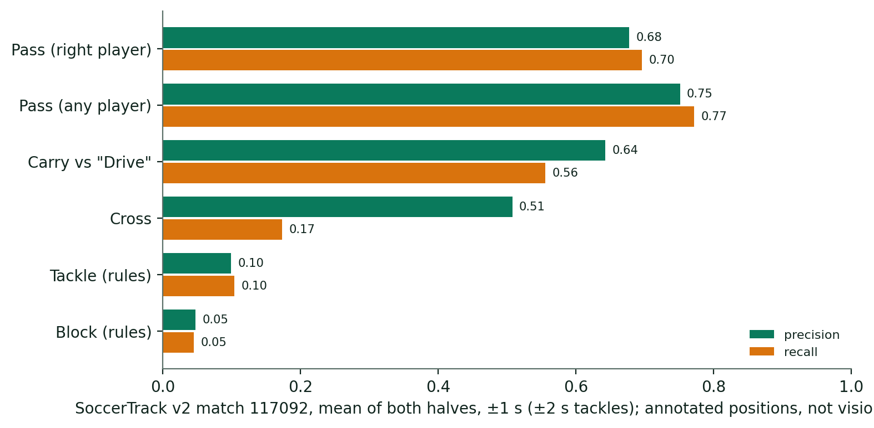
Figure 10. Event rules on perfect positions and ball track (SoccerTrack match 117092, mean of two halves). Passes and carries work well; crosses, tackles and blocks need the video model.
Event | Half 1 precision / recall | Half 2 precision / recall
Pass, right passer | 0.69 / 0.70 | 0.66 / 0.69
Pass, any passer | 0.76 / 0.77 | 0.74 / 0.77
Carry vs annotated "Drive" | 0.62 / 0.57 | 0.67 / 0.55
Cross | 0.57 / 0.17 | 0.44 / 0.17
Tackle (rules, right player) | 0.06 / 0.08 | 0.14 / 0.13
Block (rules, right player) | 0.10 / 0.09 | 0.00 / 0.00
Table 13. Rule-based events against annotations.
Per-player pass counts correlate with the annotations at 0.89 (Pearson, 23 players; Spearman 0.91). That is the reason players can be compared on passing even when individual passes are sometimes wrong. These numbers describe the logic, not the whole chain from video; real broadcast video adds detection, calibration and ball-finding errors on top.

6.5 Shots
Shots come from the video spotter. It found SoccerNet-labelled shots (score threshold 0.3, within 2 s) with 0.66 precision and 0.68 recall on the training and validation halves (227 called, 218 labelled), and 0.68 / 0.74 on four held-out test halves (62 called, 57 labelled). Per match, the spotter calls about as many shots as were labelled (5 against 6 in a fully annotated match). The comparison with the shot classifier it replaced is in Appendix D.1.

6.6 What the output looks like: the demo match
Measure | Manchester United | Chelsea
Possession (time on ball) | 55.6% | 44.4%
Touches | 393 | 341
Passes (completion) | 489 (75.9%) | 443 (67.7%)
Shots | 23 | 14
Interceptions | 44 | 41
Pressures | 222 | 167
Distance, all tracked players (km) | 33.5 | 31.5
Table 14. Team totals for the full demo match (95:20), from the stored analysis. Counts describe what the broadcast showed.

7. Limitations and how to read the numbers
- Only what the camera shows. About half of the demo match was a usable pitch view (50.6%) and the ball was located in 52.9% of it. Players off screen get no distance, speed or events. All counts are partial by construction.
- Distance is a lower bound. It sums the time the player was on screen. A midfielder who covered 11 km in a match may show 3 km if the camera showed him for a quarter of the time. Compare players with rates per minute on screen, not totals.
- Identity is partial. About half of player time is tied to a named player, and 95% of those names are right. The rest sits in consistent unnumbered players, and one real player is sometimes split across several of them. Striped kits are read worst. Connecting the match line-up can raise it (Section 2.9), but that was only tested with true squads.
- The ball has no height. A lofted ball is projected onto the pitch where it is not, so aerial passes and headers are the least reliable events.
- Tackles, blocks and crosses run low. The video model finds about one tackle for every eight real ones. They are shown as expected counts with a dagger and are good for comparing players, not as totals.
- Credit to the right player is the weakest link. Even with perfect identities, only about 59% of labelled passes land on the right player's track. Team-level counts are more reliable than player-level counts.
- Shot outcomes are unknown. The system finds shots; whether they were on target, blocked or goals needs a reviewer.
- Replays shown from a pitch angle may be analysed like live play, so an action can occasionally count twice.
- Event definitions are video approximations of data-provider definitions and will not reproduce any provider's feed.
- Licences. Several components are non-commercial or copyleft (Table 7).
- Evidence is from a small set of matches. 22 analysed halves of 11 matches, with ground truth from one fully annotated match and two SoccerNet-NDA datasets. Results on other broadcasters, kits or camera styles may differ.
The honest summary. Passes, carries, distance and speed are reliable where the player is on screen. Shots are reasonable. Identity and credit are good enough for per-player comparison with care. Tackles and blocks are rough. The report is a view of the broadcast, not of the whole match.

8. Reproducing the results
Commands run from the PitchProfile folder with the project's virtual environment; an NVIDIA GPU with CUDA is required. Setup is described in the README.
Task | Command
Fetch pretrained weights (SHA-256 checked) | .\.venv\Scripts\python.exe scripts\fetch_football_models.py
Analyse every working-set half not yet done | .\.venv\Scripts\python.exe scripts\analyse_matches.py
More thumbnails per track | .\.venv\Scripts\python.exe scripts\extract_crops.py
Run the action spotter | .\.venv\Scripts\python.exe scripts\spot_actions.py
Re-run the CPU stages only (events, identity, statistics) | .\.venv\Scripts\python.exe scripts\analyse_matches.py --postprocess-only
Train the identity model | .\.venv\Scripts\python.exe scripts\train_identity_models.py --legible-only --jersey --steps 10000
Fine-tune the action spotter | .\.venv\Scripts\python.exe scripts\finetune_action_spotter.py
Evaluate event logic on annotated positions | .\.venv\Scripts\python.exe scripts\evaluate_events_soccertrack.py
Evaluate the action spotter on labelled games | .\.venv\Scripts\python.exe scripts\evaluate_spotter_labelled.py
Evaluate identity on FOOTPASS | .\.venv\Scripts\python.exe scripts\evaluate_identity_footpass.py
Evaluate ball detection | .\.venv\Scripts\python.exe scripts\evaluate_ball_detection.py
Run the tests | .\.venv\Scripts\python.exe -m pytest -q
Table 15. Commands.
Reports are written to the evidence folder on the data drive (D:\CVDL Football Data\PitchProfile\evidence), for example event_logic_soccertrack.json, action_spotter_*.json, identity_footpass_*.json. Analysed matches are stored under D:\CVDL Football Data\PitchProfile\data\datasets.

Appendix A: thresholds and constants
Name | Value | Meaning
sample rate | 12.5 Hz | Every second frame of 25 fps video
YOLO confidence / IoU | 0.1 / 0.5 | Detector floor and merge overlap, 1,280 px input
BoT-SORT thresholds | 0.25 / 0.1 / 0.85 | High score, low score, match threshold; sparse optical flow
CUT_THRESHOLD | 0.35 | Histogram (Bhattacharyya) distance for a camera cut
KEYPOINT_THRESHOLD | 0.1486 | Pitch keypoint score
RANSAC_PX / MAX_RMSE_PX / MIN_INLIERS | 6 / 4 / 5 | Homography acceptance
MAX_INTERPOLATION_S | 1.2 s | Calibration gaps bridged inside a shot
JUMP_M | 12 m | Projected-centre jump that reveals a cut
PITCH_MARGIN | 3 m | Positions outside the lines still accepted
STITCH_MAX_GAP_S / STITCH_BASE_M / STITCH_SPEED | 1.2 s / 1.8 m / 7.5 m/s | Joining tracks into segments
BALL_MAX_SPEED | 38 m/s | Ball path limit
MISSING_COST / RESTART_COST / MAX_STEP_PX | 1.0 / 4.0 / 90 px | Ball path search costs
TOUCH_DV | 4.0 m/s | Velocity change that marks a kick
TOUCH_RADIUS_M | 2.0 m | Player to ball at a kick
CONTROL_RADIUS_M / CONTROL_MAX_SPEED / CONTROL_MIN_SAMPLES | 1.2 m / 9 m/s / 3 | Close control
SPELL_MAX_GAP_S | 2.5 s | Gap that splits a possession spell
DEFLECTION_MAX_SAMPLES / _GAP_S | 2 / 2.0 s | Opposing touch treated as a deflection
MAX_PASS_FLIGHT_S / MAX_BALL_SPEED | 4.0 s / 35 m/s | Pass limits
PROGRESSIVE_M / LONG_PASS_M | 10 m / 30 m | Progressive and long pass
CARRY_MIN_M | 2.0 m | Smallest carry
INTERCEPT_MIN_SPEED / _MIN_FLIGHT_M | 6 m/s / 3 m | Interception
TACKLE_RADIUS_M / TACKLE_MAX_GAP_S | 2.2 m / 0.6 s | Rule-based tackle (replaced by the spotter)
DRIBBLE_FRONT_M / TAKE_ON_LATERAL_M / TAKE_ON_DRIVE_MS | 2.0 m / 1.2 m / 2 m/s | Take-on
PRESSURE_RADIUS_M | 3.0 m | Pressure
spotter class thresholds | 0.3 (most), 0.475 (throw-in), 0.775 (free kick), 0.1 (goal) | Confident spots; statistics sum all scores ≥ 0.05
SMOOTH_S / STEP_S | 1.0 s / 0.4 s | Position smoothing and speed step
MAX_SPEED_MS | 11 m/s | Faster steps discarded
SPEED_ZONES (km/h) | 7.2 / 14.4 / 19.8 / 25.2 | Walk, jog, run, high speed, sprint
SPRINT | ≥ 25.2 km/h for ≥ 3 steps (about 1 s) | Sprint count
RUN_MIN_SPEED / RUN_MIN_S / RUN_JOIN_S | 5.5 m/s / 1.0 s / 0.4 s | High-intensity run
POSSESSION_MEMORY_S | 4.0 s | A team keeps possession this long after its last touch
heatmap grid | 20 × 32 | Rows across the width, columns along the length
MIN_RATE_VISIBLE_S | 60 s | Minimum screen time for per-90-on-screen rates
identity vote share / overlap tolerance | 85% / 15 s | Naming a group
legibility threshold | 0.5 | Thumbnail may vote on a number
goalkeeper safeguards | 16.5 m, 0.3, 15% | Within a goal area; team median; share of detections

Appendix B: glossary
Term | Meaning
Average precision (AP) | Area under the precision–recall curve for one class; 1.0 is perfect. Mean AP averages over classes.
Attack-normalised | Coordinates flipped so the team attacks towards x = 105
Carry | The ball moved at least 2 m with one player
Contrastive loss | Training objective that pulls examples of the same thing together and pushes different things apart
Cut | A change of camera in the broadcast
Embedding | A list of numbers (here 256) describing how a thumbnail looks, so that similar looks are close
Expected count | The sum of a model's scores instead of a count above a threshold
Fine-tuning | Continuing to train a pretrained model on new data
Foot point | Bottom centre of a player's box, used as the player's ground position
Held-out | Data a model was not trained on, used only to measure it
Homography | A 3 × 3 matrix that maps points of a plane between two views
IoU | Intersection over union: overlap of two boxes, 1 = identical
Partial label | A label that allows several classes instead of one
Precision / recall | Share of reported items that are right / share of true items that were found
Segment | One player in one camera view, made of joined tracks
Spell | Consecutive touches by one player
Spotter | A model that finds the moment of an action in video
Tracklet / track | The same box followed from sample to sample
Visible time | Seconds a player was on screen in a calibrated view

Appendix C: where things are in the code
Topic | Files (under PitchProfile/)
Models and weights loading | football_profiler/football_models.py, MODELS.md
Detection, tracking, cut detection | football_profiler/match_analysis.py, config/botsort_match.yaml
Pitch calibration | football_profiler/fieldcal.py, football_profiler/match_post.py (fill_calibration)
Teams, direction, goalkeepers, ball path | football_profiler/match_post.py, football_profiler/kits.py
Segments, touches, spells, passes, carries, take-ons, pressures | football_profiler/match_events.py
Action spotting inside the analysis job | football_profiler/match_pipeline.py (spot_actions, merge_spotted)
Action spotter | football_profiler/action_spotting.py, spotter_data.py, scripts/finetune_action_spotter.py, scripts/spot_actions.py
Shirt numbers | football_profiler/jersey.py
Identity model and naming | football_profiler/identity_model.py, match_identity.py, scripts/train_identity_models.py
Distance, speed, per-player statistics | football_profiler/match_stats.py
Runs and positional context | football_profiler/match_movement.py
Percentile profiles | football_profiler/match_profiles.py
Position groups | football_profiler/taxonomy.py
Whole-match merge | football_profiler/match_merge.py, scripts/build_whole_matches.py
Evaluation scripts | scripts/evaluate_*.py; reports in the evidence folder
Research notes | FULL_MATCH_ANALYSIS.md, DETECTION_RESEARCH.md

Appendix D: retired, removed and not adopted
This appendix collects everything that was built, trained or planned and is no longer part of the system, so that the body of the report describes only what the system does today. The code of the retired and removed items was deleted from the repository on 8 October 2026 and stays in the git history. For each item it says what it was, why it was dropped and what replaced it. The decisions were made by measuring each item against its replacement on the same held-out data.
Item | Status | Replaced by | Evidence
Shot classifier (gradient-boosted trees) | Retired 8 October 2026 | Video action spotter (T-DEED) | F1 0.70 against 0.41 on the same four held-out halves (D.1)
Hand-written shot rule | Retired 8 October 2026 | Video action spotter | Found 36 of 254 labelled shots in cross-validation, against 102 for the classifier (D.1)
Re-identification head | Retired 8 October 2026 | Identity model | Appearance matching 90.1% against 71.6% on 6,473 held-out pieces (D.2)
Fine-tuned ball detector | Not adopted | Default football and ball detectors | Finds more balls (59% against 47%) but credits fewer passes end to end (26.2% against 34.2% right) (D.3)
Second action-spotter fine-tune (tackle-weighted) | Not adopted | First spotter fine-tune | Tackle average precision 0.06 against 0.08 on FOOTPASS, crosses and headers worse (D.5)
Short-clip analysis: upload, short-interval analysis, manual calibration, YOLO11n detector | Removed 8 October 2026 | Full-half and full-match analysis (YOLOv8x pipeline) | The models are built and tested on whole halves and matches; the short-clip path used none of the identity or event models (D.6)
Archetype profiler, ratings, interval reviews, 42-role catalogue | Removed 8 October 2026 | Nothing: the project no longer rates playing styles | No player was ever labelled, so it was never fitted (D.4)
Table 16. Retired, removed and not adopted.

D.1 Shot classifier and hand-written shot rule (retired)
Why they existed. A shot at goal is often not seen as a touch: the ball blurs at the strike and the broadcast cuts to a close-up. So shots were found as candidates and then classified. Candidates were releases of the ball within 45 m of the goal a team attacks: the end of a possession spell, or a fast ball flight towards goal that no touch explains.
The hand-written shot rule was the baseline. A candidate was a shot if the ball left fast and headed at the goal mouth, or the opposing keeper touched it within 2 s inside his box, or the ball was not seen after a central release close to goal. In cross-validation it found 36 of 254 labelled shots, against 102 for the classifier.
The classifier. A scikit-learn HistGradientBoostingClassifier (depth 3, learning rate 0.05, 250 iterations, at least 15 samples per leaf) scored each candidate on 26 features: geometry (distance and angle to goal, how far from the centre line), ball flight (speed after release, whether it heads at the goal mouth and crosses the goal line, how close it gets), image evidence (ball height on the player's box, which separates headers), defenders in the shooting cone, goalkeeper distance, what happened next (who touched the ball next, how soon), and broadcast editing (whether the view leaves the pitch and how soon it cuts). The strongest features were the view leaving the pitch after the release and the ball reaching the goal line. The decision threshold (0.67) was set so that the number of shots called equalled the number labelled in cross-validation, because shot counts are statistics and maximising F1 would over-count.
Training data. Every analysed SoccerNet half contributed its candidate releases with features computed from the video analysis. SoccerNet Labels-v2 gave the targets: "shot on target", "shot off target", "goal" and "penalty" events (324 labels, of which 231 matched a candidate release). A shot label claimed the release by the labelled team that was closest in time within [−2.5 s, +1.5 s] of the label; a goal label (stamped when the ball crosses the line) claimed that team's last release in [−6 s, +0.5 s]. Other releases within 1 s of a claimed one were ambiguous and left out, and all remaining candidates were negatives. Leave-one-match-out cross-validation on 9 games (18 halves, 3,395 candidates) measured accuracy and set the threshold; the final model was scored once on four held-out test halves. Each cross-validation model analysed the match it did not see, so no half's statistics came from a model trained on that half's labels. Cost: seconds on a CPU. The report was shot_model.json.
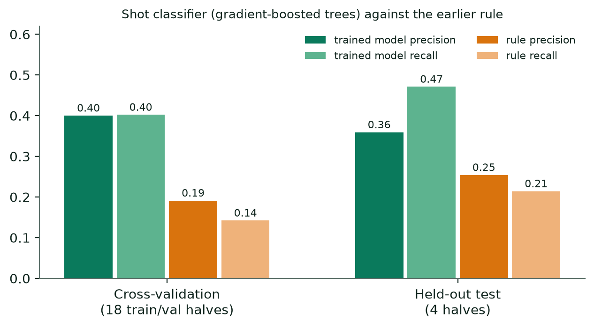
Figure 11. The retired shot classifier against the hand-written shot rule, in cross-validation and on held-out test halves.
Why it was retired. On its own protocol the classifier reached precision and recall of 0.40 / 0.40 in cross-validation and 0.36 / 0.47 on the four test halves; the rule reached 0.25 / 0.21 on the test halves. The video spotter that replaced it reached 0.66 / 0.68 on the training and validation halves and 0.68 / 0.74 on the test halves (Section 6.5). Scored side by side with identical labels (58 shots) and identical matching (one prediction to one label, within 2 s), the spotter found 42 labelled shots from 62 calls (precision 0.68, recall 0.72) and the classifier 31 from 92 calls (0.34 / 0.53). That is F1 0.70 against 0.41 at the thresholds in use, and 0.71 against 0.45 when each model is given its best threshold on these halves, so the gap is not a threshold effect. The classifier's release also made no difference to who was credited with a shot, and removing it left every end-to-end score unchanged. Shots now come from the spotter alone, which runs inside the analysis job; a half without spotter output has no shots.

D.2 Appearance re-identification head (retired)
What it was. Before the identity model, unnumbered segments were attached to numbered players with a small head (768 → 512 → 256 with GELU and dropout 0.1) on frozen CLIP ViT-B/16 features, trained with the same contrastive loss as the identity model's appearance head.
Training. The labels were this project's own shirt readings: thumbnails of segments whose number was read reliably were grouped by (half, team, number). 14 halves (7 matches) trained the head for 3,000 steps of 24 players × 8 thumbnails, AdamW with learning rate 1e-3 and weight decay 1e-4, one half per batch so that the negatives were team-mates. 8 halves of 4 other matches measured it by hiding each numbered segment in turn and matching it to the others. The attach margin was set to the smallest value at which held-out accuracy reaches 90%. No external identity labels were used, which made this the semi-supervised idea applied to identity.
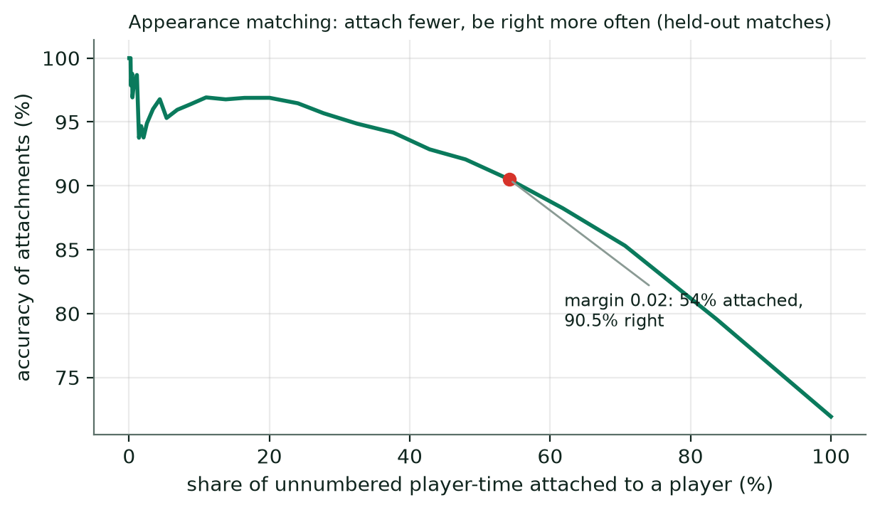
Figure 12. The retired re-identification head on 7,707 held-out segments: the stricter the margin, the fewer segments are attached and the more accurate the attachments.
Results. Frozen CLIP alone matched 65.3% of held-out segments; with the trained head, 71.9%. At margin 0.02 the head attached 54.2% of segments and was right 90.5% of the time; over all segments it was right about 72% of the time.
Why it was retired. On 6,473 held-out pieces of SoccerNet tracking clips, the identity model's appearance embedding matched 90.1% against 71.6% for this head, and the head only ran when the identity weights were missing. On FOOTPASS validation the identity model matches a tracklet to the right player 98.3% of the time (Section 6.2). The code and weights were removed.

D.3 Fine-tuned ball detector (not adopted)
What it was. A copy of the football ball model (YOLOv8x) trained further on SoccerNet tracking clips converted to YOLO format at this project's 720p resolution, where the ball is about 8 pixels across (scripts/prepare_ball_training.py). Settings: 8 epochs, image size 1,280, batch 8, the first 10 backbone layers frozen, cosine learning-rate schedule, mosaic augmentation switched off for the last 2 epochs, early stopping after 4 epochs without improvement, single class. Command: scripts\train_ball_detector.py. It exists as a separate weights file and can replace the ball candidates of an analysed match without redoing anything else; the default weights are unchanged.
Results on its own. On 7,350 SoccerNet tracking frames (the ball visible in 6,766) at confidence 0.1, the default ball model found the ball in 47.2% of the frames where it was visible, with 72.1% of its detections the real ball. The fine-tuned version found it in 58.8% of them, with 84.3% precision (Figure 13), but found fewer of the very smallest balls (32.1% under 10 px against 37.9%).
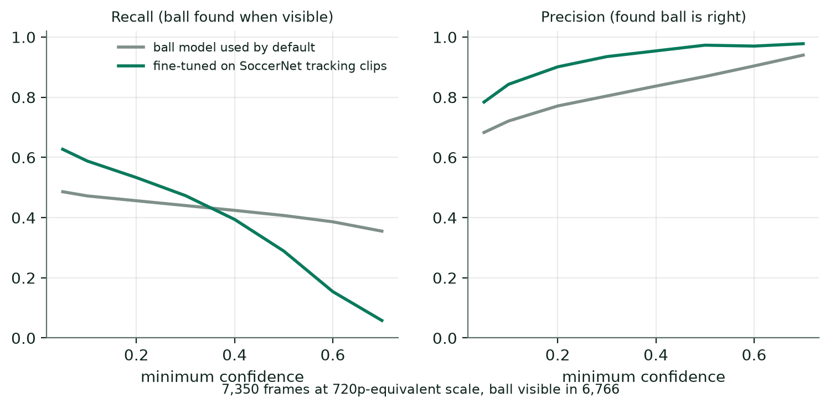
Figure 13. Ball detection on SoccerNet tracking frames: recall (left) and precision (right) as the confidence threshold changes, for the default ball model and the fine-tuned one.
Why it was not adopted. In the full pipeline on the six FOOTPASS validation halves it credited fewer passes to the right player, 26.2% instead of 34.2%, and found 87.6% of passes instead of 90.0%. The default detectors stay. Why it hurts is not yet understood; one candidate is the change of video between its 720p training clips and the 1080p FOOTPASS footage.

D.4 Archetype profiler and ratings (removed)
An earlier version of the project planned to express each player's style as percentages over 42 archetypes, from a small number of hand-labelled players, using label spreading over a nearest-neighbour graph of player statistics, with a second reviewer, interval reviews and a small convolutional network over heatmaps to follow. There was no gradient training and no labelled player, so the profiler was never fitted and has no results. It was removed on 8 October 2026 together with the rating screens, the interval reviews and the 42-role catalogue. Position groups remain, because the percentile profiles rank each player against others in the same position group.

D.5 Second action-spotter fine-tune (not adopted)
A second fine-tune of the T-DEED spotter, weighted even further towards tackles than the one in use (Section 5.3), did not help: tackle average precision went from 0.06 to 0.08 on FOOTPASS and from 0.10 to 0.09 on BAS, and crosses and headers got worse. The spotter in use is the first fine-tune, and tackle statistics remain rough expected counts.

D.6 Short-clip analysis and the YOLO11n detector (removed)
The first version of the app analysed short recorded clips. A user could upload a video (up to 512 MB, analysed for up to a few minutes), or pick a start time and length inside a library half, and then place pitch landmarks by hand to calibrate the camera. This path used a COCO-pretrained YOLO11n detector with a ByteTrack or BoT-SORT tracker and a manually fitted homography. It used none of the pitch keypoint network, the number reader, the identity model, the action spotter or the event rules, so it produced tracks and positions only, with no names and no events. It was removed on 8 October 2026 (the upload dialog, the short-interval analysis, the calibration screen, the YOLO11n weights and the detector-training script) because the models are built and tested on whole halves and whole matches. The app now analyses full halves and full matches only. Video helpers (ffmpeg lookup, overlay encoding, video metadata, frame reads) stay in football_profiler/vision.py. No result in this report came from the short-clip path.

