## **List of Document and Source**

protocol.txt - Expalin the JSON based protocol used for command request and response

RPI_RTSP_Communication.docx - Low Level Design document for the Server Client Communication

RTSPCommunication.jpg - Snapshot for Desgin File

MainApp.py - Linux Box App, which controls the stream

RTSPCommunication.py - Python main Source code file

## **Pre-requisite Installation on Raspberry PI and Linux Host**

Packages to install in Raspberry PI and Linux-Box

#python, gst plugin

sudo apt-get install gir1.2-gstreamer-1.0 gir1.2-gst-plugins-bad-1.0 gir1.2-gst-plugins-base-1.0 gir1.2-gst-rtsp-server-1.0 -y

## **Configuration Changes**

Change the audio card number in file RTSPCommunication.py, Line -- 26

AUDIO_DEVICE = "device=hw:1"

Change the number 1 to correspond card #, use output of “arecord -l “ to find your device card number

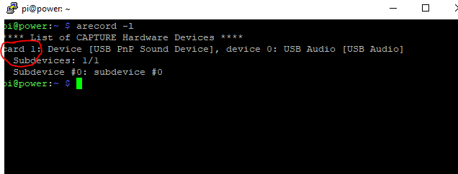

Change the network interface in file RTSPCommunication.py, Line -- 27

IFACE_NAME = "wlan0"

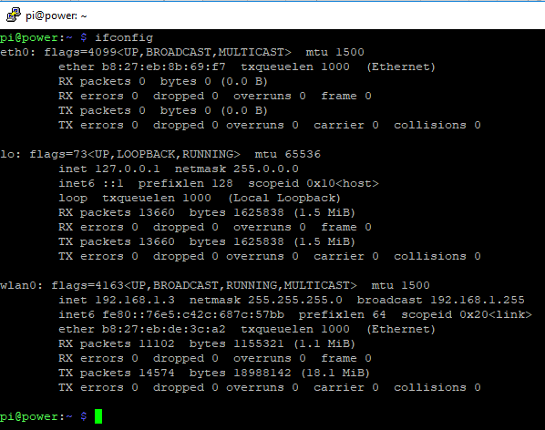

**Note, for each raspberry-pi and Linux Box you need to Change the corresponding**

AUDIO_DEVICE

IFACE_NAME

## **How to Run Program**

Linux Box

Python MainApp.py

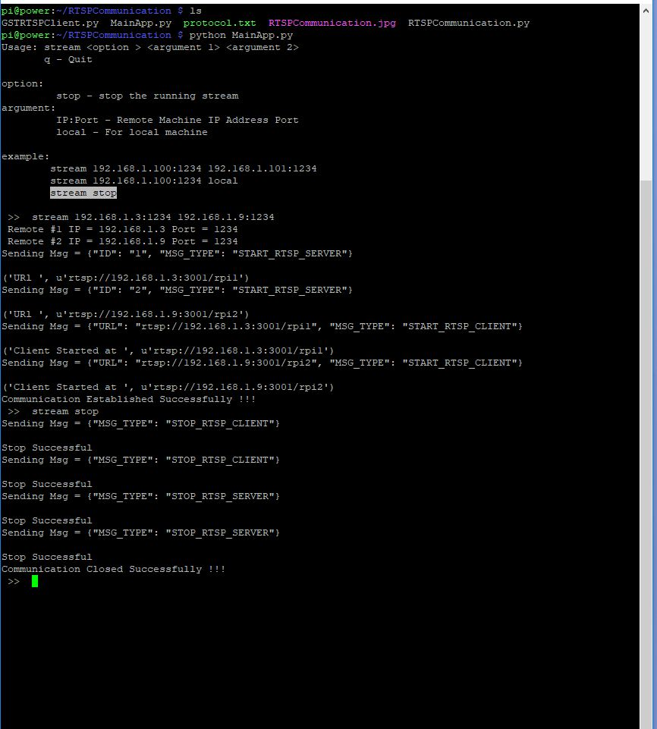

Raspberry-Pi

python RTSPCommunication.py

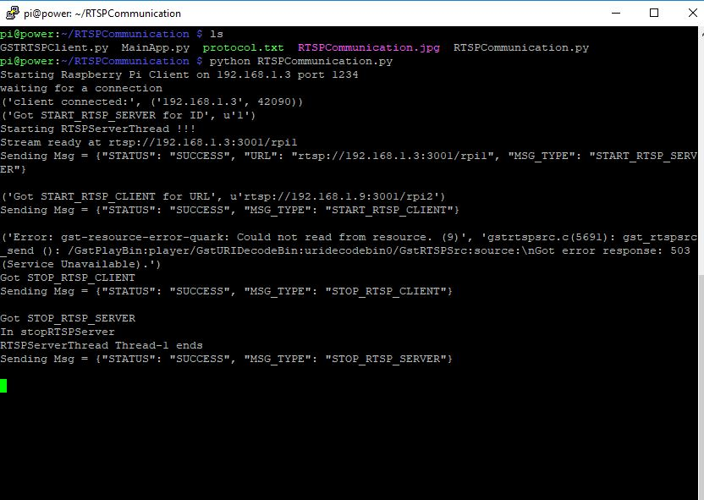

Usage:

For Communication between Rasprberry-Pi1 and Rasprberry-Pi2

* Start “python RTSPCommunication.py” in RPI#1
* Start “python RTSPCommunication.py” in RPI#2
* Start “python MainApp.py” in Linux-Box.
* Send command > stream RPI#1_IP:1234 RPI#2_IP:1234

For Communication between Rasprberry-Pi1 and Local

* Start “python RTSPCommunication.py” in RPI#1
* Start “python RTSPCommunication.py” in local Linux Box
* Start “python MainApp.py” in Linux-Box.
* Send command > stream RPI#1_IP:1234 local

For Stopping Running Stream

* In the shell where you started “python MainApp.py
  + Send command > stream stop