Nexus 2k Project Plan

Class/Modules

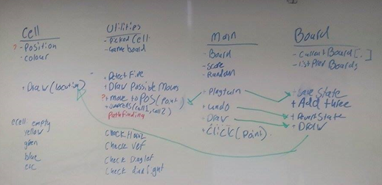

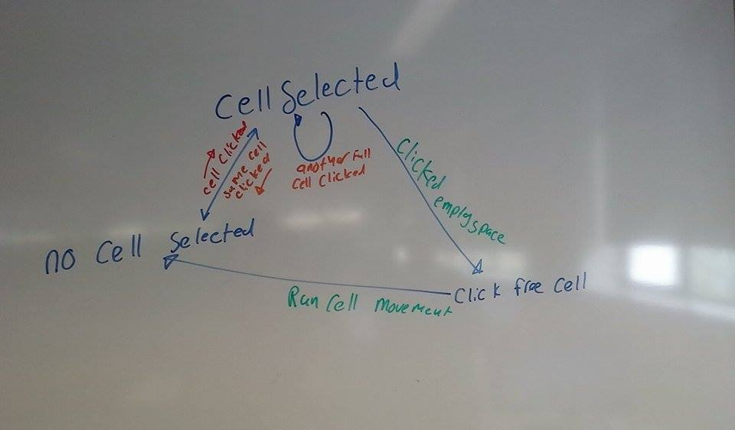Click Method

Breadth First Search

<http://www.redblobgames.com/pathfinding/a-star/introduction.html>

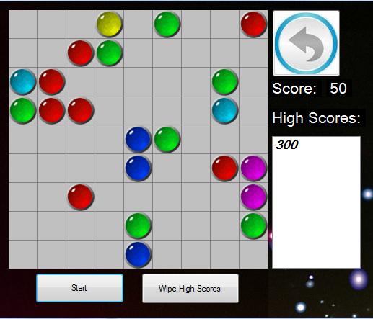Proposed Actual

