TABLE OF CONTENTS
1. Introduction 3
2. Problem Statement 3
3. Task 1: Classes, Attributes and Objects 3
3.1 Class Treatment 3
3.2 Class Animal 3
3.3 Object Creation and Interaction 3
4. Task 2: Python Data Structure 4
5. Task 3: Methods 4
6. Digital Public Goods (DPG) Alignment 4
7. Source Code 5
8. Program Execution and Screenshots 8
9. Explanation of Output 9
10. Conclusion 9

1. Introduction
This assignment presents a Livestock Health & Tracking System built in Python using Object-Oriented Programming (OOP) concepts from Lectures 1 to 3. It solves a real-world problem in the Agriculture domain: farmers need a simple way to record the treatments given to their animals and to know which animals are due for their next treatment.
The program follows Digital Public Goods (DPG) standards. It is open-source, simple to use, stores no sensitive personal data, and is built from modular, reusable parts.

2. Problem Statement
Many small farms keep livestock health information in memory or in notebooks. Vaccinations and deworming are forgotten, which leads to disease outbreaks and lost animals. The Livestock Health & Tracking System stores each animal's treatment history, rejects invalid or duplicate tags, and lists the animals that are due for a treatment. To protect privacy, no owner details are stored; each animal is identified only by a tag such as A001.

3. Task 1: Classes, Attributes and Objects
Two classes were created for the domain.

3.1 Class Treatment
Item | Description
Attributes | name, interval_days (days before the treatment is due again)
Methods | display_info() prints the treatment details

3.2 Class Animal
Item | Description
Attributes | tag_id (anonymous), species, weight_kg, history (list of treatment records)
Class attributes | total_animals (shared counter) and SPECIES (tuple of allowed species)
Instance methods | give_treatment(), update_weight(), is_due(), display_info()
Class methods | get_total_animals(), from_string(text)
Static method | is_valid_tag(tag_id)

3.3 Object Creation and Interaction
Objects are created in main(), for example deworm = Treatment("Deworming", 90) and Animal("A001", "Cattle", 320.5). The two classes interact when give_treatment() receives a Treatment object and stores its name and the date, and when is_due() uses the treatment's interval_days to decide whether the animal needs the treatment again.

4: Python Data Structure
A single data structure was used to store multiple objects: a list called herd. Each item in the list is an Animal object. A list was chosen because the herd is a simple collection that the program loops through to display records, check for duplicates and find animals that are due for treatment.
- add_animal(herd, animal) checks the tag and species, loops through the list to reject duplicates, then appends the Animal.
- display_animals(herd) loops through the list and calls display_info() on each animal.
- show_due(herd, treatment, today) loops through the list and prints animals that are due for a treatment.
- Bonus tuples: the optional tuples are Animal.SPECIES (fixed list of allowed species) and each history entry, a (treatment name, date) tuple.

5: Methods
Method type | Method | Purpose
Instance method | give_treatment() | Records a treatment and its date for one animal
Instance method | update_weight() | Updates the weight of one animal
Instance method | is_due() | Checks whether a treatment is due again
Class method | get_total_animals() | Returns how many animals were registered
Class method | from_string() | Alternative constructor: creates an Animal from "A002, Goat, 25"
Static method | is_valid_tag() | Checks the tag format without needing an object

6. Digital Public Goods (DPG) Alignment
DPG Principle | How the solution meets it
Open-source | The full code, README and sample output are published in a public GitHub repository.
Inclusive and accessible | Plain-text interface with simple wording; runs offline on any computer with Python and needs no special hardware.
Privacy-respecting | No farmer names, phone numbers or locations are stored. Only an animal tag, species and weight are used.
Modular and reusable | Each class and function has one job, so they can be reused in other agriculture or tracking systems.

7. Source Code
File: livestock_tracker.py
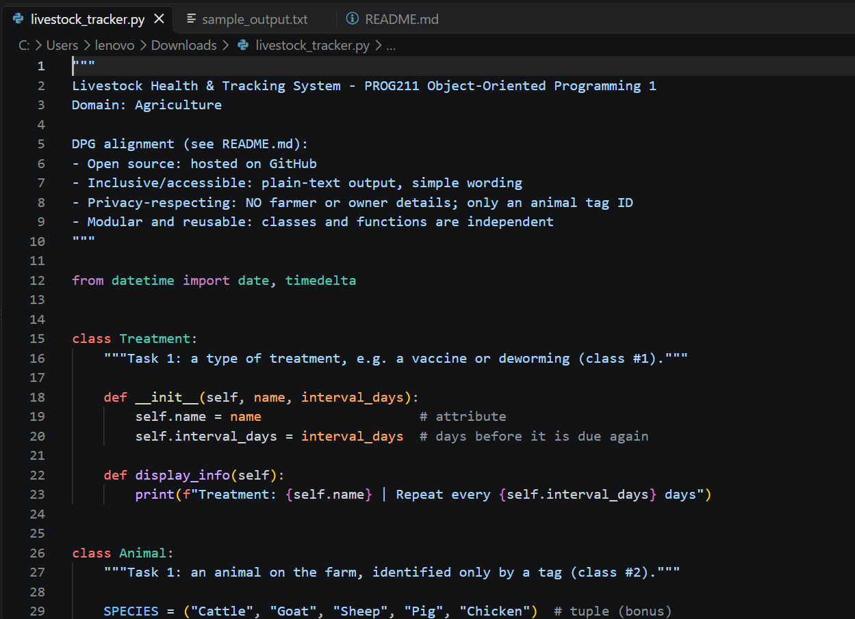

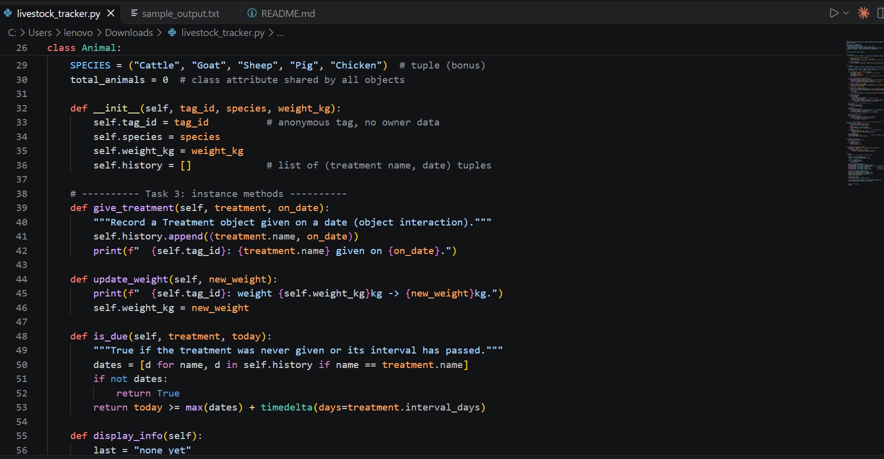
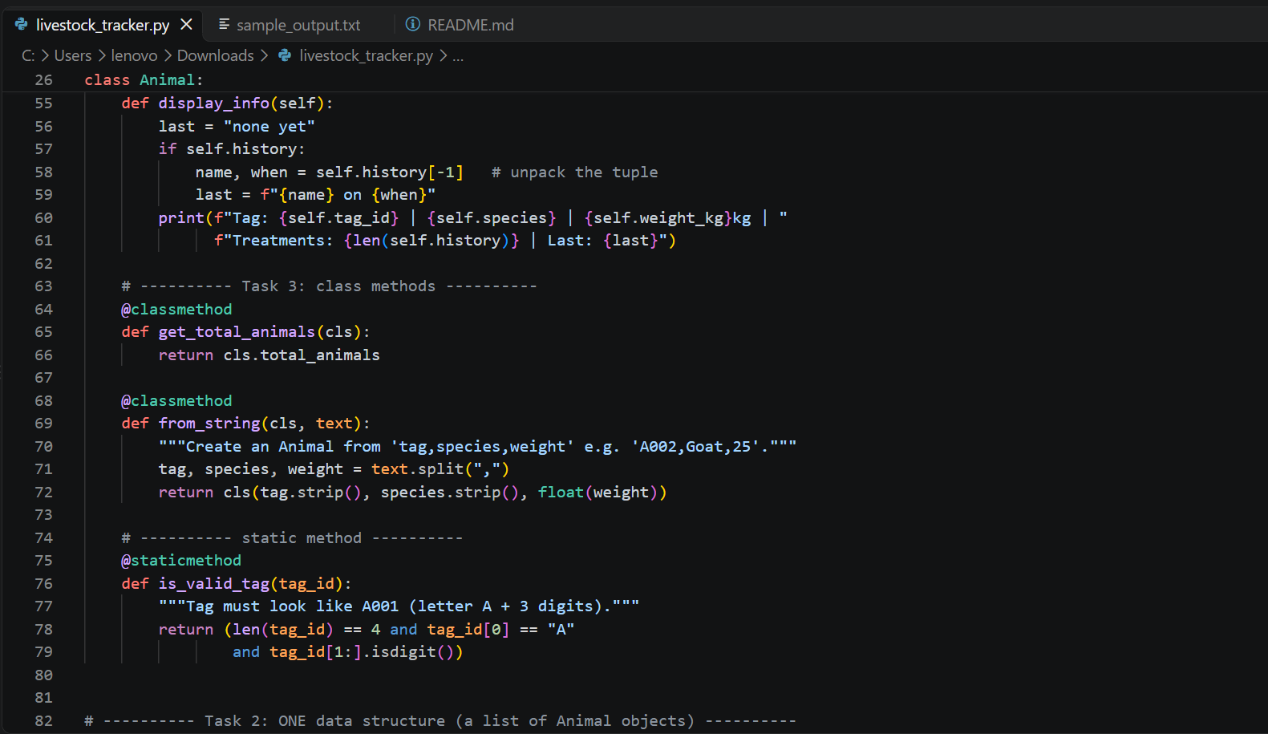

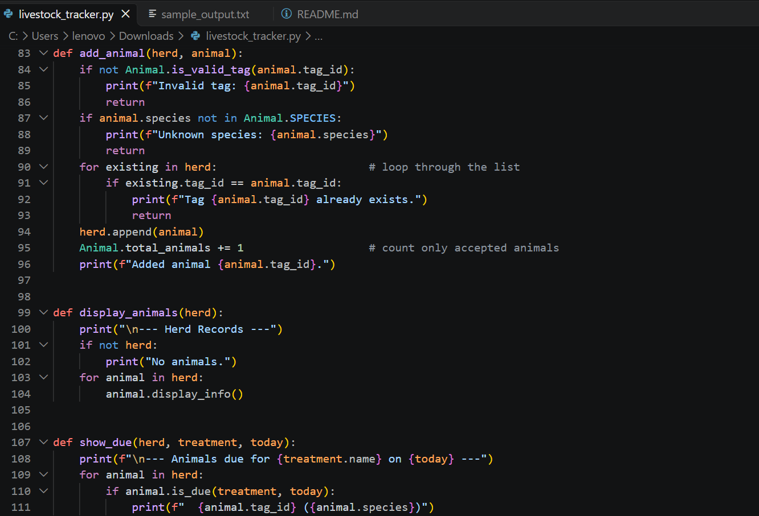

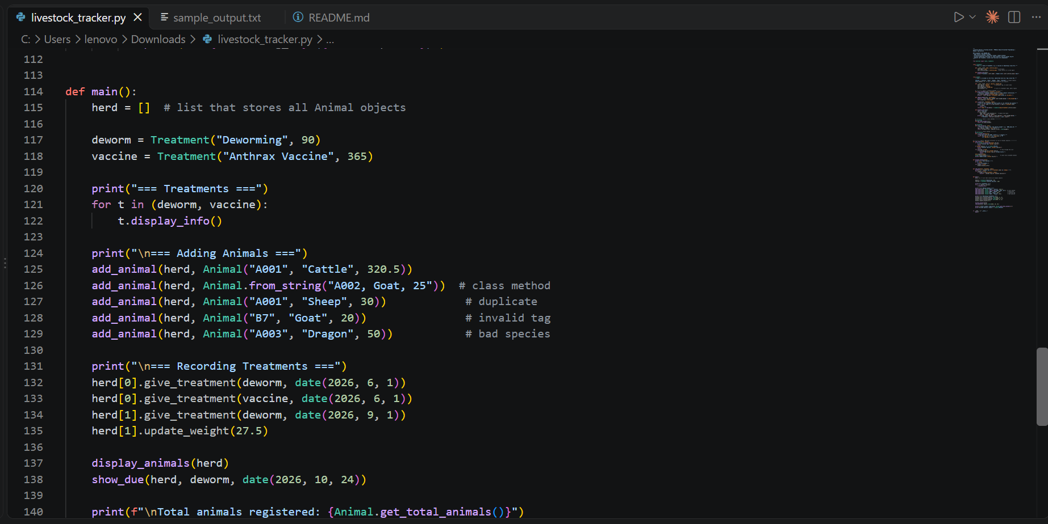

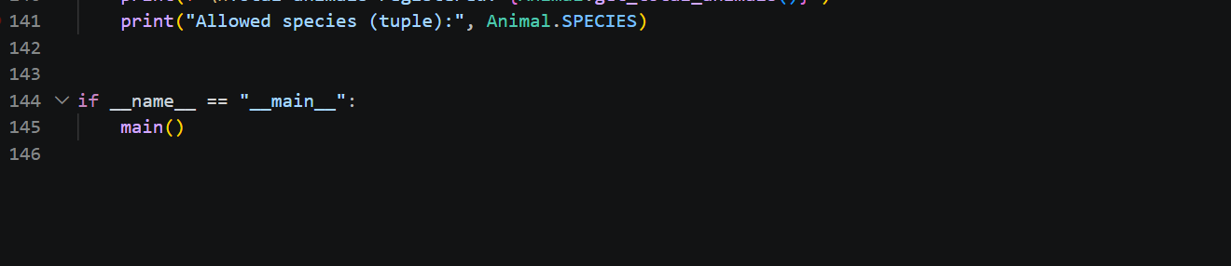

8. Program Execution and Screenshots
The program was run with the command: python livestock_tracker.py

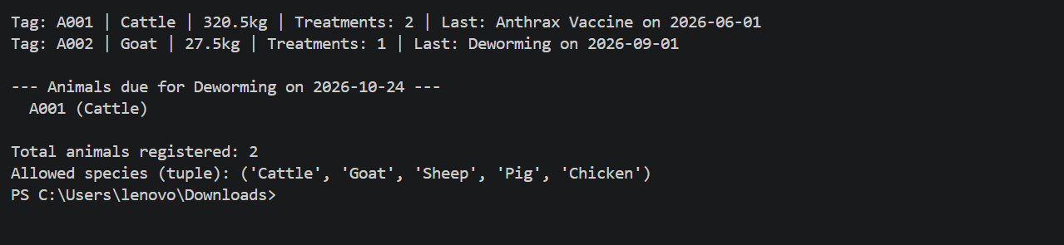

9. Explanation of Output
- Treatments: Two Treatment objects are created and displayed.
- Adding animals: A001 and A002 are added. The duplicate A001, the invalid tag B7 and the unknown species Dragon are rejected.
- Recording treatments: Treatments are recorded with dates, and A002's weight is updated from 25.0kg to 27.5kg.
- Due list: Only A001 is listed, because its last deworming (1 June) is more than 90 days before 24 October. A002 was dewormed on 1 September, so it is not due yet.
- Total animals: Only the two accepted animals are counted.

10. Conclusion
The Livestock Health & Tracking System meets the assignment requirements: two related classes, a list that stores the objects, add and display functions, and instance, class and static methods. It also follows DPG standards by being open-source, accessible, privacy-respecting and modular. Possible future improvements include saving records to a file and adding more treatments.

