Community assembly on isolated islands: Macroecology meets evolution

A. J. Rominger1*, K. R. Goodman1*, J. Y. Lim2*, F. S. Valdovinos3*, E. Armstrong1, G. M Bennett4, M. S. Brewer1, D. D. Cotoras2, C. P. Ewing5, J. Harte1, N. Martinez3, P. O’Grady1, D. Percy6, D. Price5, G. K. Roderick1, K. Shaw7, D. S. Gruner8#, R. G. Gillespie1#

1. Environmental Science, Policy, and Management, University of California, Berkeley, California 94720-3114
2. Integrative Biology, University of California, Berkeley, California 94720-3140
3. Pacific Ecoinformatics and Computational Ecology Lab, Berkeley, California 94703
4. Integrative Biology, University of Texas, Austin, Texas 78712
5. Biology, University of Hawaii, Hilo, Hawaii, 96720-4091
6. Entomology, The Natural History Museum, London, UK SW7 5BD
7. Neurobiology and Behavior, Cornell, Ithaca, New York 14853-7601
8. Department of Entomology, University of Maryland, College Park, Maryland 20742-4454
9. Contributed equally;
10. co-senior authors;
11. corresponding author: R. G. Gillespie, [gillespie@berkeley.edu](mailto:gillespie@berkeley.edu).

Keywords: networks, modularity, arthropods, population genetics, chronosequence, Hawaii

Running title: Community assembly on isolated islands

Number of words in the abstract: 297

Number of words in main body of the paper: 5117

Number of references: 81

# Abstract

#### Aim

Understanding how ecological and evolutionary processes synergistically determine biodiversity patterns remains a central goal in biology. In highly isolated archipelagoes such as the Hawaiian Islands, beyond the reach of equilibrium colonization dynamics, rapid in situ diversification and speciation have the potential to keep pace with ecological dynamics. Using multiple arthropod lineages across the Hawaiian model system, we explore how complex communities emerge from ecological (population dynamics, dispersal, trophic interactions) and evolutionary (genetic structuring, adaptation, speciation, extinction) processes.

#### Location

The Hawaiian Islands (19.5°N, 155.5°W).

#### Methods

We synthesize data on genetic structure of select arthropod species across Hawaiian landscapes of known age, which is used to infer processes involved in early diversification. We also develop a plant-herbivore bipartite network across the range of geological ages of the current high islands ( my to 5 my), analyzing measures of nestedness, modularity and degree distributions. These are then compared with theoretical predictions derived from the principle of maximum information entropy.

#### Results

Based on the time perspective provided by the island chronosequence and genetic information, we demonstrate that lower trophic levels develop local divergence more quickly than species of higher trophic levels. Higher trophic levels also show endemism, though it evolves more slowly and over larger areas. Moreover, in analyzing the plant-herbivore networks across an increasing substrate age gradient we find trends of higher specialization and increasing deviation from the statistical steady state expected from theoretical predictions of food web structure.

#### Main conclusions

A holistic approach informed by a combination of population genetic and community-level data within a clear temporal framework suggests that assembly by immigration and short time scale ecological processes gives way to evolutionary processes in the assembly of these complex Hawaiian communities. These findings also provide motivation to expand ecological theory to better incorporate dynamic evolutionary processes.

# Introduction

A central challenge in biology is understanding how the spectacularly diverse ecosystems that sustain life on Earth emerge from ecological and evolutionary processes. Thought to occur on largely different spatiotemporal scales, ecology and evolution developed into largely separate disciplines. However, new findings along with genomic and computational techniques have re-opened scientists’ eyes to the rich and dynamic interplay between these processes. These advances allow renewed focus on a synthetic understanding of how evolutionary and ecological processes and their interactions generate and maintain the biodiversity and function of communities and ecosystems. Much of such research seeks the integrated knowledge of the genetic, phylogenetic, and functional dimensions of biodiversity including interactions among these dimensions and their synergistic roles in critical ecological and evolutionary processes. Islands have been key to developing the basic yet largely separate knowledge of these processes.

Indeed, islands are bedrock model systems in the development of fundamental principles driving patterns of biodiversity, from theories of evolution (Darwin, 1959; Wallace, 1862) to the ecology of species richness and abundance in and out of equilibrium (MacArthur & Wilson, 1967; Brown, 1995; Rosindell & Phillimore, 2011). Due to their isolation and discretization islands are naturally simplified systems compared to mainlands and this simplification has been central to the success of using islands to identify general mechanisms underlying biodiversity. Similarly, island systems could provide critical opportunities for tackling the difficult task of better integrating insights from short time scale ecological theories with long-term evolutionary dynamics.

Traditionally we view evolution as responsible for regulating regional species pools, a process happening largely removed from local ecology (Hubbell, 2001; Cavender-Bares *et al.*, 2009). Evolutionary change over time in island systems has generally been studied in the context of single lineages, e.g. the adaptive radiation of Galapagos finches (Grant & Grant, 2007), Anolis lizards in the Caribbean (Losos, 2009), and cichlid fish in the great lakes of Africa (Seehausen, 2006). Such studies have reached varied conclusions about the drivers of diversification including competition (Rundle, 2003; Schluter, 2003), predation (Nosil & Crespi, 2006), ecological release (Gillespie, 2009; Yoder *et al.*, 2010) and specialization or generalization (Schluter, 2000; Wellenreuther *et al.*, 2008; Glor, 2010). Likewise, given finite ecological opportunity, it has been suggested that the rate of diversification should decline as species numbers increase during an adaptive radiation (Harmon *et al.*, 2008; Rabosky & Lovette, 2008; Bokma, 2009) while other arguments highlight the importance of species themselves as a resource base for others, with diversification increasing with species number (Odling-Smee *et al.*, 2003; Erwin, 2008).

Ecology in turn is traditionally viewed as the process acting on standing diversity to pack it into local communities through competition, facilitation and neutral ecological drift (Hubbell, 2001; Tilman, 2004; Bascompte & Jordano, 2007; Borer *et al.*, 2014). Island systems have been instrumental in developing our understanding of all these processes, especially through the conceptual lens provided by the equilibrium theory of MacArthur and Wilson (1967). Recent advances have further refined the causes and consequences of ecological drift (Hubbell, 2001; Rosindell & Phillimore, 2011; Rosindell *et al.*, 2012), re-vitalized classical niche-based mechanisms such as niche partitioning (Tilman, 2004; Chesson, 2000), competition and predation (Borer *et al.*, 2014), and put ecology in a network theoretic context (Williams & Martinez, 2000; Brose *et al.*, 2006; Berlow *et al.*, 2009). Together, these advances offer even more predictions to be tested about the processes that structure and stabilize trophic interactions.

Ecological networks are a prime starting place for integrating the mechanisms of ecology and evolution because ecological network analysis already builds off evolutionary hypotheses such as coevolution (Bascompte & Jordano, 2007; Donatti *et al.*, 2011; Nuismer *et al.*, 2013) and has clear ties with macroecology (Berlow *et al.*, 2009; Williams, 2010; Harte, 2011). To further aid in integrating ecology and evolution we also make use of the maximum entropy theory of ecology which uses principles from thermodynamics to predict the statistical steady state of ecological communities (Harte, 2011). Statistical steady state refers to the condition under which the aggregate properties of a community, such as the distribution of trophic links, are not influenced by any unique biological mechanism but instead conform to predictions of an idealized statistical system. Deviations from maximum entropy theory have been identified as indications of ecological systems in rapid transition and out of steady state (Harte, 2011; Harte & Newman, 2014).

Nevertheless, this and other ecological research historically has been poorly integrated with evolutionary perspectives (Cavender-Bares *et al.*, 2009), missing the opportunity to understand how evolutionary history can drive common patterns in contemporary ecology (Ricklefs, 1987; Qian *et al.*, 2005). There is a clear need to steer ecological theories and studies toward incorporating biodiversity dynamics during evolutionary community assembly, via the processes of invasion, microevolution, speciation, and extinction.

The confluence of ecological and evolutionary theory has the potential to greatly illuminate biodiversity dynamics through space and time. In practice, merging theories that gain their predictive power from large-scale patterns across multiple species (Brown, 1995; Hubbell, 2001; Harte, 2011) with those that yield information on the dynamic nature of single lineages is challenging. We confront the challenge of analyzing the interface of ecological and evolutionary processes by outlining a set of hypotheses that predict the structure of biological assemblages along a continuum from ecological to evolutionary assembly.

We define ecological assembly as the process that results form ecological mechanisms (e.g. neutral drift (Hubbell, 2001) or niche-based coexistence (Tilman, 2004; Chesson, 2000)) packing standing diversity into communities. In contrast, we define evolutionary assembly as the process that results from ecology and evolution having the ability to feed back on each other because they happen coincidentally in space and time (Schluter, 2000; Gillespie, 2004; Gillespie & Baldwin, 2010). These two modes of community assembly fall on a continuum and are not unique to islands. However, islands are opportune systems to study the consequences of these contrasting assembly modes due to their relative simplicity and discrete nature. In addition to definite boundaries in space oceanic island systems are also discrete in time due to their sequential formation over volcanic hotspots. The age gradient of such island systems thus has the potential to stratify ecological assembly and evolutionary assembly processes. For example, younger communities may be dominated by ecological assembly from initial immigration from the mainland, whereas on older islands, we might observe evolution keeping pace with ecology. This stratification provides an opportunity to disentangle these interacting forces.

The Hawaiian archipelago is a prime example because its geological chronology (Price & Clague, 2002) and biota are well-known (Wagner & Funk, 1995).In this age structured and simplified model system we hypothesize that the contribution of evolutionary assembly and ecological assembly will vary between taxa and between ages of lineages in communities. Specifically, we hypothesize that:

1. During periods of ecological assembly, communities strongly influenced by immigration will resemble random samples from regional source pools and thus metrics describing these communities will largely match expectations of statistical steady state after primary succession has completed (Harte, 2011). The exception will be communities still undergoing primary succession (Harte, 2011) which will change rapidly through time and represent non-random samples of source pools. We also predict that these communities will exhibit a nested network structure, assuming new species will eat or be eaten by the generalist species (Bascompte *et al.*, 2003) already present in the community.
2. Alternatively, if evolutionary processes of niche exploration, adaptation and speciation happen fast enough to keep pace with immigration, ecological communities formed by such assembly could be driven into alternate evolutionary states that fail to meet the predictions of purely statistical theories that do not account for evolutionary dynamics (Harte, 2011). We expect networks in such communities to exhibit higher levels of specialization and modularity (Bascompte & Jordano, 2007; Donatti *et al.*, 2011; Nuismer *et al.*, 2013).

Combining novel data with that gathered from the primary literature, we present evidence for the timeline over which evolution begins to keep pace with ecology using a combination of analytical approaches that incorporate population genetics, bipartite networks and maximum entropy theory. Given the paucity of available data and abundant potential directions for theoretical exploration, we also present future directions to extend and more rigorously test our framework.

# Methods

## Hawaii as an eco-evolutionary study system

The geological landscape of the Hawaiian Islands offers a matrix of volcanic substrates mapped in fine detail by chronological age and geochemical composition (Sherrod *et al.*, 2007). On Hawaii Island in particular, independent gradients in elevation and precipitation interact within a matrix of substrate ages ranging from contemporary (active) to 500,000 years. Ongoing volcanic activity has created a dynamic mosaic of habitats with transitory to long-lasting fragmentation within landscapes. Isolation on scales of hundreds to thousands of meters and hundreds to thousands of years can be sufficient for genetic differentiation of arthropod populations among habitats (Vandergast *et al.*, 2004; Goodman *et al.*, 2012; Eldon *et al.*, 2013; Bennett & O’Grady, 2013). On larger spatial scales, distinct volcanoes and islands, with their semi-independent histories of evolutionary community assembly from recent to ancient, comprise a space-for-time geological chronosequence spanning up to 5 million years from Hawaii Island to Kauai.

We use this age-structured template as a basis from which to assess evolutionary community assembly. At least two aspects of the system make this approach feasible:

1. the limited diversity of lineages allows precise identification of ecological affinities of taxa, and hence the role of ecological opportunity in adaptive radiation, and
2. the age-structured landscape offers sites across the chronosequence that have similar forest composition (dominated by *Metrosideros polymorpha* [Myrtaceae]), elevation (1100-1400m), and climate (mean annual precipitation 2000-3000 mm), which allows for comparison of replicate communities differing markedly in their age of assembly.

## Compilation and analysis of genetic data

To provide an evolutionary context for our network analysis we assessed the spatial and temporal scales at which genetic differentiation occurs across the landscape of the islands. We first asked how molecular variation is partitioned within species within locations of known substrate age on the Hawaii Island and Maui. We compiled existing and new data sets for a diversity of native Hawaiian arthropod groups that represent a spectrum of trophic levels. The arthropods represent several species of spiders and three orders of insects (spiders: COI, allozymes, (Roderick *et al.*, 2012; Croucher *et al.*, 2012); *Laupala* crickets AFLPs, (Mendelson *et al.*, 2004); *Nesosydne* planthoppers: COI, microsatellites, (Goodman *et al.*, 2012), GenBank accession numbers XXX-XXX generated following protocols described in (Goodman *et al.*, 2012); *Trioza* psyllids: COI, cytB, GenBank accession numbers XXX-XXX, generated following protocols described in (Percy, 2003); primers given in (Simon *et al.*, 1994; Timmermans *et al.*, 2010); *Drosophila sproati*: COII, (Eldon *et al.*, 2013).

We used analysis of molecular variance (AMOVA) to examine how genetic variation is partitioned at two scales of population structure: among sites within volcanoes and among volcanoes on both the Hawaii Island and Maui Nui. All analyses of allozyme and DNA sequence data were performed in Arlequin v. 3.5 (Excoffier & Lischer, 2010) using the AMOVA procedure to compute , a measure of genetic variance, or, where possible , an analog that incorporates genetic sequence information. The *Laupala* AFLP data were analyzed using TFPGA v. 1.3 (Miller, 1997), using the same hierarchical approach as described above. To provide a temporal framework for the population differentiation analysis we assembled divergence dating information from the literature for as many of the taxa as possible and additionally implemented a new divergence dating analysis for *Tetragnatha* spiders (see supplementary information).

To explicitly evaluate the role of age in allowing *in situ* genetic diversity and potential for divergence we analyzed how population structure varies with the chronosequence of volcanoes on Hawaii Island and Maui Nui. For each volcano we calculated or (Excoffier and Schneider 2005) for each taxon between sites within each volcanos.

## Construction of plant-herbivore networks

To test our hypothesis that network structure should change with island age due to changes in the relative contributions of ecological and evolutionary assembly we selected four sites according to the criteria above that span the chronosequence from 0.0002–5 million years (Kilauea and Kohala (Hawaii Island); Waikamoi (Maui), Kokee (Kauai); see Fig. 1). We constructed bipartite networks of plant-herbivore interactions between all native Hemiptera herbivores (sap feeders) and their host plant species in the Hawaiian Islands within the study sites. Each site’s set of herbivores was determined from the literature including the Hawaiian Arthropod Checklist (Nishida 2002) and available data indicating whether a species has been detected or is likely to occur within the sites (see supplement). The list of plants for each site was generated using distribution models for 1158 species of Hawaiian plants (Price, 2012). Each study site was spatially joined with all coincident plant distribution models that fell within its boundaries. Resulting site-specific networks were constructed both for conservative estimates of the geographic ranges of Hemiptera (considering only sites with definite specimen localities) and more liberal estimates (extrapolating between known localities surrounding our focal sites and with habitat comparable to our focal sites).

## Analysis of plant-herbivore networks

To understand how overall network structure changes with age, we calculated two widely used descriptive network metrics across sites—nestedness (Bascompte *et al.*, 2003; Ulrich *et al.*, 2009) and modularity (Newman & Girvan, 2004; Olesen *et al.*, 2007). We calculated nestedness using the NODF metric (Almeida-Neto *et al.*, 2008) as implemented in R package vegan (Oksanen *et al.*, 2013) and modularity using a variety of algorithms implemented in the R package igraph (Csardi & Nepusz, 2006). These metrics are not directly comparable across networks of different size and connectance (Ulrich *et al.*, 2009) so for each metric in each network we calculate z-scores using a null model that randomizes network structure while maintaining certain aggregate network properties (Ulrich *et al.*, 2009). Z-scores are calculated as the difference between the observed network metric minus the mean of the null model divided by the null model standard deviation, or (. Because z-scores can be highly sensitive to the choice of null model (Ulrich *et al.*, 2009) we implemented both a probabilistic null model (Bascompte *et al.*, 2003) and a null model that strictly constrains the degree distributions of plants and herbivores (Ulrich *et al.*, 2009).

To more explicitly test the hypothesis that communities dominated by evolutionary assembly and *in situ* diversification processes should differ from those dominated by ecological assembly and immigration, we analyzed the number of links assigned to each Hemiptera species (the degree distribution) separately for island endemics (those species found on only one island) versus island cosmopolitans (those species found on multiple islands). We hypothesized that evolutionary assembly should favor specialization and thus expected island endemics to be more specialized. To compare species’ degree between endemics and cosmopolitans across sites of different ages we conducted a generalized linear model with binomial error, treating site identity as a categorical predictor. Binomial errors effectively account for network size due to the bounded support of the binomial distribution.

To test the hypothesis that communities should differentially depart from statistical steady state during their ecological succession and evolution, we compared the degree distributions to that predicted by maximizing information entropy relative to the constraint of average degree (Williams, 2010). The maximum entropy prediction represents the hypothesis of statistical steady state (Harte, 2011).

# Results

## Population genetic inference of connectivity among populations

The analysis of molecular variance (AMOVA) revealed evidence of significant genetic structure from the smallest to the largest spatial scales examined, all within a very recent timeframe. For mitochondrial loci, the amount of significant molecular variation partitioned to among-sites, within volcanoes ranged from 0.037–0.92 and to the among volcanoes from 0–0.30. Corresponding variation at multilocus nuclear loci between-sites, within volcanoes ranged from 0.21–0.58 and among volcanoes, 0.04–0.34. Taxa in the lower trophic levels (herbivorous sap-feeding Hemiptera: planthoppers and psyllids) had as much or more molecular variation partitioned at the among-site, within volcano level than the among volcano level while the predatory spiders were less structured at localities within volcanoes (Table 1). The analysis of genetic population structure across the chronosequence of localities revealed a similar pattern. The herbivores show high genetic population structure among localities on young volcanoes compared to localities on older volcanoes (Fig. 2). By contrast, predatory spiders exhibited higher genetic population structure only on older volcanoes (e.g. Maui).

The observed levels of genetic divergence have evolved rapidly. Within species genetic divergence in planthoppers has evolved in as little as 2,600 years (Goodman *et al.*, 2012). For species from the Hawaii Island for which phylogenetic data provide divergence times, estimates of dates of species origination range from 0.34–1.15 million years, with all additional within-species genetic divergence having developed subsequently (Table 1).

## Evolving network structure

Across our chronosequence of sites network nestedness decreased with age while modularity increased (Fig. 3). This trend is found in networks constructed from both more and less stringent geographic criteria (supplemental Fig 3). Choice of null model changed the magnitude of modularity and the sign of nestedness z-scores; however, the relative pattern of decreasing nestedness and increasing modularity remained across the different null models used to standardize network metrics (supplemental Fig. 2). The patterns are also robust to sampling intensity, as demonstrated by a rarefaction analysis (supplemental Fig. 4).

The Hemiptera species degree distribution varied across sites with both the youngest and oldest sites deviating most from the statistical steady state maximum entropy predictions (Fig. 4). In the middle aged site of Kohala minor deviations from maximum entropy are no different than expected by chance indicating the Kohala Hemiptera community matches the predictions of maximum entropy.

The generalized linear model revealed that there are also significant differences between the degree distributions of island endemics (those species found on only one island) versus island cosmopolitans (those species found on multiple islands) (Fig. 4). Endemics show significantly lower degree distributions overall (i.e. more specialization) compared to more generalist cosmopolitan species. Endemics become significantly more generalist on the middle aged Maui site; however this pattern disappears when analyzing links to plant genera instead of species. The slightly younger Kohala shows increased generalization overall. When looking at the degree distribution defined by trophic links to plant genera instead of plant species, the pattern of increased generalization holds for the Kohalas but endemics on Maui no long show a difference in their degree distributions from other island endemics. This change in pattern indicates that increased generality of Maui endemics is driven by increased intra-genus plant diversity on that island.

# Discussion

The results showed that taxa in the lower trophic levels (herbivorous sap-feeders: Hemiptera *Nesosydne* and *Trioza* had as much or more molecular variation partitioned among sites within volcanoes than among volcanoes, in contrast to predatory spiders, for which molecular variation was largely partitioned among volcanoes (Table 1). Sap-feeding herbivores also illustrated high population structuring among sites on the younger volcanoes, while spiders only developed population structure on the older volcanoes (Fig. 2). At the same time, considering plant-feeding Hemiptera only, network nestedness decreased with age while modularity increased across our island chronosequence (Fig. 3). The distributions of the number of links assigned to each Hemiptera species showed the greatest deviation from maximum entropy predictions on the youngest and oldest sites. In the middle-aged sites in Kohala and on Maui, deviations are not different than expected by chance. Moreover, endemics show more specialization compared to more generalist species (Fig. 4). Together, these analyses begin to reveal the dynamics of ecological and evolutionary assembly over time.

## Population structure at different trophic levels

The analysis of available genetic data presented here indicates that divergence is occurring within the islands at small spatial scales and over short time periods (Table 1, Fig. 2). Furthermore, the scale of population structure varies with trophic position, with the sap-feeding herbivores in this study showing structure at smaller scales compared to cricket detritivores and predatory spiders (Table 1, Fig 2). Population structure within species allows for populations to take independent evolutionary trajectories, especially when aided by other evolutionary processes that may be acting differentially across each species’ range. A variety of factors have been implicated in the genetic divergence of populations and species in lineages described here, including various combinations of genetic drift associated with geographic isolation (Percy, 2003; Gillespie, 2005; Mendelson & Shaw, 2005; O’Grady *et al.*, 2011; Goodman *et al.*, 2012), adaptation associated with ecological interactions of competition, predation, and mutualism (Gillespie, 2004; Blackledge & Gillespie, 2004; Roderick & Percy, 2008), and sexual signaling (Mendelson & Shaw, 2005; Percy & Kennedy, 2006; Magnacca *et al.*, 2008; Goodman *et al.*, in review).

The sap-feeding Hemiptera group *Nesosydne* (Goodman *et al.*, 2012) provide evidence that some period of geographic isolation preceded divergence of sexual signals (Goodman *et al.*, in review). Shifts in plant host use are certainly involved at some point in the process of diversification in this group (Roderick & Percy, 2008). While this stage has not yet been identified with phylogentic methods in *Nesosydne* it has been in the parallel leafhopper radiation, *Nesophrosyne* (Bennett & O’Grady, 2013). This work found that host plant specialization drove species radiations up until approximately 1 million years ago, when plant niches were mostly exhausted on Maui. Following this period, speciation, largely on the Hawaii Island, shifted to geographic mechanisms of diversification. Our network analysis indicates that specialization and modularity begin to show pronounced signals in network data on Maui (Figs. 3, 4), in agreement with the *Nesophrosyne* results and indicating that an approximate age of 1 million years may be necessary for host plant specialization to become the dominant process in the sequence of diversification.

The *Trioza* group of psyllids (Hemiptera: Triozidae) and other herbivorous, fungivorous and detritivorous insect groups show similar signals of geographic isolation combined with ecological and sexual processes driving genetic divergence and diversification across sites as young as those on the Hawaii Island (Percy, 2003; Percy & Kennedy, 2006; Mendelson & Shaw, 2005; Magnacca *et al.*, 2008; O’Grady *et al.*, 2011).

Our analysis suggests that the mechanisms implicated in the diversification of predators, notably spiders, are different. In particular, while geographic isolation is clearly implicated in the speciation process (Gillespie, 2005), ecological divergence through natural selection is assumed to play a key role in the differentiation of sister taxa on older islands (Gillespie, 2004; Blackledge & Gillespie, 2004). In taxa that do not show major ecological differentiation, such as *Orsonwelles* spiders, differentiation appears to have been driven almost entirely by geographic isolation (Hormiga *et al.*, 2003), and on a much larger spatial and temporal scale than those found for herbivores, fungivores, and detritivores.

Differences in the patterns of population structure observed between trophic levels, as highlighted here, suggests that differentiation of predators requires a larger area and/or a longer time period to occur, which might be expected given the larger area requirement of predators compared to herbivores. Most important in the context of community assembly is that endemic sap-feeding herbivores developed structure quickly (on the order of less than 0.1 million years; Table 1), with predatory spiders showing local endemicity more slowly (Table 1). Furthermore, among those lineages that show adaptive diversification, ecological differences appear early in the process of differentiation (Percy, 2003; Gillespie, 2004; Blackledge & Gillespie, 2004; Percy & Kennedy, 2006; Magnacca *et al.*, 2008; O’Grady *et al.*, 2011; Goodman *et al.*, 2012).

## Network structure

Given the timescale provided by the genetic analysis, ecological assembly should dominate ecological communities at the youngest site, Kilauea. The results of network analysis are consistent with this hypothesis with Kilauea showing substantial nestedness and limited modularity (Fig. 3). Nestedness is likely to result if new species arriving by immigration have a high probability to eat or be eaten by the generalist species already present at the site (Bascompte *et al.*, 2003). In this way we might expect Kilauea to also conform to the statistical steady state predication of maximum entropy. However, the observed deviations from maximum entropy at Kilauea are largely driven by a surplus of singleton links (Fig 4). These in turn likely result from incomplete assembly, and thus lower species richness, of the plant and herbivore biotas. Conversely, Kohala shows a statistically significant agreement with maximum entropy perhaps because the Kohalas, at intermediate age (150 ky), have experienced complete ecological succession but are still too young to be driven away from statistical steady state by specialization and rapid *in situ* diversification driven by host plant preference.

The older Maui and Kauai sites show strong deviations from expectations of maximum entropy theory (Fig. 3), which is consistent with our hypothesis that the influence of evolutionary assembly on these biotas drives them away from statistical steady state. The application of maximum entropy to ecology does not currently take into account evolution (Harte, 2011). Indeed the use of maximum entropy in ecology is inspired by its application in physical systems whose change through time is simple and purely Markovian, potentially a far cry from the complex change through time undergone by biological systems as they change and adapt to their ecosystems (Eldredge, 1989; Arnold *et al.*, 2001). Maui and Kauai show strong evidence of evolutionary assembly driven by specialization and diversification on host plants, particularly demonstrated by decreased nestedness and increased modularity (Fig. 3). Modularity is known to result from coevolution selectively driving the traits of interacting species towards convergence (Donatti *et al.*, 2011; Nuismer *et al.*, 2013).

The analysis of island endemic and cosmopolitan (archipelago-wide) Hemiptera species sheds further light on the evolution of the networks they form. Endemics are always more specialized than cosmopolitans, further supporting the hypothesis that *in situ* diversification and evolutionary assembly favor coevolution. In the Kohalas, which show the best fit to maximum entropy theory, endemic and cosmopolitan species alike show increased generalization (i.e. higher degree; Fig 4), while at the youngest site Kilauea specialist endemics are limited by low plant diversity and thus show more apparent specialization (Fig 4). Conversely at the oldest site on Kauai, where plant diversity is not limiting (Kitayama & Mueller-Dombois, 1995), endemics again show decreased degree and thus genuine specialization (Fig. 4). On Maui endemics show statistically significant increases in apparent generalization but this pattern disappears when analyzing the data at the resolution of plant genera, thus indicating that Maui endemic Hemiptera are no more generalized on plant genera but instead benefit from the diversification of plant species within genera on Maui.

## 

## Future Research

These analyses indicate strong patterns of a dynamic assembly process despite being limited to available data. In ongoing work we are obtaining more detailed ecological and evolutionary data sets, which will allow us to understand the biodiversity dynamics in greater depth.

### Assembly of species into communities

In terms of the distribution of abundance and body size of arthropod species, Gruner (2007) provided some key insights into changes in arboreal arthropods from *Metrosideros polymorpha*, showing that abundances and sample-based species richness were highest at more productive, intermediate-aged sites (Maui Nui). This study also showed that proportions of individuals and biomass varied widely across sites, and according to trophic group and taxonomic order. However, communities tended to converge in trophic structure and composition. Recent analysis of these data in the context of the maximum entropy theory of ecology (Harte, 2011) has shown that different trophic groups conform or deviate from maximum entropy predictions across the age gradient depending on their unique eco-evolutionary histories (Rominger *et al.*, in preparation). For example, predators, whose assemblages are likely more dominated by immigration and ecological assebly (Fig. 2) never show strong deviations from maximum entropy predictions whereas herbivores show increasing deviation with age, in agreement with the network results of this paper (Fig. 4) (Rominger *et al.*, in preparation).

What is clear from this work is that the island chronosequence can reveal fascinating and important insights into the process of community assembly. However, in order to understand the nature of the assembly process and the dynamic nature of the feedbacks involved, it is important that we conduct broad sampling of all macroscopic arthropod taxa at a site, thus allowing assessment of changes in overall species composition and diversity across all players in the time-calibrated landscape.

### Diversification within species

Much work remains to determine the detailed patterns of diversification in different lineages, the extent to which patterns are associated specifically with trophic level, and the interplay between gene flow, population size and fluctuations in size in the context of speciation. Particularly important in terms of the dynamics of diversification, will be to assess the extent and location in the genome of gene flow during the course of speciation (Nosil & Crespi, 2006).

What is clear from the current study, besides showing that taxa differ in the scale at which differentiation occurs, is the importance of fragmentation of the landscape in facilitating differentiation. The scale at which this fragmentation occurs is relative to the organism in question and plays a key role in dictating the effects of fragmentation. For some taxa fragmentation clearly allows genetic separation. For others, in particular those that are more connected, the fragmentation can provide a way of enhancing adaptive differentiation (Gillespie & Roderick, 2014).

For lineages characterized by extensive ecological diversification, recent work has highlighted the potential role of multiple colonizations and admixture in enhancing variability: while a break in gene flow is necessary for adaptive differentiation, hybridization and genetic admixture are key in the generation of adaptive variation and functional novelty (Seehausen & Schluter, 2004; Rius & Darling, 2014). Numerous studies demonstrate how the negative effects of genetic founder effects may be offset if different colonization events result in multiple genotypes within the introduced population (see Rius & Darling (2014) and citations therein), highlighting the potential role of admixture among successively introduced populations in providing the genetic variation to allow adaptive evolution.

Clearly, more work is needed in order to understand the role of genetic mixing and hybridization among recently diverged populations and the potential role of such effects in fostering adaptive radiation (Nosil & Crespi, 2006; Seehausen *et al.*, 2014). Particularly intriguing will be to determine the extent to which novel genetic combinations might facilitate differentiation associated with ecological shifts, and the timeframe over which this tends to occur in different lineages.

# Acknowledgement

We are indebted to many scientists and land managers in Hawaii that have provided access to the lands: Pat Bily (The Nature Conservancy of Hawaii), Melissa Dean, Christian Giardina, and Tabetha Block (Hawaii Experimental Tropical Forests), Betsy Gagne (Natural Area Reserve System), Lisa Hadway and Joey Mello (Department of Forestry and Wildlife Hilo), Cynthia King and Charmian Dang (Department of Land and Natural Resources), and Rhonda Loh (Hawaii Volcanoes National Park). We thank Lauren Ponsisio and Anna Hiller for thoughtful commentary. We are very grateful to Guida Santos and Richard Field for organizing an excellent symposium at the INTECOL 2013 conference in London. The research was supported by the National Science Foundation DEB 1241253.

# Referecnes

Almeida-Neto, M., Gumarães, P., Gumarães, P., Loyola, R. & Ulrich, W. (2008) A consistent metric for nestedness analysis in ecological systems: reconciling concept and measurement. *Oikos*, **117**, 1227–1239.

Arnold, S.J., Pfrender, M.E. & Jones, A.G. (2001) The adaptive landscape as a conceptual bridge between micro-and macroevolution. *Genetica*, **112**, 9–32.

Bascompte, J. & Jordano, P. (2007) Plant-animal mutualistic networks: the architecture of biodiversity. *Annu. Rev. Ecol. Evol. Syst.*, **38**, 567–93.

Bascompte, J., Jordano, P., Melian, C.J. & Olesen, J.M. (2003) The nested assembly of plant-animal mutualistic networks. *Proc. Natl Acad. Sci. USA*, **100**, 9383–9387.

Bennett, G.M. & O’Grady, P.M. (2013) Historical biogeography and ecological opportunity in the adaptive radiation of native hawaiian leafhoppers (cicadellidae: Nesophrosyne). *Journal of Biogeography*, **40**, 1512–1523.

Berlow, E.L., Dunne, J.A., Martinez, N.D., Stark, P.B., Williams, R.J. & Brose, U. (2009) Simple prediction of interaction strengths in complex food webs. *Proceedings of the National Academy of Sciences*, **106**, 187–191.

Blackledge, T.A. & Gillespie, R.G. (2004) Convergent evolution of behavior in an adaptive radiation of hawaiian web-building spiders. *Proceedings of the National Academy of Sciences of the United States of America*, **101**, 16228–16233.

Bokma, F. (2009) Problems detecting density-dependent diversification on phylogenies. *Proceedings of the Royal Society B*, **276**, 993–994.

Borer, E.T., Seabloom, E.W., Gruner, D.S., Harpole, W.S., Hillebrand, H., Lind, E.M., Adler, P.B., Alberti, J., Anderson, T.M., Bakker, J.D. & others (2014) Herbivores and nutrients control grassland plant diversity via light limitation. *Nature*.

Brose, U., Williams, R.J. & Martinez, N.D. (2006) Allometric scaling enhances stability in complex food webs. *Ecology Letters*, **9**, 1228–1236.

Brown, J.H. (1995) *Macroecology*, University of Chicago Press.

Cavender-Bares, J., Kozak, K.H., Fine, P.V. & Kembel, S.W. (2009) The merging of community ecology and phylogenetic biology. *Ecology letters*, **12**, 693–715.

Chesson, P. (2000) Mechanisms of maintenance of species diversity. *Annual review of Ecology and Systematics*, **31**, 343–366.

Croucher, P.J., Oxford, G.S., Lam, A., Mody, N. & Gillespie, R.G. (2012) COLONIZATION History And Population Genetics Of The Color-Polymorphic Hawaiian Happy-Face Spider Theridion Grallator (Araneae, Theridiidae). *Evolution*, **66**, 2815–2833.

Csardi, G. & Nepusz, T. (2006) The igraph software package for complex network research. *InterJournal*, **Complex Systems**, 1695.

Darwin, C. (1959) *On the origin of species by means of natural selection. 1859*,

Donatti, C.I., Guimarães, P.R., Galetti, M., Pizo, M.A., Marquitti, F. & Dirzo, R. (2011) Analysis of a hyper-diverse seed dispersal network: modularity and underlying mechanisms. *Ecol. Lett.*, **14**, 773–781.

Eldon, J., Price, J.P., Magnacca, K. & Price, D.K. (2013) Patterns and processes in complex landscapes: testing alternative biogeographical hypotheses through integrated analysis of phylogeography and community ecology in hawai’i. *Molecular Ecology*, **22**, 3613–3628.

Eldredge, N. (1989) *Macroevolutionary dynamics: species, niches, and adaptive peaks*, McGraw-Hill New York.

Erwin, D.H. (2008) Macroevolution of ecosystem engineering, niche construction and diversity. *Trends in ecology & evolution*, **23**, 304–310.

Excoffier, L. & Lischer, H.E. (2010) Arlequin suite ver 3.5: a new series of programs to perform population genetics analyses under linux and windows. *Molecular ecology resources*, **10**, 564–567.

Gillespie, R. (2009) *Adaptive radiation*. *Guide to ecology* (ed. by S. Levin), S. Carpenter), C. Godfray), A. Kinzig), M. Loreau), J. Losos), B. Walker), and D. Wilcove), pp. 143–152. Princeton University Press, Princeton, NJ.

Gillespie, R. (2004) Community assembly through adaptive radiation in hawaiian spiders. *Science*, **303**, 356–359.

Gillespie, R. & Roderick, G. (2014) Geology and climate drive diversification. *Nature*, **509**, 207–298.

Gillespie, R.G. (2005) Geographical context of speciation in a radiation of hawaiian tetragnatha spiders (araneae, tetragnathidae). *Journal of Arachnology*, **33**, 313–322.

Gillespie, R.G. & Baldwin, B.G. (2010) Island biogeography of remote archipelagoes. *The theory of island biogeography revisited*, 358–387.

Glor, R. (2010) Phylogenetic insights on adaptive radiation. *Annu. Rev. Ecol. Evol. Syst.*, **41**, 251–70.

Goodman, K., Kelley, J., Welter, S. & Roderick, G. (in review) Rapid diversification of sexual signals in hawaiian nesosydne planthoppers (hemiptera: Delphacidae) under the influence of neutral and selective forces.

Goodman, K., Welter, S. & Roderick, G. (2012) Genetic divergence is decoupled from ecological diversification in the hawaiian nesosydne planthoppers. *Evolution*, **66**, 2798–2814.

Grant, P. & Grant, B. (2007) *How and why species multiply: The radiation of darwin’s finches.*, Princeton University Press., Princeton, NJ.

Gruner, D.S. (2007) Geological age, ecosystem development, and local resource constraints on arthropod community structure in the hawaiian islands. *Biological Journal of the Linnean Society*, **90**, 551–570.

Harmon, L., Melville, J., Larson, A. & Losos, J. (2008) The role of geography and ecological opportunity in the diversification of day geckos (phelsuma). *Systematic Biology*, **57**, 562–573.

Harte, J. (2011) *The maximum entropy theory of ecology*, Oxford University Press.

Harte, J. & Newman, E.A. (2014) Maximum information entropy: a foundation for ecological theory. *Trends in Ecology & Evolution*.

Hormiga, G., Arnedo, M. & Gillespie, R.G. (2003) Speciation on a conveyor belt: Sequential colonization of the hawaiian islands by orsonwelles spiders (araneae, linyphiidae). *Systematic Biology*, **52**, 70–88.

Hubbell, S.P. (2001) *The unified neutral theory of biodiversity and biogeography (mPB-32)*, Princeton University Press.

Kitayama, K. & Mueller-Dombois, D. (1995) Vegetation changes along gradients of long-term soil development in the hawaiian montane rainforest zone. *Vegetatio*, **120**, 1–20.

Losos, J. (2009) *Lizards in en evolutionary tree: Ecology and adaptive radiaiton of anoles*, University of California Press, Berkeley, CA.

MacArthur, R.H. & Wilson, E.O. (1967) *The theory of island biogeography*, Princeton University Press.

Magnacca, K.N., Foote, D. & O’Grady, P.M. (2008) A review of the endemic hawaiian drosophilidae and their host plants. *Zootaxa*, **1728**, 1–58.

Mendelson, T.C. & Shaw, K.L. (2005) Sexual behaviour: rapid speciation in an arthropod. *Nature*, **433**, 375–376.

Mendelson, T.C., Siegel, A.M. & Shaw, K.L. (2004) Testing geographical pathways of speciation in a recent island radiation. *Molecular ecology*, **13**, 3787–3796.

Miller, M. (1997) Tools for population genetic analysis (tFPGA), 1.3: a windows program for the analysis of allozyme and molecular population genetic data. distributed by the author: http://www.marksgeneticsoftware.net/tfpga.htm.

Newman, M. & Girvan, M. (2004) Finding and evaluating community structure in networks. *Physical Review E*, **69**, 026113.

Nosil, P. & Crespi, B. (2006) Experimental evidence that predation promotes divergence in adaptive radiation. *Proceedings of the National Academy of Sciences of the USA*, **103**, 9090–9095.

Nuismer, S.L., Jordano, P. & Bascompte, J. (2013) Coevolution and the architecture of mutualistic networks. *Evolution*, **67**, 338–354.

Odling-Smee, F.J., Laland, K.N. & Feldman, M.W. (2003) *Niche construction: the neglected process in evolution*, Princeton University Press.

Oksanen, J., Blanchet, F.G., Kindt, R., Legendre, P., Minchin, P.R., O’Hara, R.B., Simpson, G.L., Solymos, P., Stevens, M.H.H. & Wagner, H. (2013) *vegan: Community ecology package*,

Olesen, J., Bascompte, J., Dupont, Y. & Jordano, P. (2007) The modularity of pollination networks. *Proc. Natl Acad. Sci. USA*, **104**, 19891–19896.

O’Grady, P.M., Lapoint, R.T., Bonacum, J., Lasola, J., Owen, E., Wu, Y. & DeSalle, R. (2011) Phylogenetic and ecological relationships of the hawaiian drosophila inferred by mitochondrial dNA analysis. *Molecular phylogenetics and evolution*, **58**, 244–256.

Percy, D. (2003) Radiation, diversity and host plant interactions among island and continental legume-feeding psyllids. *Evolution*, **57**, 2540–2556.

Percy, D. & Kennedy, M. (2006) Psyllid communication: acoustic diversity, mate recognition and phylogenetic signal. *Invertebrate Systematics*, **20**, 431–445.

Price, J. & Clague, D. (2002) How old is the hawaiian biota? Geology and phylogeny suggest recent divergence. *Proc R Soc Lond B Biol Sci*, **269**, 2429–2435.

Price, J.P. (2012) *Mapping plant species ranges in the hawaiian islands: developing a methodology and associated gIS layers*, US Department of the Interior, US Geological Survey.

Qian, H., Ricklefs, R.E. & White, P.S. (2005) Beta diversity of angiosperms in temperate floras of eastern asia and eastern north america. *Ecology Letters*, **8**, 15–22.

Rabosky, D.L. & Lovette, I. (2008) Explosive evolutionary radiations: decreasing speciation or increasing extinction through time? *Evolution*, **62**, 1866–1875.

Ricklefs, R.E. (1987) Community diversity: relative roles of local and regional processes. *Science*, **235**, 167–171.

Rius, M. & Darling, J.A. (2014) How important is intraspecific genetic admixture to the success of colonising populations? *Trends in ecology & evolution*, **29**, 233–242.

Roderick, G., Croucher, P., Vandergast, A. & Gillespie, R. (2012) Species differentiation on a dynamic landscape: shifts in metapopulation and genetic structure using the chronology of the hawaiian archipelago. *Evolutionary Biology*, **32**, 192–206.

Roderick, G.K. & Percy, D. (2008) *Host plant use, diversification, and coevolution: Insights from remote oceanic islands*. *Specialization, speciation, and radiation. evolutionary biology of herbivorous insects* (ed. by K. Tilmon), pp. 151–161. University of California Press, Berkeley.

Rominger, A.J., Grunder, D.S., Gillespie, R.G. & Harte, J. (in preparation) Making and breaking a new ecological theory: Maximum entorpy in rapidly evolving ecoystems.

Rosindell, J. & Phillimore, A.B. (2011) A unified model of island biogeography sheds light on the zone of radiation. *Ecology Letters*, **14**, 552–560.

Rosindell, J., Hubbell, S.P., He, F., Harmon, L.J. & Etienne, R.S. (2012) The case for ecological neutral theory. *Trends in ecology & evolution*, **27**, 203–208.

Rundle, H. (2003) Divergent environments and population bottlenecks fail to generate premating isolation in drosophila pseudoobscura. *Evolution*, **57**, 2557–2565.

Schluter, D. (2003) Frequency dependent natural selection during char- acter displacement in sticklebacks. *Evolution*, **57**, 1142–1150.

Schluter, D. (2000) *The ecology of adaptive radiation.*, Oxford University Press, Oxford.

Seehausen, O. (2006) African cichlid fish: a model system in adaptive radiation research. *Proceedings of the Royal Society B: Biological Sciences*, **273**, 1987–1998.

Seehausen, O. & Schluter, D. (2004) Male–male competition and nuptial–colour displacement as a diversifying force in lake victoria cichlid fishes. *Proceedings of the Royal Society of London. Series B: Biological Sciences*, **271**, 1345–1353.

Seehausen, O., Butlin, R.K., Keller, I., Wagner, C.E., Boughman, J.W., Hohenlohe, P.A., Peichel, C.L., Saetre, G.-P., Bank, C., Brännström, Å. & others (2014) Genomics and the origin of species. *Nature Reviews Genetics*, **15**, 176–192.

Sherrod, D.R., Murai, T. & Tagami, T. (2007) New k–ar ages for calculating end-of-shield extrusion rates at west maui volcano, hawaiian island chain. *Bulletin of volcanology*, **69**, 627–642.

Simon, C., Frati, F., Beckenbach, A., Crespi, B., Liu, H. & Flook, P. (1994) Evolution, weighting, and phylogenetic utility of mitochondrial gene sequences and a compilation of conserved polymerase chain reaction primers. *Annals of the entomological Society of America*, **87**, 651–701.

Tilman, D. (2004) Niche tradeoffs, neutrality, and community structure: a stochastic theory of resource competition, invasion, and community assembly. *Proceedings of the National Academy of Sciences of the United States of America*, **101**, 10854–10861.

Timmermans, M.J., Dodsworth, S., Culverwell, C., Bocak, L., Ahrens, D., Littlewood, D.T., Pons, J. & Vogler, A.P. (2010) Why barcode? High-throughput multiplex sequencing of mitochondrial genomes for molecular systematics. *Nucleic acids research*, **38**, e197–e197.

Ulrich, W., Almeida-Neto, M. & Gotelli, N.J. (2009) A consumer’s guide to nestedness analysis. *Oikos*, **118**, 3–17.

Vandergast, A., Gillespie, R. & Roderick, G. (2004) Influence of volcanic activity on the population genetic structure of hawaiian tetragnatha spiders: fragmentation, rapid population growth, and the potential for accelerated evolution. *Molecular Ecology*, **13**, 1729–1743.

Wagner, W. & Funk, V. (1995) *Hawaiian biogeography evolution on a hot spot archipelago*, Smithsonian Institution Press, Washington, DC.

Wallace, A.R. (1862) *Contributions to the theory of natural selection*, Macmillan; Company.

Wellenreuther, M., Barrett, P. & Clements, K. (2008) The evolution of habitat specialisation in a group of marine triplefin fishes. *Evolutionary Ecology*, **23**, 557–568.

Williams, R.J. (2010) Simple maxEnt models explain food web degree distributions. *Theoretical Ecology*, **3**, 45–52.

Williams, R.J. & Martinez, N.D. (2000) Simple rules yield complex food webs. *Nature*, **404**, 180–183.

Yoder, J., Clancey, E., Des Roches, S., Eastman, J., Gentry, L., Godsoe, W., Hagey, T., Jochimsen, D., Oswald, B., Robertson, J., Sarver, B., Schenk, J., Spear, S. & Harmon, L. (2010) Ecological opportunity and the origin of adaptive radiations. *Journal of Evolutionary Biology*, **23**, 1581–1596.

# Biosketch

The authors are part of a large team involved in understanding how biodiversity and complex ecosystems emerge from ecological and evolutionary processes. The project, funded by the National Science Foundation’s “Dimensions in Biodiversity”, focuses on the geological chronosequence provided by the Hawaiian Islands. Each of the co-authors are involved in the effort, although Rominger, working closely with Goodman, Lim, and Valdavinos, played the key role in tying the elements together for the current manuscript. Macroecological tools that have been employed for the study include those developed by Harte and Martinez. From the more empirical side, Gruner has long standing projects in the Hawaiian Islands on the ecological underpinnings of community diversity. Rominger, Lim and Fernandez bring a macroecological perspective to the project. From the evolutionary perspective, Shaw’s research focuses on Laupala crickets; Ewing on nitidulid beetles, Goodman and Roderick on Hawaiian planthoppers; Percy on endemic psyllids; O’Grady and Price on Hawaiian Drosophila; and Cotoras with Gillespie on spiders.

# Tables

**Table 1**



# Figure captions

**Figure 1.** Substrate age map of the islands of Kauai, Maui and Hawaii Island. Colors correspond to substrate age from young (yellow) to old (blue). Focal sites are shown as black circles while sampling sites for genetic data are represented by gray circles.

**Figure 2.** Genetic population structure () among sites within volcanoes with volcano age for insects and spiders. The plant-feeding groups, specifically the sap-feeding Hemiptera, show high genetic structure among sites on young volcanoes whereas detritivores (crickets), fungivores (*Drosophila*), and in particular predators (spiders), show little structure on young volcanoes. For spiders, substantial structure develops only later in the chronosequence, e.g., on Maui at approximately 1 million years. Number refer to different species: 1. *Nesosydne chambersi*, 2. *Nesosydne raillardiae*, 3. *Nesosydne bridwelli*, 4. *Trioza HB*, 5. *Trioza HC*, 6. *Drosophila sproati*, 7. *Laupala cerasina*, 8. *Tetragnatha anuenue*, 9. *Tetragnatha brevignatha*, 10. *Tetragnatha quasimodo*, 11. *Theridion grallator*.

**Figure 3.** Trends in network metric nestedness and modularity through time. Nestedness decreases while modularity increases. Error bars come from a null model simulation. While the sign of the z-score depends on null model and method of calculating modules (see supplemental figure) the overall trend is robust. Some level of nestedness is likely a statistical property of these networks, however it could also be driven by stabilizing ecological mechanisms. Modularity is thought to be a sign of coevolution driving convergence in traits of plants and herbivores. Note the very interesting peaks on Maui where adaptive diversification may be at its maximum.

**Figure 4.** Patterns in degree distributions across sites and different biogeographic classifications of taxa. Top panels show that networks deviate most from MaxEnt on youngest and oldest sites. Inset figures show the distribution of simulated mean squared errors; if the red line falls within the gray region (95% confidence interval) the data conform to maximum entropy; thus the observed minor deviation on Kohala is not different than expected by chance. Kohala shows minimal modularity, and maximal connectance. The bottom panel shows the number of links for island endemics versus island cosmopolitans. Endemics show lower linkage overall, but significantly increase on the middle aged site Maui (highlighted with dotted box). Kohala shows increased linkage overall (highlighted with solid box). When looking at links to plant genera this pattern holds except that endemics on Maui no long show a difference in generality, indicating that the pattern is driven in part by plant diversity.

# Figures

**Figure 1**

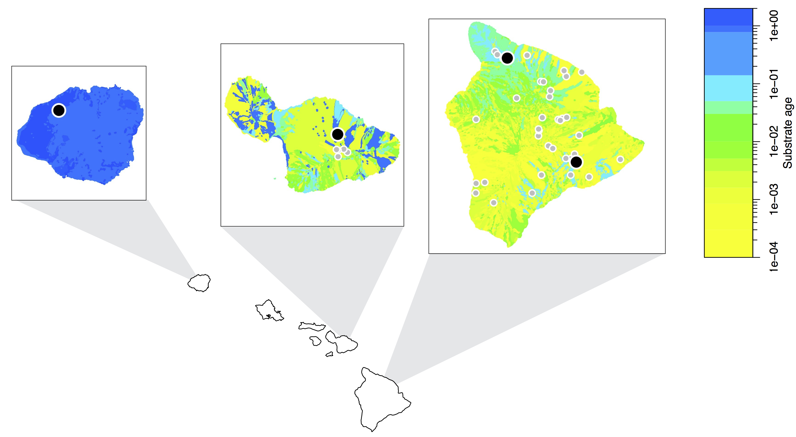

**Figure 2**

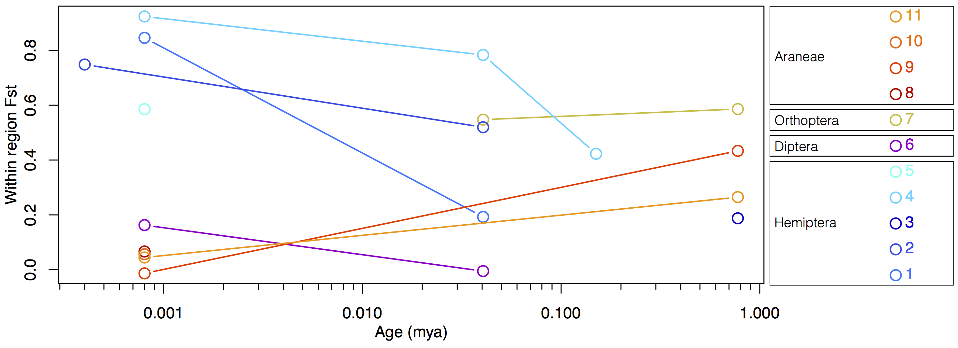

**Figure 3**

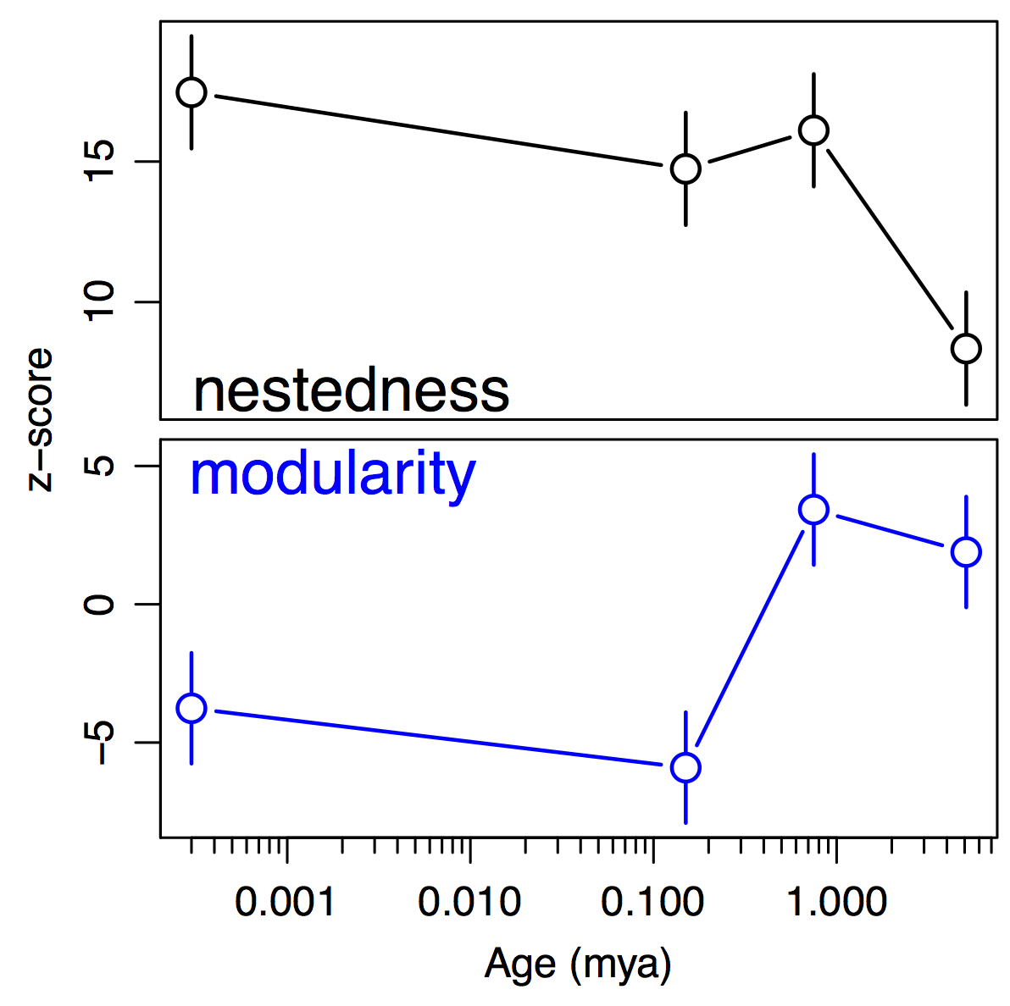

**Figure 4**

