**COMMUNITY ASSEMBLY ON ISOLATED ISLANDS:**

**MACROECOLOGY MEETS EVOLUTION**

***Global Ecology and Biogeography: Supplemental Material***

A.J. Rominger1*, K.R. Goodman1*, J.Y. Lim2*, E.E. Armstrong1;3+, L.E. Becking1;4 G.M. Bennett5, M.S. Brewer1;6+, D.D. Cotoras2;7+, C.P. Ewing3, J. Harte1, N.D. Martinez8,

P.M. O’Grady1, D.M. Percy9, D.K. Price3, G.K. Roderick1, K.L. Shaw10, F.S. Valdovinos8*, D.S. Gruner11#, R.G. Gillespie1#

1. Department of Environmental Science, Policy, and Management, University of California,

Berkeley, California 94720-3114, USA

2. Department of Integrative Biology, University of California, Berkeley, California 94720-

3140, USA

3. Department of Biology, University of Hawaii, Hilo, Hawaii, 96720-4091, USA

4. Institute for Marine Resources and Ecosystem Studies (IMARES), Wageningen University &

Research Centre, Den Helder, The Netherlands

5. Department of Integrative Biology, University of Texas, Austin, Texas 78712, USA

6. Department of Biology, East Carolina University, Greenville, North Carolina 27858, USA

7. Department of Entomology and Center for Comparative Genomics, California Academy of

Sciences, San Francisco, California 94118, USA.

8. Pacific Ecoinformatics and Computational Ecology Lab, Berkeley, California 94703, USA

9. Department of Life Sciences, The Natural History Museum, London, SW7 5BD, UK

10. Department of Neurobiology and Behavior, Cornell, Ithaca, New York 14853-7601, USA

11. Department of Entomology, University of Maryland, College Park, Maryland 20742-

4454, USA

* Contributed equally;

+ Current affiliation;

# co-senior authors;

corresponding author: R. G. Gillespie, gillespie@berkeley.edu.

**Compilation of networks and metric validation**

We compiled plant-herbivore networks from published sources as described in the main text. Table S1 lists publications used in compiling these networks.

Researchers have put forward to set of “network metrics," including nestedness (Bascompte et al., 2003; Ulrich et al., 2009) and modularity (Newman & Girvan, 2004; Olesenet al., 2007), to understand the complex structure of ecological networks. Null models are used to evaluate the statistical significance of these metrics and to compare between networks of different size (Ulrich et al. 2009). We compare the results derived from two common null models: the “probabilistic null" of Bascompte et al. (2003) and the “fixed-fixed null" (Ulrich et al., 2009). The “probabilistic null" uses the relative degree distributions of plants and herbivores as weights while randomizing links, but suffers from high Type II error (Ulrich et al., 2009). The “fixed-fixed null" (Ulrich et al., 2009) maintains the exact number of links assigned to each species while randomizing which interactors fill the requisite set of links, but suffers from high Type I error (Ulrich et al., 2009). We find that using these different null models does not change any trends in our network statistics across the Hawaiian chronosequence but different null models do influence the sign and significance of the network metrics (Fig. 1). We therefore do not interpret the sign or significance of the metrics but only their relative trends across site age.

Because these networks are based on opportunistic data associated with species descriptions and not based on standardized ecological surveys, we cannot interpret patterns in network metrics without evaluating possible sampling biases (Nielsen & Bascompte, 2007; Gibson et al., 2011; Rivera-Hutinel et al., 2012). To do so we rarify networks by the number of Hemiptera species included and, for each subsampled network, re-calculate nestedness and modularity z-scores. This rarefaction procedure shows that nestedness is very sensitive to network size (Fig. 3), a known property of nestedness (Nielsen & Bascompte, 2007; Gibson et al., 2011; Rivera-Hutinel et al., 2012). However the relative nestedness z-scores across networks remain qualitatively similar to those observed for the complete networks (Fig. 3). Modularity depends on network size in a more variable way (Fig. 3). Modularity is expected to decrease with network size (Rivera-Hutinel et al., 2012) and so the marked increase in modularity with network size on Haleakala is unexpected. However in light of the large number of highly specialized taxa this pattern is more reasonable if most species only have within module links then removing these species through subsampling will only reduce overall modularity. Thus this pattern speaks to the high level of specialization on Haleakala, and to a lesser extent at Kokee, which also shows a slight increase in modularity

with network size (Fig. 3).

**References**

Bascompte, J., Jordano, P., Melian, C.J. & Olesen, J.M. (2003) The nested assembly of

plant-animal mutualistic networks. *Proc. Natl Acad. Sci. USA*, **100**, 9383-9387.

Gibson, R.H., Knott, B., Eberlein, T. & Memmott, J. (2011) Sampling method influences the structure of plant-pollinator networks. *Oikos*, **120**, 822-831.

Newman, M. & Girvan, M. (2004) Finding and evaluating community structure in networks. *Physical Review E*, **69**, 026113.

Nielsen, A. & Bascompte, J. (2007) Ecological networks, nestedness and sampling effort. *Journal of Ecology*, **95**, 1134-1141.

Olesen, J., Bascompte, J., Dupont, Y. & Jordano, P. (2007) The modularity of pollination networks. *Proc. Natl Acad. Sci. USA*, **104**, 19891-19896.

Rivera-Hutinel, A., Bustamante, R., Marin, V. & Medel, R. (2012) Effects of sampling

completeness on the structure of plant-pollinator networks. *Ecology*, **93**, 1593-1603.

Ulrich, W., Almeida-Neto, M. & Gotelli, N.J. (2009) A consumer's guide to nestedness

analysis. *Oikos*, **118**, 3-17.

**Supplemental Figures**

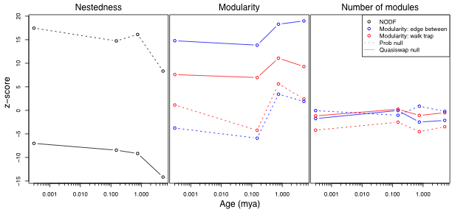

**Figure S1.** Comparison of different null models (“Prob" and “Quasiswap") used to standardize network metrics and comparison of different algorithms for assessing modularity (“edge between" and “walk drap"). Choice of null model has a strong influence on the sign and magnitude of metrics but not on their relative trends. The different modularity algorithms led to largely similar qualitative patterns.

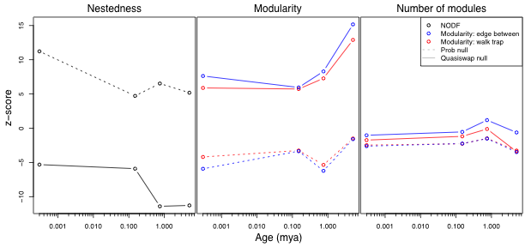

**Figure S2.** Metrics NODF and modularity calculated for networks based on more biogeographically conservative assignment of Hemiptera to localities. Colors and metric specifics as in Figure 1.

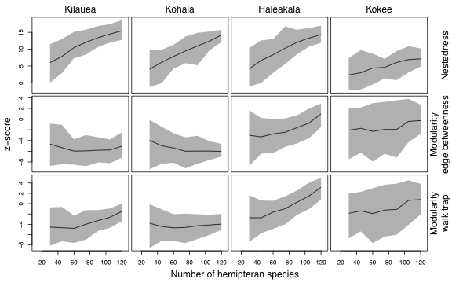

**Figure S3.** Result from rarifacation analysis showing sensitivity of network metrics to number of Hemiptera sampled.