Title of Paper

First Author1, Second Author2 & Last Author3

1,2Author affiliation

3Author affiliation

1Corresponding author Email

**Abstract.** Use 10 pt Times font for body of the text with one spacing between lines, and 12 pt spacing for the next heading. Left and right indent 0.5cm. Maximum length 250 words.

**Keywords:** use 10 pt; lower case; italic; Times; write alphabetically in 5-10 words.

# Introduction

The section title use 12 pt, bold, Times, title case with 6 pt spacing to the body text. Use 12 pt Times for body of the text with one spacing between lines, 12 pt spacing between paragraph and 18 pt spacing for the next heading.[1] To set the style, simply use this template and follow the instructions on section 2.

# Style and Formatting

This template already set the *style and formatting* for the paper, so you can use those styles by typing the style name on the **style** box as shown in the figure below:

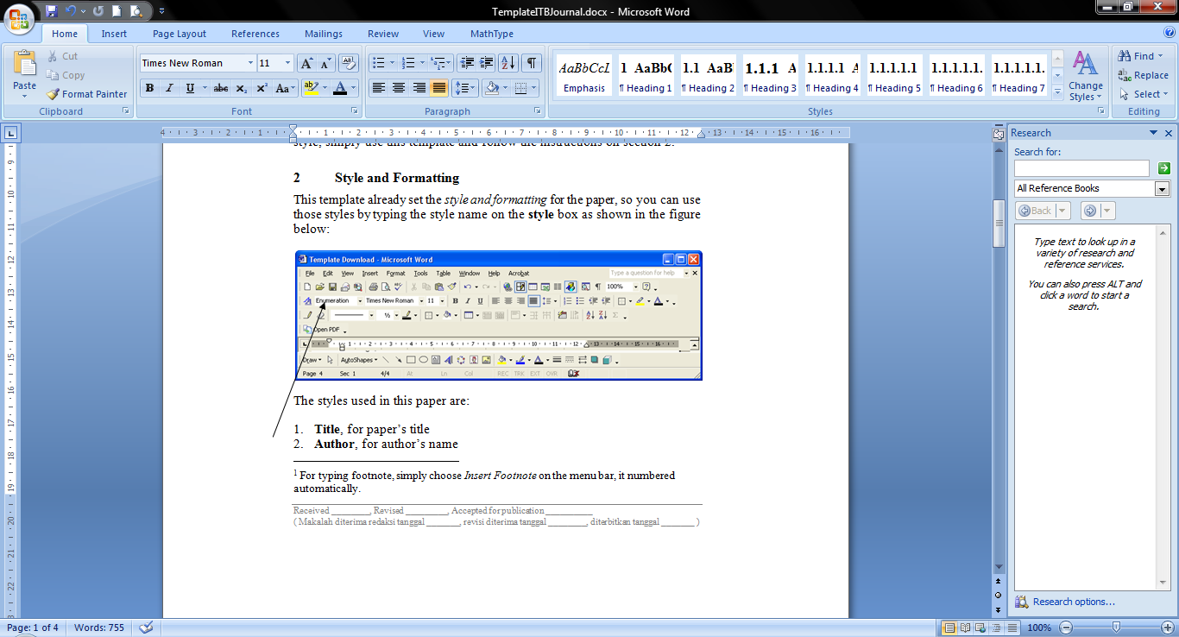

The styles used in this paper are:

1. **Title**, for paper’s title
2. **Author**, for author’s name
3. **Address**, for author’s address
4. **Abstract**, for abstract
5. **Heading 1**, for section title
6. **Heading 2**, for sub section title
7. **Heading 3, 4**, **5**, **6**, **7**, **8**, **9** for the next sub … sub-section title
8. **Text**, for body text
9. **Equation** and **Enumeration**
10. **Figure**, for figure caption
11. **Table,** for table caption
12. **Reference**, for references
13. **Appendix**, for appendix

## Mathematical Formulation

Equation should be type with indent 1.27 pt, and numbered consecutively starting with (1) set flush right.

To set the style, type *Equation* in the **style** box. But this style only set the tab stop position. To put the equation on the right place just press **tab** button one time. And to type the equation number, press **tab** button once again from the right side of the equation.

$x^{2}+y^{2}=z^{2}$ (1)

### Section and Sub-section Title

Just type *Heading 1* for section title, *Heading 2* for sub section title, and *Heading 3* for sub sub-section title. The number will set automatically.

### Figures and Tables

All figures and tables should be centered and numbered consecutively.

FIGURE

1. Type *Figure* in style box. The caption should be typed in lower case. Choose *center* if the caption fit on one line.
2. Summary of physical parameters.

|  |  |  |  |
| --- | --- | --- | --- |
| **No** | **Segments** | **Length**  **(km)** | **Elevation**  **(meter)** |
| 1 | A-B | 25 | 30 |
| 2 | B-C | 75.15 | 10 |
| 3 | C-D | 44.75 | 50 |
| 4 | D-E | 72.5 | 10 |
| 5 | E-F | 21.25 | 10 |

# Length

Maximum length of article is 15 pages including all pictures, tables, nomenclature, references, etc.

# Nomenclature (if necessary)

List the nomenclature in alphabetical order. List Roman letters followed by Greek symbols followed by subscript and superscripts.

|  |  |  |
| --- | --- | --- |
| *A* | = | Amplitude |
| *Cd* | = | drag coefficient |
| *fe* | = | linearization coefficient |
| *Ki* | = | modification factor |
| ** | = | wave number |
| ** | = | Complex wave number |

# References

Within the text, references should be cited by giving last name of the author(s) and the order number in the reference as:

Whitson [1] has studied ….

...... the resulting equation is [2]:

$\frac{x^{2}}{4}+\frac{y^{2}}{9}=r^{2}$ (2)

Note that in the case of three or more authors, only the last name of the first author is cited and the others are denoted by et al. The same rule is also hold for header title in even page.

Use the same typeface as the body of the text for the references, or just type *Reference* in style box. Examples are:

1. Sutasurya, L.A. & Riyanto, B., 1999, *Title of Paper*, Name of Journal, **8**(4), 20-25. (Journal)
2. Sutasurya, L.A., Handojo, A. & Riyanto, B., 1999, *Title of book*, 2nd ed., Publisher, pp. 5-10. (Book)
3. Williams, J., 2001, *Name of Paper*, Name of Book, Name of the editor(s) (ed(s).), Publisher, pp. 67-69. (Book with paper title and editor)
4. Williams, J., 2004, *Title of paper,* in Name of Proc., Name of the editor(s) (ed(s).), pp. 5-10. (Conference Proceedings)
5. Name of the author(s), *Title of paper* (if available), Organization, URL Link, (1 April 1999). (URL Link)
6. Rashid, L., 1997, *Title of Dissertation*, PhD dissertation, Name of Dept., Name of Univ., City. (Thesis or Dissertation)

# Manuscript Content

The contents of the paper should be in the following order:

1. Title of Paper
2. Author names and affiliation
3. Abstract
4. Body of the text (Introduction ………. Conclusion)
5. Nomenclature
6. References

Article is written on one side of good quality of A4 papers.

Appendix

If necessary you can type your appendix here.

1. For typing footnote, simply choose *Insert Footnote* on the menu bar, it numbered automatically.