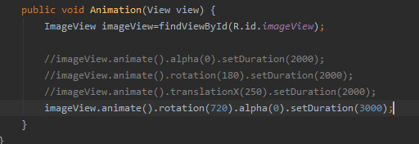

A screenshot of a red car

Description generated with high confidenceA picture containing text

Description generated with very high confidence

1. Now we add scaling animation

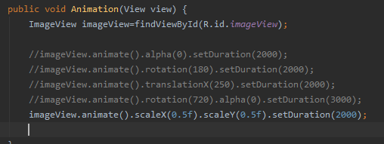

A screenshot of a red car

Description generated with high confidenceA picture containing graphical user interface

Description generated with very high confidence

1. Now we add video activity as launcher activity and add videoView in it
2. 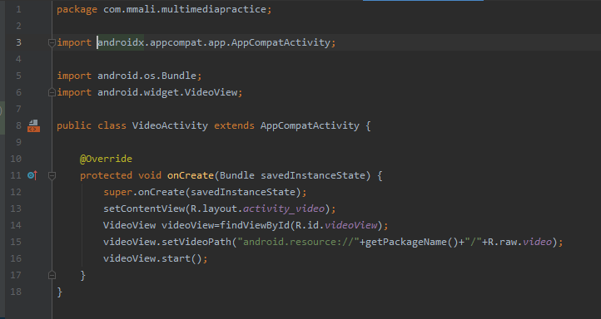

Graphical user interface, application

Description generated with very high confidence