**NAVIGATION DRAWER**

1. Navigation drawer is used to navigate between different activities. It provides us a menu from which we can select given activities
2. Change Main Activity’s layout to drawer layout

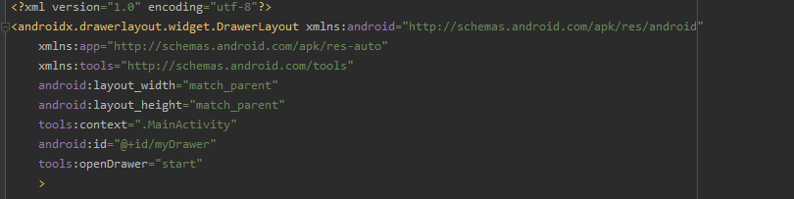

1. Now add a toolbar to main activity

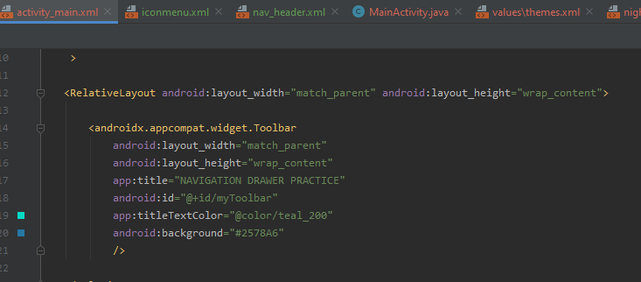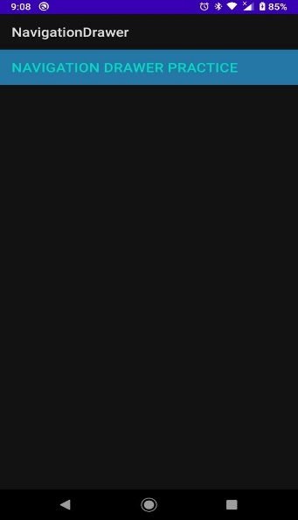

1. Add a menu resource directory and add menu resource file in itGraphical user interface, application

   Description generated with very high confidenceGraphical user interface, application

   Description generated with very high confidence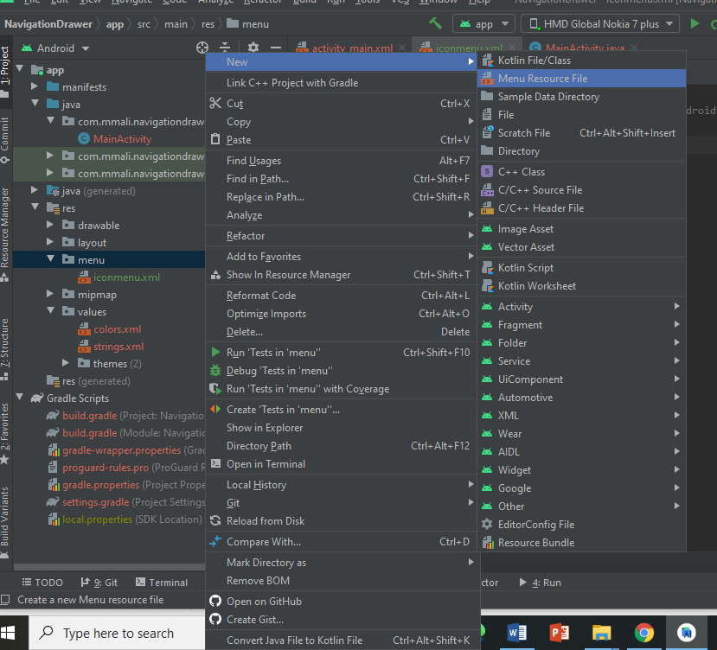
2. Add icons for menu items using vector asset and select clip arts as you like home, call and settings etc

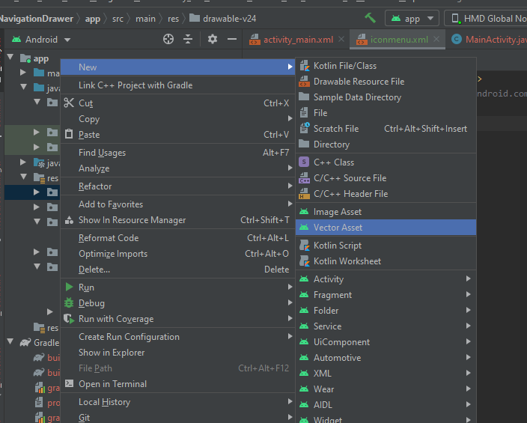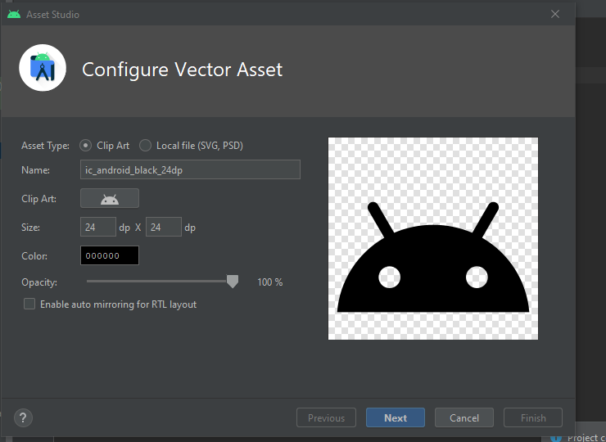

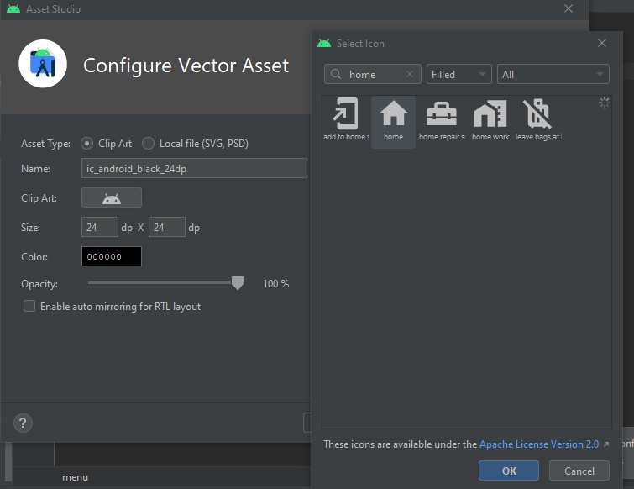

1. Now add item in menu xml