**RECYCLER VIEW**

1. RecyclerView makes it easy to efficiently display large sets of data. You supply the data and define how each item looks, and the RecyclerView library dynamically creates the elements when they're needed
2. To implement recycler view we first add a recycler view in our activity

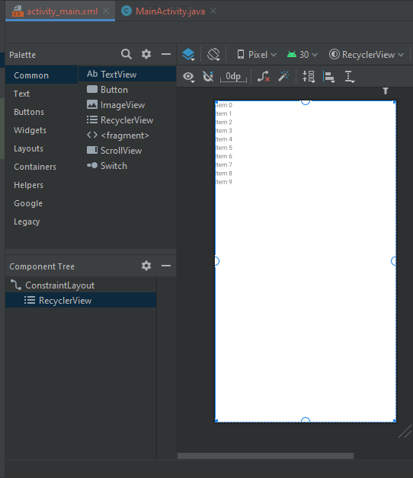

1. Now we define a layout for our list item of recycler view by making a layout in layout folder named my_row.xml. Here we defined a card and inside it we placed a constraint layout having an image and two textViews.

