**ANDRIOD STUDIO**

After installing, and making a new project , made a screen and run on virtual device

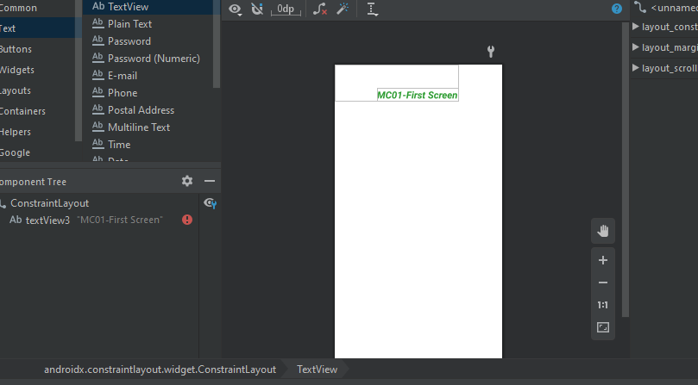

**2-Now create text-view field**

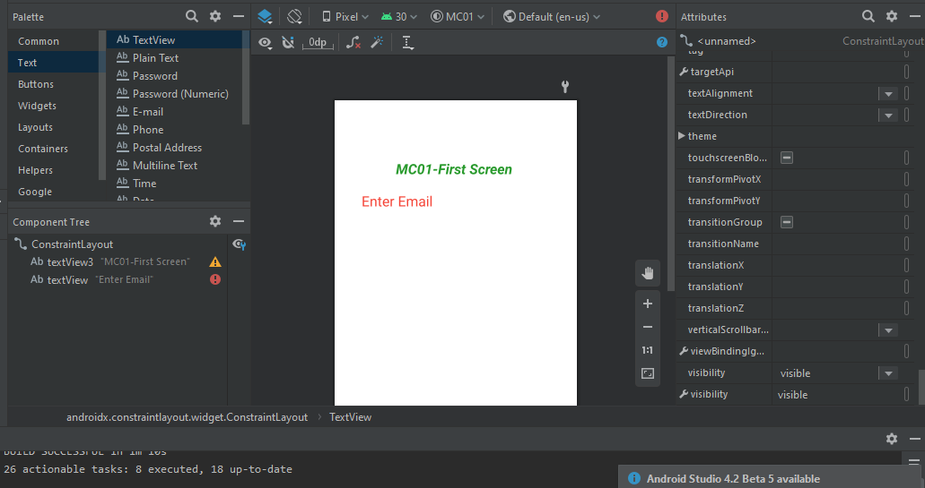

**3-now creating plain-text view field.**

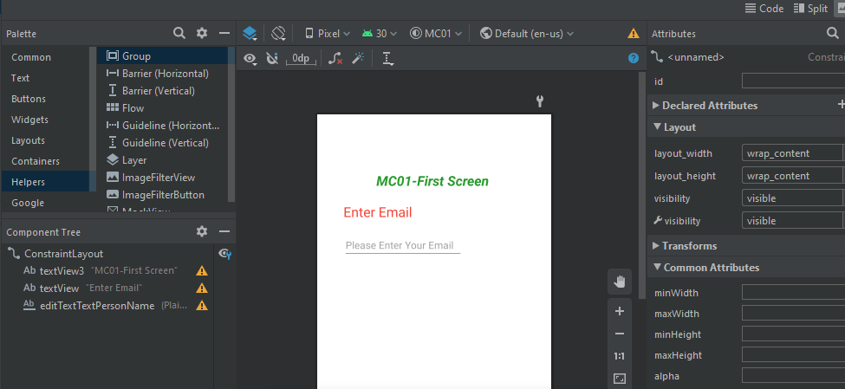

4-**adding radio button**

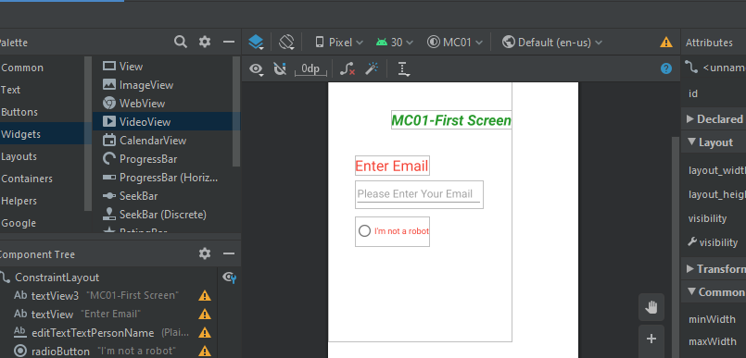

**5-adding button**

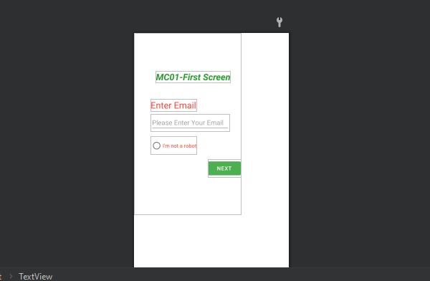

**6-after setting all the margin and field, run app on virtual device**

