* **View:**
  + A view usually draws something the user can see and interact with. Physical thing that user can touch such as buttons, touch boxes.
  + The View objects are usually called **Widgets** and can be one of many subclasses, such as **Button** or **TextView**.
* **ViewGroup:**
  + Invisible container
  + The ViewGroup objects are usually called **layouts** can be one of many types that a different layout structure, such as **LinearLayout** or **ConstraintLayout**.

**Linear Layout**

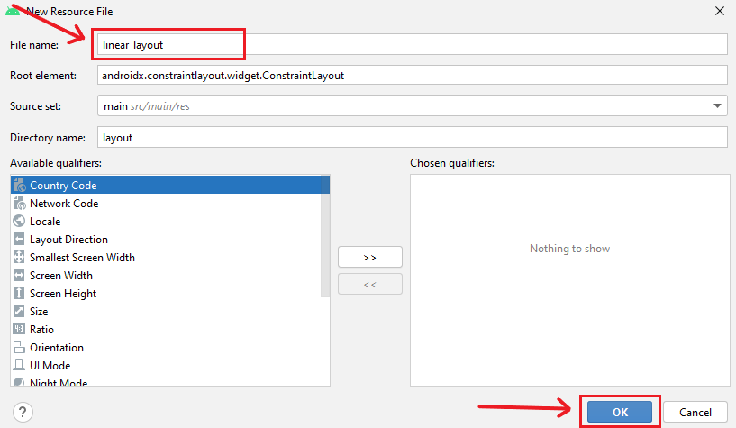

**Adding a TextView:**

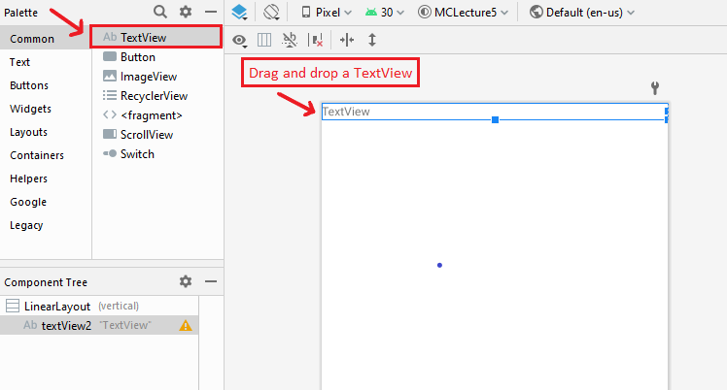

Change the text

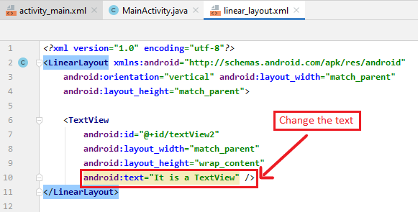

**Adding a Button**

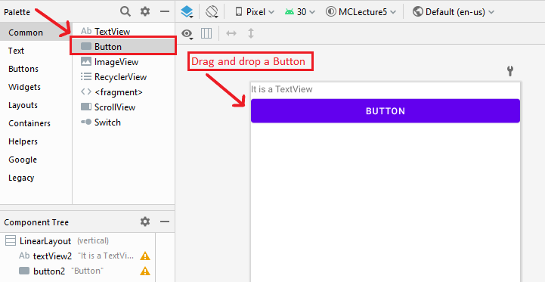

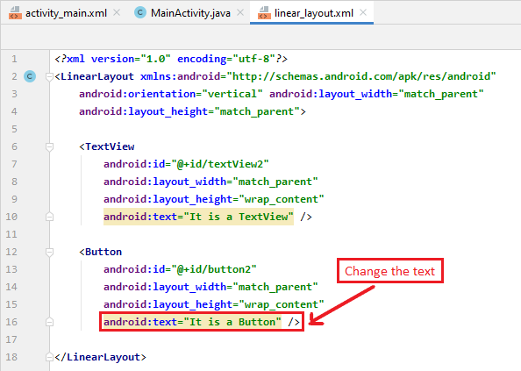

**linear_layout.xml:**

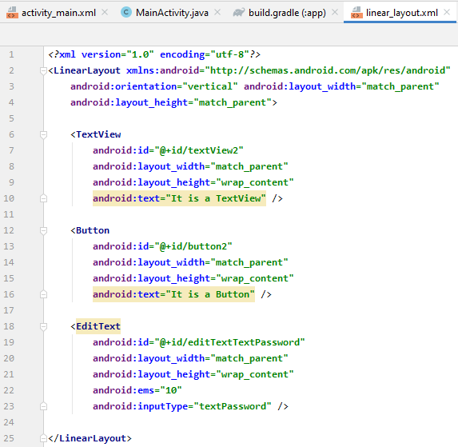

* **MainActivity.java**

Change the layout inMainActivity.java

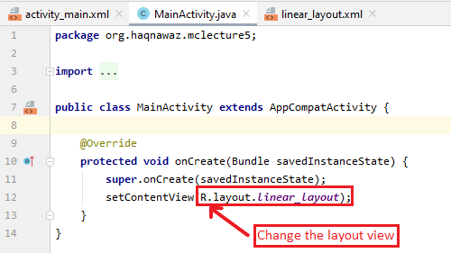

* + **Run App:**

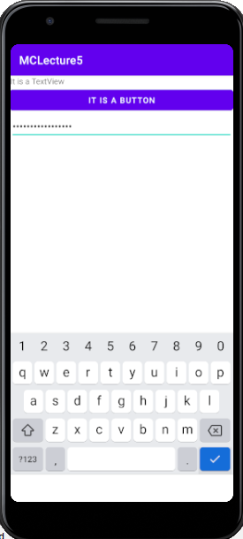

**Dependency:**

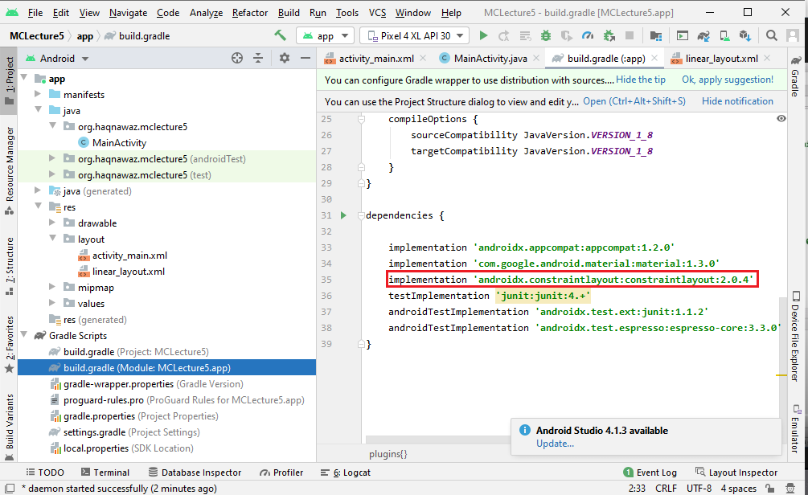

* **Activity_main.xml:**
  + **Adding a Button:**
    - Drag and drop the Button.
    - Set its tops constraint to the bottom of the text.

Set its left constraint to the side of the screen

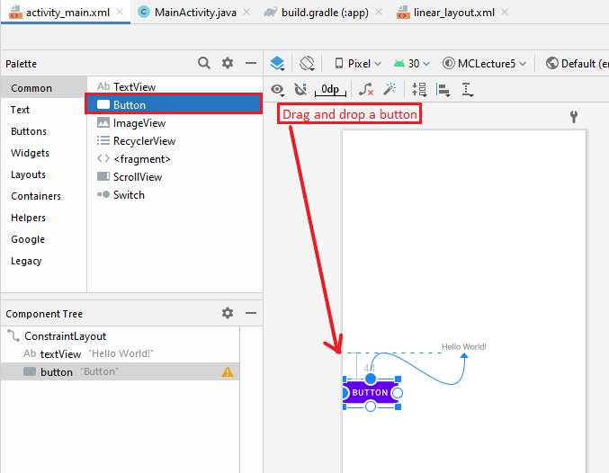

* + **Adding a Phone:**
    - Drag and drop the Phone under the Text.
    - Set its bottom constraint to the top of the text.

Set its left constraint to the right of the button

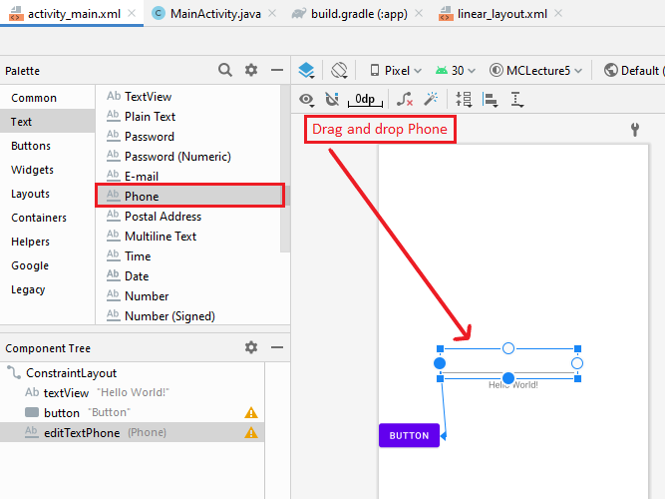

* + **Run App:**

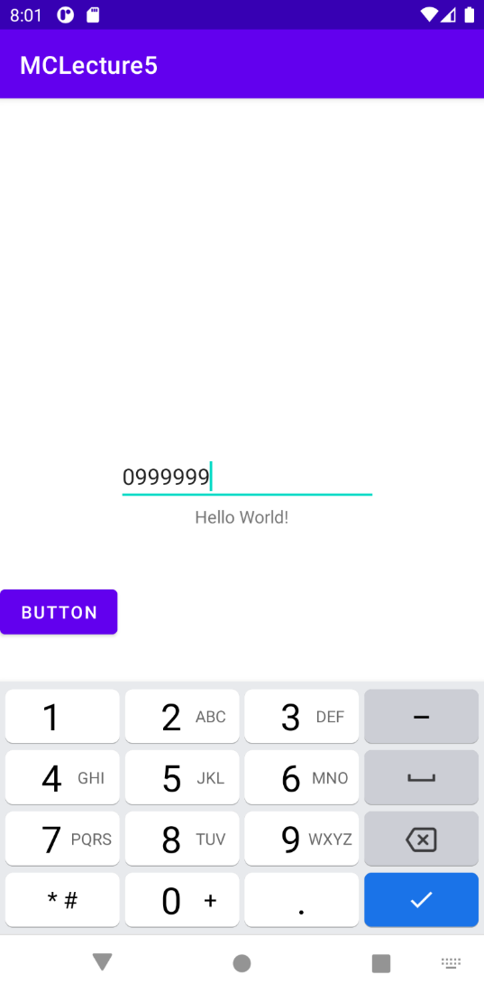

* + **Remove Constraints:**

Click the clear all constraints button on the top

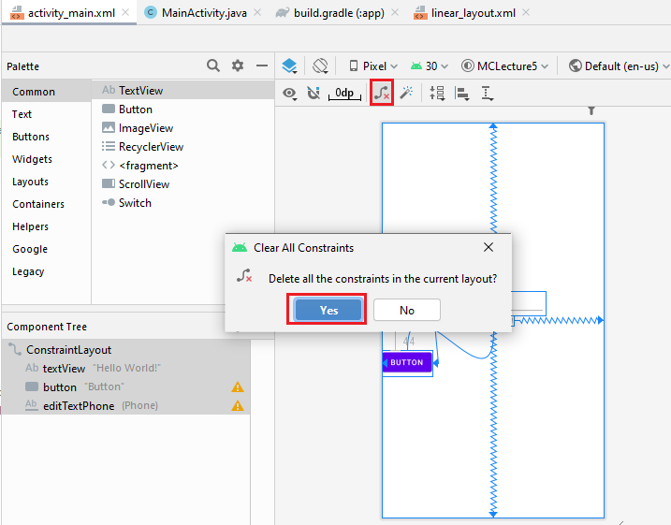

**After clearing all constrainst:**

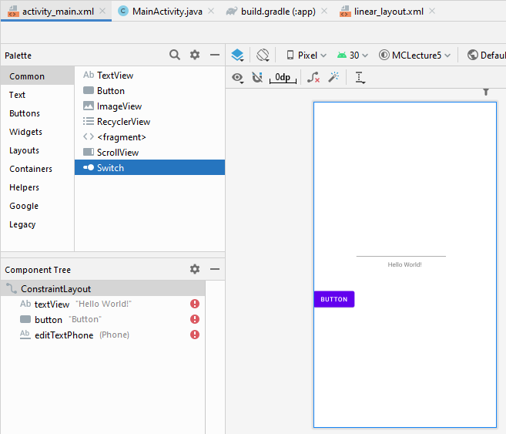

* + **Run App:**

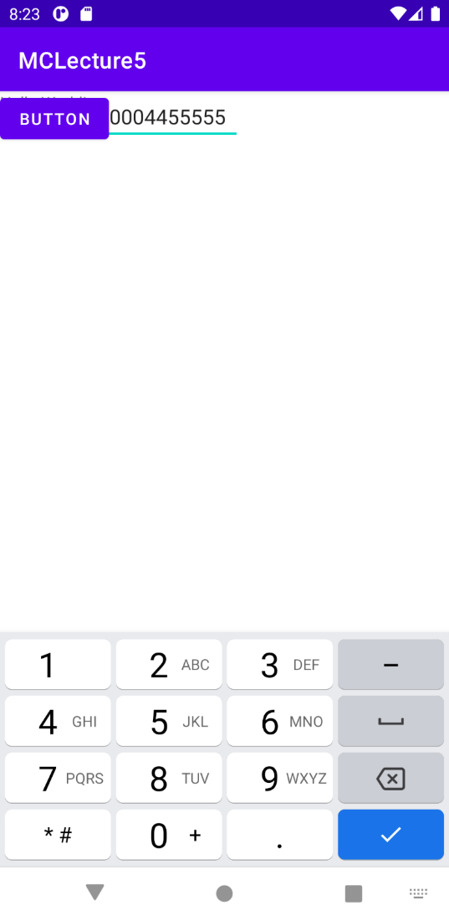

* + **TextView:**
    - Add a TextView by drag and drop.

Add some text.

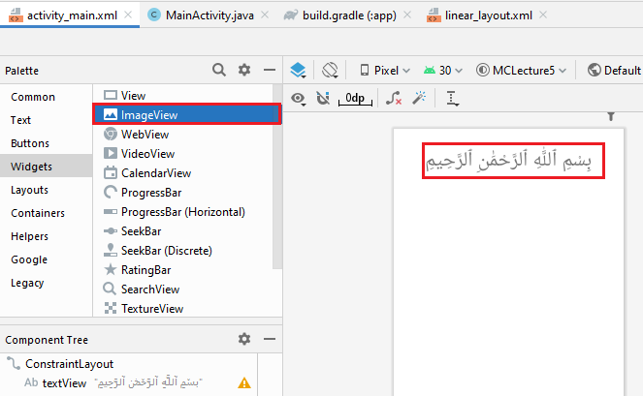

* + - Set its constraints.

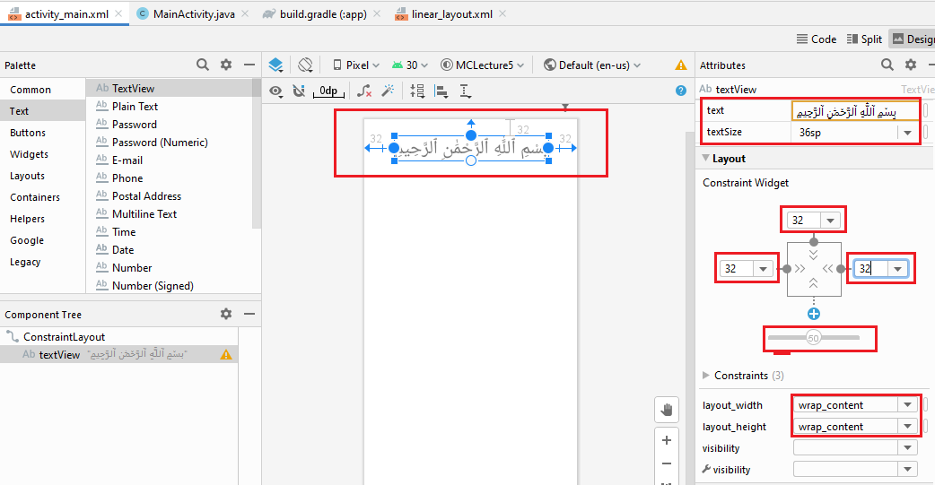

* + **Run App:**

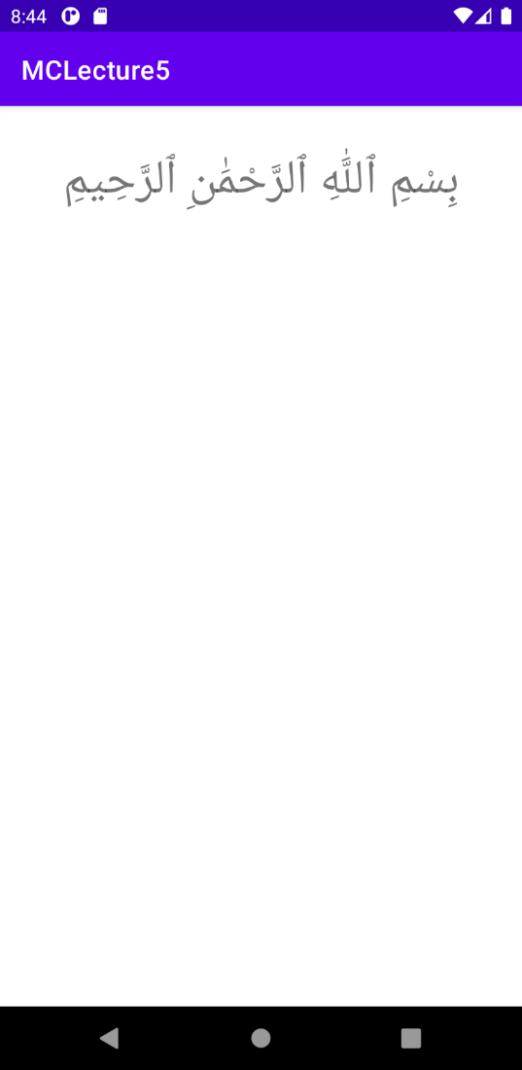

* + **Adding an ImageView:**