**ACTIVITY LIFECYCLE**

1. There are three activities performed in application:-

* OnCreate()
* OnStart()
* OnResume()
* OnPause()
* OnStop()
* OnDestroy()

1. When an activity destroys it’s data is also destroyed.
2. For example let us create a counter which keeps count of clicks on button

Text

Description generated with very high confidence

Graphical user interface, application

Description generated with high confidence

4)Now when we try to increase the count and rotate it we see that it resets to zero its because new activity is started and previous activity is destroyed.

Graphical user interface, application

Description generated with high confidenceGraphical user interface, text, application

Description generated with high confidence

5)Now we log the activities to see what is happening

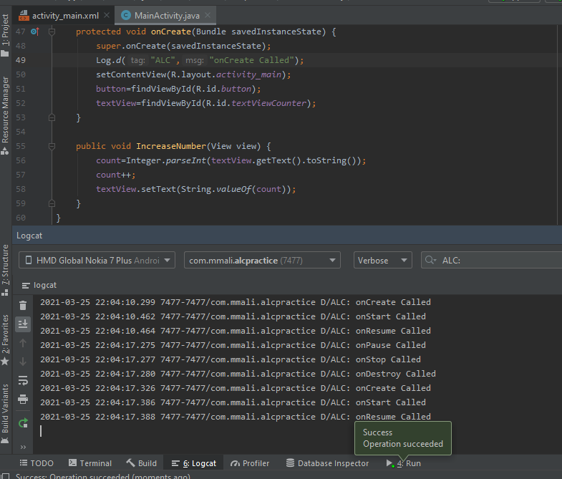

6)Now to solve this issue we will save the previous state of activity