5.1 collaboration diagram admit to Hospital
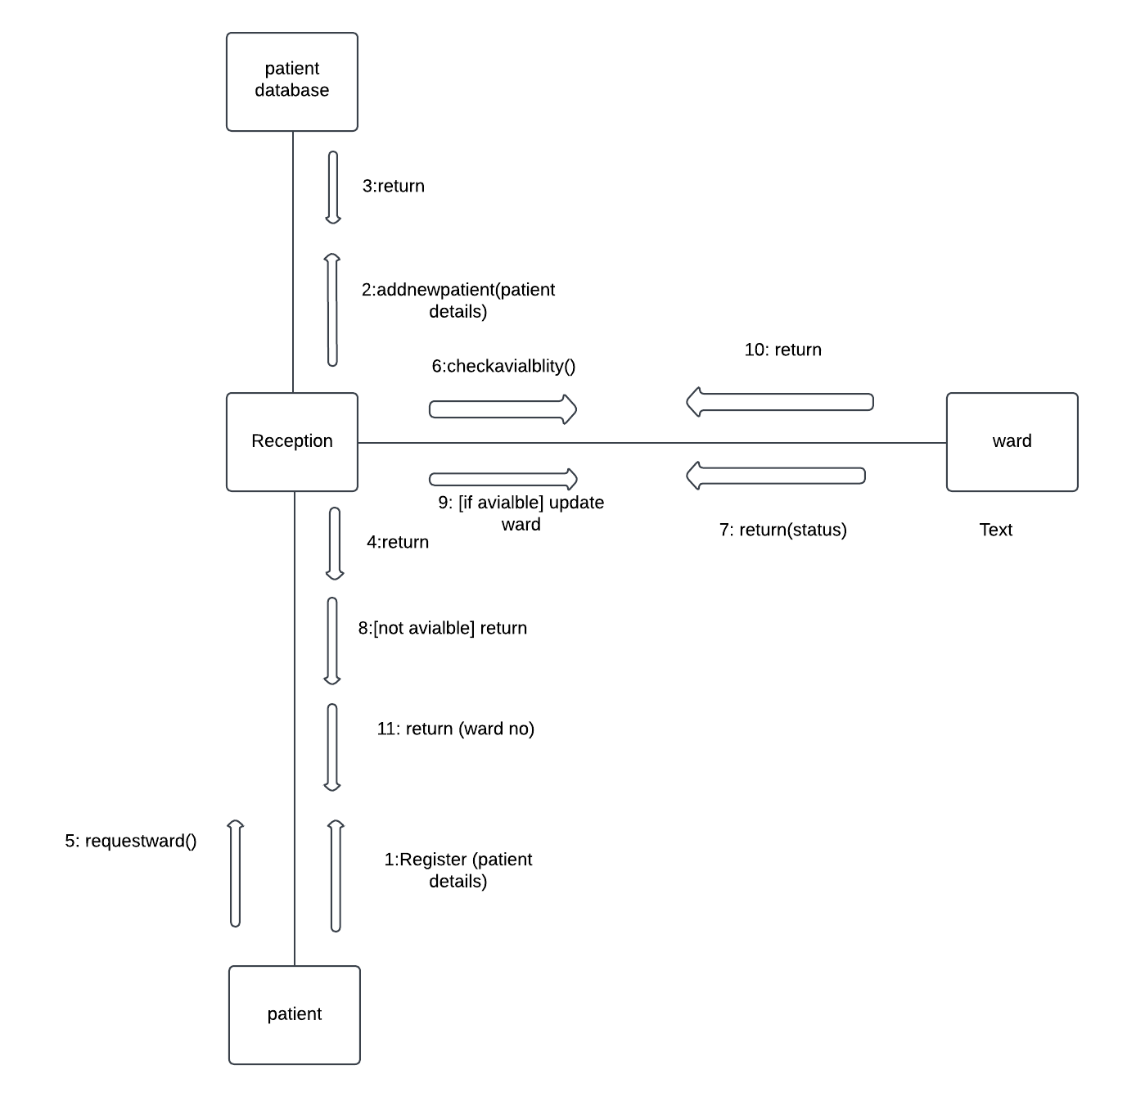
5.2 collaboration diagram for treatment at Hospital
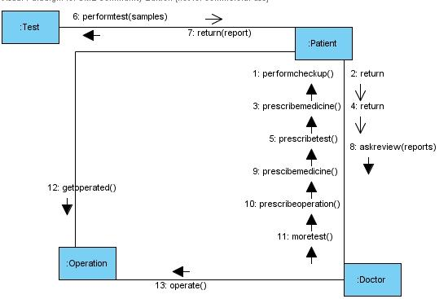
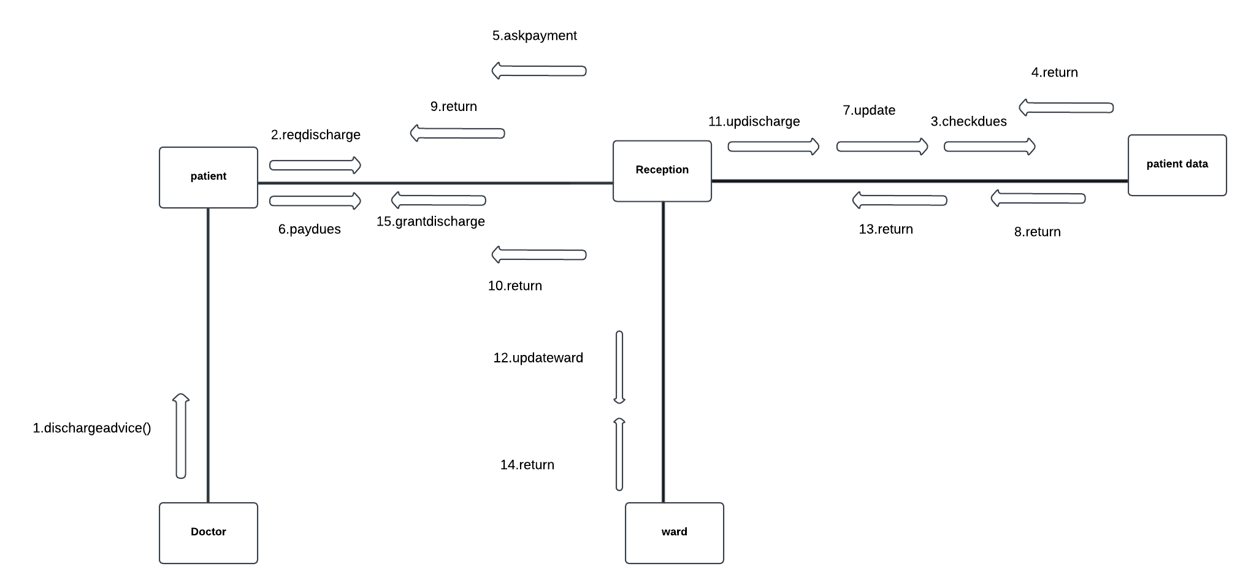
5.3 collaboration diagram for discharge from Hospital
6.1 state chart diagram for patient
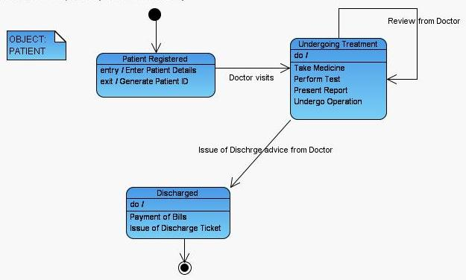
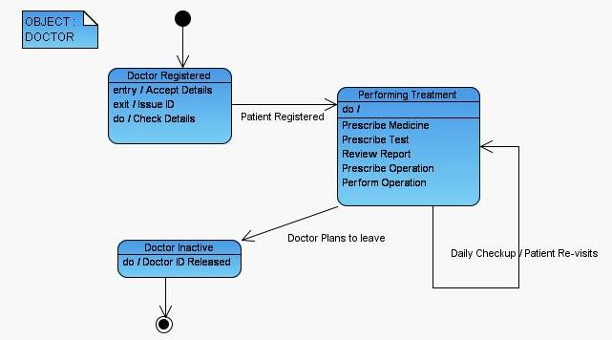
6.2 state chart diagram for doctor
6.3 state chart diagram for ward object
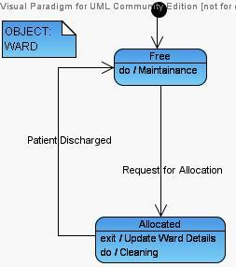
7.1 component diagram for hospital management
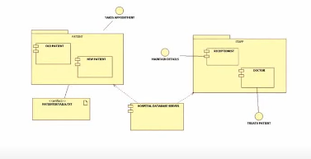
8.1 Deployment diagram for hospital management
