WALMART

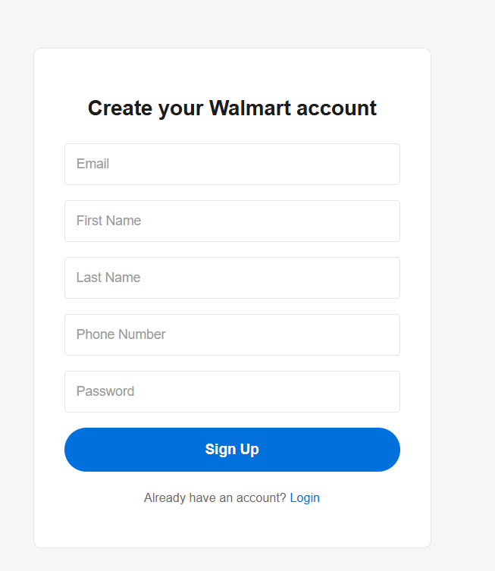

Test case
Test Case ID | Action | Input | Expected Output | Actual Output | Status
TC_01 | Sign up with all valid details | Valid Email, First Name, Last Name, Phone, Strong Password | Account created successfully and user redirected to Home page | Same as expected | Pass
TC _02 | Sign up with one or more empty fields | Leave any mandatory field empty | Error message displayed, account not created | Same as expected | Pass
TC _03 | Sign up with invalid email format | Email: user@com | Validation error shown for email field | Same as expected | Pass
TC _04 | Login with valid credentials | Registered Email & Password | User logged in and redirected to Home page | Same as expected | Pass
TC _05 | Login with invalid credentials | Incorrect Email or Password | Error message shown, login denied | Same as expected | Pass
TC _06 | Logout from Home page | Click Logout button | User logged out and redirected to Login page | Same as expected | Pass

Test case -1
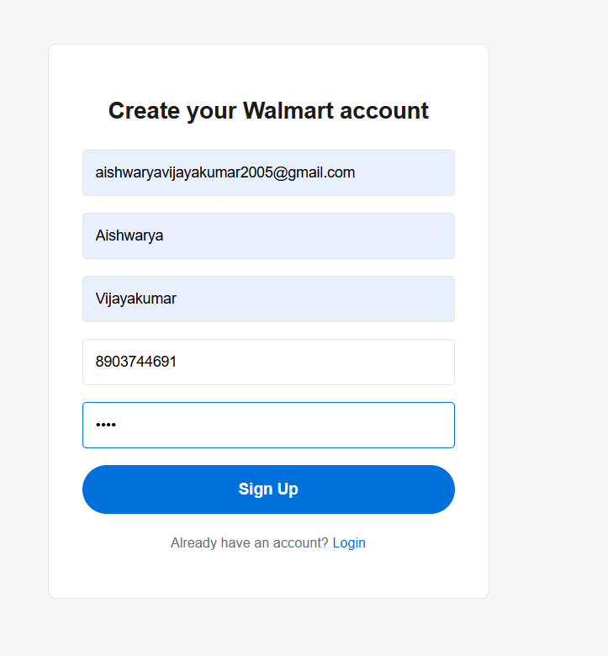

Test case 2
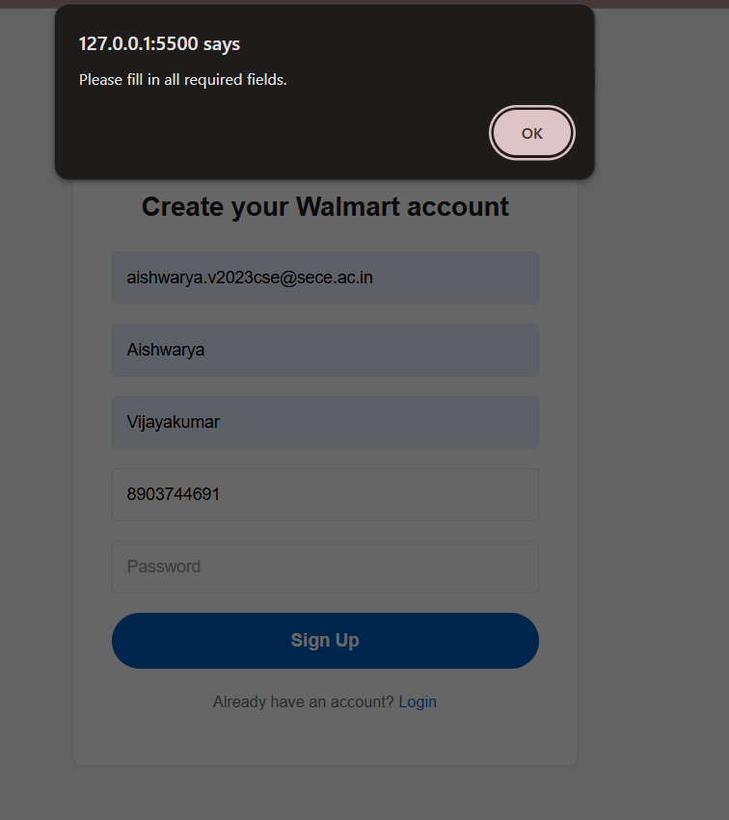

Test case-3
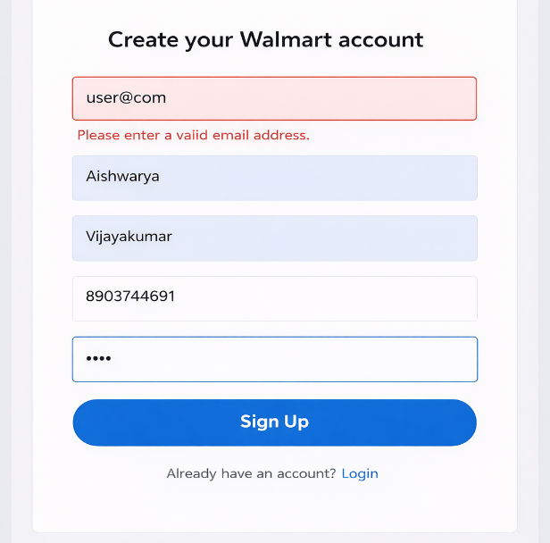

Test case-4
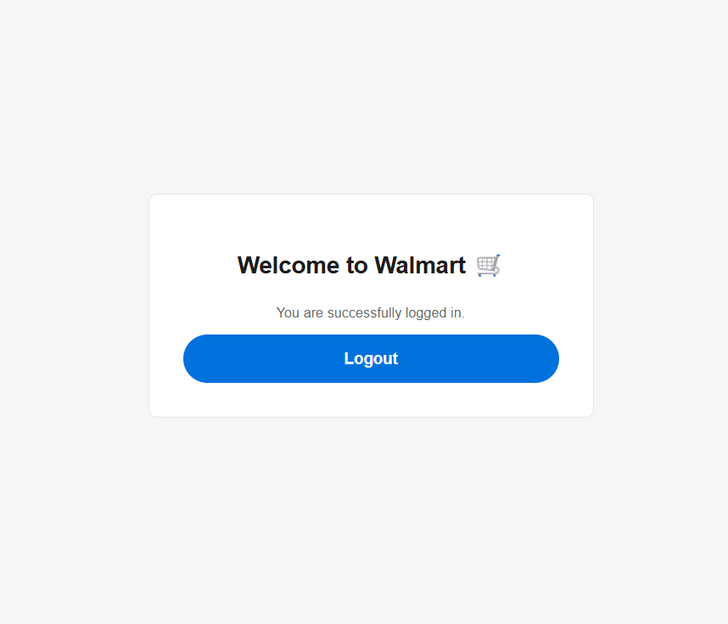

Test Case-5
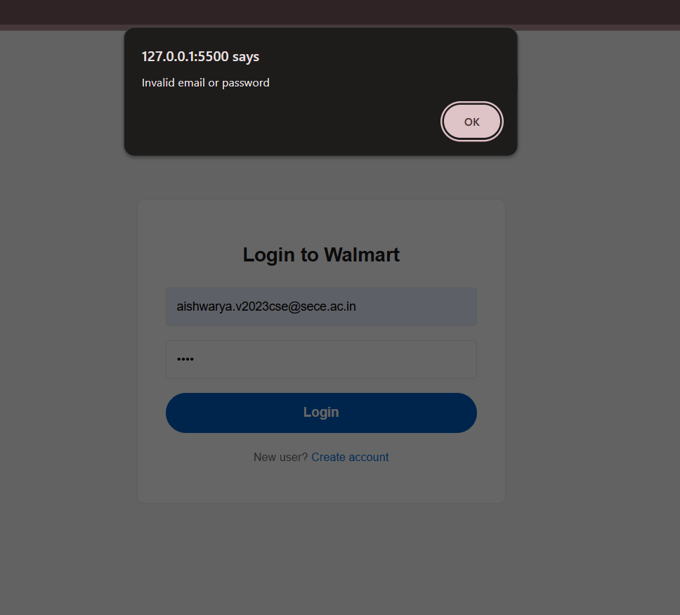

Test Case-6
