Executive Summary
This analysis examines Fitbit smart-device usage data to identify trends in physical activity and sleep. The analysis found that users averaged about 7,638 steps per day and spent significantly more time sedentary than actively exercising. Users also averaged approximately 7 hours of sleep per night. Based on these findings, Bellabeat could encourage users to increase daily movement, reduce sedentary time, and use sleep-tracking features. These recommendations can be incorporated into the Bellabeat app through step challenges, movement reminders, and personalized sleep insights.
1. Ask
Business Task:
Analyze Fitbit smart-device usage data to identify trends in how consumers use smart devices for physical activity and sleep. Use these insights to make recommendations for Bellabeat's marketing strategy and apply the findings to one Bellabeat product.
Key Questions:
- What are some trends in smart device usage?
- How could these trends apply to Bellabeat customers?
- How could these trends help influence Bellabeat's marketing strategy?
Stakeholders:
- Urška Sršen – Bellabeat co-founder and Chief Creative Officer
- Sando Mur – Bellabeat co-founder and executive
- Bellabeat marketing analytics team
These questions and stakeholders come directly from the case study.
2. Prepare
Data Source
The data used for this analysis is the FitBit Fitness Tracker Data dataset. It was made available through Mobius and contains fitness tracker data from 30 Fitbit users.
What the Data Contains
The dataset includes information about users' physical activity, daily steps, calories burned, sleep, heart rate, and other fitness-tracker measurements.
Data Used for Analysis
The main datasets I will use are:
- dailyActivity_merged.csv — daily activity, steps, distance, calories, and activity levels.
- sleepDay_merged.csv — daily sleep information.
The original data will be kept unchanged, and copies will be used for cleaning and analysis.
3. Process – Data Cleaning
I checked the activity and sleep data for errors before analyzing it.
- I checked for duplicate rows in the activity data and found no duplicates.
- I checked the activity data for blank cells and found no blank cells.
- I checked that the activity dates were formatted correctly.
- I checked that the TotalSteps values were recorded as numbers.
- I checked the sleep data for duplicates and found 3 duplicate rows, which I removed.
- I checked the sleep data for blank cells and found no blank cells.
- I matched the sleep data with the activity data using the user ID and date so I could compare steps with sleep.
Data was kept in separate original and cleaned sheets so the original data remained unchanged.
Analysis
Key Findings
- Users averaged 7,638 steps per day, below the 10,000-step goal.
- Users spent much more time sedentary (991 minutes/day) than in very active activity (21 minutes/day).
- Users averaged about 7 hours of sleep per night.
- On sleep-recorded days, 40.24% also reached 10,000+ steps.
Visualizations
- Chart 1: Average Daily Minutes by Activity Level
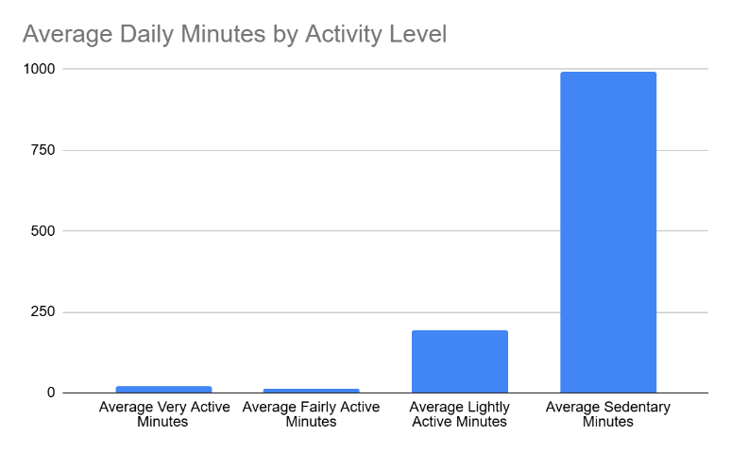

- Chart 2: Average Daily Steps vs. 10,000-Step Goal
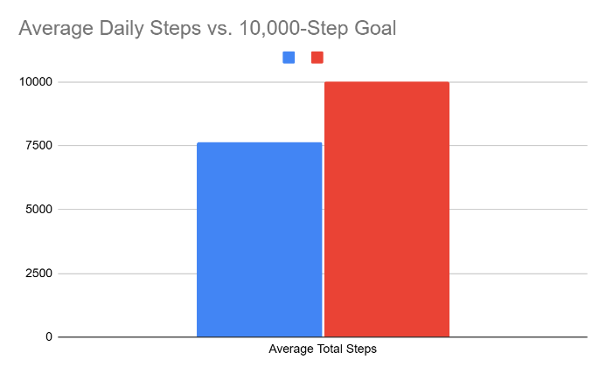

Chart 3: Average Sleep Time vs. Time in Bed
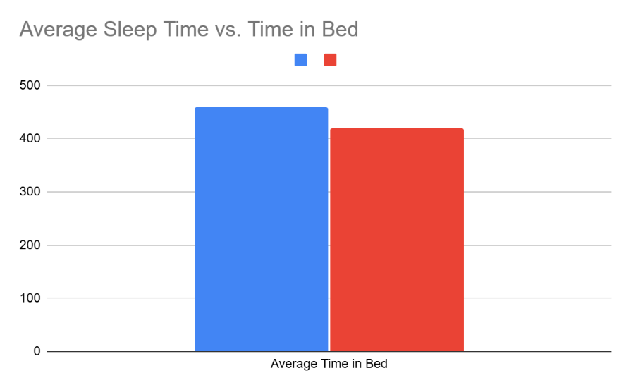

Recommendations
1. Encourage More Daily Movement
The average user recorded 7,638 steps per day, which was below the 10,000-step goal. Bellabeat could promote daily step challenges that encourage users to gradually increase their activity.
2. Reduce Sedentary Time
Users averaged 991 sedentary minutes per day. Bellabeat could use its app to send movement reminders and encourage users to take short walking or stretching breaks.
3. Promote Sleep Tracking
Users averaged about 7 hours of sleep per day. Bellabeat could promote personalized sleep insights and bedtime reminders to help users better understand and improve their sleep habits.
Product Focus: Bellabeat App
The Bellabeat app should be the primary product focus because it can use activity and sleep insights to encourage healthier daily habits.
Act
Based on the analysis, Bellabeat can use its app to encourage users to be more active, reduce sedentary time, and improve their sleep habits. Step challenges, movement reminders, and personalized sleep insights could help users build healthier daily routines.
Overall recommendation:
Bellabeat should focus its marketing on encouraging small, consistent improvements in daily activity and sleep rather than only promoting intense exercise.

