HAWASSI-AB

User Manual





by

© LabMath-Indonesia

ver.1.240210

mail address : LabMath-Indonesia

Lawangwangi - LMI

Jl. Dago Giri No.99

Warung Caringin, Mekarwangi

Bandung 40391, Indonesia

e-mail : hawassi@labmath-indonesia.org

home page : [www.hawassi.labmath-indonesia.org](http://www.hawassi.labmath-indonesia.org)



Copyright ©2015 LabMath-Indonesia

Contents

Preamble 1-3

1 Introduction 1-5

2 Description of HAWASSI-AB 2-6

2.1 Introduction HAWASSI-AB 2-6

2.2 Units and computational grid 2-7

2.3 Model features and capabilities 2-8

2.3.1 Geometry 2-8

2.3.2 Bathymetry and run-up 2-8

2.3.3 Embedded wave influxing of various wave types 2-9

2.3.4 Initial value problems 2-10

*2.3.5* Model versions (evolution equations) 2-10

2.3.6 Internal flow calculations [5] 2-11

2.4 Software facilities 2-11

3 Installing HAWASSI-AB software 3-13

3.1 System requirements 3-13

3.2 First step: Installing MCR 3-13

3.3 Second step: Installing HAWASSI-AB 3-13

4 GUI’s of HAWASSI-AB 4-14

4.1 Start page GUI 4-15

4.2 New project GUI 4-15

4.3 Main GUI 4-16

4.4 Post-Processing GUI 4-18

4.5 Internal Flow GUI 4-20

4.6 Required lay-out of user defined input files 4-21

4.6.1 Influx time signal 4-21

4.6.2 Initial wave profile 4-21

4.6.3 Bathymetry 4-21

4.6.4 External measurement data 4-21

4.6.5 Interior flow External measurement data 4-21

4.6.6 Dispersion relation 4-22

5 Test cases 5-23

5.1 Non-breaking waves above flat bottom 5-24

5.1.1 1F001Foc: MARIN_202002, Strong focussing wave 5-24

5.1.2 IF002Draup: MARIN204001, Draupner Wave 5-24

5.1.3 IF003Irreg MARIN_224002F, Irregular wave in deep water 5-24

5.1.4 IF004Wall AB1_Wall, Full wave reflection from wall [5] 5-25

5.1.5 1F005WallFreq, Frequency dependent wall reflection [5] 5-25

5.1.6 1F006Bor, Undular bore 5-25

5.2 Breaking waves above flat bottom 5-26

5.2.1 1FBr001Foc MARIN203001, Strong focussing wave 5-26

5.2.2 1FBr002Foc TUD1403Foc7, Focussing Breaking Wave [3] 5-26

5.2.3 1FBr003BiB TUD1403Bi8, Bichromatic wave breaking 5-26

5.2.4 1FBr004Ir MARIN_223002F, Irregular wave breaking [10] 5-27

5.2.5 1FBr005Bor Undular_breaking bore [5] 5-27

5.3 Non-breaking waves above non-flat bathymetry 5-28

5.3.1 2B001IrSlope MARIN_103001, Irregular wave above a slope [5, 13] 5-28

5.3.2 2B002HarmBar, Harmonic over bar 5-28

5.3.3 2B003IrBar, Irregular wave over bar 5-28

5.4 Breaking waves above bathymetry 5-29

5.4.1 2BBr001HarmBar [10] 5-29

5.4.2 2BBr002IrBar Irregular wave, Spilling breaker [5] 5-29

5.5 Run-up of waves (breaking and non-breaking) 5-30

5.5.1 3R001Harm: Harmonic Run-up (non-breaking) 5-30

5.5.2 3RBr001Harm: Spilling Breaker Run-up (with interior flow) [5] 5-30

6 References 6-31

6.1 References to basic papers and applications 6-31

6.2 Other references 6-33

# Preamble

Waves are fascinating, important and challenging.

The importance can be substantiated from some well-known observations:

* Half of the world population lives less than 150 km from the coast
* The sea is a relatively easy medium for transport of people and goods (half of all the world crude oil and increasingly more natural gas) and for intercontinental telecommunication through cables
* Ocean resources of food and minerals are only at the start of discovery, profits from wind parks and harvesting of wave energy in coastal areas is expanding.

Therefore, a sustainable and safe development of the oceanic and coastal areas is of paramount importance. Nowadays that means that for the design of harbours, breakwaters and ships, calculations are performed with increasingly more accurate and fast simulation tools. Tools that are, packaged in software, based on the basic physical laws that describe the properties of waves, the wave-ship interaction, the forces on structures, etc.

HAWASSI software is aimed to contribute to extend the accuracy, capability and speed of existing numerical methods and software using applied-mathematical modelling methods that are at the basis.

A basis with a rich history that is fascinating and challenging. Starting in the 18th century with Euler who generalized Newton’s law for fluids, in the 19th century Airy ‘solved’ the problem to describe small amplitude surface water waves. In that same century, many renowned scientists like Scott Russel, Stokes, Boussinesq, Rayleigh and Korteweg & De Vries investigated the nonlinear aspects of finite amplitude waves. As much as possible without the need to fully calculate the internal fluid motion; started with Boussinesq in an approximative way, this was formulated accurately in the 1960-1970’s by Zakharov and Broer by providing the Hamiltonian form of the dynamic equations.

HAWASSI software is based on these last findings, with methods for making the principal description into a practical (numerical) modelling and implementation tool.

The first release of the software deals with wave propagation, but the developers are in the process to extend the capabilities to include coupled wave-ship interactions, amongst others, in later releases.

We sincerely hope that the use of the software, just as the design of it has been, will be fascinating and challenging for students and academicians as well as for practitioners; from both groups we hope to receive comments and suggestions for further improvements and extensions in a way that can be profitable for both sides.

*Let nature tell its secrets*

*Listen to the physics in its mathematical language*

*Restrain from idealization*

*Only then models will serve us in abundance*

By downloading and using the software you agree that Yayasan AB is not liable for any loss or damage arising out of the use of the Software. Although much care is taken to arrive at trustful results of simulations with HAWASSI, Yayasan AB cannot be held responsible for any result of simulations obtained with the software, or consequential actions or calculations that are based on the results, e.g. because of possible bugs, wrong use of the software, or other causes.

© Copyright of HAWASSI software is with LabMath-Indonesia, an independent research institute under the Foundation Yayasan AB in Bandung, Indonesia.

The software has been developed over the past years in collaboration with the University of Twente, Netherlands, with additional financial support of Netherlands Technology Foundation STW and Royal Netherlands Academy of Arts and Sciences KNAW.

This program is free software: you can redistribute it and/or modify it under the terms of the GNU General Public License as published by the Free Software Foundation, either version 3 of the License, or (at your option) any later version.

This program is distributed in the hope that it will be useful, but WITHOUT ANY WARRANTY; without even the implied warranty of MERCHANTABILITY or FITNESS FOR A PARTICULAR PURPOSE. See the GNU General Public License for more details.

You should have received a copy of the GNU General Public License along with this program. If not, see <http://www.gnu.org/licenses/>.

# Introduction

This document is the Manual of HAWASSI-AB software that serves as a guide for using and running the software.

HAWASSI-AB simulates phase resolved waves in 1 Horizontal Direction (1HD, long crested waves), as are generated in wave tanks to simulate on scale coastal and oceanic waves above flat and varying bathymetry, and with (partially) reflecting walls and damping zones.

Section 2 describes briefly the mathematical background and the capabilities of the code, such as the various dispersive and nonlinear properties, together with the features of the software; it is advised to read this Section before continuing to the rest of the manual[1].

Section 3 provides a step-by-step installation procedure of the software.

A condensed description to handle the software, regarding GUIs and input/output parameters, is given in Section 4.

Section 5 describes briefly the 18 TestCases that show capabilities of the code and its use. (More test-cases will become available on [www.hawassi.labmath-indonesia.org](http://www.hawassi.labmath-indonesia.org))

# 

# Description of HAWASSI-AB

## Introduction HAWASSI-AB

This section provides background information of HAWASSI-AB about the basic scientific ideas.

HAWASSI – AB is a software package for the simulation of realistic waves in wave tanks (1HD), i.e. long-crested waves as can appear in oceanic and coastal areas, with the option of reflections from walls with various reflection properties.

The acronym HAWASSI stands for

**Hamiltonian Wave-Ship-Structure Interaction**.

HAWASSI –AB is a spatial-spectral implementation of the **Analytic Boussinesq** Model (AB).

Presently the code is for simulation of wave-structure interactions; coupled wave-ship interaction is foreseen in future releases.

**Underlying Modelling Methods**

HAWASSI-AB is based on the following principles

* The free surface dynamics for inviscid, incompressible fluid in irrotational motion is governed by a set of Hamilton equations for the surface elevation  and the potential  at the surface.
* With the Hamiltonian, the sum of potential and kinetic energy, the Hamilton equations are given by (Zakharov 1968, Broer 1974)



Here denotes the time derivative and  the variational derivative with respect to  and similarly for .

* By approximating the kinetic energy functional  explicitly as an expression in  and the simulation of the interior flow can be avoided, the Boussinesq character of the code.
* The way of approximating  is based on Dirichlet’s principle for the boundary-value problem in the fluid domain. By restricting the set of competing functions in the minimization, an approximation of  is obtained. The variational derivative



is the corresponding consistent approximation of the Dirichlet-to-Neumann operator.

* The (approximate) Hamilton system conserves the (approximate) positive definite total energy exactly, avoiding sources of instability.
* The time dynamics is explicit, no CFL-conditions are required. Time stepping is done with matlab odesolver code, with automatic variable time step.

In AB (with exact dispersion) the interior flow is approximated by using a nonlinear extension of the potential as given by the Airy theory of small amplitude waves, and Taylor expansion of the kinetic energy leading to Hamiltonian consistent approximations.

**Numerical Implementation**

Fourier Integral Operators (FIO’s) multiply the Fourier Transform of a function by the symbol of the operator. These are generalizations of (Pseudo-) Differential Operators since for FIO the symbol will depend both on the wave number and on the spatial variable; the spatial dependence is for nonlinear extensions and varying bottom. FIO’s are used in a spatial-spectral implementation; these are approximated by interpolation techniques to enable efficient Fast FT-methods [13]. Localization methods (a difficult point in Fourier-type implementations) have been successfully implemented to deal with walls, run-up, breaking waves, etc. [5]

## Units and computational grid

HAWASSI-AB expects all quantities to be expressed in S.I units: *m, kg, s* (meter, kilogram, second). As a consequence, the wave height and water depth are in *m*, wave period in *s*, etc.

## Model features and capabilities

HAWASSI-AB accounts for the following physical circumstances and phenomena of waves in 1 HD, i.e. ***long -crested waves***.

### Geometry

***Simulation interval and Grid***  
A uniform grid is defined by specifying an *x*-interval  and a grid with grid size

.

Here the number of points has to be chosen such that the largest prime factor satisfies . The choice of *N* determines computation speed of FFT calculations; the fastest computation speed will be achieved when the largest factor of *N* is 2.

*Wave numbers* *k* in Fourier space are defined in accordance with the spatial grid:



***Fourier Boundary***

For the use of Fast Fourier Transformations, all quantities (except bathymetry) are tapered to vanish near the end points; this takes place is the so-called Fourier Boundary, the length of which can be specified. The Fourier Boundary should be such that reflection of outgoing waves has to be prevented; hence the Fourier Boundary also acts as a ***damping zone***.

***Walls*** [5]

The position of a wall inside the simulation interval can be specified. Depending on the reflection properties, the following choices can be made:

* A ***uniform, partially reflecting wall*** by specifying the reflection coefficient in [0,1] for all wave lengths (frequencies)
* A ***frequency depending (non-uniform) partially reflecting wall*** by providing a reflection function with reflection coefficients depending on frequency.

### Bathymetry and run-up

The ***bathymetry*** can be user-specified. The software provides parameterized bathymetries, for flat bottom (depth), and linear sloping (parts of the) bottom, including run-up. For interpolating the depth depending Fourier Integral operators, the number of depths can be chosen to be 2 or 3; except for very abrupt, large changes, the choice of 2 depths gives usually sufficient accuracy. For 3 depths interpolation, user has to specify a depth reference in between minimum and maximum depth. Suggestion for linear sloping, the depth is half of minimum and maximum depth and for the runup is 1/6 of maximum depth.

***Bottom friction***

Bottom friction can be applied at a specified part of the bottom; in the bottom friction formula

typical values for the manning coefficient are depending on bottom.

### Embedded wave influxing of various wave types

***Wave influxing*** [9]

In AB the wave influxing is done through a source in the continuity equation.

The ***influx position*** and a ***time signal*** of the desired elevation at the influx position have to be specified.

A choice can be made between

***uni-directional influxing***: for waves propagating in one direction,

in the direction of the positive (**uni+**) or negative (**uni-**) x-axis,

or ***bi-directional influxing*** for waves running symmetrically in both directions.

The spatial extent over which the influxing takes place can be chosen:

With a ***point-influx*** the ‘generation area’ is restricted to the immediate neighbourhood of the influx point (using Dirac delta-functions). Then the desired time signal is modified into a (much) higher modified time signal to guarantee the correct waves being influxed.

A smoother influx (better suited for high, steep waves) is ***area-*** (or ***area-short***) ***influxing***; then the waves are generated over a broader interval, better suited for high, steep waves.

***Nonlinear adjustment zone*** [9]

In order to prevent spurious modulations in the influxed wave when using a nonlinear wave model, a nonlinear adjustment zone of length to be specified has to be applied; in the adjustment zone a coefficient in front of the nonlinear terms in the Hamiltonian grows from 0 at the influx point to 1 at the end of the zone. Typically, especially for harmonic waves, the required length will be at least 2 times the peak-wavelength (and substantially more for steeper waves on shallower water).

***Wave types***

Any type of waves can be influxed from a ***user-specified time signal***.

The software makes it possible to specify parameters for ***harmonic waves*** and for ***irregular waves*** with Jonswap (JS) spectrum; for irregular waves, the phases are chosen randomly. The parameterized influx signal will be stored for possible re-use for comparison of different evolution models.

Any influx signal will start and end by default with a smooth ***ramp function***, the length of which can be specified as a number of periods.

### Initial value problems

Instead of wave influxing, data for an initial value problem (***initial elevation profile*** and ***initial potential***) can be user-specified or chosen from predefined parameterized cases: a ‘Gaussian’ as a single hump, and ‘Nwave’ for an N-wave shaped wave, all with zero initial velocity.

The Gaussian is given by specifying the three parameters in



and the N-wave is the derivative with adjusted amplitude.

### Model versions (evolution equations)

***All combinations are possible of choices for dispersion (also user-specified), nonlinearity, and breaking***, with various choices for each item as described below.

#### Dispersion

The main property of HAWASSI-AB is that it can handle ***exact dispersion*** of small-amplitude (so-called *linear*) waves of any wave length, owe to the Fourier character and implementation of AB.

As a consequence, the continuity equation is exactly satisfied above flat bottom, and in a very good approximation above varying bottom.

Besides that, mainly for *educational/academic purposes*, to enable simulations for models with approximate dispersion, other predefined or user-defined dispersive models can be chosen:

* ***Shallow Water (SW) dispersion***
* ***KdV (Korteweg-de Vries) dispersion*** [KdV 1895]
* ***BBM (Benjamin-Bona-Mahony) dispersion*** [BBM 1972]
* ***User-specified dispersion*** to be specified in input panels.

For the given or user-specified dispersion, all nonlinear terms are calculated consistently, above flat as well as above varying bottom.

A brief explanation is given, referring to the table for the explicit expressions. The exact dispersion relation  is the correct expression for small amplitude waves. For , i.e. ‘rather’ long waves or ‘rather’ shallow water, this relation can be Taylor expanded, leading to

* ***SW dispersion*** (first order Taylor) , which gives a translation of waves of any wave length with the limiting speed 
* ***KdV – dispersion*** (3th order Taylor) ; note that short waves with  will travel in the opposite direction.

*Remarks:*  Since influxing uses properties of the group-velocity, *Uni-directional influxing* in the KdV model will show the short waves running in the ‘wrong’ direction, corresponding to the dispersion relation. *Bi-directional influxing* will include these wrongly-directed waves, which is *not* corresponding to the original KdV dispersion relation for uni-directional waves.

* ***BBM-dispersion*** , same as KdV in 3th order, but uni-directional

Note: To avoid problems with too poor dispersion, KdV and BBM uses exact dispersion for influxing.

In the table the explicit formulas and plots for the various cases are given.

|  |  |  |
| --- | --- | --- |
| **Model** | **Dispersion relation** | **Plots Disp. relation & Phase velocity** |
| Exact dispersion |  |  |
| Shallow Water |  |
| KdV |  |
| BBM |  |  |
| User-specified | Provide *dispersion relation* and *group velocity* in input panels, using only wave number ***k*** and depth ***d*** as variables, in matlab-formula style. |

#### Nonlinearity

The ***order of nonlinearity*** of the Hamiltonian System (HS) is specified by the number in the present version of HAWSSI-AB

**HS*m* for orders *m=1* (linear), *2, 3* and *4***

To avoid aliasing in the Fourier implementation, the wave numbers have to be restricted to be at most a fraction *1/(2m)*, with 2*m* the so-called ***cutfrac*** in the input for the specified code. (Note: This cut only applies to the terms in the nonlinear equation; the spatial grid remains as determined by *p*, i.e. *2p* gridpoints.)

#### Breaking [10]

Breaking of waves is modelled with an eddy viscosity method; to initiate the breaking process, the value of a kinematic initiation ***breaking criterion*** has to be specified, the quotient of fluid velocity at the crest and the velocity of the crest: ***U/C***, usually in the interval *[0.6, 1]*

### Internal flow calculations [5]

As an option it is possible to calculate (in a post-processing step, but indicated in the preparation-step)

* the ***horizontal and vertical velocities and accelerations*** of the interior fluid motion,
* all components of the total ***pressure***,

at a user defined grid in horizontal and vertical direction in a specified time interval.

## Software facilities

Facilities of the software include (to be described in Section 4)

* ***GUI for input*** of wave characteristics and model parameters, with efficient project management
* ***GUI for post-processing*** of the output of the wave simulation and comparison with data
* ***GUI for internal flow calculations***
* ***Wave Calculator***
* ***Time partitioned simulation*** to reduce (computer) hardware requirements
* ***Pre-processing step*** with warnings/suggestions for improved settings
* 18 ***TestCases*** (see Chapter 5) with examples of various kind, several of which include measurement data to compare with simulations.
* ***Comparison with experimental data*** that have been reported in various publications (see the references in Section 6 and the examples of *TestCases* in Section 5).

# Installing HAWASSI-AB software

`

The HAWASSI-AB installer will install the HAWASSI-AB code, including documentation.

HAWASSI-AB software is programmed under the MATLAB environment. The compiled MATLAB applications can be run on PC’s that do not have MATLAB installed using the MATLAB Compiler Runtime (MCR). The MCR will install MATLAB Runtime Libraries on the computer.

## System requirements

HAWASSI-AB (v.1.1) can run on Windows operating system with 64bit architecture. The minimum memory (RAM) needed is 2GB (for some test cases and extensive applications 4GB RAM or more).

## First step: Installing MCR

The HAWASSI-AB package (v.1.1) requires MCR installer for version ***MATLAB R2018a*** for Windows operating system 64bit. The MCR installer can be downloaded directly from the MATLAB website: <http://www.mathworks.com/products/compiler/mcr/>; after downloading install the MCR by double clicking the installer and following the instruction in the installation wizard.

## Second step: Running HAWASSI-AB

After installing MCR, HAWASSI-AB can be started by double clicking the executable ‘**HAWASSI_AB_startpage**’.

In the Help- Menu of Main-GUI, the ‘Documentation’ will show this manual. Test Cases can be found in the test case directory.

# GUI’s of HAWASSI-AB

For ease of operation, HAWASSI-AB software includes three GUI’s, Graphical User Interfaces, as input-output managers.

|  |  |  |
| --- | --- | --- |
|  |  |  |
| **Main GUI** for providing input for the simulation | **Post-Processing GUI** for specifying output of the simulation | **Internal Flow GUI** for calculating interior flow properties |

The GUI’s will be described briefly in the next 3 sections. The meaning of most required input fields needs no or little explanation; the choices that can be made will be described. The function of, and required input format for input panels is indicated when the cursor is moved over it; when an optional panel is checked, additional input fields may appear that have to be filled out.

User-input is accepted for various purposes to replace pre-programmed choices;

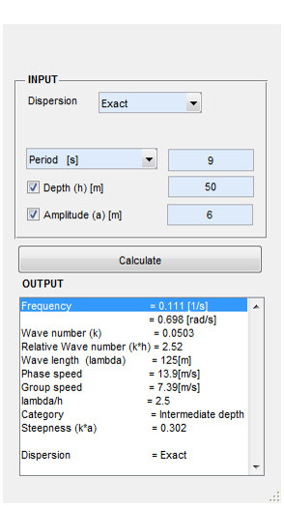this is the case for

* influx signal
* initial wave profile
* Bathymetry
* dispersion function
* measurement data for comparison with simulations

The required lay-out of such files or formula’s is described in Section 4.4.

There is a simple ***Wave-Calculator*** that expects as input the period of a harmonic wave and the depth, and will then calculate all wave-relevant quantities; by also specifying the amplitude, the calculated steepness is added.

## Start page GUI

This GUI panel is for choosing an existing project from a list previous projects, for browsing for an existing project that is not listed in the panel or for creating a new project by calling a new project GUI.

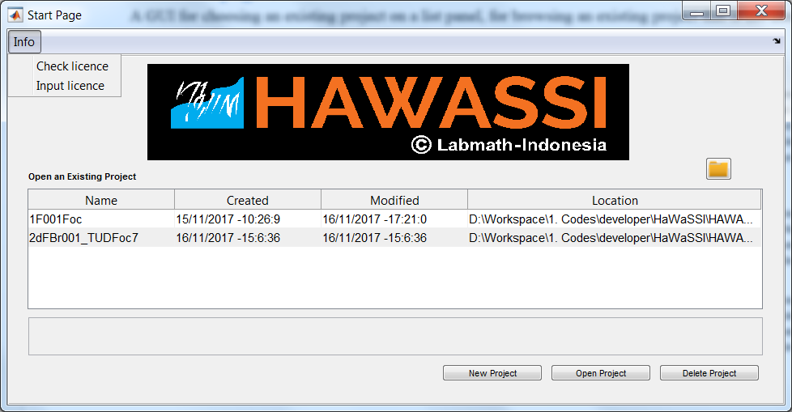

Information about the licence

List of existing projects

Button for opening the chosen project on the list

Button for deleting the chosen project on the list

Panel for notes of the chosen project

Browse button for an existing project that is not listed in the project list

Button for creating a new project

## New project GUI

This GUI panel is for creating a new project by specifying product type, modules, project name, the directory and project’s note. The choice of product type can be AB 1D or 2D for simulations in one or two horizontal dimensions. Module choices are for wave simulations, for wave-ship interactions and for wave-radar applications. In the present version, only the module for wave simulations is available.

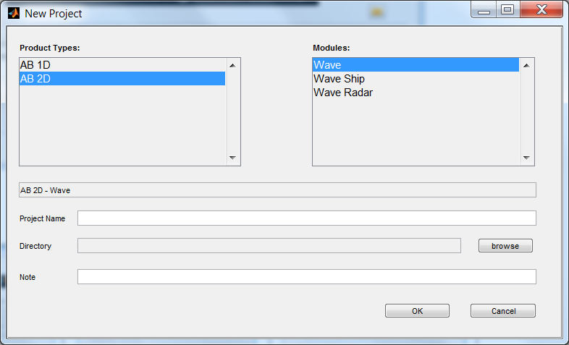

## Main GUI

Choosing the wave model characteristics, wave parameters, the domain, input signal and initial profile are all managed in the Main GUI. An overview of the GUI with its main functionalities and input requirements is shown in the Figure below; some of the ingredients are described thereafter.

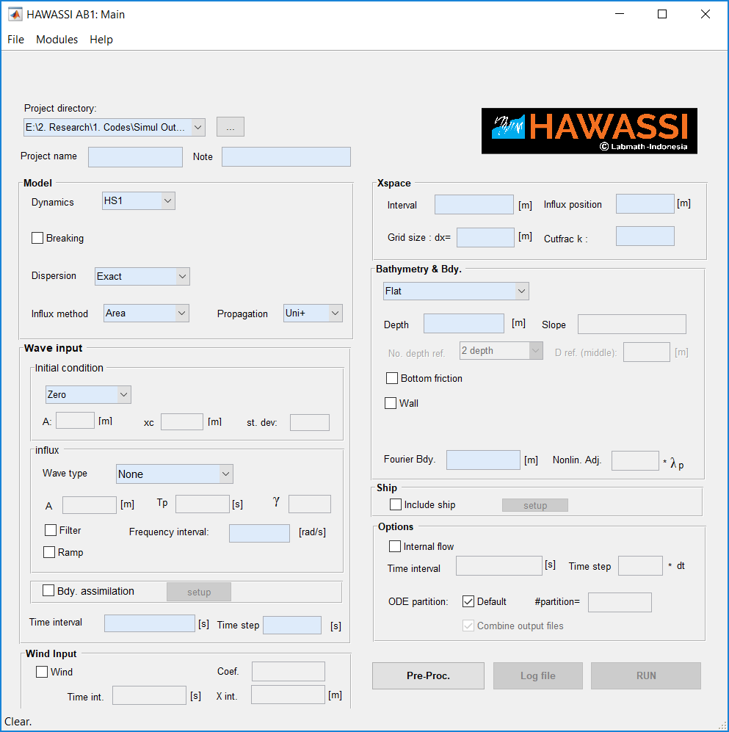

Opening ***File*** will show

* ***New Project***: to go to the start page GUI to choose ‘project’ that has been created before (including the provided test cases) from which data can be loaded to be inserted in the GUI or to create a new project.
* ***Save Project***: Saves all data entered in the GUI (after pre-processing this info will be stored)
* ***Clear***: clears the GUI from inserted input
* Quit HAWASSI

Opening ***Modules*** will give possibility to activate the ***Post-Processing GUI***, the ***Internal Flow GUI*** and the ***Wave Calculator***.

Help contains info about the loaded version in ***About***, this manual in ***Documentation***, and ***Activation*** is used for loading the licence (first use) or renewing the licence.

The ***Working Directory*** can be chosen and specified; the software will create a new folder named ‘Output’ if the working directory does not contain this folder yet; if the folder already exists, it will keep and use it.

By specifying a ‘***Project Name***’, the software will create a subfolder with that name under ‘Output’.   
*ALL* output of a simulation will be stored in this subfolder, together with selected output of post-processing.

A *User* ***Note*** gives the possibility to provide details or a short description of the specific simulation; this text will be copied to the log-file.

Input panels are separated to provide various details of the simulation to be executed:

* ***Model***
* ***Initial condition***
* ***Wave Input***
* ***Xspace***
* ***Bathymetry***
* ***Options***: there are two major options:
  + ***Internal Flow***: details can be given of the times at which in a *post*-processing step interior flow properties have to be calculated (see the Interior Flow GUI)
  + ***ODE partition***: to reduce hardware requirements, it is possible to split one simulation time interval in various consecutive time intervals; the data of each subinterval will be stored at the end of that time interval, so that memory requirements and size of data are restricted. The option to collect the data in one file after finishing the simulation can be checked.

Clicking the ***Pre-Proc*** (pre-processing) button will prepare the input before the actual evolution simulation starts. A ***pop-up figure*** will summarise graphically the input, including the geometric lay-out and the quality of dispersion used in the computation compared to exact dispersion. Warnings /suggestions may be given to optimise the results of the simulation; the input can be changed, after which a new Pre-Proc step is required.

The ***log-file*** is available after Pre-Proc, and contains info about the waves to be simulated; note that calculated data may slightly differ from input values because of the statics used to calculate wave length, period etc. The log-file will be updated after finishing the calculation with info about the computation time. Successive simulations under the same ‘Project Name’ will be added successively in the log-file, but files of computations will be overwritten (as warned on the GUI).

***At the bottom of the screen*** there will be ***warnings/suggestions*** when specifying input.

After ‘***RUN***’, during the simulation a time-indicator estimates the remaining time.

## Post-Processing GUI

After a simulation is finished the Post-Processing (PP) GUI will automatically pop-up loaded with the simulation data. The GUI can also be called directly from the Main GUI, and selected data can be loaded.

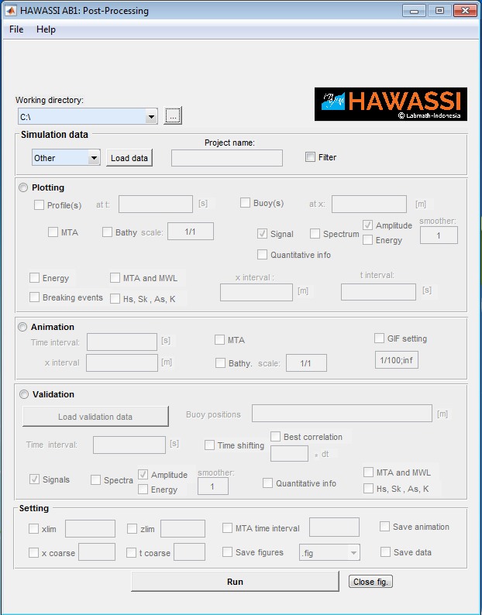

The working directory will be as selected in Main-GUI after automatic pop-up when a simulation is finished. Else the directory can be selected.

There are several panels in the PP-GUI:

* ***Simulation data*** is automatically loaded with results after finishing a simulation case; data of previous projects (including Test Cases) can be selected to be loaded using ‘Other’ .
* ***Plotting*** *Profile and Buoy* to plot (multiple) wave profile(s)/time-signal(s) at specified time(s)/ position(s), with various options to include spectra, bottom, MTA (maximal temporal crests and troughs), and ***quantitative information*** (see below)
* ***Animation***, with options to make a gif-movie, on specified *x*- and *t*- interval
* ***Validation***, to compare simulation results with experimental data or other simulations   
  For comparing at a certain position a time signal as simulated with a signal from a measurement or a previous simulation, there is the option ***Time shifting*** to shift the simulated signal: automatically optimized for best correlation or with a user-specified number of time steps. Quantitative information is provided also (see below)
* ***Setting***, options for any of the above graphical/animation output methods. (Be aware that coarsening may change the quality, such as time traces or profiles, spectra, etc, and will influence the validation results.)

***Quantitative information***

To analyse properties of simulated results, and/or to compare simulation results with experimental data or other simulations, two formats are available:

* **Graphical output**: for time signals at specified positions calculated (amplitude or energy) spectra, spatial values of the ***Energy***, of ***MTA*** and ***MWL*** (height of Mean Water Level), ***Hs***, ***Skewness***, ***Asymmetry*** and ***Kurtosis*** and a position vs. time plot of ***breaking events***.
* **Quantitative information** for time signals at a specified position:
  + the ***correlation*** of the signals (for validation)
  + the value (or quotient) of the ***Variance, Skewness, Asymmetry*** and ***Kurtosis*** of simulated and measured signal

The definitions of these quantities is as follows, for signals with zero-mean and with < > denoting time averaging.

The ***correlation*** of the simulated signal *s(t)* and the measured signal *m(t)* is



and for a signal *s* (with *H* the Hilbert transform)



## Internal Flow GUI

In order to calculate (a posteriori) internal flow properties, it is needed that *before the simulation is started* this has been indicated in the Main-GUI, since some data during the calculation will be stored to be used for the interior flow calculations. This storage will slow down the simulation, and therefore the times of interest can be indicated. Quantities that can be computed are

* the ***horizontal and vertical velocities and accelerations*** of the interior fluid motion,
* each of the components of the total ***pressure***.

Be aware that the amount of data can become very large, depending on the chosen discretization settings.

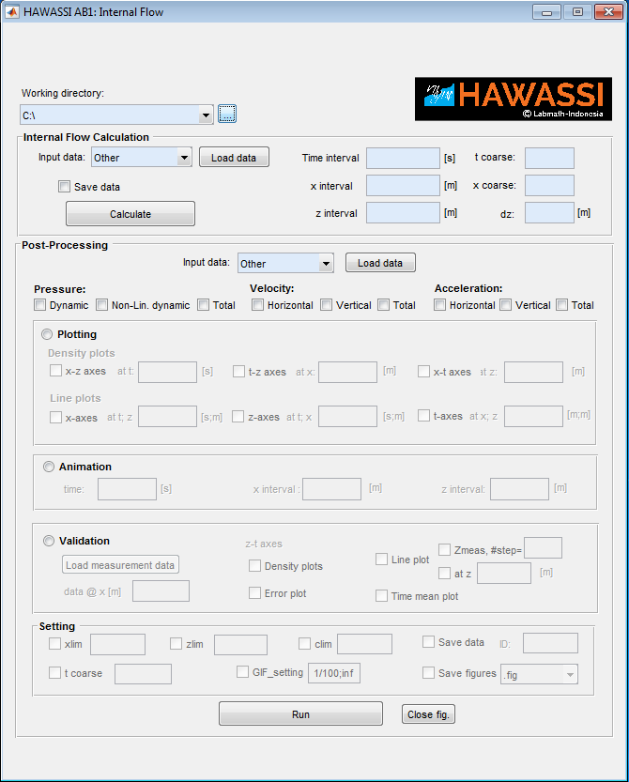

## Required lay-out of user defined input files

User input of data-files for various purposes need to be prepared with an extension (.mat, .dat, .txt,  etc) with a specified format as described below.

### Influx time signal

A 2-column matrix (*time, elevation*)

first column the (equidistant) time ([s]),

second column the corresponding elevation ([m]).

### Initial wave profile

A 3-column matrix (*space point x, elevation*)

first column the (equidistant) x-value ([m]) (covering the whole interval; if only partially, the data will be taken to have value 0),

second column the prescribed elevation ([m]),

third column the prescribed tangential velocity (space derivative of the potential, [m/s])

### Bathymetry

A 2-column matrix (*space point x, bathymetry*)

first column the (equidistant) *x*-value ([m]) (covering the whole interval),

second column the corresponding bathymetry ([m]).

### External measurement data

***Time signals*** at *m* measurement positions. Matrix with (*m+1*) columns:

First row, columns 2 to *m*+1: specify measurement position (*0, position x_1, …, position x_m*)

Next rows: time and elevation at the measurement positions (*time, elevation_1, …, elevation_m*)

### Interior flow External measurement data

Make a separate file for each horizontal measurement point with a name depending on the quantity that has been measured, for instance ***data_U_X1.mat*** , for a measurement of horizontal (U) or vertical (V) velocity at position ***X1***. Each data file has the following format.

***Time signals*** at *m* measurement positions in the vertical direction: matrix (*2+T_length, (m+1)*)

(*1, 1*) = [horizontal position *x*], (*1, 2*) = [water depth at position *x*];

(*2, 2: m+1*) = [vertical positions of measurement];

(*3: T(end),1:m+1*) = [*time, u_1: u_m*]

### Dispersion relation

The software can handle different dispersion relations. Default is the exact dispersion, but other dispersion relations for Shallow Water, KdV and BBM dispersion are predefined and can be dealt with for simulations of nonlinear waves over bathymetry.

A user defined dispersion relation can be given through input-panels in matlab-formula style. Needed are the

* ***dispersion relation***  (which should be defined as an odd function) and
* the corresponding ***group velocity***.

# Test cases

HAWASSI-AB provides 18 Test-cases which are identified with a code of which the first letter has the following meaning:

F: for various cases of non-breaking waves above Flat bottom

B: for various cases of non-breaking waves above non-flat bathymetry

Br: for various cases of breaking waves above flat or varying bottom

R: for run-up on a coast

The basic properties of the test cases are listed with references to relevant publications in the next sections.

**Acknowledgements:**

We are very grateful to be allowed to use measurement data of

* MARIN (Maritime Research Institute Netherlands), Dr. T. Bunnik
* TUD (Technical University of Delft), Prof.dr. R.H.M. Huijsmans
* Authors of publications:
  + Beji & Battjes
    - S. Beji, J. Battjes, Numerical simulation of nonlinear wave propagation over a bar, *Coastal Engineering* 23 (1994) 1 – 16.
    - S. Beji, J. Battjes, Experimental investigation of wave propagation over a bar, *Coastal Engineering* 19 (1993) 151 – 162.
  + Ting& Kirby
    - F. C. Ting, J. T. Kirby, Observation of undertow and turbulence in a laboratory surf zone, Coastal Engineering 24 (1994) 51 – 80.
  + Wei e.a.
    - G. Wei, J. T. Kirby, S. T. Grilli, R. Subramanya, A fully nonlinear Boussinesq model for surface waves. Part 1. Highly nonlinear unsteady waves, *Journal of Fluid Mechanics* 294 (1995) 71–92.

Only by testing with realistic data the software can be validated and improved.

## Non-breaking waves above flat bottom

### 1F001Foc: MARIN_202002, Strong focussing wave

Dynamic Model : HS2F

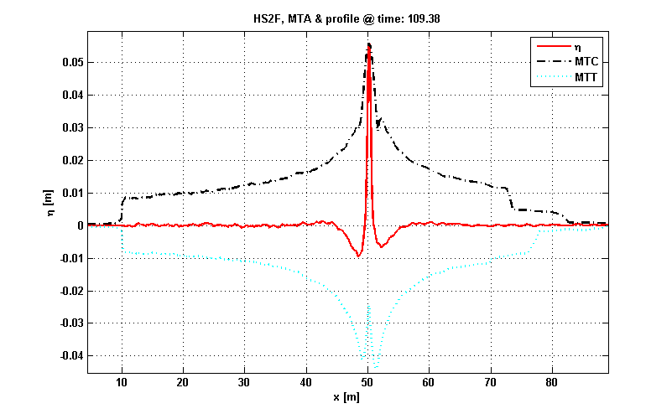

Focussing wave: using dispersion to generate high waves in wave tanks.

*Simulation of MARIN – measurement.*

Dispersion Model : OmExact

Bathymetry : Flat; Depth: 1[m]

Significant wave Height (Hs) : 0.013[m]

Peak period (Tp) : 1.304[s]

Peak frequency (nu) : 4.817[rad/s]

Peak wave-number (kp) : 2.404

Peak wave-length : 2.613[m]

Peak phase speed : 2.003[m/s]

Steepness (kp*(Hs./2)) : 0.015

Relative wave-length(lambda/h): 2.6133

(kp*h) : 2.404

Category : Intermediate depth

### IF002Draup: MARIN204001, Draupner Wave

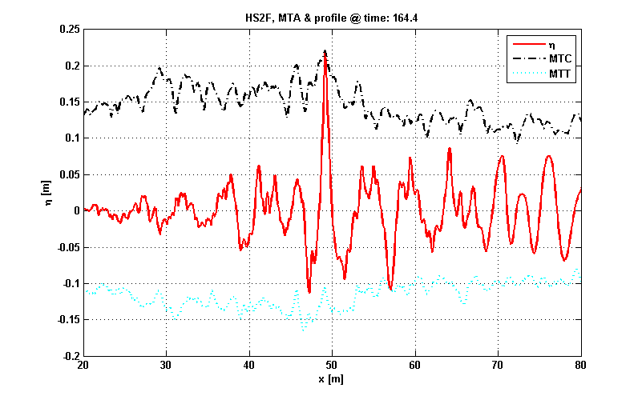

Environmental *Freak Wave*, measured at the Draupner platform in the NorthSea 1995 (18.5 crest height on 75m depth); here for simulation in MARIN wave tank. *Simulation of MARIN – measurement*

Dynamic Model : HS2F

Dispersion Model : OmExact

Bathymetry : Flat; Depth: 1[m]

Significant wave Height (Hs) : 0.076[m]

Peak period (Tp) : 2.061[s]

Peak frequency (nu) : 3.048[rad/s]

Peak wave-number (kp) : 1.156

Peak wave-length : 5.437[m]

Peak phase speed : 2.638[m/s]

Steepnest (kp*(Hs./2)) : 0.044

Relative wave-length(lambda/h): 5.437

(kp*h) : 1.156

Category : Intermediate depth

### IF003Irreg MARIN_224002F, Irregular wave in deep water

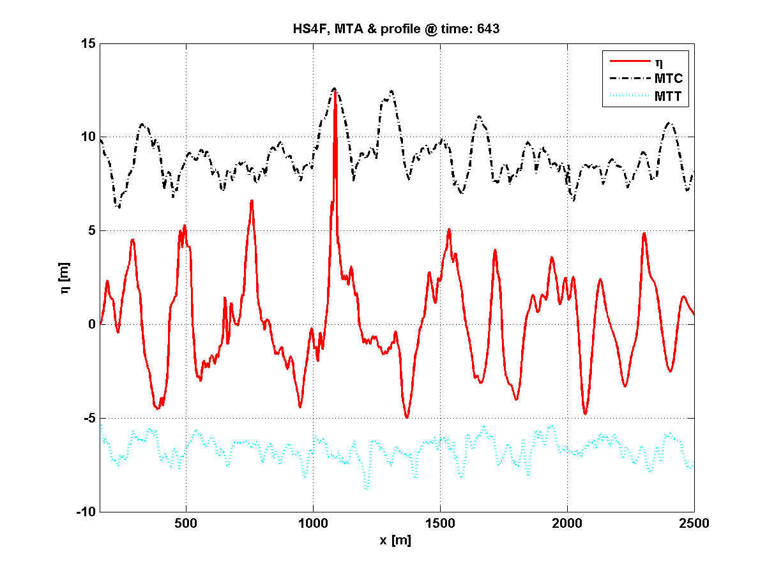

Observe nonbreaking freak wave on deep water

*Simulation of MARIN – measurement*

Dynamic Model : HS4F

Dispersion Model : OmExact

Bathymetry : Flat; Depth: 510[m]

Significant wave Height (Hs) : 9.829[m]

Peak period (Tp) : 13.887[s]

Peak frequency (nu) : 0.452[rad/s]

Peak wave-number (kp) : 0.021

Peak wave-length : 301.056[m]

Peak phase speed : 21.679[m/s]

Steepness (kp*(Hs./2)) : 0.103

Relative wave-length(lambda/h): 0.59031

(kp*h) : 10.644

Category : Deep water

### IF004Wall AB1_Wall, Full wave reflection from wall [5]

Dynamic Model : HS1FWall

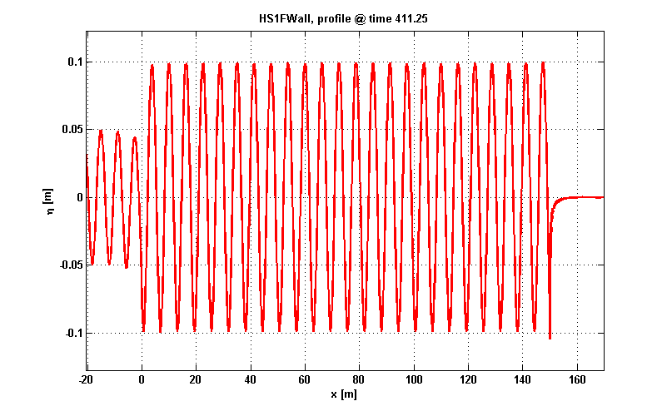

Full wave reflection of a linear harmonic wave from a wall

Dispersion Model : OmExact

Bathymetry : Flat; Depth: 5[m]

Signal type : Harmonic

Significant wave Height (Hs) : 0.1[m]

Peak period (Tp) : 2[s]

Peak frequency (nu) : 3.141[rad/s]

Peak wave-number (kp) : 1.006

Peak wave-length : 6.247[m]

Peak phase speed : 3.123[m/s]

Steepness (kp*(Hs./2)) : 0.05

Relative wave-length(lambda/h): 1.2494

(kp*h) : 5.029

Category : Deep water

### 1F005WallFreq, Frequency dependent wall reflection [5]

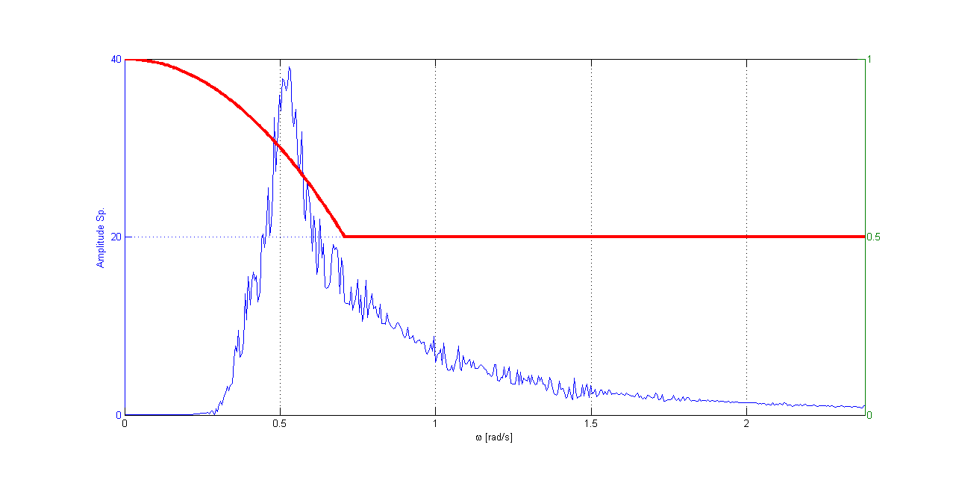

Reflection of an irregular wave with ***frequency dependent reflection*** at a wall: from full reflection of long waves to half for short waves, shown in the spectrum plot (red line)

Dynamic Model : HS2FWall

Dispersion Model : OmExact

Bathymetry : Flat; Depth: 25[m]

Signal type : User-defined

Significant wave Height (Hs) : 0.1[m]

Peak period (Tp) : 12.362[s]

Peak frequency (nu) : 0.508[rad/s]

Peak wave-number (kp) : 0.036

Peak wave-length : 172.264[m]

Peak phase speed : 13.935[m/s]

Steepness (kp*(Hs./2)) : 0.002

Relative wave-length(lambda/h): 6.8906

(kp*h) : 0.912

Category : Intermediate depth

### 1F006Bor, Undular bore

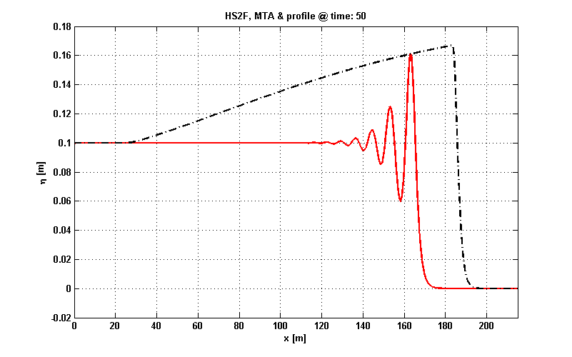

Undular bore, non-breaking. Settings and results as in *Wei e.a.*

See also Testcase 1FBr005Bor (section 5.2.5) for the breaking bore

*.*

Dynamic Model : HS2F

Dispersion Model : OmExact

Bathymetry : Flat; Depth: 1[m]

INITIAL VALUE PROBLEM

## Breaking waves above flat bottom

### 1FBr001Foc MARIN203001, Strong focussing wave

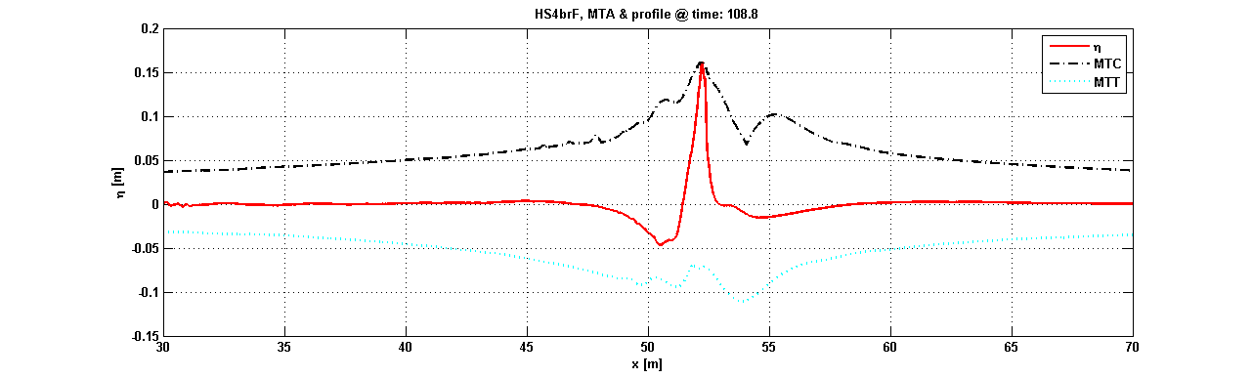

Strong focussing, breaking wave

*Simulation of MARIN – measurement.*

Dynamic Model : HS4brF

Dispersion Model : OmExact

Bathymetry : Flat; Depth: 1[m]

Signal type : User-defined

Significant wave Height (Hs) : 0.038[m]

Peak period (Tp) : 1.446[s]

Peak frequency (nu) : 4.346[rad/s]

Peak wave-number (kp) : 1.998

Peak wave-length : 3.145[m]

Peak phase speed : 2.176[m/s]

Steepnest (kp*(Hs./2)) : 0.038

Relative wave-length(lambda/h): 3.1454

(kp*h) : 1.998

Category : Intermediate depth

### 1FBr002Foc TUD1403Foc7, Focussing Breaking Wave [3]

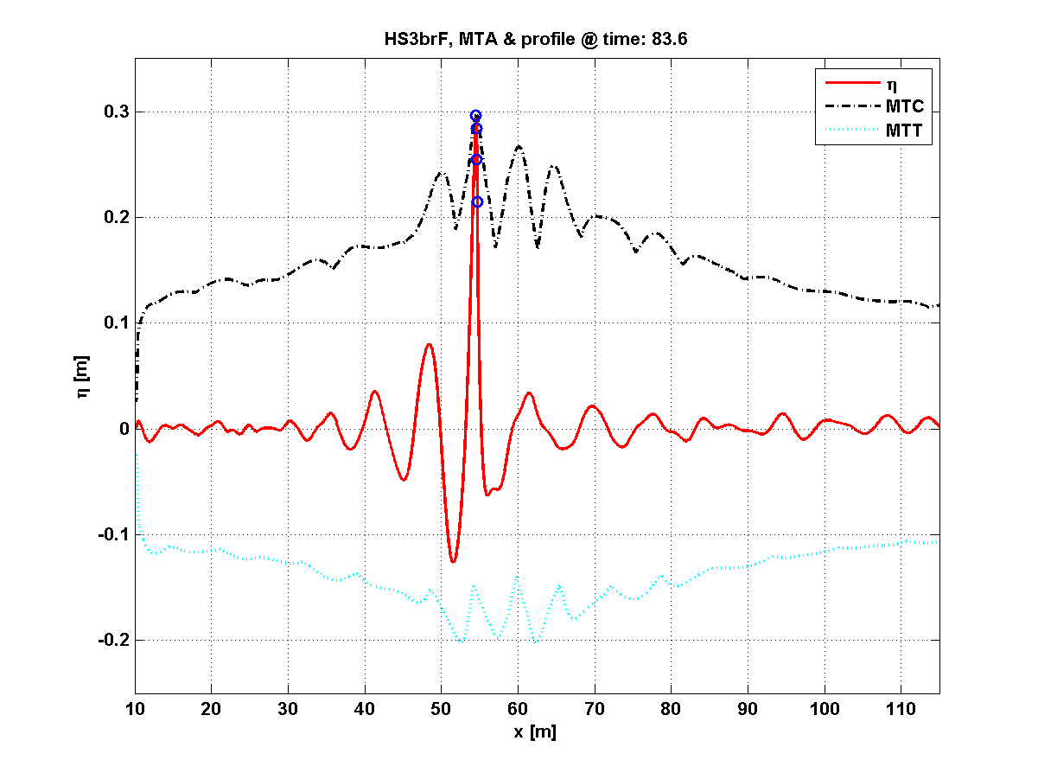

Strong focussing breaking wave

*Simulation of TUD – measurement.*

Dynamic Model : HS3brF

Dispersion Model : OmExact

Bathymetry : Flat; Depth: 2.132[m]

Significant wave Height (Hs) : 0.078[m]

Peak period (Tp) : 1.99[s]

Peak frequency (nu) : 3.157[rad/s]

Peak wave-number (kp) : 1.041

Peak wave-length : 6.038[m]

Peak phase speed : 3.034[m/s]

Steepness (kp*(Hs./2)) : 0.04

Relative wave-length(lambda/h): 2.832

(kp*h) : 2.219

Category : Intermediate depth

### 1FBr003BiB TUD1403Bi8, Bichromatic wave breaking

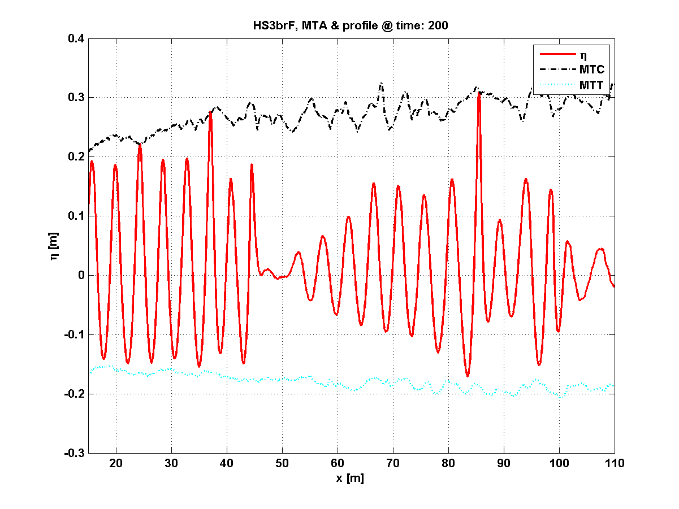

Bichromatic breaking wave

*Simulation of TUD – measurement*

Dynamic Model : HS3brF

Dispersion Model : OmExact

Bathymetry : Flat; Depth: 2.132[m]

Significant wave Height (Hs) : 0.356[m]

Peak period (Tp) : 1.634[s]

Peak frequency (nu) : 3.845[rad/s]

Peak wave-number (kp) : 1.511

Peak wave-length : 4.157[m]

Peak phase speed : 2.544[m/s]

Steepness (kp*(Hs./2)) : 0.269

Relative wave-length(lambda/h): 1.9498

(kp*h) : 3.222

Category : Deep water

### 1FBr004Ir MARIN_223002F, Irregular wave breaking [10]

Dynamic Model : HS4brF

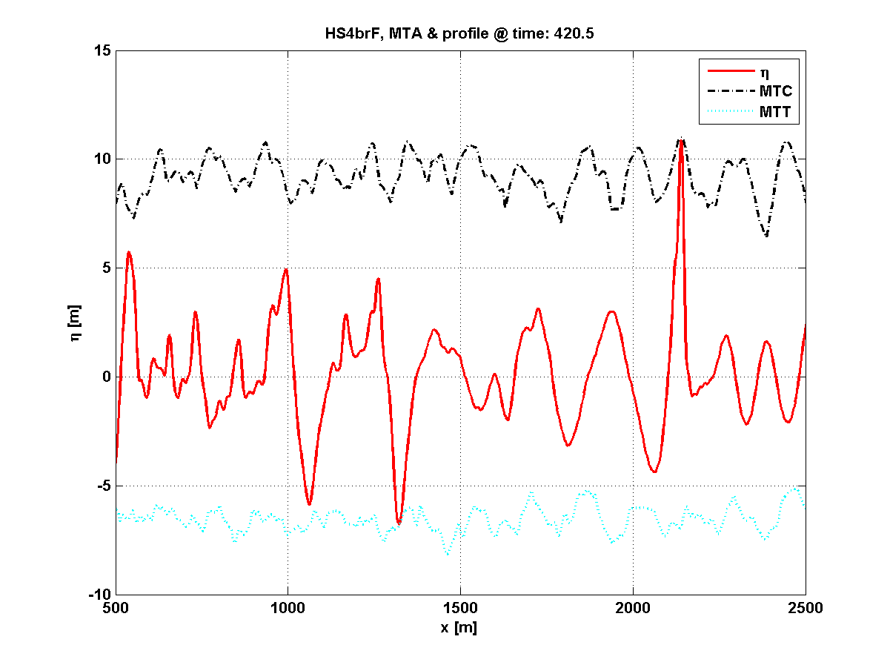

Irregular wave breaking

*Simulation of MARIN – measurement.*

Dispersion Model : OmExact

Bathymetry : Flat; Depth: 510[m]

Significant wave Height (Hs) : 10.23[m]

Peak period (Tp) : 12.656[s]

Peak frequency (nu) : 0.496[rad/s]

Peak wave-number (kp) : 0.025

Peak wave-length : 250.057[m]

Peak phase speed : 19.758[m/s]

Steepness (kp*(Hs./2)) : 0.129

Relative wave-length(lambda/h): 0.49031

(kp*h) : 12.815

Category : Deep water

### 1FBr005Bor Undular_breaking bore [5]

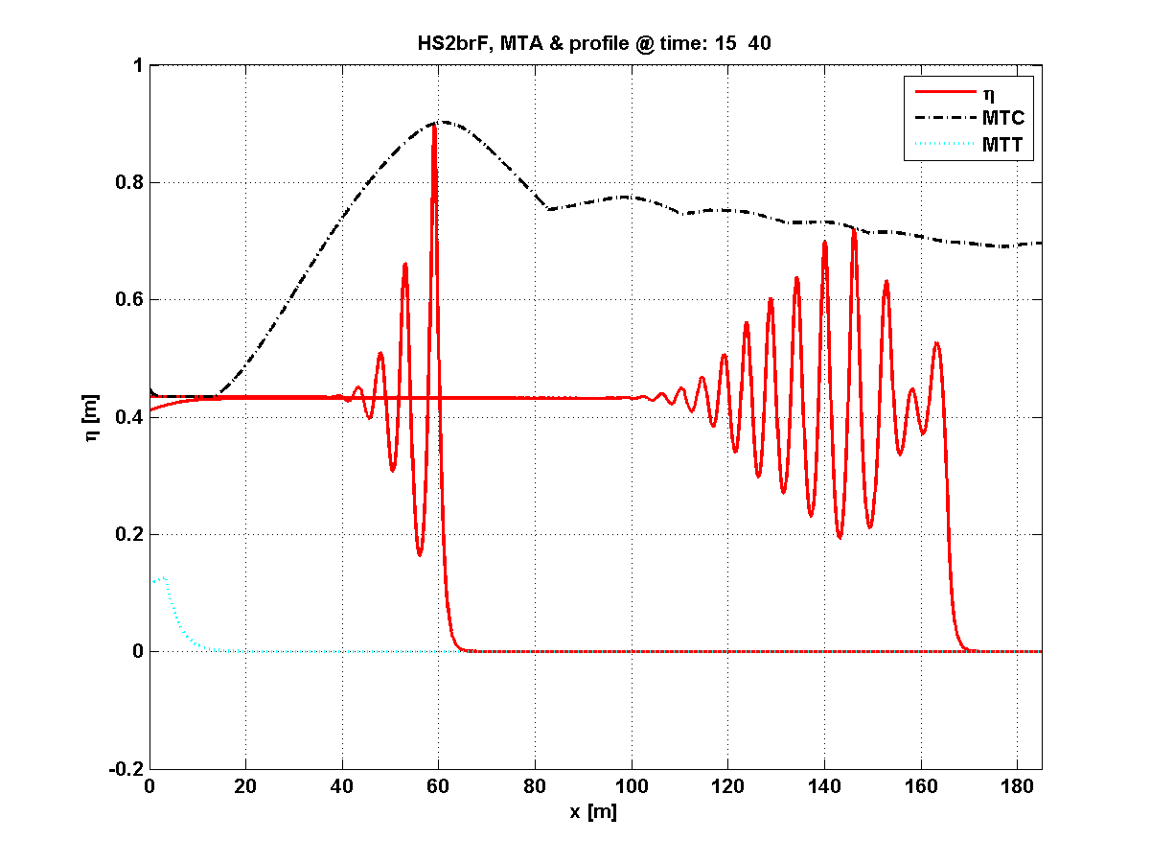

Breaking undular bore, at two different times. Settings and results as *Wei e.a.*, for higher amplitudes for which no validation data are available.

See also Testcase 1F006Bor (section 5.1.6) for the non-breaking bore

*.*

Dynamic Model : HS2brF

Dispersion Model : OmExact

Bathymetry : Flat; Depth: 1[m]

INITIAL VALUE PROBLEM

## Non-breaking waves above non-flat bathymetry

### 2B001IrSlope MARIN_103001, Irregular wave above a slope [5, 13]

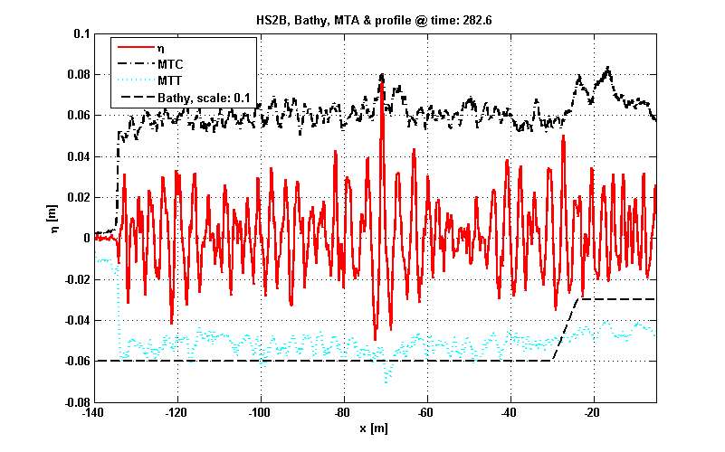

Non-breaking irregular wave over slope. Observe Freak Wave above deep part at *x=-71, t=282.8*

*Simulation of MARIN – measurement.*

Dynamic Model : HS2B

Dispersion Model : OmExact

Bathymetry : Slope;

Max Depth: 0.6[m] Min Depth : 0.3[m]

Slope: 0.05[m] Foot slope position: -30[m]

Significant wave Height (Hs) : 0.062[m]

Peak period (Tp) : 1.701[s]

Peak frequency (nu) : 3.694[rad/s]

Peak wave-number (kp) : 1.769

Peak wave-length : 3.551[m]

Peak phase speed : 2.088[m/s]

Steepness (kp*(Hs./2)) : 0.055

Relative wave-length(lambda/h): 5.9186

(kp*h) : 1.062

Category : Intermediate depth

### 2B002HarmBar, Harmonic over bar

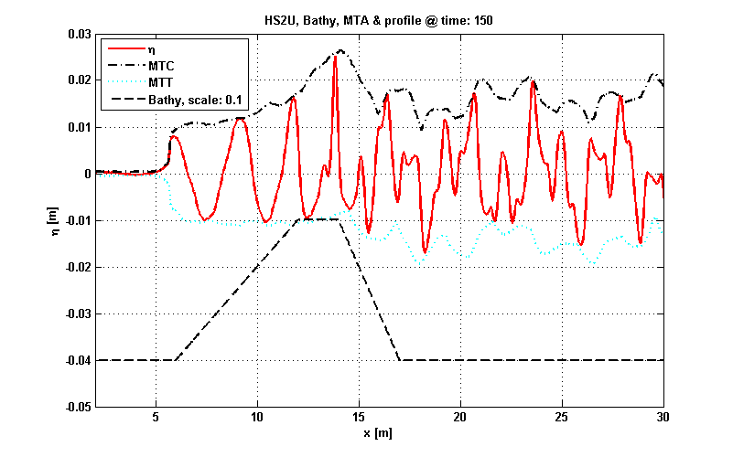

Harmonic waves over under water bar. Strong mode generation: compare spectra at *x=8* (red) and *x=16* (black) below

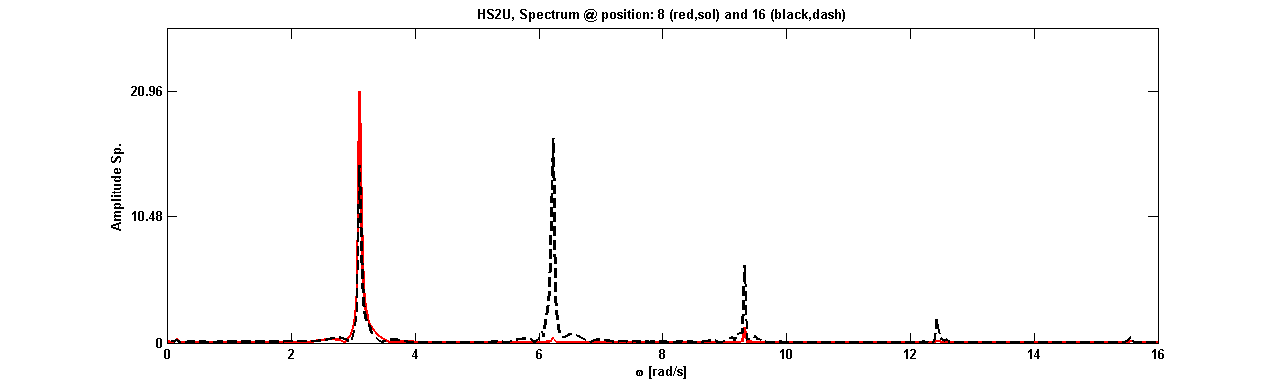

*Simulation of Beji & Battjes Experiment*

Dynamic Model : HS2U

Dispersion Model : OmExact

Bathymetry : Under-water bar;

Significant wave Height (Hs) : 0.027[m]

Peak period (Tp) : 2.026[s]

Peak frequency (nu) : 3.101[rad/s]

Peak wave-number (kp) : 1.675

Peak wave-length : 3.75[m]

Peak phase speed : 1.851[m/s]

Steepness (kp*(Hs./2)) : 0.023

Relative wave-length(lambda/h): 9.3752

(kp*h) : 0.67

Category : Intermediate depth

### 2B003IrBar, Irregular wave over bar

BB94SL:Jonswap;Low Freq: Non breaking

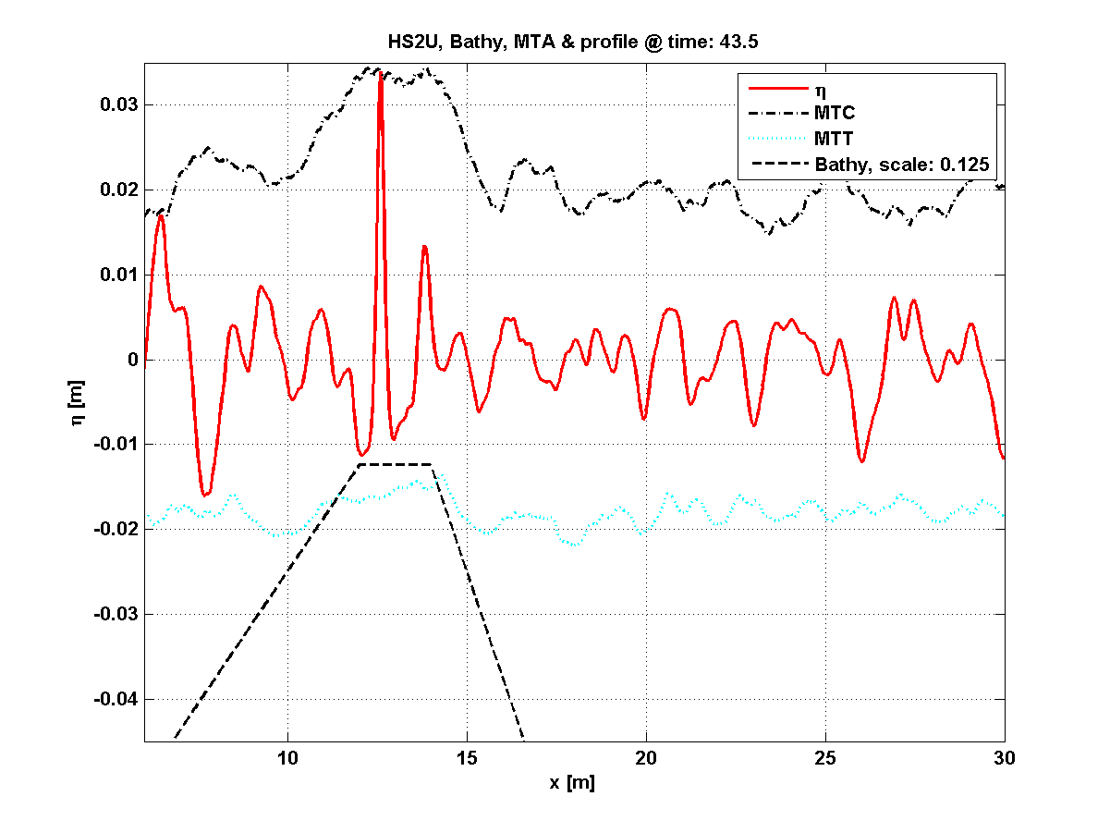

*Simulation of Beji & Battjes Experiment*

Dynamic Model : HS2U

Dispersion Model : OmExact

Significant wave Height (Hs) : 0.021[m]

Peak period (Tp) : 1.666[s]

Peak frequency (nu) : 3.772[rad/s]

Peak wave-number (kp) : 2.109

Peak wave-length : 2.979[m]

Peak phase speed : 1.788[m/s]

Steepness (kp*(Hs./2)) : 0.022

Influx position : 5.7157[m]; Relative wave-length(lambda/h): 7.447

(kp*h) : 0.844

Category : Intermediate depth

## Breaking waves above bathymetry

### 2BBr001HarmBar [10]

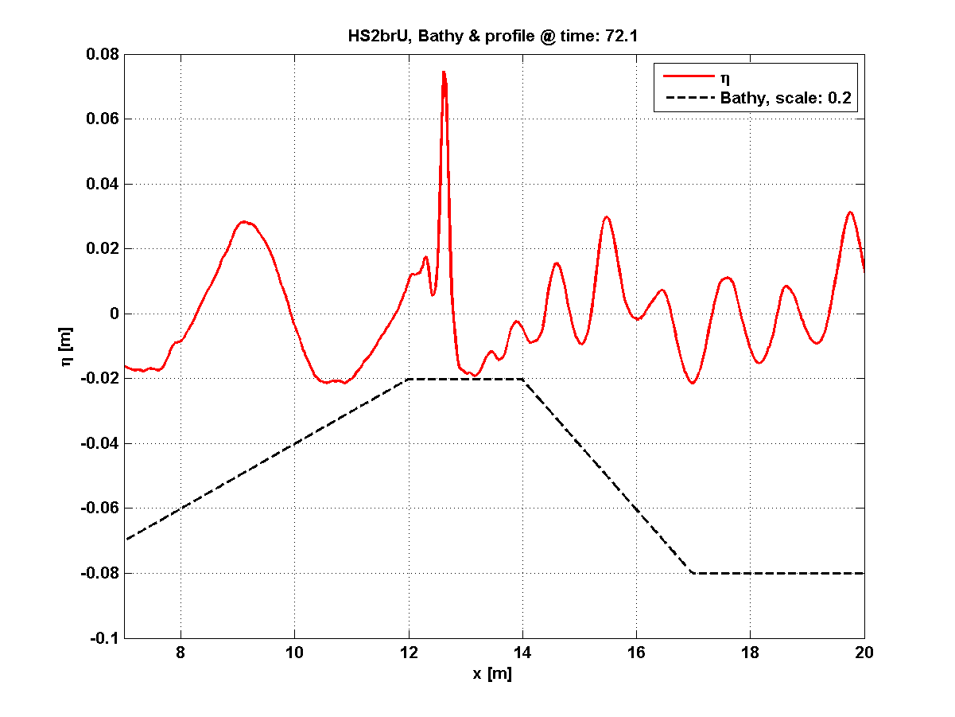

Breaking harmonic waves over bar

*Simulation of Beji & Battjes experiment*

Dynamic Model : HS2brU

Dispersion Model : OmExact

Bathymetry : Under-water bar

Significant wave Height (Hs) : 0.058[m]

Peak period (Tp) : 2.537[s]

Peak frequency (nu) : 2.476[rad/s]

Peak wave-number (kp) : 1.305

Peak wave-length : 4.816[m]

Peak phase speed : 1.898[m/s]

Steepnest (kp*(Hs./2)) : 0.038

Relative wave-length(lambda/h): 12.0391

(kp*h) : 0.522

Category : Intermediate depth

### 2BBr002IrBar Irregular wave, Spilling breaker [5]

Dynamic Model : HS2brU

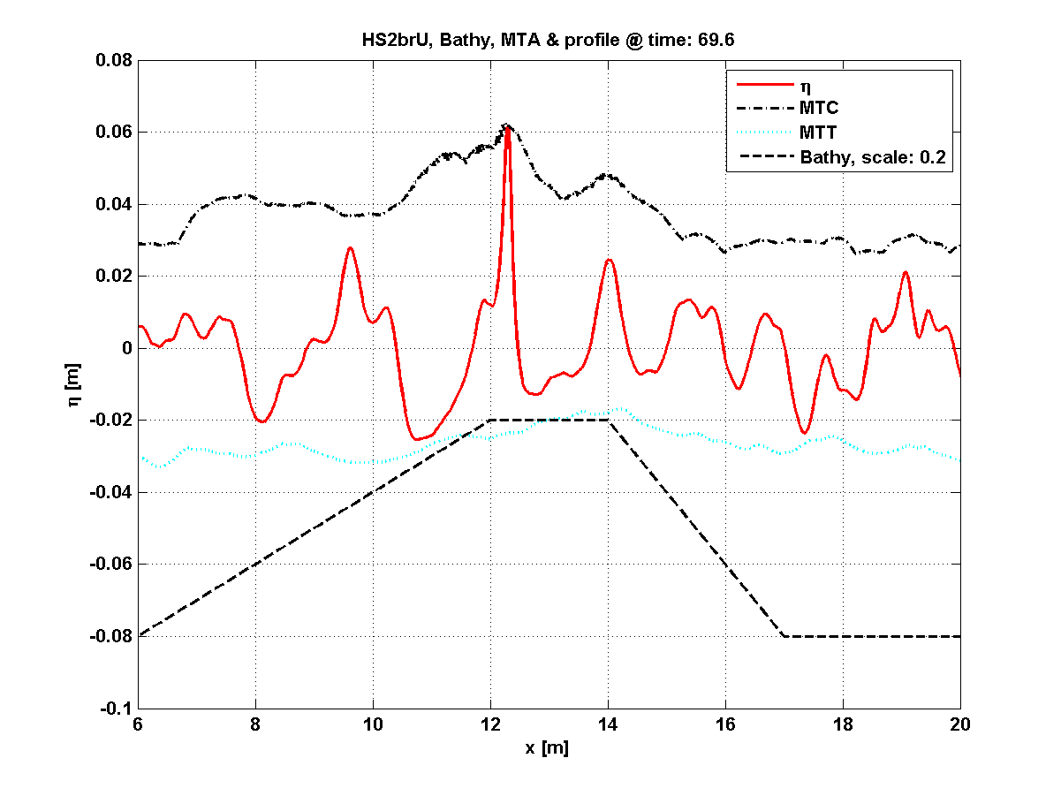

Spilling breaker over bar

*Simulation of Beji & Battjes experiment*

Dispersion Model : OmExact

Bathymetry : Under-water bar

Significant wave Height (Hs) : 0.035[m]

Peak period (Tp) : 1.898[s]

Peak frequency (nu) : 3.31[rad/s]

Peak wave-number (kp) : 1.806

Peak wave-length : 3.479[m]

Peak phase speed : 1.832[m/s]

Steepness (kp*(Hs./2)) : 0.032

Relative wave-length(lambda/h): 8.6966

(kp*h) : 0.722

Category : Intermediate depth

## Run-up of waves (breaking and non-breaking)

### 3R001Harm: Harmonic Run-up (non-breaking)

Dynamic Model : HS2BR

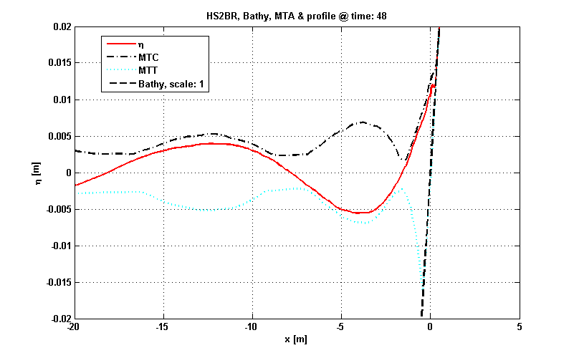

Harmonic nonbreaking wave run-up on 1:25 coast

Dispersion Model : OmExact

Bathymetry : Slope (Shore);

Max Depth: 0.5[m]

Signal type : Harmonic

Significant wave Height (Hs) : 0.006[m]

Peak period (Tp) : 10[s]

Peak frequency (nu) : 0.62[rad/s]

Peak wave-number (kp) : 0.281

Peak wave-length : 22.384[m]

Peak phase speed : 2.207[m/s]

Steepness (kp*(Hs./2)) : 0.001

Relative wave-length(lambda/h): 44.7688

(kp*h) : 0.14

Category : Shallow water

### 3RBr001Harm: Spilling Breaker Run-up (with interior flow) [5]

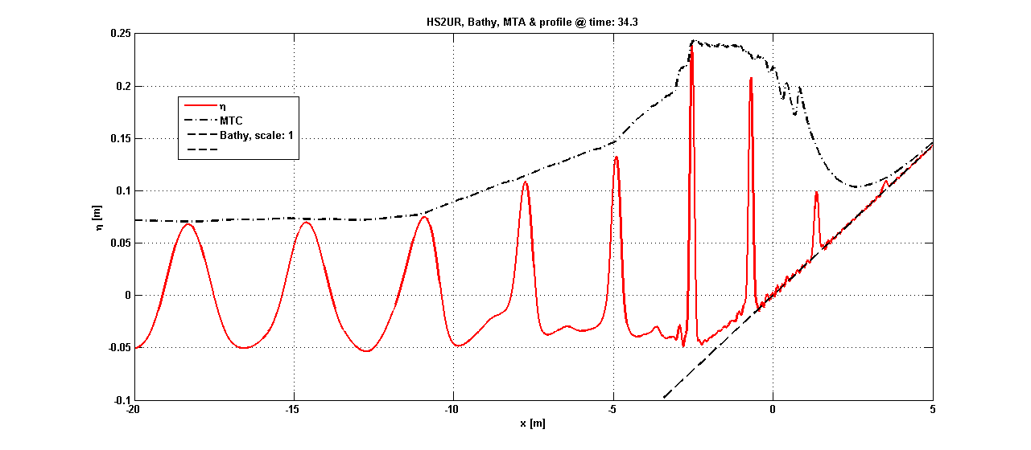

Harmonic wave run-up on 1:35 coast, spilling breaker

*Simulation, including interior flow properties, of Ting & Kirby experiment*

Dynamic Model : HS2brUR

Dispersion Model : OmExact

Bathymetry : Slope (Shore);

Max Depth: 0.4[m]

Signal type : Harmonic

Significant wave Height (Hs) : 0.125[m]

Peak period (Tp) : 2[s]

Peak frequency (nu) : 3.141[rad/s]

Peak wave-number (kp) : 1.7

Peak wave-length : 3.695[m]

Peak phase speed : 1.847[m/s]

Steepness (kp*(Hs./2)) : 0.106

Relative wave-length(lambda/h): 9.2387

(kp*h) : 0.68

Category : Intermediate depth

# References

**Publication or report using HAWASSI should refer to:**

* R. Kurnia & E. van Groesen, High Order Hamiltonian Water Wave Models with Wave-Breaking Mechanism, *Coastal Engineering* **93** (2014) 55–70
* R. Kurnia & E. van Groesen, Localization for spatial-spectral implementations of 1D Analytic Boussinesq equations, *Wave Motion,* **72** (2017) 113-132
* E. van Groesen & Andonowati, Hamiltonian Boussinesq formulation of Wave-Ship interactions, Part 1: Evolution equations, *Applied Mathematical Modelling.* **42** (2017) 133-144

## References to basic papers and applications

1. R. Kurnia, E.van Groesen, Hamiltonian Boussinesq Simulation of Wave-Body Interaction Above Sloping Bottom, *IJOPE,* ***32*** *(2022) 244-252*
2. R. Kurnia, P. Turnip, and E. van Groesen.Spectral AB Simulations for Coastal and Ocean Engineering Applications. In *Murali K., Sriram V., Samad A., Saha N. (eds) Proceedings of the Fourth International Conference in Ocean Engineering (ICOE2018). Lecture Notes in Civil Engineering, vol 23*. Springer, Singapore 2019.
3. R. Kurnia, M.R. Badriana & E. van Groesen, Hamiltonian Boussinesq simulation for waves entering a harbour with access channel, *J. Waterway, Port, Coastal, Ocean Eng.* (2018) **144(2)**:04017047 1-14
4. E. van Groesen, P. Turnip & R. Kurnia, High waves in Draupner seas, Part 1: Numerical simulations and characterization of the seas, *J. Ocean Engineering and Marine Energy,* **3** (2017) 233-245
5. Kurnia & E. van Groesen, Localization for spatial-spectral implementations of 1D Analytic Boussinesq equations, *Wave Motion*, **72** (2017) 113-132
6. E. van Groesen & Andonowati, Hamiltonian Boussinesq formulation of Wave-Ship interactions, *Applied Mathematical Modelling,* ***42*** *(2017) 134-144*
7. R. Kurnia, Simulations of extreme wave runup on a vertical wall, *OMAE 2016-54365,* 8 pages
8. R. Kurnia, T. van den Munckhof, C.P. Poot, P. Naaijen, R.H.M. Huijsmans & E. van Groesen, Simulations for design and reconstruction of breaking waves in a wavetank, *OMAE 2015* Vol2,41633, 7 pages
9. R. Kurnia & E. van Groesen, Spatial-spectral Hamiltonian Boussinesq wave simulations, Advances in Computational and Experimental Marine Hydrodynamics, VOL. 2 Conference Proceedings, 2015, pp. 19-24,*ISBN: 978-93-80689-22-7*R.
10. R. Kurnia & E. van Groesen, Design of Wave Breaking Experiments and A-Posteriori Simulations, Memorandum 2042, (January 2015), <http://www.math.utwente.nl/publications> ISSN 1874−4850
11. R. Kurnia & E. van Groesen, Localization in Spatial-Spectral Methods for Water Wave Applications, *Proceedings ICOSAHOM* 2014
12. W. Kristina. O. Bokhove & E. van Groesen, Effective coastal boundary conditions for tsunami wave run-up over sloping bathymetry, *Nonlin.Processes GeoPhys*, **21**(2014) 987-1005
13. Lie S Liam, D. Adyia & E. van Groesen, Embedded wave generation for dispersive surface wave models, *Ocean Engineering* **80** (2014) 73-83
14. R. Kurnia & E. van Groesen, High Order Hamiltonian Water Wave Models with Wave-Breaking Mechanism, *Coastal Engineering* **93** (2014) 55–70
15. Lie She Liam, Mathematical modelling of generation and forward propagation of dispersive waves PhD-Thesis UTwente, 15 May 2013
16. A.L. Latifah & E. van Groesen, Coherence and Predictability of Extreme Events in Irregular Waves,*Nonlin. Processes Geophys*, **19** (2012)199-213
17. E. van Groesen *&* I. van der Kroon, Fully dispersive dynamic models for surface water waves above varying bottom, Part 2: Hybrid spatial-spectral implementations, *Wave Motion* **49**(2012) 198-211
18. E. van Groesen *&* Andonowati, Fully dispersive dynamic models for surface water waves above varying bottom, Part 1: Model equations, *Wave Motion* **48**(2011) 657-666
19. E. van Groesen *&* Andonowati, Time-accurate AB-simulations of irregular coastal waves above bathymetry, Proceedings of the *Sixth International Conference on Asian and Pacific Coasts* (APAC 2011) December 14 – 16, 2011, Hong Kong, China, World Scientific ISBN: 978-981-4366-47-2, pp.1854-1864
20. E. van Groesen, T. Bunnik *&* Andonowati, Surface wave modelling and simulation for wave tanks and coastal areas, *International Conference on Developments in Marine CFD, 18 - 19 November 2011, Chennai, India,* RINA, ISBN: 978-1-905040-92-6, p. 59-63
21. L. She Liam & E. van Groesen, Variational derivation of KP-type equations, *Physics Letters A*, **374**(2010) 411-415
22. E. van Groesen*,* Andonowati, L. She Liam & I. Lakhturov, Accurate modelling of uni-directional surface waves, *Journal of Computational and Applied Mathematics* 234 (2010) 1747-1756
23. E. van Groesen*,* L. She Liam, I. Lakhturov & Andonowati, Deep water Periodic waves as Hamiltonian Relative Equilibria, *Proceedings of Waves 2007*, N. Biggs e.a. (eds), Reading UK, 23-27 July 2007, pp. 482-484;
24. E. van Groesen & Andonowati, Variational derivation of KdV-type of models for surface water waves, *Physics Letters A* **366** (2007)195-201

## Other references

Beji & Battjes

* S. Beji &J. Battjes, Numerical simulation of nonlinear wave propagation over a bar, *Coastal Engineering* **23** (1994) 1 – 16.
* S. Beji & J. Battjes, Experimental investigation of wave propagation over a bar, *Coastal Engineering* **19** (1993) 151 – 162.

BBM

* T.B. Benjamin, J.L. Bona & J.J. Mahony, On model equations for long waves in nonlinear dispersive systems, *Phil. Trans. Roy. Soc. London* **A272** (1972)47

Broer

* L.J.F. Broer, Approximate equationsn for long water waves, *Appl. Sc. Res.*, **31**(1975)377-395

KdV

* D.J. Korteweg & G. de Vries, On the change of form of long waves advancing in a rectangular canal and anewtype of long stationary waves, *Phil. Mag.* **39**(1895)422

Ting& Kirby

* F. C. Ting & J. T. Kirby, Observation of undertow and turbulence in a laboratory surf zone, Coastal Engineering **24** (1994) 51 – 80.

Wei e.a.

* G. Wei, J. T. Kirby, S. T. Grilli & R. Subramanya, A fully nonlinear Boussinesq model for surface waves. Part 1. Highly nonlinear unsteady waves, *Journal of Fluid Mechanics* **294** (1995) 71–92.

YAB LabMath,

YAB LabMath , Water Wave Modelling & Simulation, with Introduction to HAWASSI-software

Zakharov

* V.E. Zakharov, Stability of periodic waves of finite amplitude on the surface of a deep fluid, *J. of Mechanics and Technical Physics* **2**(1968)190-194

1. Users with limited experience in mathematical-physical wave modelling may consult the service booklet [1]

   **Water Wave Modelling & Simulation, with Introduction to HAWASSI-software, YAB LabMath**