Deliverable 2

Garrett Hawes

11/13/2019

## Summary Statistics

Need to figure out a way to get this to look good on pdf

table_one <- tableby(point_cat ~ ., data = wine_data_clean %>% select(c("price", "points", "point_cat", "title_length", "taster_review_count", "taster_n_tweets", "country_lump")))  
#summary(table_one, title = "Wine Data by Country")

## Including Plots

You can also embed plots, for example:

## `stat_bin()` using `bins = 30`. Pick better value with `binwidth`.  
## `stat_bin()` using `bins = 30`. Pick better value with `binwidth`.  
## `stat_bin()` using `bins = 30`. Pick better value with `binwidth`.  
## `stat_bin()` using `bins = 30`. Pick better value with `binwidth`.

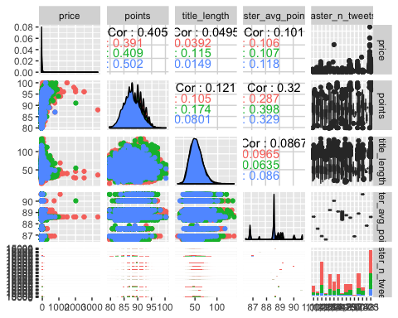

Note that the echo = FALSE parameter was added to the code chunk to prevent printing of the R code that generated the plot.