1. low fidelity

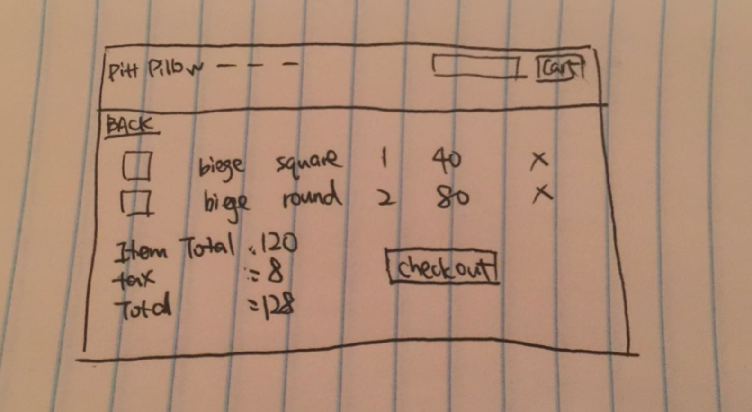

I simply build a new webpage that shows a list of added items.

1. high fidelity

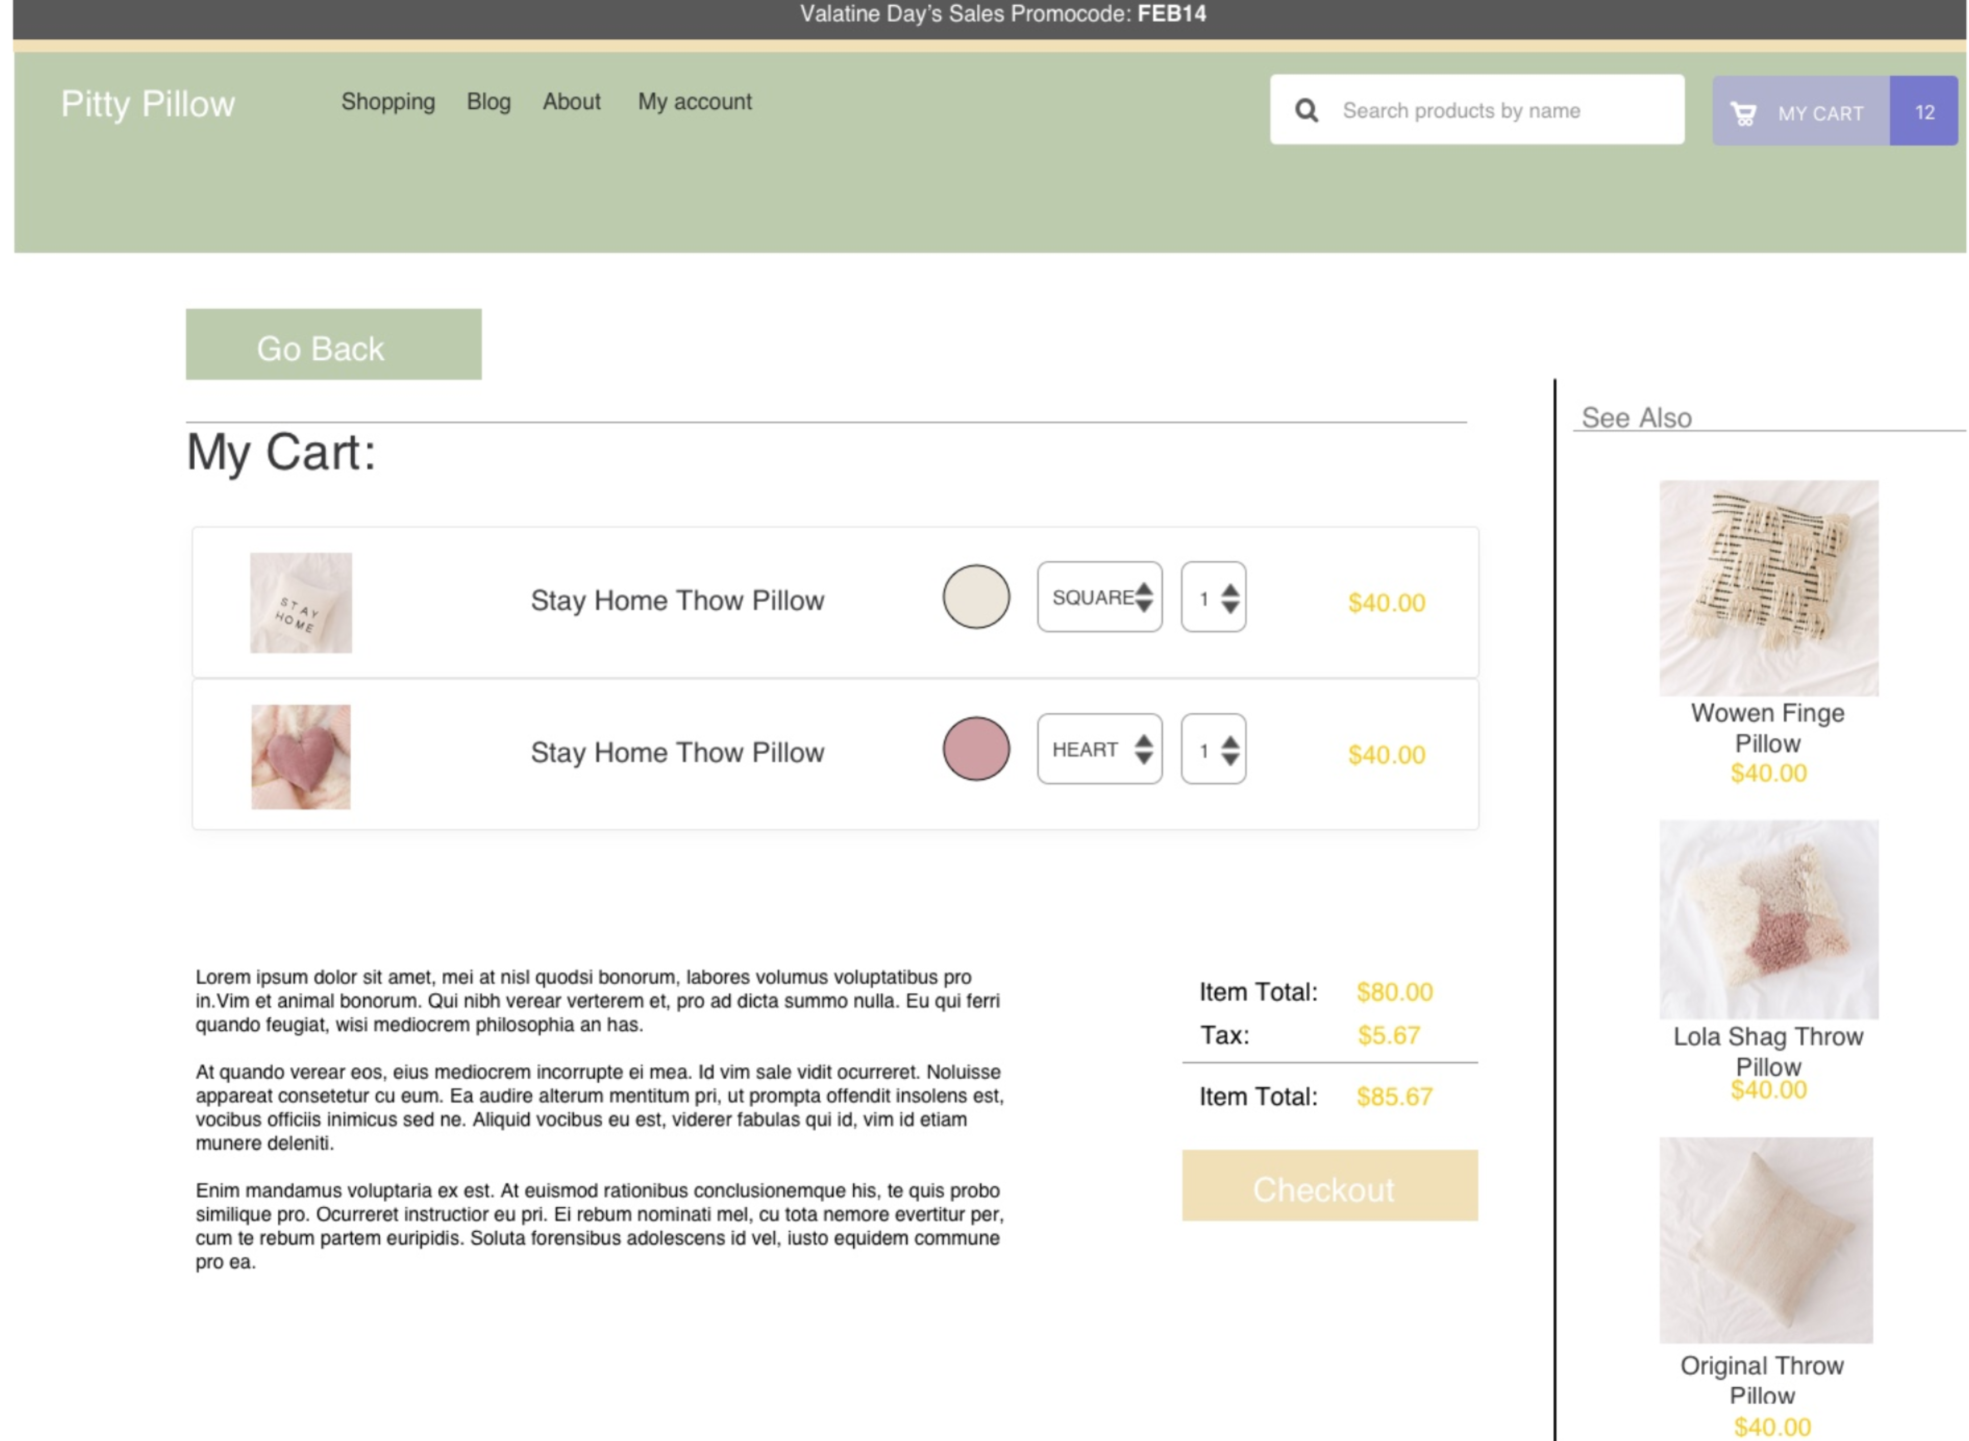

This is the high fidelity prototype from my previous assignments. I changed it a little bit during my implementation since the original design is too hard to implement. I only have a remove button to remove every line instead of a dropdown button that can edit features. The final implementation looks more like the design in the low-fidelity prototype.

1. reflection:
2. When updating the cart quantity after adding new item, the quantity count for the cart is not right.
3. I console.log the qty attribute to see where is the bug, and figure out that I need to reset currentItem.