IT设备进出流程  
IT Device Access Process

**文 件 编 号: KD-LJ01-001**

**Doc. No.:**

**编 制:安全策略部**

**Prepared by:** **Security Policy Department**

**审 核:**

**Reviewed by:**

**批 准:**

**Approved by:**

**版本 /修订状态: A4**

**Rev./Revision status:**

**受 控 状 态:**

**Controlled status:**

**2020-1-1发布 2020-1-1实施**  
**Issued on 1 / 1 /2020** **Implemented on 1 / 1 /2020**

**修改记录表**Document Changes

|  |  |  |  |  |  |  |
| --- | --- | --- | --- | --- | --- | --- |
| **修改条款** **Modified terms** | **修订状态** **Revision Status** | **修改内容** **Description** | **修改日期** **Date** | **修改人** **Changed by** | **审核人** **Reviewed by** | **批准人** **Approved By** |
| / | A/0 | 初次发行 Initial release | 2015/09/22 | 韩德均 Han Dejun | 韩德均 Han Dejun | 刘劲松 Liu Jinsong |
| 3，4，5，6 | A/1 | 1.添加安保人员的职能职责 1. Add duties and responsibilities of safety officers  2.更新IT设备进出流程图 2. Update the IT device access process chart  3.添加设备进出路程细节 3. Add details on the device access path | 2016/03/11 | 曹良攀 Cao Liangpan | 曹良攀 Cao Liangpan | 刘劲松 Liu Jinsong |
| 1，5.1，5.2 | A/2 | 1. 更新依据文件版本 Update the version of supporting document 2. 修改进入机房流程 Modify room access process 3. 资产更新 Update assets   4.更新logo 4. Update logo | 2017/3/3 | 徐锐 Xu Rui | 徐锐 Xu Rui | 刘劲松 Liu Jinsong |
| / | A/3 | 更换log及公司名称 Change log and company name | 2018/7/25 | 黄伟 Huang Wei | 王建勋 Wang Jianxun | 刘劲松 Liu Jinsong |
| All | A/4 | 修改与实际情况不相符的规则 | 2020.1.1 | 黄伟 Huang Wei | 王建勋 Wang Jianxun | 刘劲松 Liu Jinsong |

# 目 录

# Contents

1 目的 Purpose 1

2 适用范围 Application Scope 1

3 职能职责 Duties and Responsibilities 1

4 IT设备进出流程图 IT Device Access Process Chart 3

5 IT设备进入 IT Device Access 3

6 IT设备外出 IT Device Withdrawal 5

7 相关表单 Relevant Sheets 7

# 1 目的 Purpose

此流程用于IT设备进出管理，四川科道芯国智能技术股份有限公司智能卡及数据生产中心（以下简称为生产中心）依据GB/T19001-2008《质量管理体系要求》，结合生产中心生产经营特点，形成生产中心的《IT设备进出流程》。

This process is applicable to IT device access management. The intelligent card and data production center (hereinafter referred to as the "production center") of KEYDOM prepares its own *IT Device Access Process* based on its production and operation features according to the GB/T19001-2008 *Quality Management System Requirements*.

# 2 适用范围 Application Scope

此流程用于IT设备进出管理，不包括IT设备安装、变更等操作。

This process is applicable to IT device access management, excluding operations such as IT device installation and change.

# 3 职能职责 Duties and Responsibilities

逻辑安全管理员：负责完成IT设备进出管理，并按照流程规定完成相应业务。

Logical safety administrator is responsible for IT device access management, and completing relevant businesses according to the process.

安保人员：监督人员进出及物品携带情况。

Safety officer is responsible for supervising personnel and materials access.

# 4 IT设备进出流程图 IT Device Access Process Chart

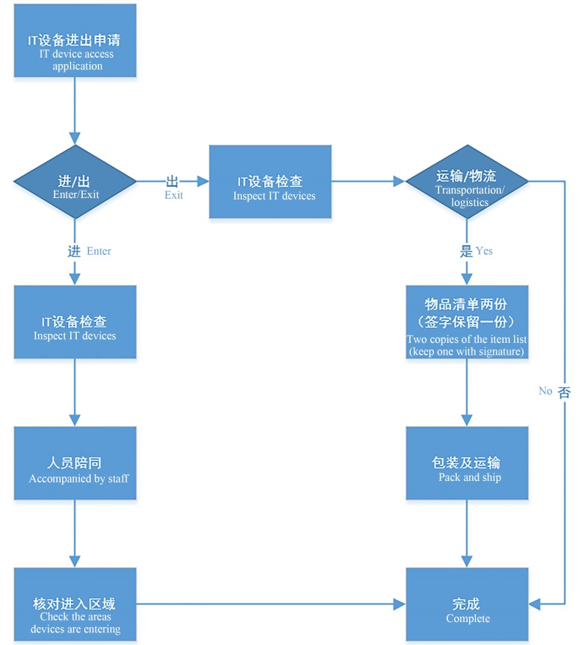

# 5 IT设备进入 IT Device Access

**5.1 携入授权**

**5.1 Entrance authorization**

（1）当事人填写《可携式电脑/存储介质携带许可申请表》，通过安全策略部逻辑安全组、物理安全组及总监审批同意后方可执行后续工作。  
(1) The party fills in the *Application Form for Carrying Portable Computer/Storage Medium*, and implement subsequent jobs after getting approval from logical safety team, physical safety team and director of the safety policy department.

（2）逻辑安全管理员应确认设备进入具体位置，对设备进行安全检查，在《可携式电脑/存储介质携带许可申请表》中填写检查结果。  
(2) The logical safety administrator shall confirm the specific device entrance position, carry out safety inspection to the device, and fill inspection results in the *Application Form for Carrying Portable Computer/Storage Medium*.

（3）经授权后，至少应有一人全程陪同，陪同人必须已与生产中心签署劳动合同，且陪同人必须具有申请进入区域的门禁权限。  
(3) After being authorized, the person should be accompanied by at least one person in the whole process, and the accompanying person must have signed labor contract with the production center, and have right to apply to enter the area.

（4）若进入原因为IT技术类操作，应至少有一位逻辑安全管理员全程陪同。  
(4) If the device enters for IT technology operations, at least one logical safety administrator shall accompany in the whole process.

（5）《可携式电脑/存储介质携带许可申请表》中可授权进入区域不包括生产机房和网络机房，进入以上区域时，逻辑安全管理员先对带入设备进行安全检查检查结果记录在《IT设备检查报告》中，然后由带入人填写《机房进出申请表》，审批通过后由两名逻辑安全管理员全程陪同，进出机房时应填写《机房进出记录表》。  
(5) Access areas authorized by the *Application Form for Carrying Portable Computer/Storage Medium* exclude production rooms and network rooms. when entering these areas, the device should be inspected by the logical safety administrator who records the inspection result in the *IT Device Inspection Report*. The person carrying the device fills in the *Room Access Application Sheet* and should be accompanied by two logical safety administrators in the whole process after getting approval, and he/she shall fill in the *Room Access Record* when accessing or getting out of the room.

**5.2 验收检查**

**5.2 Acceptance inspection**

（1）逻辑安全管理员在接到IT设备验收通知后，应对IT设备进行包装及硬件检查，在必要情况下应检查设备的软件系统及配置情况。  
(1) The logical safety administrator shall package and check hardware of the IT device when receiving the IT device acceptance notice, and check software system and configurations of the device when necessary.

（2）检查完成后根据检查情况填写《IT设备检查报告》，该报告可用于证明IT设备的完好性，在需要向其余部门或机构提供《IT设备检查报告》用作证明用途时，逻辑安全管理员应仅提供复印件。  
(2) After the inspection, the logical safety administrator shall fill in the *IT Device Inspection Report*, which is used to prove completeness of the device. He or she should only provide copy of the report to other departments or authorities for approving its completeness.

（3）当进入的IT设备属于新设备且为公司资产时，逻辑安全管理员应按照IT设备分类及编码规则（见《系统安全程序》）编码，并及时更新《IT固定资产统计表》，更新后提交行政管理部更新资产。  
(3) When the entered IT device is a new device belonged to the Company, the logical safety administrator shall code it according to IT device classification and coding rules (see the *System Safety Procedures*), update the *IT Fixed Asset Statistic Form* in time, and submit updated asset to the administrative management department.

# 6 IT设备外出 IT Device Withdrawal

**6.1外携授权**  
**6.1 Withdrawal authorization**

（1）当事人填写《可携式电脑/存储介质携带许可申请表》，通过安全策略部逻辑安全组、物理安全组及总监审批同意后方可执行后续工作。  
(1) The party fills in the *Application Form for Carrying Portable Computer/Storage Medium*, and implement subsequent jobs after getting approval from logical safety team, physical safety team and director of the safety policy department.

（2）对于临时申请携带进入的物品，在外携时无需再次申请授权。  
(2) For the object which is applied to carry in temporarily, it is unnecessary to apply for authorization again when withdrawing.

（3）逻辑安全管理员应确认设备外携的目的位置，对设备进行安全检查，在《可携式电脑/存储介质携带许可申请表》“带出检查”一栏中填写检查结果。  
(3) The logical safety administrator shall confirm target position to withdraw the device, carry out safety inspection to the device, and fill in the inspection result in "withdrawal inspection" column of the *Application Form for Carrying Portable Computer/Storage Medium*.

（4）《可携式电脑/存储介质携带许可申请表》中可授权带出区域不包括生产机房和网络机房，在以上区域只须填写《机房进出申请表》，带出过程必须由两名逻辑安全管理员陪同，进出机房时应填写《机房进出记录表》。  
(4) The withdrawal areas authorized by the *Application Form for Carrying Portable Computer/Storage Medium* exclude production rooms and network rooms, and only *Room Access Application Form* needs to be filled in for these areas. Two logical safety officers must accompany in the withdrawal process and fill in *Room Access Record* when people access or get out of the room.

**6.2 运输及物流**  
**6.2 Transportation and Logistics**

（1）申请人应填写《IT设备运输申请表》，经申请者部门负责人、安全负责人签字批准后方可执行后续工作。  
(1) The applicant shall fill in the *IT Device Transportation Application Form*, and implement following jobs after getting signature and approval from director and safety officer of the applicant's department.

（2）逻辑安全管理员应检查设备配件，在必要情况下应检查软件系统及配置，检查完成后填写《IT设备检查报告》并签字，其复印件一份与《IT设备交接函》一式两份随设备一同运输。  
(2) The logical safety administrator shall check device fittings, and check software system and configurations when necessary, fill in the *IT Device Inspection Report* and sign on it, and transport copy of the report and the *IT Device Handover Letter* (in duplicate) together with the device.

（3）若运输设备为HSM，《IT设备检查报告》复印件、《IT设备交接函》两份、权限卡、PSAM卡、加密狗和包装箱钥匙必须使用不同的物流公司单独发送。  
(3) If the transported device is HSM, the copy of *IT Device Inspection Report*, two copies of *IT Device Handover Letter*, privilege card, PSAM card, dongle and the key of packing case must be transported by different logistics companies separately.

（4）接收方收到设备后，在其中一份《IT设备交接函》上签字确认并返回我方。  
(4) After receiving the device, the recipient shall sign on one of the *IT Device Handover Letters* and return it to us.

# 7 相关表单 Relevant Sheets

《可携式电脑/存储介质携带许可申请表》

Application Form for Carrying Portable Computer/Storage Medium

《机房进出申请表》

Room Access Application Form

《机房进出记录表》

Room Access Record

《IT设备运输申请表》

IT Device Transportation Application Form

《IT设备检查报告》

IT Device Inspection Report

《IT设备交接函》

IT Device Handover Letter

《生产区域IT设备清单》

IT Fixed Assets Statistics Form