四川科道芯国智能技术股份有限公司
Sichuan Keydom Smart Technology Co., Ltd
标准文件
Standard File

安全事故报告及处置管理标准
Security Incident Report and Management Procedure

文 件 编 号: KD-MFX-03
Doc. No.:
编 制:
Prepared by:
审 核:
Reviewed by:
批 准:
Approved by:
版本 /修订状态: A1
Rev./Revision status:
受 控 状 态:
Controlled status:

2020年 1月 1 日发布 2020年 1 月 1 日实施 Issued on 1 / 1 /2019 Implemented on 1 / 1 /2019
修订历史记录Document Changes
序号  No. | 日期  Date | 修订内容  Description of Change | 版本  Version | 编制  Made by | 审核  Reviewed by | 批准  Approved by
01 | 2019.9.2 | 初版制定  First edition | A 0 | 付显兰 | 刘劲松 | 陈为明
02 | 2019.12.29 | 更改文件格式 | A1 | 付显兰 | 刘劲松 | 陈为明
03
04
05
06
07
08
09
10

目录Table of Content
1. 目的 Purpose 6
2. 范围 Scope 6
3. 名称和缩略词 Definition 6
3.1. 安全事故 Security Incident 6
3.2. 安全隐患 Safety Hazard 6
4. 职责 Responsibility 7
4.1. 公司总经理及管理者代表 General Manager and Management Representative 7
4.2. 安全策略部 Security Policy Dept. 7
4.3. 各中心及部门 Other Dept. 8
5. 安全事故分级Security Incident Classification 8
5.1. 安全事故分级Safe Incident Classification 8
5.2. 一般事故分级 Ordinary 9
6. 事故类别 The Kinds of Incidents 9
6.1. 安全生产事故Safety Incident 10
6.2. 产品安全事故Product Security Incident 10
6.3. 信息安全事故Information Security Incident 11
6.4. 安防事故Security Control Incident 11
7. 安全事故处置流程Security Incident Processing Procedure 12
7.1. 安全隐患及事故汇报 Hazards and Incidents Report 12
7.2. 安全生产事故处置流程Procedure for Safety Incidents 12
7.5. 安防事故处置流程Security Control Incident 20
8. 安全事故教训汲取和预防 Learning and Prevention 21
9. 参考文件及表格 Reference Doc and Record 21

目的 Purpose
为了加强安全事故管理，规范安全事故的分类、报告、迅速的应急处理、调查和事故管理等，把安全事故造成的损失控制在最小范围内，并汲取教训预防下次类似事故的发生，特制订本规定。
Specially make this standard to enhance security incident mgt., standardize the classification, report, quick emergency treatment, investigation of security incidents and minimize the loss resulted from security incident to prevent analogous recurrence.

范围 Scope
本规定适用于公司各类经营活动中造成的人员伤亡/财产损失事故、环境破坏事故、产品安全事故、信息安全事故、安防事故等，如：火灾、爆炸、人员中毒、工伤、危化品泄露并导致环境污染、非授权侵入高安全区、产品遗失、产品被盗、敏感数据信息泄露以及由此导致的客户及公司的重大损失等。
This standard is applicable for all kinds of incidents could result personnel casualty/property loss, negative impact on environment, product security, information security and security and so on, such as fire, explosion, food poisoning, occupational injury, hazard leakage, intrusion etc.

名称和缩略词 Definition

安全事故 Security Incident
造成人员伤害、死亡、职业病、环境污染，或导致设备/设施损坏、产品及敏感数据丢失/泄露等引起的财产损失和其它损失的意外安全事件。
It refers security incidents could result personnel casualty, occupational diseases, environmental pollution, equipment damage, product and data loss etc.

安全隐患 Safety Hazard
实际情况与安全规范不符，有可能会导致安全事故发生的行为或状况。
It refers behavior or situation which is not compliance with security requirements and may cause security incidents.

职责 Responsibility

公司总经理及管理者代表 General Manager and Management Representative
- 负责事故调查和整改的全面领导工作。To lead the investigation and remediation of incident overall.
- 负责保证安全管理所需资金的投入。To support the financial request required by security safeguard.

安全策略部 Security Policy Dept.
- 制定本规定，并对责任部门的负责人作全面的培训；To make this standard and provide overall training to responsible of depts.
- 负责主导公司范围内已发生安全事故的调查，并制定相应的处置流程；To organize other depts. to carry out the investigation and remediation of relevant incidents occurred.
- 负责对违反安全规定的人员、组别、部门作相应考核；To request the punishment procedure for the personnel, team and dept. breach this document.
- 负责公司范围内的安全事故汇总建档，并及时上报公司领导；To keep the records of security incidents on file and report them to related leaders in time.
- 负责协调各类重大安全事故发生后的经营恢复；To organize the operation recovery of Tianyu after significant security incidents.
- 负责指导各部门/中心，解决各类日常工作中的安全隐患，以防止重大安全事故的发生。To assist other depts. to deal with all kinds of security hazards to prevent security incidents from occurring.

各中心及部门 Other Dept.
- 根据指导对业务范围内的安全事故进行预防控制，并负责安全事故发生后的及时通报，做第一时间自救、自查；To carry out prevention measures for incidents may happened related to activities within their own business and self-rescue and self-investigation at the first time.
- 负责参与事故发生后的抢险工作；To take part in emergency response activities.
- 配合安全策略部的事故调查工作，提供各自管辖区域内的证据和线索；To support Security Policy Dept. with the investigation of incidents.
- 协助各自管辖区域内已发生事故的处理；To help to deal with incidents happened.
- 协助各自管辖区域内的事故汇总建档，并及时上报安全策略部和公司领导。To keep incident record in file and report them to Security Policy Dept.

安全事故分级Security Incident Classification

安全事故分级Safe Incident Classification
根据生产安全事故（以下简称事故）造成的人员伤亡或者直接经济损失，事故一般分为以下等级：Safe incidents are classified as below by considering the personnel casualty and economical loss caused:
- 特别重大事故，是指造成30人以上死亡，或者100人以上重伤（包括急性工业中毒，下同），或者1亿元以上直接经济损失的事故；Special significant: personnel death≥30, personnel serious injury≥100; or economical loss≥0.1 billion RMB.
- 重大事故，是指造成10人以上30人以下死亡，或者50人以上100人以下重伤，或者5000万元以上1亿元以下直接经济损失的事故；Significant: 30＞personnel death≥10, 100＞personnel serious injury≥50; or 0.1 billion RMB＞economical loss≥50 million RMB.
- 较大事故：是指造成3人以上10人以下死亡，或者10人以上50人以下重伤，或者1000万元以上5000万元以下直接经济损失的事故；Serous: 10＞personnel death≥3, 50＞personnel serious injury≥10; or 50 million RMB＞economical loss≥10 million RMB.
- 一般事故，是指造成3人以下死亡，或者10人以下重伤，或者1000万元以下直接经济损失的事故。Ordinary: 3＞personnel death≥0, 10＞personnel serious injury≥0; or 10 million RMB＞economical loss≥0 RMB.
说明：上述所称的“以上”包括本数，所称的“以下”不包括本数。如：30人以上，即包含30人。Remark: The phrase ‘以上’ includes the number itself.

一般事故分级 Ordinary
上述一般事故，根据事故的严重程度，可再分为以下三个级别：Ordinary incidents are divided into three levels by considering their severity.
- 一般事故1级：造成直接经济损失5万元以下或造成人身伤害休工3个月之内；Level 1: personnel absence for it within 3 months; or 50 thousand RMB＞economical loss≥0 RMB.
- 一般事故2级：造成直接经济损失5万元（含5万元）以上、50万元以下或造成人身伤害休工等于或超过3个月，小于1年的；Level 2: personnel absence for it for more than 3 months; economical loss≥50 thousand RMB.
- 一般事故3级：造成直接经济损失50万元（含50万元）以上、1000万元以下，或造成人身伤害休工等于或超过1年的。Level 2: personnel absence for it for more than 1 year; 10 million RMB＞economical loss≥50 thousand RMB.

事故类别 The Kinds of Incidents
按照事故的不同属性，可将事故分成安全生产事故、产品安全事故、信息安全事故、安防事故。
Incidents has been classified as safety incident, product security incident, information security incident and security control incident according to the properties of incident.

安全生产事故Safety Incident

以下是典型的安全生产事故举例 Below is description of samples of the safety incidents.
事件  Incident | 举例  Sample
人员伤亡事故  Personnel Casualty | 包含但不限于：Including but not limited to:  - 生产作业过程中，由生产设备、工夹具、运输工具等造成的人员伤亡事故；Casualty incidents caused by equipment or devices during production.  - 上下班途中，发生人员伤亡的交通安全事故；Casualty incidents for traffic accidents.  - 员工食物中毒事故；Employee poisoning incidents.  - 自然灾害事故；Disaster
经济损失事故  Economic Loss | 包含但不限于：Including but not limited to:  - 公司财产被破坏、被盗、遗失；Property damage, stolen and loss.  - 公司机密信息被窃取、盗用；Confidential info divulging.
消防安全事故  Fire Incident | - 火灾事故；Fire incidents  - 爆炸事故；Explosion incidents
环境安全事故  Environmental incident | 包含但不限于：Including but not limited to:  - 有毒有害气体、液体的泄漏；Hazard gas or liquid leakage  - 危化品、易燃易爆物品的违规处理；Improper treatment of hazardous chemicals.
职业健康危害事故  Health Hazard | 包含但不限于：Including but not limited to:  - 噪音、粉尘、有毒有害气体对员工造成的伤害事故；Injury incidents of noise, dust, hazardous gas

产品安全事故Product Security Incident
为便于产品安全事故的确认，以下为典型产品安全事故举例：
事件  Incident | 记录事件  Record Incident | 产品事件  Product Incident | 订单事件  Order Incident
举例  Example | - 记录表单填写不规范；  Record is not maintained as required.  - 记录表单遗失；  Record missed.  - 记录表单篡改、作假；  Tamper and false Record | - 产品遗失；  Product missed.  - 帐与实物不符；  Discrepancy between product quantity and account.  - 产品被盗；  Product is stolen.  - 样卡未作安全处理；  Sample is without security treatment. | - 生产非法产品；  Produce unlawful product.  - 提供产品给非法客户；  Provide product to unlawful customer.

信息安全事故Information Security Incident
以下为典型信息安全事故举例：Examples of the typical product security incident is listed as below:
事件  Incident | 系统事件  System Incident | 网络事件  Network Incident | 数据事件  Data Incident | 密钥事件  Key Incident
举例  Example | - 账户异常；  Account abnormities.  - 病毒攻击；  Virus attack  - 高危漏洞；  High risk vulnerability  - 异常访问；  Abnormal access. | - 网络设备异常；  Network equipment abnormity.  - 硬化配置异常；  Harden deployment abnormity.  - 配置变更异常；  Deployment change abnormity  - 访问流量异常；  Access traffic abnormity. | - 数据篡改；  Data tampering.  - 非法访问、泄露；  Unauthorized access and compromise.  - 敏感信息未加密；  Sensitive information is not encrypted. | - 密钥相关记录、授权不完整；  Incomplete key record and key authorization  - 密钥活动未按要求执行；  Key activity not taken place as required.  - 密钥被非法访问或泄露；  Key is unauthorized accessed or key compromise.

安防事故Security Control Incident
以下为典型的安防事故Examples of the typical security control incident is listed as below:
等级 Level | 描述 Description
安防异常Abnormality | 因未遵循安防控制流程，或因安防设施故障，导致无权限人员非授权进入高安全区，未导致公司财产损失的 Unauthorized access to HSA for breach to security control requirements and failure of security control devices do not cause economic loss.
安防事故  Incident | 因未遵循安防控制流程，或因安防设施故障，导致无权限人员非授权进入高安全区，导致公司轻微财产损失的（5万元以下）Unauthorized access to HSA for breach to security control requirements and failure of security control devices cause economic loss less than 50 thousands.
重大安防事故  Significant Incident | 因未遵循安防控制流程，或因安防设施故障，导致无权限人员非授权进入高安全区，导致公司较重财产损失的（5万元以上含5万）Unauthorized access to HSA for breach to security control requirements and failure of security control devices cause economic loss more than 50 thousands.

安全事故处置流程Security Incident Processing Procedure

安全隐患及事故汇报 Hazards and Incidents Report
在日常工作中，发现或怀疑有任何安全隐患或事故情况，均需要通过正式途径，及时向其部门领导、安全策略部汇报。对不便于公开汇报的安全隐患或事故情况，可通过设置在各处的安全策略部信箱，填写匿名汇报表格如实反馈情况，安全策略部每周开启信箱收集信息并进行调查，调查结果及时向公司汇报。Employees should inform dept. leader and Security Policy Dept. of Hazards and incidents discovered. If normal report method is not applicable, there are mailbox of Security Policy dept. for any anonymous report needs.

安全生产事故处置流程Procedure for Safety Incidents
安全生产事故的处置流程如下：事故确认、事故评估、及时抢救、调查行动、后续处理。
Here is the handling procedure for safety incidents: Incident Confirmation, Incident Assessment, Rescue Timely, Investigation, Handle the Aftermath.

事故确认 Incident Confirmation
安全事故发生后，负伤者或最早发现的人，必须立即报告其部门领导，部门领导得知情况后必须立即报安全策略部。
The injured or the original discover should report the safety incident to their dept. leader immediately. The dept. leader must report the Security Policy Dept. at the first time.

事故评估 Incident Assessment
- 安全策略部接收到事故信息后，需及时到达事故现场，并根据事故的性质、严重程度做出评估，再根据评估结果制定相应的行动方案。Security Policy dept. should reach the scene timely and make the action plan on the basis of the evaluation result of the nature and extent of the incidents.
- 安全策略部确认事故后，必须立即将事故情况报告公司领导。Security Policy dept. should report the situation of incident to the leader of the company.

及时抢救 Rescue Timely
- 对于工伤事故，现场人员需根据伤者情况，及时作临时救援处理，再将伤员送到医院进行急救，或拨打120急救电话。For industrial injury, the on-site staff should take some temporary rescue actions firstly before send the injury to the hospital or call 120.
- 对于较小的火灾、爆炸等事故，现场人员在确保自身安全的前提下，需及时使用救援设备，如灭火器、消防栓等，进行抢救。并尽一切可能抢救伤员和公司财产，制止事故发展和扩大损失。For fire and explosion with little influence, the on-site staff should take rescue actions by using the rescue equipment immediately to try their best to keep the injury and company asset being safe, such as fire extinguisher, fire hydrant
- 对于较大的火灾、爆炸或有毒有害气体泄漏等事故，现场人员应立即停止作业，迅速撤离事故现场。并在第一时间切断事故扩大的路径和产生的根源，有效阻止事故的蔓延。然后在事故现场外围设置警戒线，禁止一般人员进入。如有人员伤亡，需及时进行抢救处理，并拨打119消防急救电话，等待救援。For the fire, explosion and toxic gases leakage with significant influence, the on-site staff should escape there immediately and cut off the route and original of the incident to stop its spreading.
- 妥善保护事故现场，不得人为破坏和随意清理。Keep the incident scene well and any artificially change and optionally clear is prohibited.

调查行动 Investigation
- 事故调查的目的：掌握事故情况，查明事故原因，制定改进措施，分清事故责任，提出对事故责任者的处理意见和填写调查报告。Purpose: To have knowledge of the incident details, reasons and responsibilities differentiation. To require the responsibility to submit corrective action plan. To complete investigation report.
- 事故调查组组成：一般事故1—3级由事故发生部门会同安全策略部组成调查组进行调查。对于较大的安全事故，需由公司领导组成的调查小组组织调查。较大事故、重大事故、特大事故由安全策略部配合政府部门展开调查。Composition: Normally, for level 1-3 incidents, the investigation team will be comprised by incident dept. and Security Policy dept. For safety incident with significant influence will be investigated by company leader team or government.
- 事故调查程序 Procedure
- 调查组明确任务和分工、了解事故现场及事故前的情况；Investigation team should specify the task assignments and have a good knowledge of the incident.
- 针对现场情况进行必要的技术鉴定和试验；To perform necessary technical evaluation and testing.
- 初步确定事故发生的原因、影响范围、经济损失等；To verify the reason, influence scope and economic loss initially.
- 在事故调查中，分清责任事故、非责任事故、破坏事故：To verify if the incident is Responsible Incident, Non-responsible Incident and Damage Incident.
- 责任事故：指应有关人员的过失而造成的事故Responsible Incident: It refers that the incident which is caused by personnel negligence.
- 非责任事故：指由于自然的因素而造成的不可抗拒的事故，或未知领域的技术问题Non-responsible Incident: It refers the natural and irresistible incidents.
- 破坏事故：指为达到一定目的而蓄意制造的事故。Damage Incident: It refers the incidents deliberated for some purpose.

后续处理Handle the Aftermath
- 明确事故造成的经济损失，并及时给予补助，其项目如下：To verify the economic loss caused and provide financial assistance for below items:
- 医疗费（包括营养费）、护理、陪人费；Medical, nursing and accompanying expenses;
- 因工负伤休工工资；Salary for the absenteeism for injury;
- 伤残补助，抚恤金；Disability allowance;
- 事故善后处理交通、住宿、饮食、招待费等；Expenses for travel, accommodation and hospitality caused for handling the aftermath of incident.
- 事故间接损失等费用。Indirect loss.
- 通过对事故进行原因分析，提出整改及防范措施，并在事故发生的15天内形成《生产安全类事故调查报告》，如果事故涉及到三个以上不同的环节，需填写《8D报告》。事故报告内容包含但不限于：To complete the Safety Incident Investigation Report within 15 days after the incident which should include reason analysis, corrective action and preventive action. If the incident involves more than three processes, the 8D report is needed.
- 事故发生时间、地点以及事故现场情况；The 3W(when, where and what) information of the incident.
- 事故的详细经过（可附事故现场的实测图和照片）The detail process of the incidents, related photos could be attached.
- 事故造成或者可能造成的伤亡人数和初步估计的经济损失 The quantity of the injured and the amount of economic loss.
- 伤者姓名、年龄、工种、伤害程度 The name, age, work station and the level of the injury.
- 事故原因，及已经采取的临时性措施和后续的防范措施；Incident reason and the temporary corrective action and subsequent preventive action adopted.
- 事故的责任认定及处理意见。The responsibility identification and handling opinion.
- 事故报告后出现新情况的，应当及时补报。较大事故、重大事故、特大事故的报告安全相关政府部门的要求提交。The new incident happened should be reported immediately. For the incidents with significant influence should be with report as government’s requirements.
说明：针对各种生产安全事故的具体处置流程，详见《安全事故应急预案》。For different safety incident, details could be found in the Emergency Plan for Safety Incident.
  - 产品安全事故处置流程Procedure for Product Security Incident
产品安全的事故处置流程如下：事故确认、事故评估、调查行动、后续处理。
Product security incident processing procedure always have four parts: incident confirmation, incident assessment, investigation and follow-up treatment.

事故确认Incident Confirmation
- 当员工发现或怀疑发生安全事故时，必须向直接主管报告这些事故行为以进一步调查和验证。如有必要，部门负责人需协助上述主管确定事故原因。Employee should report discovered or suspicious incident to direct supervisor for further investigation and verification. Dept. leader should assist supervisor to confirm the incident reason as necessary.
- 责任工序/部门需要在第一时间进行自查，并详细记录事故发生的时间、地点、过程、当事人等重要信息。Responsible position/dept. should conduct self-investigation at the first time and detail important information such as incident time, location, process, party involved.
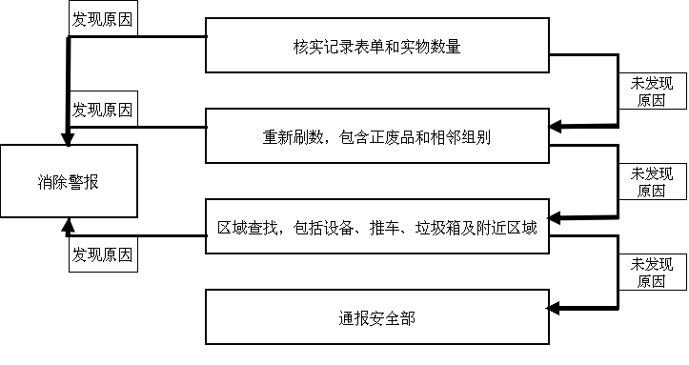
- 以下为产品数量异常的自查流程（主要适用于生产部门）：Below is the self-investigation procedure for product discrepancy.

- 以下为产品数据异常的自查流程（主要适用于数据组）：Below is the self-investigation procedure for product data abnormity (mainly for data team).
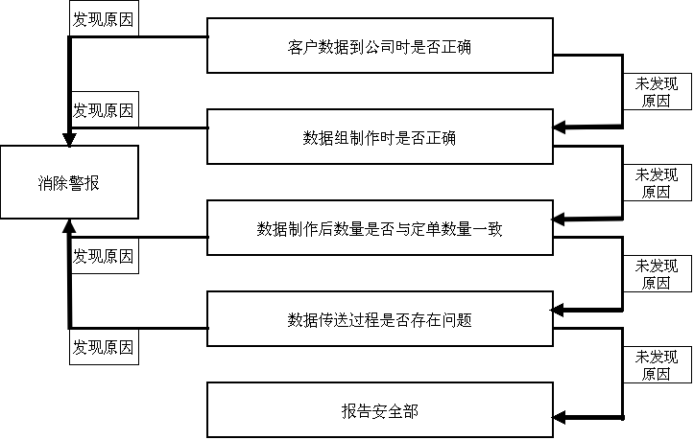
通报安全策略部

- 以下为外协产品事故的自查流程（主要适用于生产中心计划部和仓库）：Below is the self-investigation procedure for outsourced product incident (mainly for Planning Dept. and warehouse).

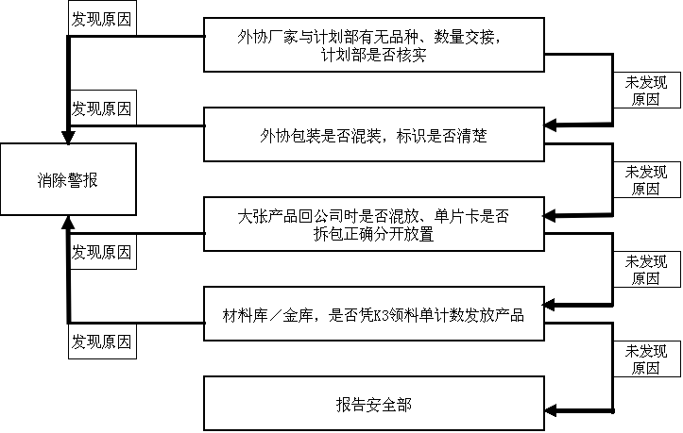
通报安全策略部

- 通过上述方式进行自查后，如仍未发现差异原因，需在2个小时内通报安全策略部介入调查。Ask Security Policy dept. to involve within 2 hours when abnormity reason is not confirmed after self-investigation according above method.
- 原则上，产品安全事故发生后，区域内所有相关人员都不得离开现场。In principle, all the relative personnel should not leave the involved area after the product security incident.

事故评估Incident Assessment
基本确认事故情况后，安全策略部要对事故性质、严重程度和对公司、客户可能造成的影响和损失作出评估，并根据评估制订行动方案。
Security Policy dept. should assess the incident character, severity, influence and damage to Tianyu and customer after basic incident confirmation. And make action plan according to the assessment result.

调查行动Investigation
- 安全策略部先确认事故的真实性，并立即利用可以利用的渠道、资源开展调查。可重复上述自查方式，并结合监控录像、门禁系统记录等进行调查。Security Policy dept. should confirm the authenticity of incident firstly. Investigation by utilize available channel and source such as CCTV video and access control record. Repeat above investigation procedure is appropriate.
- 当事故发生的原因找出，责任部门需及时完成《产品安全类事故调查报告》或者《8D报告》(涉及到三个或三个以上不同环节时使用)。在报告中，责任部门需制定完善的整改措施，并在规定时间内整改完成，防止此类事故再次发生。安全策略部对整改进度作及时追踪。If incident reason is confirmed, responsible dept. should complete Product Security Incident Investigation Report or 8D report. Responsible dept. should make corrective in the report and correct within the required time to prevent the incident happened once more. Security Policy dept. should track the correction schedule.

后续处理Follow-up Treatment
- 当安全事故调查清楚并确定了相应责任人，需立即通报相关各方，解除警报。所有事故相关资料归档封存。Immediately inform relevant parties the investigation result after relevant responsible is confirmed. All the incident material should be archived.
- 责任部门需针对此安全事故，对相关人员进行宣导、培训。Responsible dept. should provide relevant training to related personnel aiming at the security incident.
说明：针对各种产品安全事故的具体处置流程，详见《产品安全事故应急预案》。
Remark: Detail procedure for all kinds of product security incidents could be found in Emergency Plan for Product Security Incident.
  - 信息安全事故处置流程Procedure for Information Security Incident
信息安全事故的处置流程与一般产品安全事故基本相同（参见7.2.1至7.2.4章节），以下为基本响应图：Information security incident processing procedure is basically same with ordinary product security incident, referring to section 7.2.1 and 7.2.4. Below is the basic responding diagram:
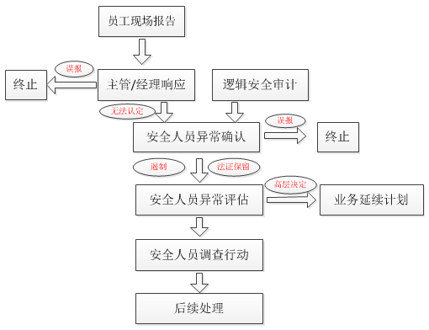
说明：针对各种信息安全事故的具体处置流程，详见《安全事故类应急预案》。相关报告记录在《信息安全类事故调查报告》中。
Remark: Detail procedure for all kinds of product security incidents could be found in Emergency Plan. The incident also should be recorded in Information Security Incident Investigation Report.

安防事故处置流程Security Control Incident
安防事故的处置流程与生产安全事故基本相同（参见7.2.1至7.2.4章节），以下为基本响应图：Security control incident processing procedure is basically same with ordinary product security incident, referring to section 7.2.1 and 7.2.4. Below is the basic responding diagram:

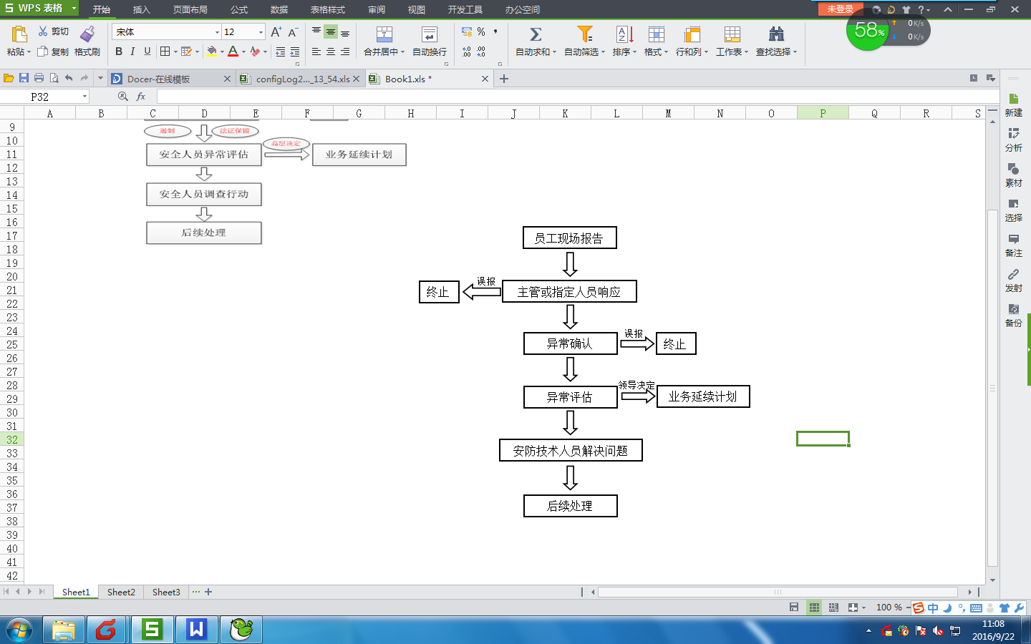
具体的处置流程详见《安全事故应急预案》。相关报告记录在《安防类事故调查报告》中。
Remark: The incident also should be recorded in Information Security Incident Investigation Report.

安全事故教训汲取和预防 Learning and Prevention
安全策略部存档安全事故的相关资料，每年定期组织公司人员参加安全事故的回顾学习，从以往的事故案例中，学习到事故的预防、处理、改善等知识，增加安全管理能力。
Security Policy Dept. will keep information related to security incidents on file and provide annual training to review and learn from previous cases about prevention, treatment and improvement to enhance security mgt. ability.

参考文件及表格 Reference Doc and Record
- 安全事故类应急预案
- 产品安全类事故调查报告
- 信息安全类事故调查报告
- 安防类事故调查报告
- 8D报告

说明 Remark
- 本管理规定由安全策略部负责最终解释。Security Policy dept. is responsible for final explanation of this standard.
- 本规定自发布之日起执行。This standard is effective from the publication date.

