ICT ACADEMY OF KERALA
Project Report

CampusEventHub

College Event Management Portal

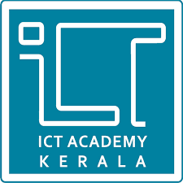

Hawin Joe
Sahrdaya College of Engineering and Technology
26.10.2026

EXECUTIVE SUMMARY
CampusEventHub is a full-stack College Event Management Portal developed by Hawin Joe as an individual project using the MERN stack (MongoDB, Express.js, React and Node.js). The portal replaces scattered Google Forms and paper sign-up sheets with a single web application where students can discover campus events and register for them, and where administrators can create events, monitor seat availability and view the list of registered attendees in real time.
The project covered the complete development lifecycle: designing the database schema, building a RESTful API, developing a responsive React interface, and deploying both the client and the server to Vercel with data stored in MongoDB Atlas. Source code was managed with Git and hosted on GitHub.

Key Achievements
- Full CRUD-style event management: view, create and delete events through a REST API.
- Dynamic, real-time seat and registration tracking, with capacity and current registrations shown on every event.
- Student registration workflow that stores name, email, roll number and registration time against each event.
- Admin view to inspect the list of students registered for any event.
- Search bar and category quick-filters (Technical, Cultural, Sports) for fast event discovery.
- Cloud deployment: React frontend and Express backend hosted on Vercel, connected to MongoDB Atlas.

INTRODUCTION

Background
Colleges host a steady stream of technical fests, cultural programmes and sports meets. In many institutions these events are still managed through fragmented tools: a separate Google Form for each event, paper sign-up sheets on notice boards, or messages forwarded through class groups. Organisers end up reconciling several lists by hand, and students have no single place to see what is happening on campus.

Problem Statement
The traditional approach leads to the following problems:
- Double bookings and duplicate entries because registrations are spread over multiple forms and sheets.
- No capacity tracking, so organisers cannot easily tell how many seats remain or when an event is full.
- Poor visibility for students, who must rely on word of mouth to find out about events.
- Manual administration, as attendee lists have to be compiled and cleaned by hand.

Proposed Solution
CampusEventHub centralises event discovery and student registration in one responsive single-page application (SPA). Events are stored in a cloud database and exposed through a REST API, so every registration immediately updates the occupancy count that all users see. Administrators get a dashboard to create and remove events and to inspect who has registered.

OBJECTIVES
The aim of this project was to design, build and deploy a complete full-stack web application while gaining practical experience with the MERN stack. The specific objectives were:
- Develop a modern, responsive user interface using React (with Vite) and Tailwind CSS.
- Build a scalable RESTful API backend using Node.js and Express.js.
- Implement persistent storage using MongoDB Atlas through the Mongoose ODM.
- Enable the key features: event creation and deletion, real-time seat tracking, student event registration, and an admin view of registered students.
- Deploy both the client and the server to Vercel, with full Git version control on GitHub.

SCOPE AND DELIVERABLES
The project is delivered as three parts: a frontend portal, a backend API and a database schema. As the sole developer, all three were designed and implemented by Hawin Joe.

Frontend Portal (Client)
- Responsive dashboard listing all events with dynamic seat availability counters.
- Category quick-filters for Technical, Cultural and Sports events.
- Search bar to find events by keyword.
- Registration modal where a student submits name, email and roll number.
- Attendee list modal for administrators to inspect registered students.

Backend API (Server)
The Express.js server exposes four REST endpoints:
Method | Endpoint | Description
GET | /api/events | Fetch all events.
POST | /api/events | Create a new event.
POST | /api/events/:id/register | Register a student: appends the student to the event's student array and updates the occupancy count.
DELETE | /api/events/:id | Remove an event.
Table 1: REST API endpoints

Database Schema
Data is stored in MongoDB Atlas using a single Event document model. Registered students are embedded inside the event document, so one read returns an event together with its attendees.
Field | Type | Description
title | String | Name of the event.
category | String | Event category (Technical, Cultural or Sports).
date | Date | Date of the event.
location | String | Venue of the event.
description | String | Short description of the event.
capacity | Number | Maximum number of seats available.
Current registrations count | Number | Number of students registered so far; used to compute seats left.
registeredStudents | Array | Embedded sub-documents, one per registered student.
name | String | Student's full name.
email | String | Student's email address.
rollNo | String | Student's roll number.
registeredAt | Date | Timestamp of registration.
Table 2: Event document model

METHODOLOGY

System Architecture
CampusEventHub follows a decoupled client–server MERN architecture. The React single-page application runs in the browser and communicates with the Express.js API over HTTP using Axios, exchanging JSON. The API uses Mongoose to read from and write to the MongoDB Atlas cloud database. Keeping the client and server independent allows each to be developed, deployed and scaled separately.
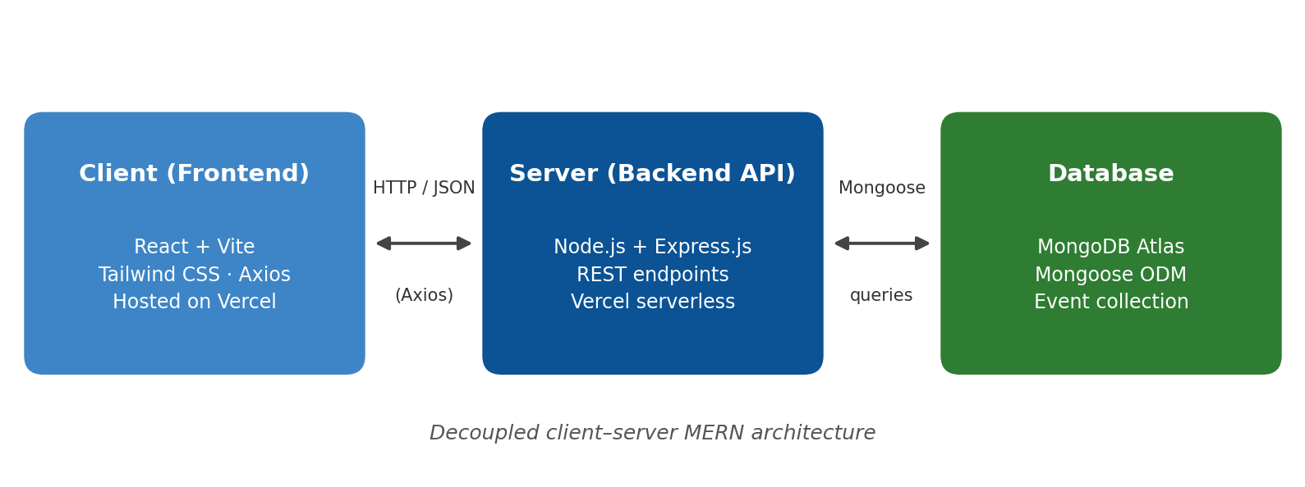
Figure 1: CampusEventHub system architecture

Technology Stack
Layer | Technology | Purpose
Frontend | React.js, Vite | Component-based SPA with fast development builds.
Styling | Tailwind CSS | Utility-first styling for a responsive layout.
HTTP client | Axios | Calls from the React client to the REST API.
Icons | Lucide React | Consistent icon set for the interface.
Backend | Node.js, Express.js | REST API and business logic.
ODM | Mongoose | Schema definition and database queries.
Database | MongoDB Atlas | Cloud-hosted document database.
Version control | Git, GitHub | Source management (hawinjoe-shr/college-event-system).
Hosting | Vercel | Multi-service hosting for client and serverless API.
Table 3: Technology stack

Development Approach
The project was built iteratively, with each stage tested before the next was started:
- Design the Event schema and set up the MongoDB Atlas cluster.
- Build the Express routes for listing, creating and deleting events.
- Develop the React interface and connect it to the API with Axios.
- Add the registration workflow, the admin attendee view, search and category filtering.
- Fix integration bugs found while testing the client against the API.
- Configure environment variables and deploy both services to Vercel.

Registration Data Flow
- The student opens an event and submits the registration modal (name, email, roll number).
- The client sends a POST request to /api/events/:id/register.
- The server finds the event, appends the student to registeredStudents and updates the registration count.
- The updated event is saved to MongoDB Atlas and returned to the client.
- The dashboard refreshes, showing the new seat availability; the admin can open the attendee list to see the new entry.

PROJECT ACTIVITIES

Frontend Development and UI/UX Enhancement
The first version of the interface displayed static event cards. This was transformed into an interactive dashboard: a search bar filters events as the user types, category quick-filters narrow the list to Technical, Cultural or Sports events, and each card shows a dynamic seat availability counter. A registration modal and an attendee list modal were added using React state, and Tailwind CSS was used to keep the layout responsive on desktop and mobile screens.

Backend and Database Development
The Express.js server was organised around a dedicated events router. Mongoose was used to define the Event model and to run queries. The embedded registeredStudents array stores each student's name, email, roll number and registration time, and the registration route updates the occupancy count whenever a student is added.

Deployment and Version Control
The code was versioned with Git and pushed to GitHub. The frontend and backend were deployed as separate Vercel projects; the backend runs as serverless functions. The MongoDB connection string was supplied through the MONGO_URI environment variable rather than being hard-coded, and MongoDB Atlas network access was set to allow connections from any address (0.0.0.0/0) so that Vercel's serverless functions, which do not use a fixed IP, can reach the database.

Challenges Overcome
Challenge | Cause | Resolution
Frontend endpoint mismatch | The registration requests sent by the client did not match any route on the server, so registrations failed. | Created a dedicated Express route (/:id/register) and aligned the client calls with it.
Storing multiple students per event | The original Mongoose schema could not hold a list of registrants. | Updated the schema to include an array of embedded student sub-documents.
Static, hard-to-use interface | Events were shown as plain static cards with no way to search or filter. | Added search, category quick-filters and live seat counters.
Git authentication across accounts | Git was using credentials from a different account than the target GitHub repository. | Reconfigured the credentials so that pushes went to the correct account.
Cloud configuration | The server could not reach the database after deployment without its environment variables. | Configured MONGO_URI on Vercel and deployed the API as serverless functions.
Table 4: Challenges and resolutions

RESULTS & FINDINGS
CampusEventHub was successfully built and deployed. Both the client and the API are publicly reachable on Vercel.

Live Deployment
Component | URL
Frontend App | https://college-event-system.vercel.app
Backend API | https://college-event-backend-three.vercel.app
GitHub Repository | https://github.com/hawinjoe-shr/college-event-system
Table 5: Live URLs and source code

Features Delivered
Feature | Implementation | Status
View all events | GET /api/events + dashboard | Completed
Create an event | POST /api/events | Completed
Delete an event | DELETE /api/events/:id | Completed
Student registration | POST /api/events/:id/register + modal | Completed
Real-time seat tracking | Capacity vs. registration count | Completed
Admin attendee list | Embedded registeredStudents + modal | Completed
Search and category filters | Client-side filtering | Completed
Cloud deployment | Vercel + MongoDB Atlas | Completed
Table 6: Feature checklist

Findings
- Embedded documents suit this data. Storing registered students inside the event keeps reads simple: a single query returns an event together with its attendees, which is all the admin view needs.
- Seat visibility changes behaviour. Showing remaining seats on each card gives students immediate feedback and gives organisers a live view of participation without compiling spreadsheets.
- Decoupled architecture simplified deployment. Because the client and API are independent, each was deployed and debugged on its own.
Overall, the project achieved its goal of a full-stack application that handles registration logic, capacity limits and admin monitoring in one place, replacing the fragmented Google Forms and paper process.

CONCLUSION
CampusEventHub meets all of its stated objectives. A responsive React and Tailwind CSS interface, a Node.js and Express.js REST API and a MongoDB Atlas database work together as a complete event management portal, deployed to the cloud and available through live URLs. Students can find events and register in a few steps, and administrators can create events, watch seat availability and inspect attendee lists.

Learning Outcomes
- Designing and consuming REST APIs, and keeping client calls aligned with server routes.
- Data modelling with Mongoose, including embedded sub-documents.
- Building interactive React interfaces with state, modals, search and filtering.
- Deploying a decoupled MERN application to Vercel and managing environment variables.
- Using Git and GitHub for version control, and troubleshooting authentication issues.

Limitations and Future Scope
- Add login and role-based access control so that only authorised administrators can create or delete events and view attendee lists.
- Restrict the MongoDB Atlas network access list from 0.0.0.0/0 to a tighter set of sources for production use.
- Prevent duplicate registrations (for example by email or roll number) and block registration once an event is full.
- Add an event edit (update) endpoint, email confirmations, and export of attendee lists to CSV.
- Introduce pagination and automated tests as the number of events grows.

APPENDIX

A. Project Links
Source code: https://github.com/hawinjoe-shr/college-event-system
Frontend app: https://college-event-system.vercel.app
Backend API: https://college-event-backend-three.vercel.app

B. Example API Request
Registering a student for an event (illustrative request body):
POST /api/events/:id/register
Content-Type: application/json

{
"name": "Student Name",
"email": "student@example.com",
"rollNo": "CS21001"
}

C. Environment Configuration
Variable | Purpose
MONGO_URI | MongoDB Atlas connection string used by the Express server. Set in the Vercel project settings; not stored in the repository.
Prepared by Hawin Joe.

