### Experience

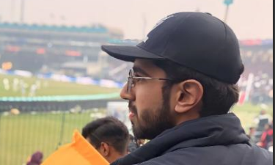

Abdullah

# profile

I’m a computer science student focused on learning and applying programming skills, especially in JavaScript. I enjoy solving problems and exploring new coding techniques. While I’m not using Git yet, I’m working to build a strong foundation in development.

## contact

[abdullah@gmail.com](mailto:abdullah@gmail.com)

www.linkedin.com/in/t.mcgowan

0022-233733-223

4567 Main Street

Bahria Town, Lahore

## Activities and Interests

Theater • Environmental conservation •Art • Hiking • Fishing• Travel

##### august 2016-present

In university, I've been focused on building my coding skills, especially in JavaScript. I enjoy tackling challenges in my coursework and applying what I learn to real-world problems. I'm always looking to deepen my understanding of programming concepts and improve as a developer.

#### future ambitions

• Master advanced programming languages and frameworks.

• Gain expertise in web development and software engineering.

• Contribute to open-source projects and collaborate with other developers.

• Pursue internships or job opportunities in tech companies to gain industry experience.

• Develop innovative solutions to real-world problems using technology.

• Continuously improve my skills in areas like algorithms, data structures, and system design.

### Education

Bachelor of Science in computer

Comsats university, lahore

##### june 2022

intermediate degree

Punjab college, lahore

##### june 2020

### key skills and characteristics

• Proficient in JavaScript for web development

• Understanding of HTML and CSS for front-end design

• Basic knowledge of data structures and algorithms

• Familiar with problem-solving and debugging techniques

• Ability to work with DOM manipulation and event handling