LEMBAR JAWAB LATIHAN SOAL

**NIM : 71220932**

**NAMA : Chrisilia Aveline**

**NILAI :**

**Latihan Pengamatan 8**

1. Tampilan laporan yang sudah selesai

Designnya:

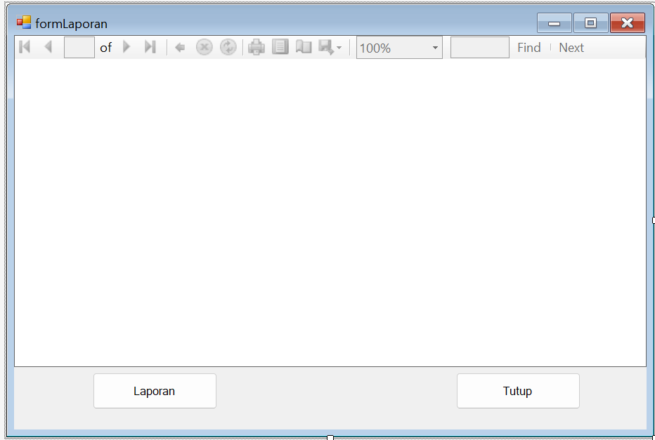

Ketika sudah di run:

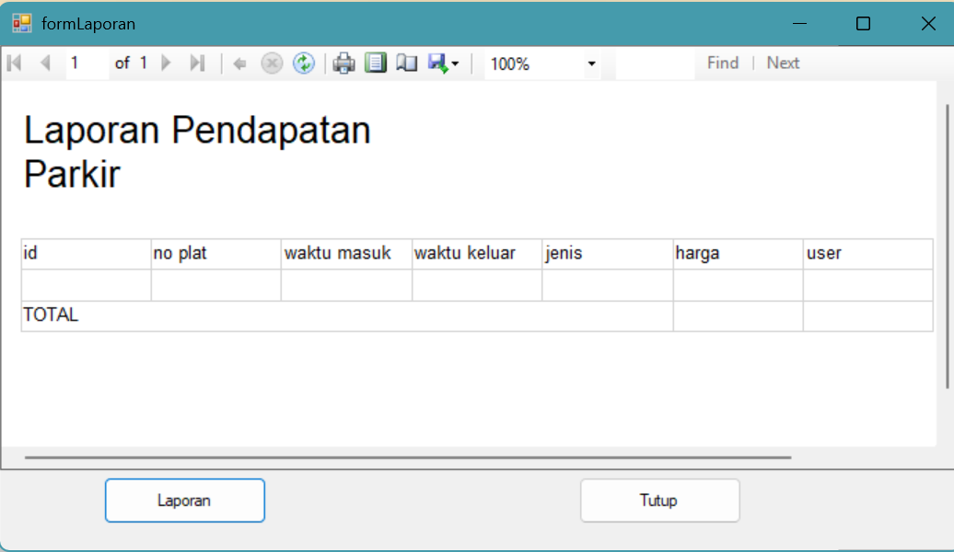

Ketika sudah di klik btnLaporan:

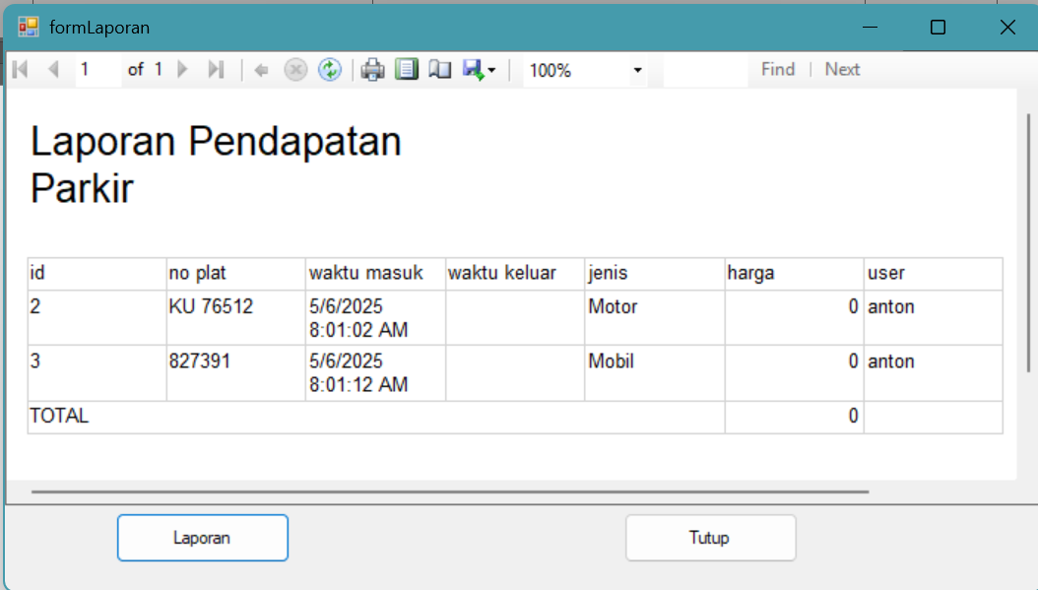

1. Klik kanan pada total harga, lalu pilih expression, pada category pilih Datasets, di item pilih DataSet1_LapParkir, dan pada values pilih sum(harga), lalu klik OK untuk menyimpan perubahan
2. Code yang ada didalam **Private Sub btnLaporan_Clicksebelumnya**, dipindahkan ke **Private Sub formLaporan_Load**. Berikut kode terbarunya agar laporan langsung muncul

**Imports MySql.Data.MySqlClient**

**Imports Microsoft.Reporting.WinForms**

**Public Class formLaporan**

**Private Sub formLaporan_Load(sender As Object, e As EventArgs) Handles MyBase.Load**

**Dim ds As New DataSet1**

**Dim myAdapter As New MySqlDataAdapter**

**If myConn.State = ConnectionState.Closed Then**

**myConn.Open()**

**End If**

**myAdapter.SelectCommand = New MySqlCommand("SELECT * FROM tblparkir", myConn)**

**myAdapter.Fill(ds.Tables(0))**

**ReportViewer1.Reset()**

**ReportViewer1.ProcessingMode = Microsoft.Reporting.WinForms.ProcessingMode.Local**

**ReportViewer1.LocalReport.ReportPath = System.Environment.CurrentDirectory & "\laporan.rdlc"**

**ReportViewer1.LocalReport.DataSources.Clear()**

**ReportViewer1.LocalReport.DataSources.Add(New Microsoft.Reporting.WinForms.ReportDataSource("DataSet1_LapParkir", ds.Tables(0)))**

**ReportViewer1.DocumentMapCollapsed = True**

**Me.ReportViewer1.RefreshReport()**

**End Sub**

**Private Sub btnTutup_Click(ByVal sender As System.Object, ByVal e As System.EventArgs) Handles btnTutup.Click**

**frmUtama.Show()**

**Me.Hide()**

**End Sub**

**Private Sub btnLaporan_Click(ByVal sender As System.Object, ByVal e As System.EventArgs) Handles btnLaporan.Click**

**Me.ReportViewer1.RefreshReport()**

**End Sub**

**End Class**

1. Di perbaiki pada frmUtama.vb pada bagian Private Sub Form1_KeyDown, pengguna = “anton” dihapus saja, karena pengguna sudah tersimpan saat login. Berikut codenya yang baru

Private Sub Form1_KeyDown(ByVal sender As System.Object, ByVal e As System.Windows.Forms.KeyEventArgs) Handles MyBase.KeyDown

Dim sql As String

Dim harga As Integer = 0

Dim nomor As String = String.Empty

If e.KeyCode = Keys.F1 Then

jns = "Motor"

ElseIf e.KeyCode = Keys.F2 Then

jns = "Mobil"

ElseIf e.KeyCode = Keys.F3 Then

jns = "Taksi/Umum"

ElseIf e.KeyCode = Keys.F4 Then

jns = "Sepeda"

ElseIf e.KeyCode = Keys.F5 Then

jns = "Bus/Truk"

End If

lblInfoJenis.Text = jns

If myConn.State = ConnectionState.Closed Then

myConn.Open()

End If

If e.KeyCode = Keys.Return Then

sql = "select * from tblparkir where no_plat='" & txtPlat.Text.ToUpper & "' and waktu_keluar is null"

If myCommand Is Nothing Then

myCommand = New MySqlCommand(sql, myConn)

Else

myCommand.CommandText = sql

End If

Dim hasil1 As MySqlDataReader = myCommand.ExecuteReader()

If hasil1.HasRows Then 'kalau sudah ada, update jadi keluar

If MessageBox.Show("Keluar dari Parkir?", "Keluar", MessageBoxButtons.YesNo, MessageBoxIcon.Question) = Windows.Forms.DialogResult.Yes Then

hasil1.Read()

jns = hasil1("jenis").ToString

nomor = hasil1("id").ToString

If jns = "Motor" Then

harga = 2000

ElseIf jns = "Mobil" Or jns = "Taksi/Umum" Then

harga = 3000

ElseIf jns = "Sepeda" Then

harga = 1000

ElseIf jns = "Bus/Truk" Then

harga = 4000

End If

If hasil1.IsClosed = False Then

hasil1.Close()

End If

sql = "update tblparkir set waktu_keluar = CURRENT_TIMESTAMP(), harga = IF(ceil((UNIX_TIMESTAMP(waktu_keluar) - UNIX_TIMESTAMP(waktu_masuk))/60/60)>1,ceil((UNIX_TIMESTAMP(waktu_keluar) - UNIX_TIMESTAMP(waktu_masuk))/60/60)*" & Str(harga) & "," & Str(harga) & ") where id = " & nomor

myCommand.CommandText = sql

myCommand.ExecuteNonQuery()

sql = "select * from tblparkir where id = " & nomor

myCommand.CommandText = sql

hasil1 = myCommand.ExecuteReader

hasil1.Read()

lblHarga.Text = "Rp. " & hasil1("harga").ToString

If hasil1.IsClosed = False Then

hasil1.Close()

End If

MsgBox("Sukses Keluar!")

jns = String.Empty

Else

RefreshGrid()

End If

Else 'kalau belum ada masukkan baru

If jns = String.Empty Then

MsgBox("Masukan jenis kendaraan berikut:" & vbCrLf & lblJenis.Text)

hasil1.Close()

Exit Sub

End If

sql = "insert into tblparkir(no_plat,jenis,user) values ('" & txtPlat.Text.ToUpper & "','" & lblInfoJenis.Text & "','" & pengguna & "')"

If hasil1.IsClosed = False Then

hasil1.Close()

End If

myCommand.CommandText = sql

myCommand.ExecuteNonQuery()

jns = String.Empty

End If

lblPlat.Text = txtPlat.Text.ToUpper

End If

RefreshGrid()

HitungJumlah()

If myConn.State = ConnectionState.Open Then

myConn.Close()

End If

End Sub

1. Mengubah pada bagian MySqlCommand di Private sub formLaporan_Load pada file formLaporan.vb agar lebih detail untuk menampilkan data untuk hari ini saja

Private Sub formLaporan_Load(sender As Object, e As EventArgs) Handles MyBase.Load

Dim ds As New DataSet1

Dim myAdapter As New MySqlDataAdapter

If myConn.State = ConnectionState.Closed Then

myConn.Open()

End If

**myAdapter.SelectCommand = New MySqlCommand("SELECT * FROM tblparkir WHERE DATE(waktu_masuk) = CURDATE()", myConn)**

myAdapter.Fill(ds.Tables(0))

ReportViewer1.Reset()

ReportViewer1.ProcessingMode = Microsoft.Reporting.WinForms.ProcessingMode.Local

ReportViewer1.LocalReport.ReportPath = System.Environment.CurrentDirectory & "\laporan.rdlc"

ReportViewer1.LocalReport.DataSources.Clear()

ReportViewer1.LocalReport.DataSources.Add(New Microsoft.Reporting.WinForms.ReportDataSource("DataSet1_LapParkir", ds.Tables(0)))

ReportViewer1.DocumentMapCollapsed = True

Me.ReportViewer1.RefreshReport()

End Sub

Link Github: