Links between S&P 500 Company Stocks and Changes to Their Wikipedia Pages

Introduction
An open question among educators is whether to allow citation of Wikipedia entries in student reports and essays. There are myriad studies that have compared the quality and quantity of Wikipedia articles with traditional, printed encyclopedias. Part of what makes Wikipedia different from a traditional encyclopedia is the ever-evolving nature of its content. Changes to a page on Wikipedia follow the real-world very closely. This is a double-edged sword: The information on Wikipedia may be more up-to-date but the instability may make it inappropriate for citation and/or unreliable. Educators may allow citations of Wikipedia pages that change infrequently on the assumption that their content is stable and well-reviewed.

The goal of this study is not to assess the quality of Wikipedia content as a whole. Instead, the goal is to look at a category of Wikipedia pages and determine if/when real-world events affect the rate of change to those pages.

The study targets high school civics, economics and marketing teachers and students. In particular, the goal of this study is to investigate the relationship between the characteristic's of a publicly traded company's stock (e.g., trading volume, price change) and the characteristic's of their page on Wikipedia. The question is important for students and teachers to decide on how and when it is appropriate to use a company's Wikipedia page implicitly (gathering citations for additional study) or explicitly (citing the page in a finished report or essay). There may be times that real-world events in the economy and society trigger changes to a company's page that make unsuitable for use in a report about the company, its history and/or its role in the broader economy and society.

Study Description, Definitions and Assumptions
In order to assess the stability of a company's Wikipedia page with respect to real-world events, this study compares variables of a company's Wikipedia page to variables of a company's stock. This study limits itself to the companies in the S&P 500 as of October, 2015. Data in this study is from October, 2015.

Variables
Company's Wikipedia page. This study considers two different variables of a Wikipedia page. First, it considers an edit count. The edit count is the number of edits to that page in a particular time period. Second, it considers an edit volume. The edit volume is the size of the change (in bytes) to a page in a particular time period.
Company's stock. This study considers two different variables for a stock. First, it considers stock volume. The stock volume is the volume of trades of a company's stock during a particular time period. Second, it considers stock price change. The stock price change is a percentage change to a stock's daily closing price during a particular time period. Depending on the context, the stock price change is considered with a direction (stock price change direction) or as just a magnitude (stock price change magnitude).

Assumptions
Recent research suggests that stock price change and stock volume correlate with the presence of a company in financial news (i.e., real-world events) (Alanyali, 2013). Based on this result, it is reasonable to assume that changes to the company's trading volume are a good proxy for whether or not real-world events have effected that company. Moreover, we assume that the reason for a company's presence in the news is important enough to warrant a change to a general article about the company. Although a company's Wikipedia page is a general article about a company, this is not the same as assuming that page will change, since that is the question under study. This assumption is simply about the newsworthiness of the event.

Limitations
Properly understanding the relationship between the real-world and the rate of change to pages on Wikipedia requires far more statistical techniques than we have in our toolkit. The use of longitudinal techniques would allow us to study the changes over time and likely produce more meaningful results. Because we do not have those tools available, the study is limited to the company's of the S&P 500 for the month of October, 2015.

Methods

Data Acquisition
The data for this study were acquired from an open source and the use of an application programming interface (API).

This study used Quandl for access to stock price change and stock volume. Quandl is an open source repository of “[f]inancial and [e]conomic [d]ata” “... in the precise format [researchers] need.” Of the many databases that Quandl hosts, this study utilized their Wiki EOD Stock Prices database. This database contains “[e]nd of day stock prices, dividends and splits for 3,000 US companies, curated by the Quandl community and released into the public domain.”

This study used Wikipedia's API to calculate edit count and edit volume. This API allows users to write tools that extract properties about a Wikipedia page. In particular, it can be used to extract information about page revisions which was used to calculate the edit count and edit volume.

The code used to acquire the data is available online.

Data Analysis
The data collected in acquisition was analyzed using R. All analysis code is available online.

Results
The results presented herein will be used to assess whether or not real-world events affect the stability of a company's Wikipedia page. Again, a page's stability is an important factor in determining whether or not the content of a company's Wikipedia entries is suitable for inclusion in reports and essays.

Descriptive
Stock. The mean of the stock price change of the stocks' closing prices for the month of October, 2015 is 0.0726. The standard deviation is 0.0821. The mean of the stock volume for the month of October, 2015 is 106486731. The standard deviation is 159838118.
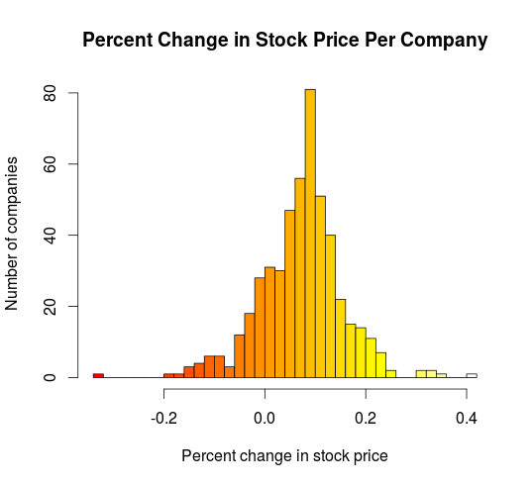 | 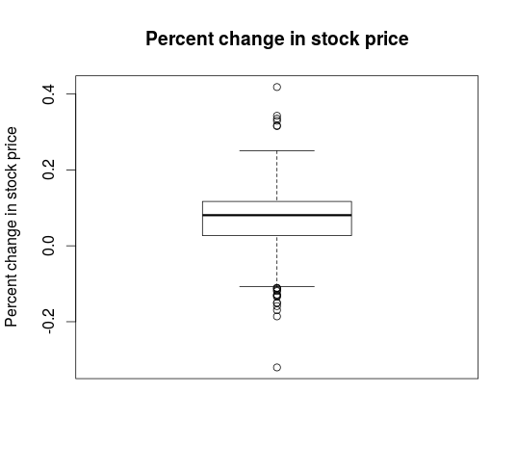
Figure 1: a: The number of companies binned by stock change; b: A box plot showing mean, standard deviation and outliers of the stock change variable.

Wikipedia. The mean of the number of edits per Wikipedia entry associated with the companies in the S&P 500 for the month of October, 2015 is 5.33. The standard deviation is 10.70. Figure 2a shows that the distribution is skewed. More than half of the Wikipedia entries were never changed or changed only once during the month. The mean of the size of the edits (edit volume) per Wikipedia entry associated with the companies in the S&P 500 for the month of October, 2015 is 320070 bytes. The standard deviation is 1180284 bytes. Figure 2b shows that this distribution, too, is skewed. Most of the pages had changes of less than a few hundred bytes throughout the month.

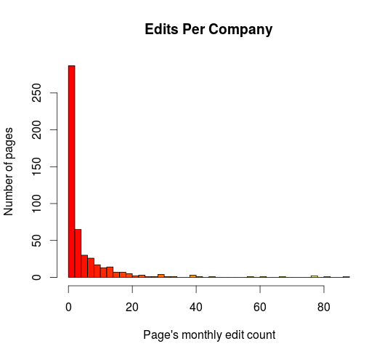 | 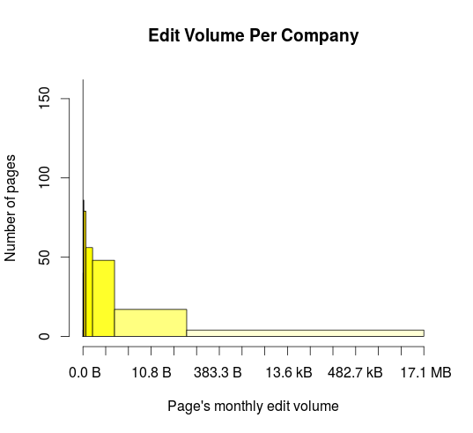
Figure 2: Histogram showing the number of pages binned by the number (a) and volume (b) of edits during the course of October, 2015.
Correlation. Correlation between variables in shown in Table 1.
 |  |  | r | r²
1 | Edit Count | Stock Volume | 0.2651228
2 | Edit Count | Stock Change Magnitude | 0.08948788
3 | Edit Count | Stock Change Direction | 0.05965355
4 | Edit Volume | Stock Volume | 0.2799773
5 | Edit Volume | Stock Change Magnitude | 0.05913718
6 | Edit Volume | Stock Change Direction | 0.03950573
7 | Edit Count | Edit Volume | 0.8002952
8 | Stock Volume | Stock Change Magnitude | 0.1066347
9 | Stock Volume | Stock Change Direction | 0.05795046
Table 1: Caption goes here.
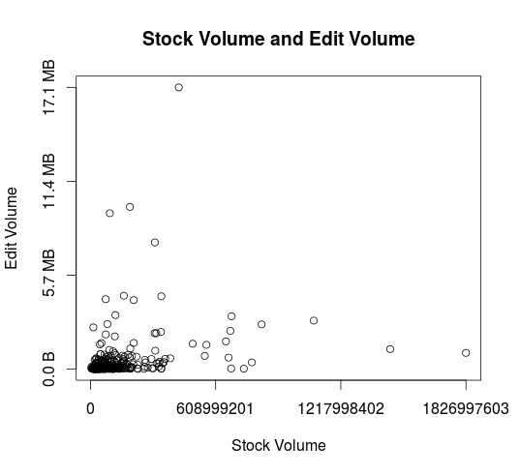 | 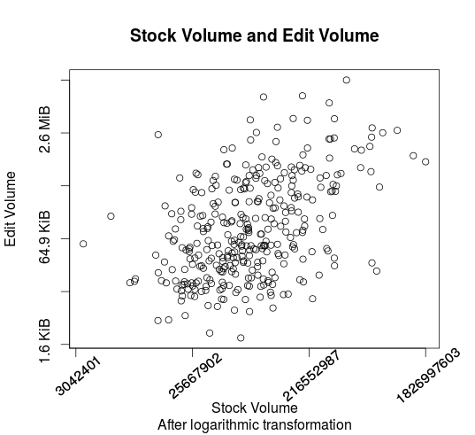
Figure 3: Visualizing correlation between stock volume and edit volume (on a linear scale (a) and on a log-log scale (b)).

Inferential
To support the substantive research question, this study hypothesizes that the average trading volume of companies whose Wikipedia pages where changed during the month will be greater than the average trading volume of those companies whose pages were not changed during the same period.

To repeat from above, the population stock volume mean is 106486731 and the population stock volume standard deviation is 159838118. Out of the 496 total company Wikipedia pages, 334 entries were edited during the month of October, 2015 with a sample stock volume mean of 126155318. Because we know the population parameters, we can test the hypothesis with a z-test.
H₀: u_{change} – u_{no change} ≤ 0
H₁: u_{change} – u_{no change} > 0

u_{no change} | σ_{no change} | X | n | α | z_cv | z | d
106486731 | 159838118 | 126155318 | 334 | 0.05 | 1.645 | 2.248879 | 0.1230532

To support our substantive research question, we furthermore hypothesize that the average edit count of companies whose stock change was more than 1% (either positively or negatively) during the month will be greater than the average edit count of those companies whose stock change was less than 1% during the same period. To repeat from above, the population edit count mean is X and the population edit count standard deviation is X. Out of the 496 total companies under study here, the closing price of 465 of the stocks changed more than 1% either positively or negatively.
H₀: u_{no change} – u_{change} ≤ 0
H₁: u_{no change} – u_{change} > 0

u_{change} | σ_{change} | X | n | α | z_cv | z | d
5.330645 | 10.702 | 5.48172 | 465 | 0.05 | 1.645 | 0.3044071 | 0.01411654

Discussion
For the most part, the data analyzed in this study are not normally distributed and are skewed. The exception is stock change direction. Based upon visual inspection, that variable seems normally distributed (see Figure 1a). Because only this variable is nearly normally distributed, it is the only one that lends itself to presentation in a box plot (see Figure 1b). The standard deviations for the skewed, non-normally distributed variables (i.e., edit count, edit volume, stock volume) is greater than the mean implying that the values cover a wide range.

Edit count and stock volume and edit volume and stock volume show at least a non-negligible amount of correlation (r=.265 and r=.279, respectively). Based on these values, it is possible to conclude that 7% of the variation in edit count is accounted for by variation in stock volume (and vice-versa) and that 7.7% of the edit volume is accounted for by variation in stock volume (and vice-versa).

As Coladarci and Cobb emphasize, the Pearson correlation coefficient “is a measure of linear association” (Coladarci, 2014, p. 111). Based on visual inspection of the data, the associations presented in Table X are anything but linear. However, when the data are plotted in a log scale, the association is linear. For example, consider the association between stock volume and edit volume (with companies whose pages were not edited in October, 2015 removed) on a logarithmic scale (Figure 3b). So transformed, the association is linear and shows a remarkable amount of correlation (r=0.46).

The results of the z tests help provide a final answer to the substantive research question. To reiterate, this study is interested in determining whether real-world events affect the stability of a company's Wikipedia entry, where stability of a page is a key determining factor in educator's assessment of the information's suitability for reference in a report or essay. In the first test, we reject the null hypothesis and conclude, with a significance level of α=0.05, that companies whose Wikipedia entries changed during October, 2015 had a statistically significant increase in mean stock volume. More importantly, d=0.1230532 shows a xxx effect size. While interesting, that result is the opposite of what the study aims to determine.

The results of the second z test may provide more information. However, in this test, we fail to reject the null hypothesis. Therefore, at a significance level of α=0.05, we cannot conclude from the October, 2015 data that a stock price change magnitude of more than 1% can be used to infer anything about number of edits to a company's Wikipedia entry.

As mentioned previously, properly understanding the relationship between the real-world and the rate of change to pages on Wikipedia requires far more statistical techniques than we have in our toolkit. The use of longitudinal techniques would allow us to study the changes over time and likely produce more meaningful results. The skew and large range in the data also make the use of linear regression, z tests and other introductory statistical methods highly suspect. Before drawing further conclusions from the data, more sophisticated analysis must be applied.

Conclusion
The study targeted high school civics, economics and marketing teachers and students and investigated the relationship between the characteristic's of a publicly traded company's stock (e.g., trading volume, price change) and the characteristic's of their page on Wikipedia. The question is important for students and teachers to decide on how and when it is appropriate to use a company's Wikipedia page for academic work. Based upon the available data and stastical methods available, this study shows that there are certain relationships among real-world events (as proxied by stock change and stock volume) and changes to Wikipedia entries. However, the extent of those relationships and their direction is harder to assess and requires further study.

Alanyali, M., Moat, H.S. & Preis, T. (2013). Quantifying the Relationship Between Financial News and the Stock Market. Sci. Rep. 3, 3578. DOI:10.1038/srep03578
Coladarci, T., & Cobb, C. D. (2014). Fundamentals of statistical reasoning in education (4th ed.). Hoboken, NJ: Wiley.
API:Revisions – MediaWiki. (2015). Retrieved December 13, 2015 from the MediaWiki Wiki: https://www.mediawiki.org/wiki/API:Revisions
Quandl. (n.d.) Quandl financial and economic data. Retrieved from http://www.quandl.com

