**How to get station ID from station name**

1. Go to <http://climate.weather.gc.ca/>.
2. In Step 1, select “Daily”.
3. In Step 2, choose a year in which there could be some daily data.
4. In Step 3, input the station name

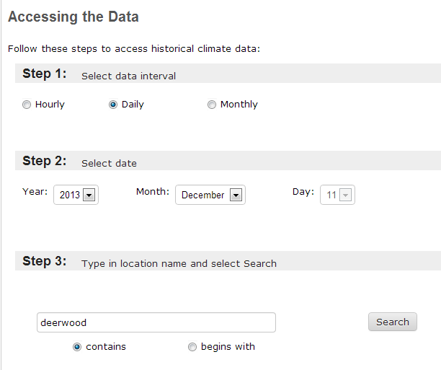

1. Hit the “Search” Button.
2. If more than one station is given, select the station you want to use.
3. Then you will be navigated to the daily data report page.

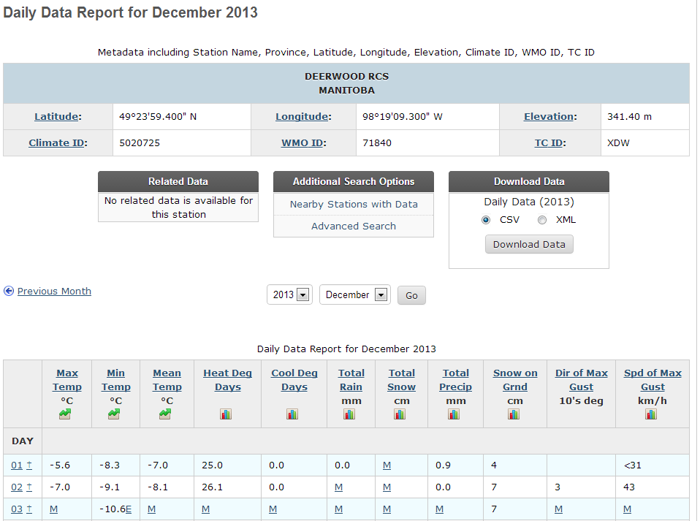

The address of this page would be in following format: *http://climate.weather.gc.ca/climateData/dailydata_e.html?timeframe=2&Prov=MAN%20&****StationID****=****29886****&dlyRange=2000-01-01|2013-12-11&Year=2013&Month=12&Day=11*

A key named **StationID** will be found in this address. The value for this key is the station ID we need. In this case, the station ID is **29886**.

