BIOS_6643 Project Check-in (Phase 2)

Trent Hawkins

# Introduction

Colorado is seen as an outdoor-recreation paradise for many. Backcountry Skiing, Snowshoeing, Cross-Country Skiing, and Snowmobiling allow recreationists to depart from the limitations of ski resorts, and explore the millions of acres of beautiful backcountry that Colorado has to offer. When users leave the resorts, however, the also leave the curated safety of pre-blasted slopes and boundaries that mitigate avalanche danger.

Over the past decade, backcountry skiing has exploded in popularity sending more recreationists than ever into the wilderness, but also into harm’s way. Looming quietly in the background of this sports rebirth is the omnipresent issue of climate change. It is no secret that global temperatures are rising. Rising temperatures have a complex impact on state-wide or even more local climate patterns which are difficult to quantify. Avalanche frequency and severity are both *extremely* sensitive to local climate patterns, but the impacts of climate change on these two outcomes have not yet been evaluated in the state of Colorado.

This study will aim to describe trends in climate throughout the state of Colorado over the past decade and their impact on avalanche frequency and severity.

# The Data

I have obtained data from the Colorado Avalanche Information Center (CAIC), which characterizes avalanches in Colorado since 2010. Data are user-reported and can be broken down into “Natural” and “Artificial” triggers.

Figure : Avalanche Zones of Colorado (CAIC)

I have also obtained daily weather/climate records from the SNOTEL network maintained by USGS and USDA. These data has open access to the public and can be found [here](https://wcc.sc.egov.usda.gov/reportGenerator/). Figure 2 shows what the average SNOTEL site would look like.

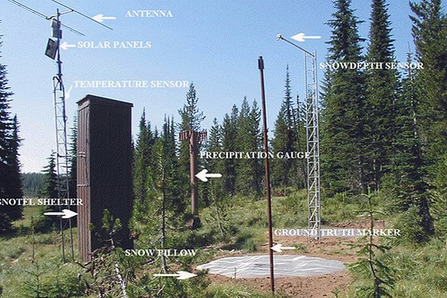

Figure : Description of an average SNOTEL site

Most avalanches in Colorado occur above tree line, which can vary by region. To control for the variability in tree line based on location. I have simply grabbed data from the highest-elevation site in each zone as described by CAIC weather records [here](https://www.avalanche.state.co.us/observations/weather-stations/). Weather records are at a daily resolution and contain information about snow depth, snow accumulation, average air temperature, max. air temperature, min. air temperature, and average wind speed. Figures 3 and 4 show summary graphs of these data.

Figure : Mean Annual Temperature by Zone (2010-Present) The variability in the elevation and site-level characteristics are visible in this graph.

Although Figure 3 is quite noisy, it is clear that most sites follow a similar non-linear trend. We should be able to account for variability by including a random intercept for site at the very least.

Figure : Daily Snow-Water Equivilent since 2010

The variability due to elevation and site-level characteristics (e.g. tree cover) are visually obvious in this plot. It still appears that most sites follow a similar non-linear trend.

Figures 3 and 4 are meant only to summarize the data. Climate variables will be paired with avalanche observations at a daily resolution.

Figures 5 and 6 summarize the frequency and severity of avalanches in Colorado over the last 10 years.

Figure : Naturally triggered avalanches since 2010

Figure 5 shows naturally triggered avalanches since 2010. Interestingly, there is an obvious non-linear increase that that most avalanche zones are following.

Figure : Artificially triggered avalances since 2010

Figure 6 shows all artificially triggered avalanches since 2010. This graph is noisier and probably still needs further cleaning. There are some types of “Artificial” avalanches that are intentional (i.e. blasting to protect highway corridors) that are still included here.

# Data Correlation

Avalanche and climate data could be correlated spatially, temporally, or spatio-temporally. We will experiment with several correlation structures for our data to explore the advantages and limitations of each method.

# Expected Limitations

As discussed earlier, the direct effects that climate change has on local weather patterns are complex and riddled with sources of confounding/multicollinearity. This study will address that challenge by only trying to characterize the relationship that high-level climate trends have with avalanche frequency and severity.

An undeniable driving force of artificial avalanche frequency and severity are the number of people recreating in the outdoors. I have not been able to acquire that data yet, but I am still looking.

The models used for this study will have to make *many* simplifying assumptions.