For the given 8 test cases, we divided them into 2 test suites. The first suite tests cases 1 through 4. And the second tests the rest.

There’re four test files in total, namely **1_file2047 2_file2048 3_file2CR** and **pycharm.dmg**

# Test Suite 1:

Since we’ve implemented BONUS feature, the WRQ function will be tested first. We append an extra character ‘s’ before the original file to indicate that this is the file received by the SERVER. We then test the RRQ function. We append an extra character ‘d’ before the original file to indicate that this is the file that is [double] transferred back to the client. For file 1 and file 2, we’ll transfer the server received file back to the client, for file 3, according to test demands, we’ll transfer the original file to the client. Figure 1,2 shows the test results.

We first put 3 files to the server, then put a large binary file to the server.

We then use ‘diff’ command to compared the copied file and the original file, which is the same.

We then look at the ‘netascii’ mode file to see if there’re two extra NULL characters added to the copied file, which is true.

Finally, we transferred a big file ‘pycharm.dmg’, which is of 200+MB size. The transferred file and the original file are the same.

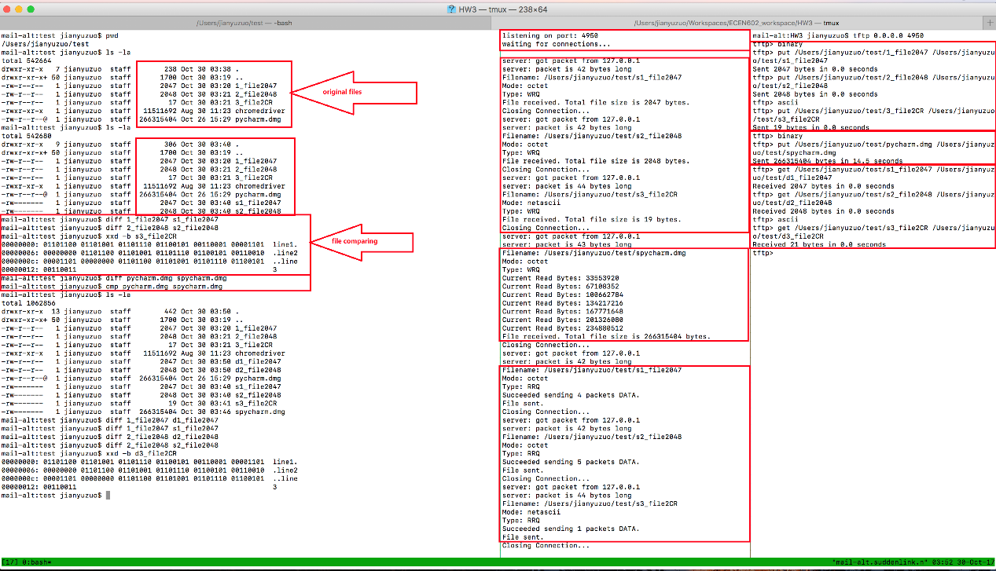

Figure 1

After the above procedures, we transferred back each copied file to the client, except for the third ‘netascii’ mode file. Figure 2 shows that all three files are the same, and the file transferred in ‘netascii’ mode is correctly configured.

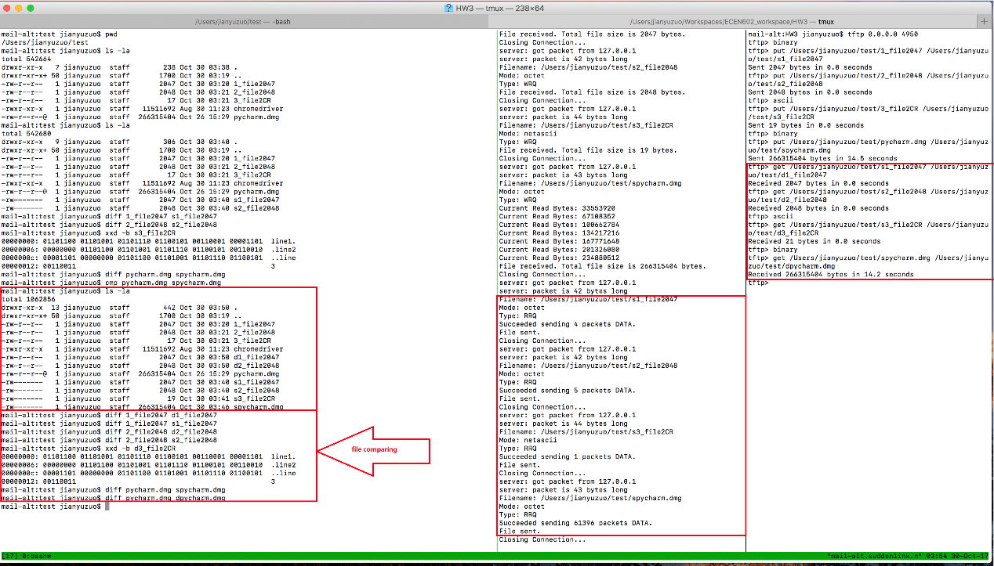

Figure 2

# Test Suite 2:

In this test suite, we will test for multi-connections, error message and timeouts.

Figure 3 shows 4 identical ‘get’ requests to the server at the same time. Figure 4 shows the file comparing result.

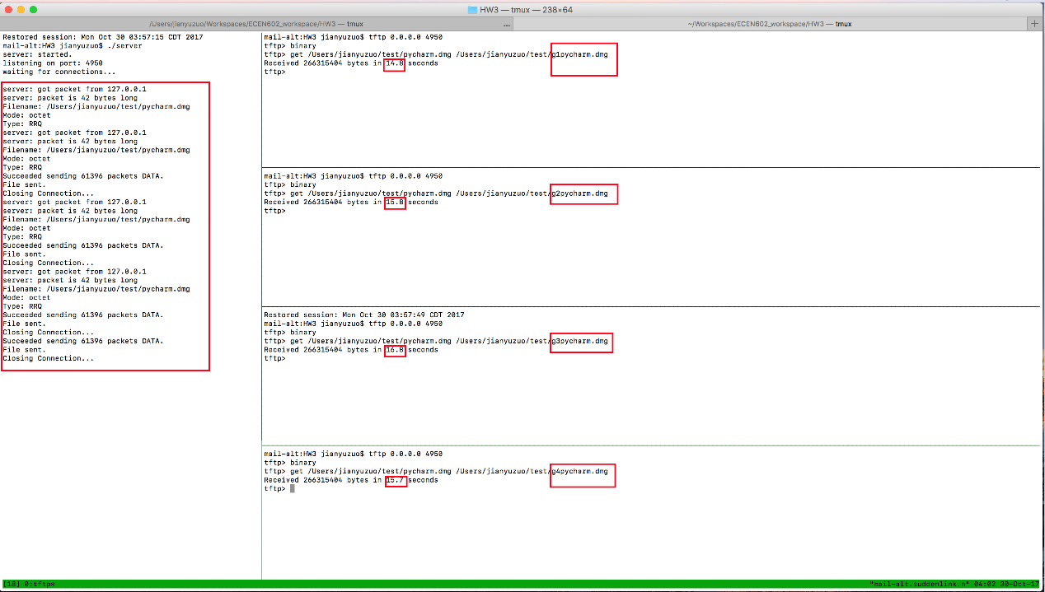

Figure 3

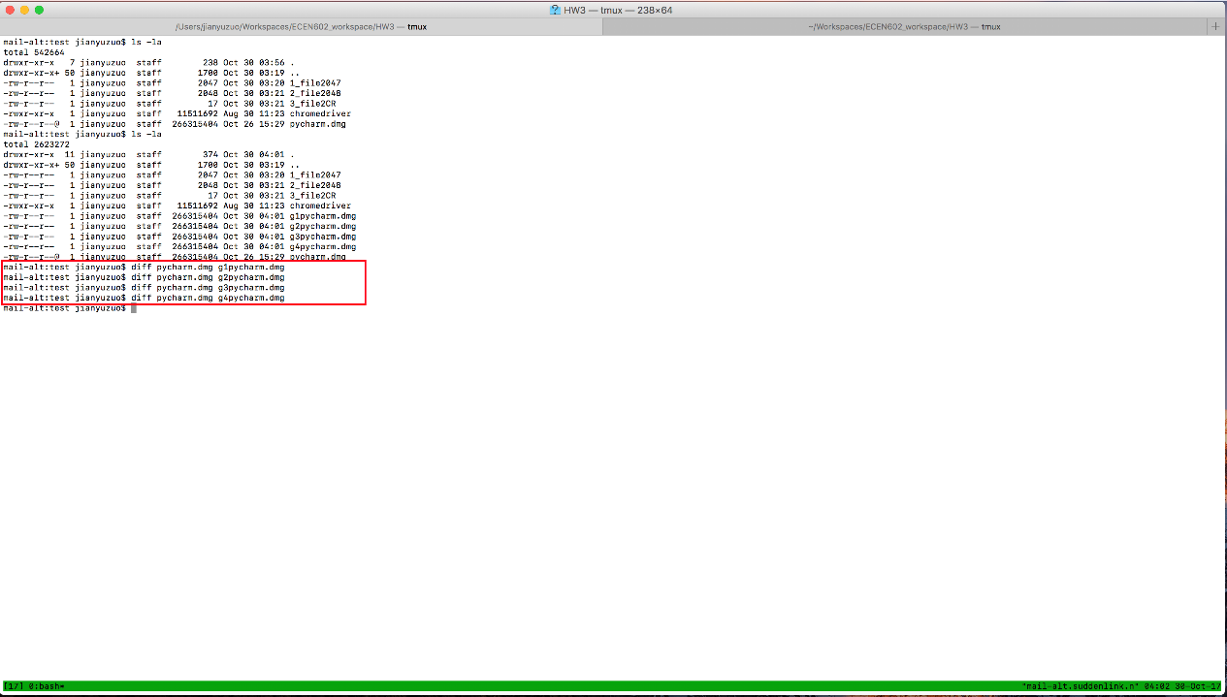

Figure 4

Figure 5 shows the timeout figure.

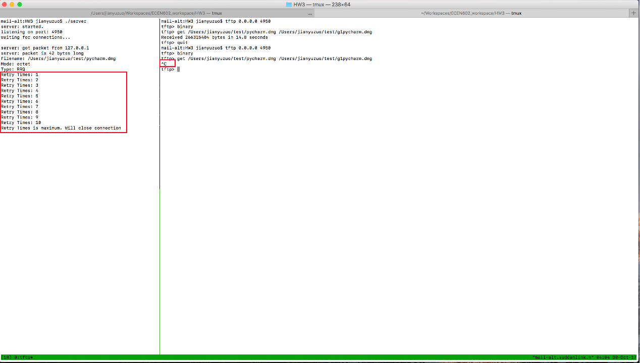

Figure 5

Figure 6 shows the ERROR message type

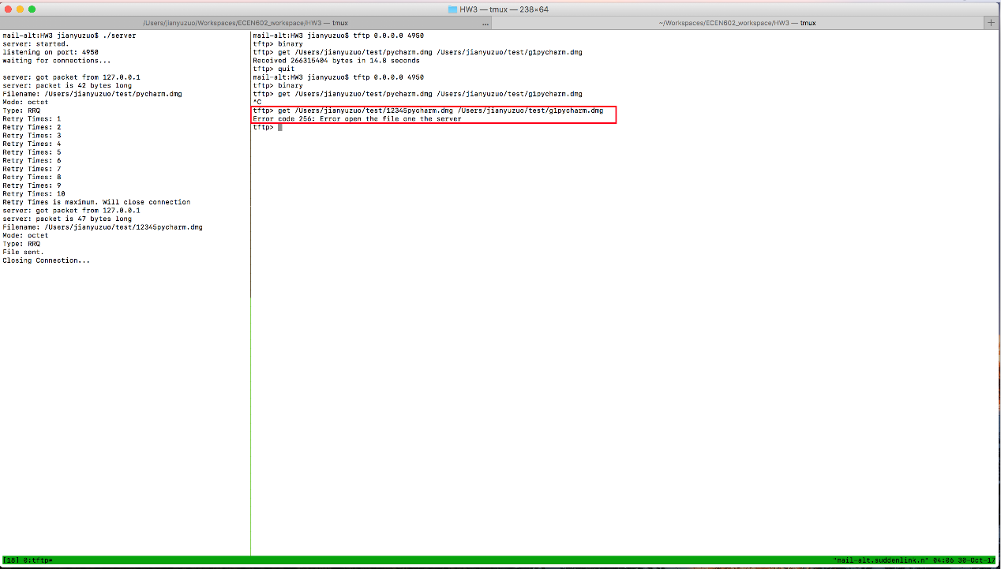

Figure 6