EDA Assignment Report

Task 1: Data Quality Issues
Dataset Shape: (740, 21)
Missing Values:
All columns have 0 missing values.
Duplicate Rows:
34
Data Types:
All features are numerical (int64/float64).

Task 2: Missing Value Strategy
Artificial missing values were introduced in Age column (5 values).
Before handling: 5 missing values
After mean imputation: 0 missing values

Task 3: Outlier Detection (IQR)
Number of outliers detected: 44
Shape before removing outliers: (740, 21)
Shape after removing outliers: (662, 21)

Task 4A: Min-Max Normalization
Applied Min-Max scaling to selected numeric features.
Values scaled between 0 and 1.
Min-Max Normalization:
Distance from Residence to Work Age Work load Average/day \
0 0.659574 0.230769 0.244925
1 0.170213 0.884615 0.244925
2 0.978723 0.423077 0.244925
3 0.000000 0.461538 0.244925
4 0.659574 0.230769 0.244925

Absenteeism time in hours
0 0.250
1 0.000
2 0.125
3 0.250
4 0.125

Task 4B: Z-Score Standardization
Applied StandardScaler.
Features transformed to mean=0, std=1.
Z-Score Standardization:
Distance from Residence to Work Age Work load Average/day \
0 0.407282 -0.514836 -0.831678
1 -1.150437 2.276089 -0.831678
2 1.423186 0.306025 -0.831678
3 -1.692253 0.470197 -0.831678
4 0.407282 -0.514836 -0.831678

Absenteeism time in hours
0 -0.079391
1 -1.247321
2 -0.663356
3 -0.079391
4 -0.663356

Task 5: PCA
Explained Variance Ratio:
[0.2907, 0.2790, 0.2310, 0.1993]
Cumulative Explained Variance:
[0.2907, 0.5697, 0.8007, 1.0000]
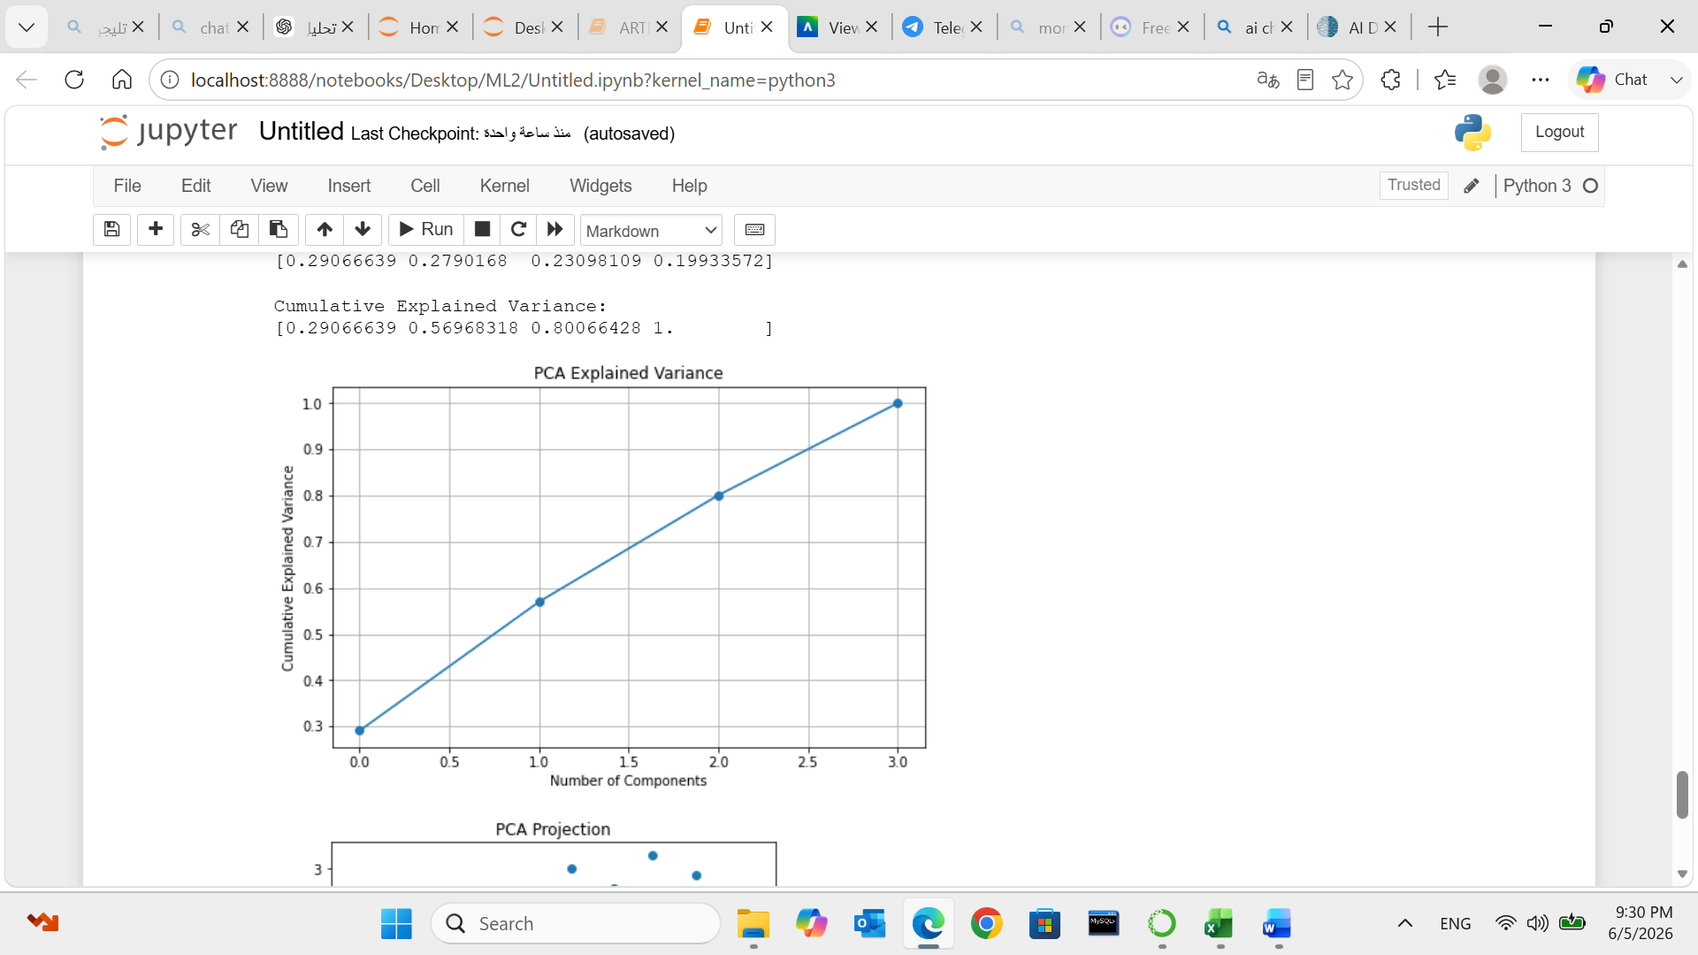
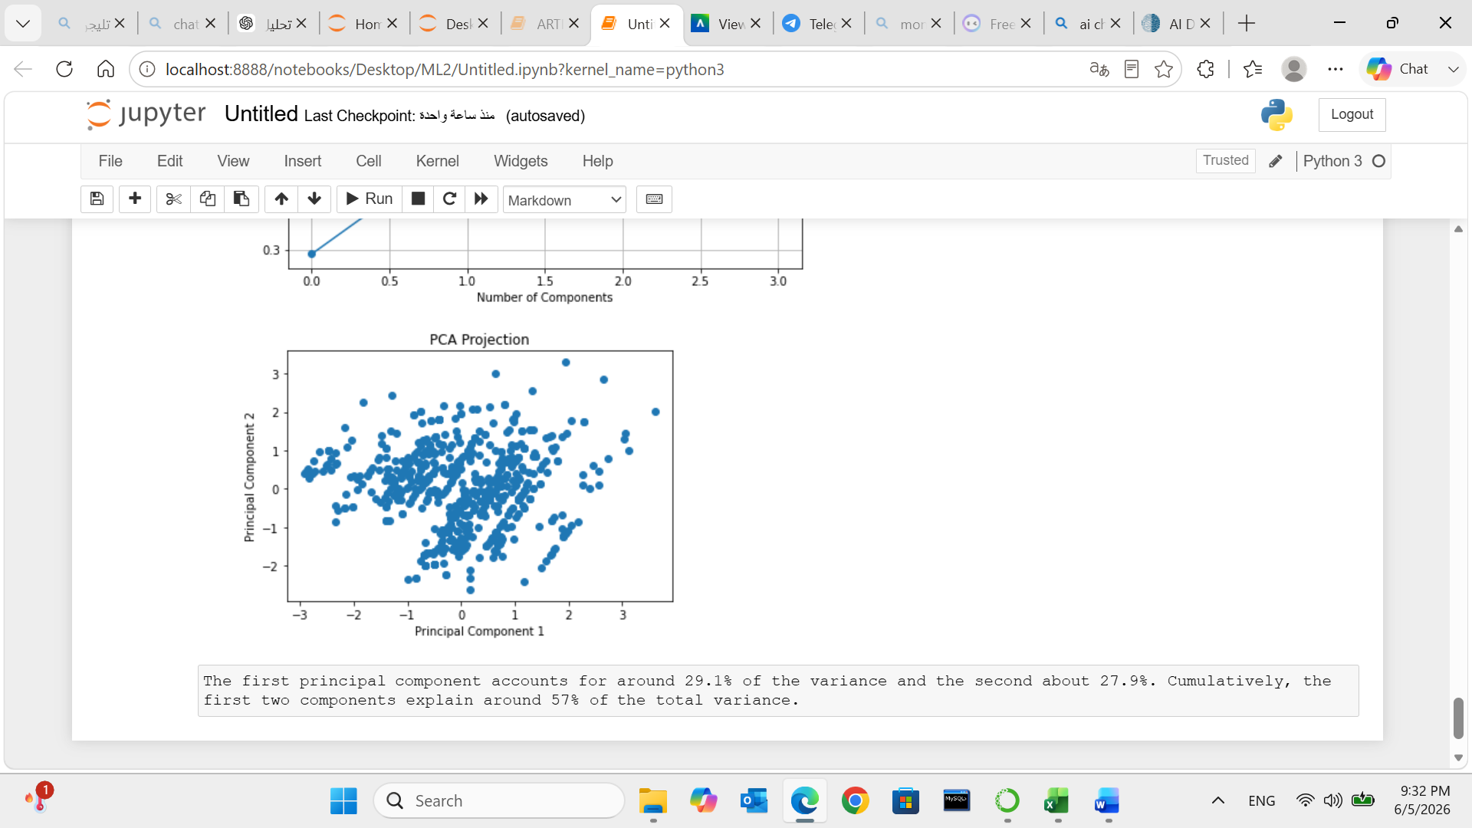
First 2 components explain ~57% variance.

