**bash-Rscript-RMarkdown**

Timeline:

* **Skim and take notes Ch 2 – 3.1 (20min)**
* Determine framework of Rscript and Rmd (ex: where do library calls go? where other code) (10m)
* Write code and test as I go (30m)

Chapter 2 – 3.1 Notes:

* .Rmd quite similar to Java setup (metadata aka header, chunked code)
  + YAML (metadata) is indent dependent
* Chunk: ```{r} ... ```; Inline: `r ... `
  + Chunk: 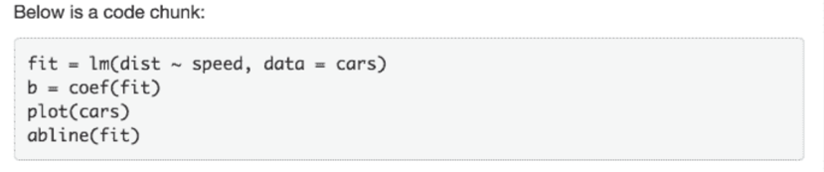
  + Inline: 
* Chunk options inside curly braces: ```{r, fig.height = 5} – figure is 5 in tall
* Knit: Cmd + Shift + K; Console: rmarkdown::render()
* Italics: _text_ or *text*
* Bold: **text**
* Subscript: H~3~PO~4~
* Superscript: Cu^2+^
* Inline Code: `code is within back ticks`
* Backticks: Surround *n* backticks with *n + 1* backticks (`` `like this many` ``)
* Links: [text displayed] (link)
* Images: ![Image Label] (path/to/image)
* Footnotes: ^[put footnotes inside]
* Headers: decrease in size as # increases
* Chunk Options: <https://yihui.name/knitr/options>
  + Ex: Chunk execution (time, error, caching)
  + Ex: Output (figure appearances, captions)
* Rmd supports many languages (ex: Python, Javascript, etc.)
* Rmd allows for interactive R documents and shiny documents (ex: change plot settings on the fly)

Chapter 3.1 features many stylistic choices available in Rmd including themes and tabs.