Interviewer Notes:

- Ask, describe the Observer pattern.
Its used in event notification.. One class (subject) takes a collection of others (observer), and notifies them when something happens.

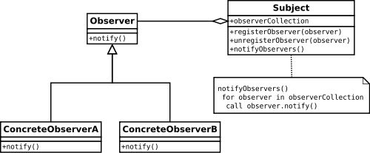

Next Steps:
Other Design: Patterns: (Easy)

