BAHJAH
بهجة
Game Design Document
Game flows for the full Bahjah party-game suite
Attribute | Value
Product | Bahjah — bilingual (English / Arabic) multiplayer party games
Games covered | Trivia · Mafia · Knows You Best · Fabrication · Auction (مزاد) · Insan Hayawan Jamad (إنسان حيوان جماد) · Welcome to a Saudi Home (Hayakom)
Source of truth | Server game engines in apps/server/src/modules/games (staging branch)
Document date | 7 November 2026
Status | Reflects the behaviour currently implemented in code

Contents

Right-click the table above and choose "Update Field" if page numbers are not shown.

1. Platform Overview

1.1 Vision
Bahjah is a collection of social party games played in the same room. A host puts one shared screen (usually a television or laptop) in front of the group, and every player joins and plays on their own phone. All games are bilingual (English and Arabic) and built around the culture of Saudi gatherings — the majlis, the family evening, the company event.

1.2 Roles at the table
Role | Device | Responsibilities
Host | Shared screen (TV / laptop) | Creates the room, configures the game, presses Start, monitors and controls the room. In every game the host does not play and is never scored.
Player | Own phone | Joins with the room code, readies up, and takes all in-game actions (answering, voting, writing, etc.).
Practice bot | Server-side | Optional filler players the host can add to a short room. Bots act automatically; phase-ending actions are held back to the last ~30% of the phase timer so humans still get most of the phase.

1.3 Common room lifecycle
Every game shares the same outer flow. The game engine only owns the part between Start and Finished.
- Create room — the host picks a game and receives a short room code.
- Lobby — players join by code on their phones, see each other appear, and mark themselves Ready. The host opens the game-specific setup panel (categories, rounds, timers, language…). Any setting the host skips falls back to a sensible default.
- Start — only the host can start. The room must have at least the game's minimum number of non-host players and no more than its maximum.
- In progress — the engine runs its phases. Phases end either on a server timer, when everyone present has acted, or when the host advances. Players who disconnect stop being waited on, so the room never stalls on an empty seat.
- Finished — final standings and stats are shown; results are saved to game history and feed the Game-Night Recap awards.
- Play again / End — the host can restart the same room (same code, settings kept, everyone returns to the lobby) or end it.

1.4 Player counts at a glance
Game | Min players | Max players | Typical length
Trivia | 2 | 150 | 10 questions (~5 min)
Mafia | 5 | 50 | Until one side wins (≤ 12 rounds)
Knows You Best | 3 | 12 | 3–10 rounds (default 3)
Fabrication | 2 | 20 | 3–8 rounds (default 6)
Auction (مزاد) | 3 | 10 | 3–8 lots (default 5)
Insan Hayawan Jamad | 3 | 8 | 3–8 letters (default 5)
Welcome to a Saudi Home | 1 | 12 (or the event's limit) | 5 rooms + 5 final questions
Counts exclude the host, who never plays.

1.5 Game-Night Recap awards
Per-game highlights are saved with each finished game and combined into a night-wide recap: MVP, Fastest, Brainiac, Hot Streak, Best Liar, Lie Detector, Mind Reader, Open Book, Original, Quick Draw, Big Bidder, Mastermind and Survivor.

2. Trivia

2.1 Concept
A fast, multiple-choice quiz. Everyone sees the same question at the same moment on the big screen and races to tap the right answer on their phone. Speed and consistency both pay.
Attribute | Value
Players | 2 – 150 (host does not play)
Rounds | 10 questions per game
Content | Built-in question bank (by category and difficulty) plus optional host-authored custom categories
Win condition | Highest total score after 10 questions (ties share the win)

2.2 Host setup (lobby)
- Difficulty — any mix of Easy / Medium / Hard (default: Medium). The 10 questions are shared out across the chosen difficulties.
- Categories — any of the built-in categories (default: all except seasonal ones such as Saudi National Day, which must be opted into).
- Custom categories — up to 10 host-written categories, each with 1–30 four-choice questions.
- Questions the same host has served recently (last 30 days) are drawn last, so repeat game nights stay fresh.

2.3 Game flow
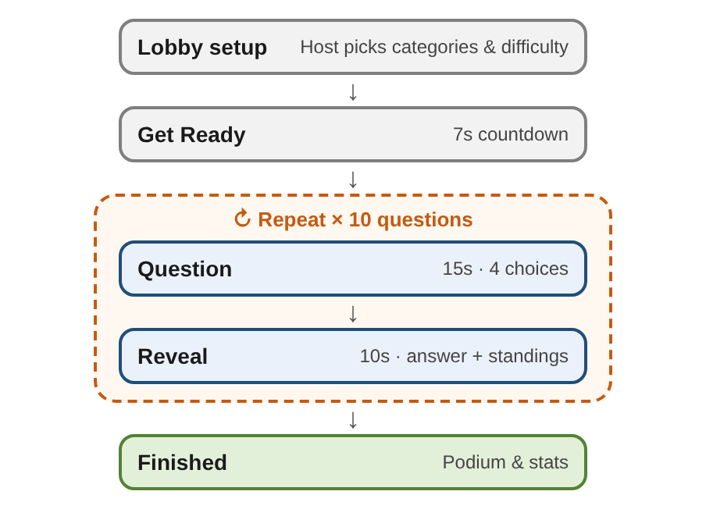
Figure 2.1 — Trivia flow
Phase | What happens | Ends when | Duration
Get Ready | Countdown on all screens so players can put their thumbs on their phones. | Timer | 7 s
Question | Question and four choices shown. Each player taps one answer; it is locked once sent. | Every player has answered, or timer | 15 s
Reveal | Correct answer highlighted, each player's points for the round, updated leaderboard. | Timer | 10 s
Finished | Winner(s), final scores, correct-answer count and average speed per player. | — | —

2.4 Scoring
Component | Points | Rule
Correct answer | 100 | Base points for the right choice.
Speed bonus | 0 – 50 | 50 × fraction of the 15 s timer still remaining when the answer arrived.
Streak bonus | 0 – 50 | +10 for each consecutive correct answer after the first (capped at +50).
Wrong / no answer | 0 | Also resets the streak.

3. Mafia

3.1 Concept
A social-deduction game. A hidden Mafia team eliminates one player each night; the Village (Citizens, Doctor and Detective/Sheriff) must work out who the Mafia are and vote them out during the day. The host narrates from the big screen; every role acts secretly on their phone.
Attribute | Value
Players | 5 – 50 (host is never dealt a card)
Teams | Mafia vs. Village
Length | Until one side wins; forced Village win after round 12 to prevent stalemates
Win condition | Village: all Mafia eliminated. Mafia: Mafia outnumber the Village, or the last two alive are 1 Mafia + 1 Citizen.

3.2 Roles
Role | Team | Night ability
Mafia | Mafia | Private team chat; all living Mafia vote on one kill target. The kill only happens if every living Mafia member has chosen (ties broken at random).
Doctor | Village | Protects one player per night. Cannot protect the same player two nights in a row; self-protection is a host setting. If time runs out, a protection is picked automatically.
Detective (Sheriff) | Village | One ability per night: Investigate a player (learns Mafia / not Mafia; cannot repeat a target), or from night 2 Read — choose a player and open one of their previous-round private conversations (the other party stays anonymous).
Citizen | Village | No special ability. May open private one-to-one chats with any living player during the night.

Role distribution
By default the deal gives 2 Mafia for every complete group of 5 players (5–9 players → 2 Mafia, 10–14 → 4, 15–19 → 6, …), plus exactly one Doctor and one Detective; everyone else is a Citizen. The host may override the Mafia count (clamped so the Mafia never start with a win).

3.3 Host setup (lobby)
Setting | Default | Range / options
Day discussion | 120 s | 30 – 300 s
Night | 120 s | 30 – 300 s
Vote | 60 s | 15 – 180 s
Mafia count | Automatic | 1 – 25 override
Tie rule (day vote) | Random | None (no elimination) · Revote between tied players · Random pick
Reveal eliminated role | On | On / Off (applies to players voted out)
Include Doctor / Detective | On / On | Each can be switched off
Doctor may self-protect | On | On / Off

3.4 Game flow
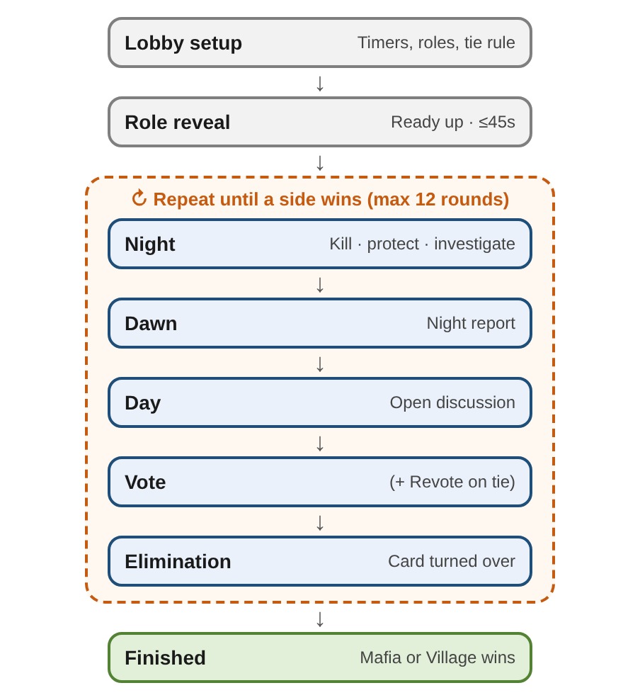
Figure 3.1 — Mafia flow. A win is checked after every Dawn and every Elimination.
Phase | What happens | Ends when | Duration
Role reveal | Each player privately sees their card and taps "I'm Ready". | All ready, or failsafe timer | ≤ 45 s
Night | Mafia chat and vote a kill; Doctor protects; Detective investigates or reads; anyone may hold private chats. | All night roles have acted, or timer | Night timer
Dawn | Room is told who the Mafia took (role stays hidden) or that the Doctor saved someone. Win check. | All living humans tap Start the day, or failsafe | ≤ 45 s
Day | Open group chat and table discussion. | Timer (or host) | Day timer
Vote | Every living player votes to eliminate someone. | All voted, or timer | Vote timer
Revote | Only when tie rule = Revote: vote again among tied players. A second tie = no elimination. | All voted, or timer | Vote timer
Elimination | The voted-out player's card is shown (role revealed if enabled). Win check. | All living humans tap Begin the night, or failsafe | ≤ 45 s
Finished | Winning side announced; all roles revealed; Doctor saves, Detective finds and voting accuracy shown. | — | —

3.5 Host controls
- Advance — ends the current phase immediately, resolving exactly what the timer would have.
- Pause / Resume — freezes the clock; resuming restores the remaining time.
- Eliminated players can no longer act, chat or vote.

4. Knows You Best

4.1 Concept
A get-to-know-you game. Everyone answers the same personal prompt anonymously, then tries to match each answer to the friend who wrote it. There is no clock — the room moves at its own pace.
Attribute | Value
Players | 3 – 12 (host does not play)
Rounds | 3 – 10 (default 3)
Question banks | Break the Ice · Imagine If · For Close Ones Only (one is chosen per game)
Win condition | Highest total score at the end

4.2 Game flow
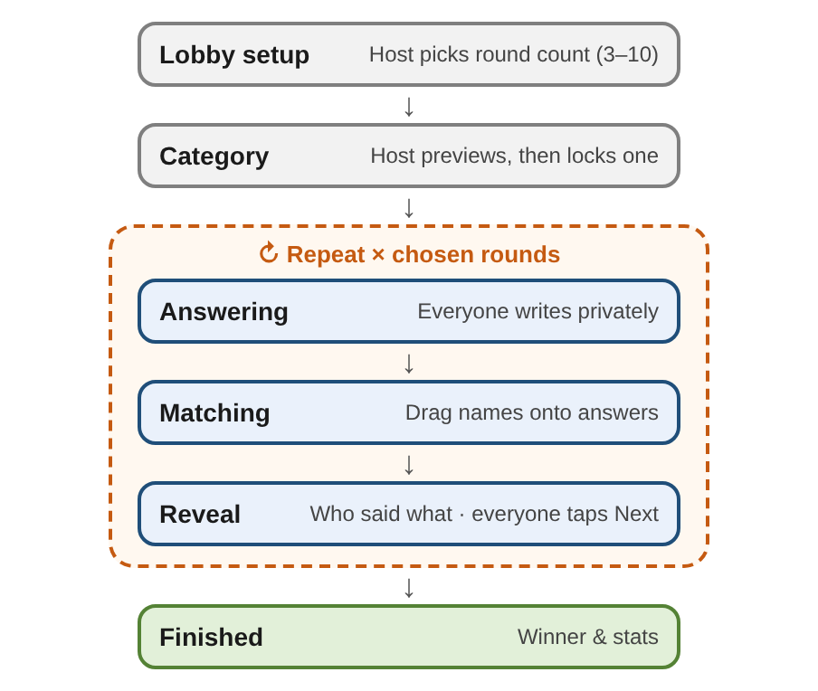
Figure 4.1 — Knows You Best flow
Phase | What happens | Ends when | Duration
Category | The room controller previews a category on the TV (so the room can object), then locks it in. The prompts for the game are drawn from it. | Category picked | No timer
Answering | The prompt is shown; each player privately writes an answer (max 280 characters). | Every present player has answered | No timer
Matching | All answers are shown anonymously in a shuffled order. Each player drags a name onto every answer except their own (one name per answer) and can change the board until it closes. | Every present player has a complete board | No timer
Reveal | Each answer's author is shown, with who guessed right and wrong, round points and the single round winner. | Every player taps Next (or host advances) | No timer
Finished | Winner, total correct matches, perfect rounds, accuracy %, and "who knows you best". | — | —

4.3 Scoring
- 100 points for each answer correctly matched to its author.
- +100 perfect-round bonus for matching every answer correctly.
- Round-winner tie-break: higher round score → more correct matches → board locked first.

4.4 Host controls
- Advance any phase early, or Skip to Finale to end the game with the current scores.

5. Fabrication

5.1 Concept
A bluffing game. The room is shown a surprising fact with a blank. Each player writes a believable fake answer; then everyone tries to spot the real answer among all the lies. You score by finding the truth and by fooling your friends.
Attribute | Value
Players | 2 – 20 (host does not play)
Rounds | 3 – 8 (default 6); questions never repeat within a room until the bank runs out
Language | English or Arabic, locked at start (questions, the real answer and decoys all use it)
Win condition | Highest total score at the end

5.2 Host setup (lobby)
- Rounds — 3 to 8.
- Writing timer — 45, 60 (default) or 90 seconds.
- Language — English or Arabic.

5.3 Game flow
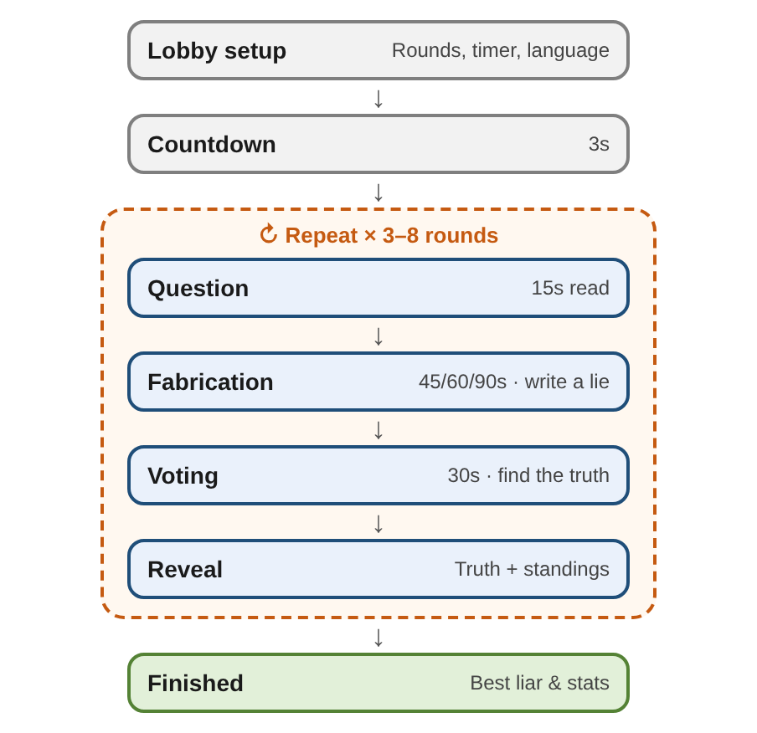
Figure 5.1 — Fabrication flow
Phase | What happens | Ends when | Duration
Countdown | Short "get ready" beat. | Timer | 3 s
Question | Everyone reads the fact at the same time; nobody can type yet. | Timer | 15 s
Fabrication | Each player writes one fake answer. A submission that matches the real answer (or an accepted variant) is rejected with "That is the real answer". | All connected players submitted, or timer | 45 / 60 / 90 s
Voting | Board of lettered options: the truth, every player's lie (identical lies merged) and built-in decoys to top the board up to at least one lie per player (min. 2). Players vote for what they think is true; they cannot vote for their own lie. | All connected players voted, or timer | 30 s
Reveal | The truth is revealed, then who wrote each lie and who fell for it; host's Next shows the standings. | All connected players tap Next, or host advances | No timer
Finished | Winner(s), correct votes, players fooled, times fooled, and each player's best lie. | — | —

5.4 Scoring
Action | Points
Voting for the real answer | 2
Each player who voted for your lie | 2 per player fooled
Game-written decoys | Score nobody
Both paths are deliberately worth the same, so knowing the fact and fooling the room are equally viable strategies.

6. Auction (مزاد)

6.1 Concept
A rapid-fire listing game styled as an auction. A category ("lot") goes up — e.g. "Saudi cities" — and every player types as many valid answers as they can before the clock runs out. The host strikes anything that should not count, and the lot is SOLD to whoever named the most.
Attribute | Value
Players | 3 – 10 (host does not play)
Rounds | 3 – 8 lots (default 5)
Language | English or Arabic for every screen
Win condition | Highest total score after the last lot

6.2 Host setup (lobby)
- Lots — 3 to 8 (setup offers 3 / 5 / 7).
- Answer timer — 45, 60 (default) or 90 seconds.
- Categories — any subset of the category bank (empty = all).
- Language — English or Arabic.

6.3 Game flow
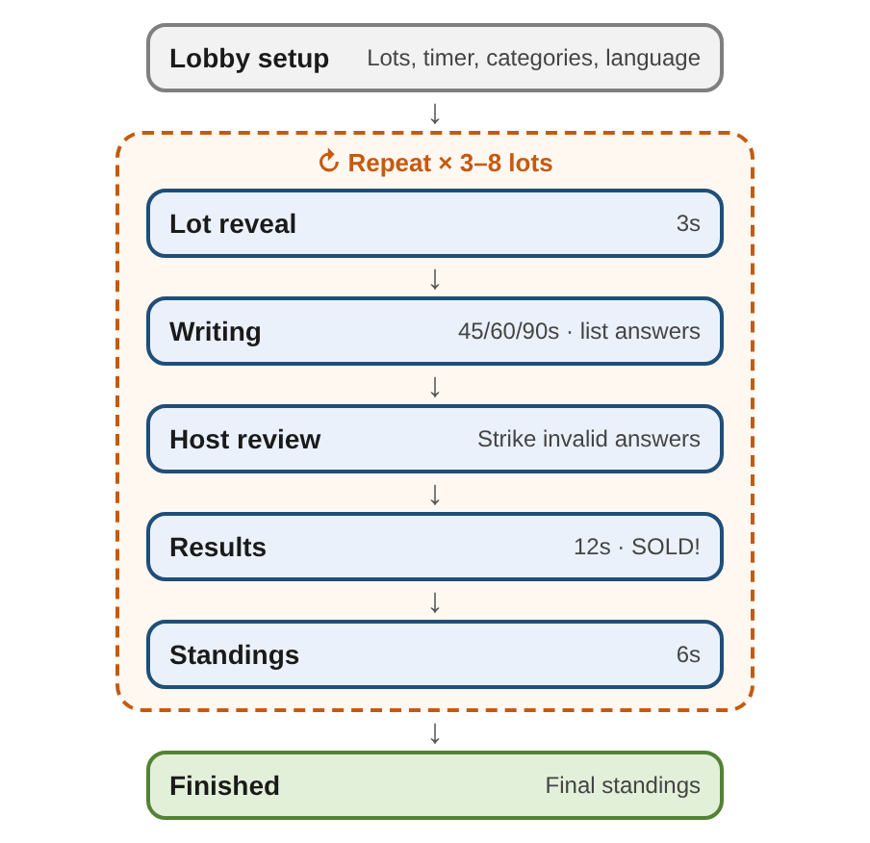
Figure 6.1 — Auction flow
Phase | What happens | Ends when | Duration
Lot reveal | The category name is shown large on every screen. | Timer | 3 s
Writing | Players type answers one at a time (max 60 characters, 200 per lot). Others see only each player's live count, never the words. A player repeating their own answer sees it struck through and uncounted. Players can tap "I'm done". | Timer, or every present player is done | 45 / 60 / 90 s
Host review | All lists become public. The host taps any answer to strike (or restore) it, then confirms. Skipped if nobody wrote anything. | Host confirms | No timer
Results | Counts rise like bids, then SOLD! to the top count. | Timer (host can skip) | 12 s
Standings | Leaderboard between lots (skipped after the final lot). | Timer (host can skip) | 6 s
Finished | Winner(s), lots won, best single-lot count, total valid answers. | — | —

6.4 Scoring
- 1 point per valid answer (not duplicated, not struck by the host).
- +5 bonus to the player(s) with the top count for the lot (ties share it). If nobody scores, the lot goes unsold.

7. Insan Hayawan Jamad (إنسان حيوان جماد)

7.1 Concept
The classic Arab paper game, digitised. Each round a letter is drawn, and every player races to fill five categories — Person, Animal, Object, Plant, Country by default — with words starting with that letter. The first player to finish stops the round for everyone. Unique answers score more than shared ones.
Attribute | Value
Players | 3 – 8 (host does not play)
Rounds | 3 – 8 letters (default 5); weighted draw with no repeated letters
Categories | Exactly 5 per game; host can swap bank categories in and approve categories proposed by players
Win condition | Highest total score after the last letter

7.2 Host setup (lobby)
- Rounds — 3 to 8.
- Answer timer — 30, 60 (default) or 90 seconds.
- Categories — pick five; players may propose new ones, which the host approves or rejects. An approved category replaces the fifth slot.

7.3 Game flow
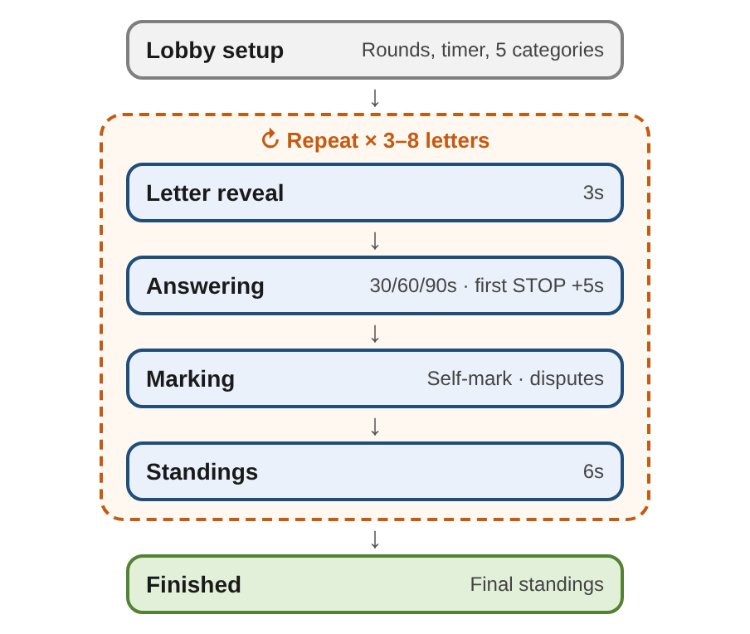
Figure 7.1 — Insan Hayawan Jamad flow
Phase | What happens | Ends when | Duration
Letter reveal | The round's letter is shown, circled, on every screen. | Timer | 3 s
Answering | Each player fills the five boxes privately. The first player to submit presses STOP: everyone else gets a 5-second grace period, then their sheets are sent automatically. | All submitted, STOP grace ends, or timer | 30 / 60 / 90 s
Marking | The full board is shown. The system pre-marks each answer (unique, shared, blank, wrong letter, unrecognised word). Players may mark their own answers down (never up); other players can dispute an answer, which the host settles. Open disputes hold the round. | All players tap Next and no disputes are open, or host advances | No timer
Standings | Round and total scores. | Timer | 6 s
Finished | Winner(s), unique / shared / blank counts, best round, times stopped first. | — | —

7.4 Scoring
Answer | Points
Unique (nobody else wrote it) | 10
Shared (someone else wrote the same word) | 5
Blank, wrong starting letter, or struck | 0
Answers are normalised before comparison (so spelling variants match), but each player's own spelling is kept for display. The host's ruling on a dispute outranks the player's own mark.

8. Welcome to a Saudi Home (Hayakom)

8.1 Concept
A guided cultural quiz-tour through a Saudi house. The group starts in the Majlis and visits four more rooms, each with a challenge themed on that room, then faces a five-question Final Challenge. Originally built for private events (opened from an event link with its own language and player limit) and now also part of the public suite.
Attribute | Value
Players | 1 – 12 (or the event's maximum)
Structure | 5 rooms × 1 challenge, then 5 final questions
Rooms | Majlis (always first) plus four of: Kitchen, Library, Office, Garage, Closet, Living Room, Courtyard
Win condition | Highest score; ties broken by total time taken on correct answers

8.2 Host setup (lobby)
- Optionally hand-pick up to four rooms to follow the Majlis, in order; otherwise rooms are random, with recently shown rooms and challenges put last.
- Late joiners cannot enter once the game has started (scoring is fixed at start).

8.3 Game flow
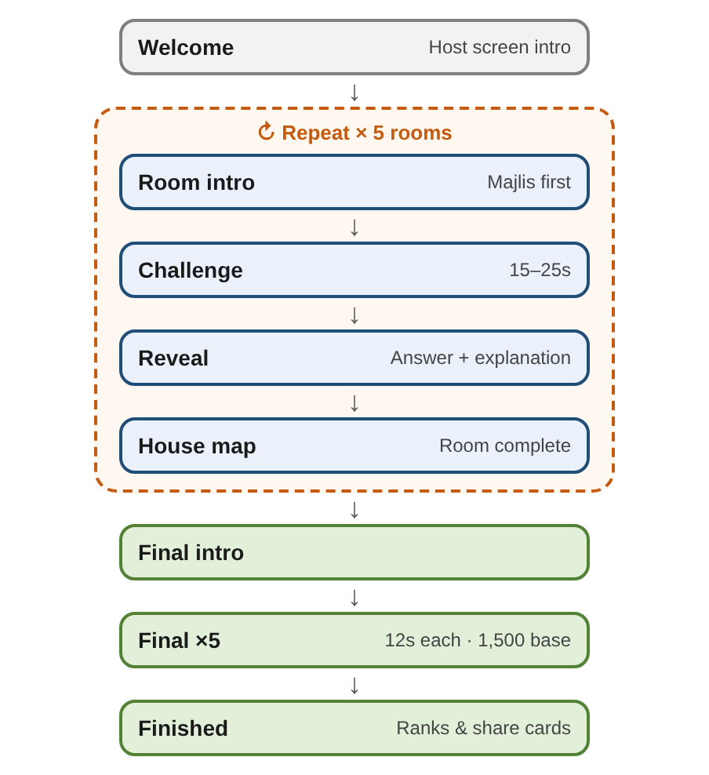
Figure 8.1 — Welcome to a Saudi Home flow
Phase | What happens | Ends when | Duration
Welcome | Intro on the shared screen. | Host taps Next | No timer
Room intro | The room and its theme (e.g. Majlis — Hospitality). | Host taps Next | No timer
Challenge | A single-choice, multi-select or true/false question, often with a large emoji/image. Players answer on their phones. | Timer, all present answered, or host closes | Single 20 s · T/F 15 s · Multi 25 s
Reveal | Correct answer, short explanation, answer distribution and each player's points. | Host taps Next | No timer
House map | Progress through the house; room marked complete. | Host taps Next | No timer
Final intro | Introduces the Final Challenge: Hospitality, Food, Heritage, Modern Saudi, Social & Regions. | Host taps Next | No timer
Final question ×5 | Faster, higher-value questions, each followed by a reveal. | Timer / all answered | 12 s each
Finished | Ranked standings; each player gets a shareable result page; results feed the event/daily leaderboard. | — | —

8.4 Scoring
Component | Room challenge | Final question
Base (correct answer) | 1,000 | 1,500
Speed bonus | Up to 500 × fraction of timer left | Up to 500 × fraction of timer left
Hard-difficulty multiplier | × 1.25 on (base + speed) | × 1.25 on (base + speed)
Wrong / no answer | 0 | 0
Multi-select answers must match the exact correct set.

8.5 Host controls
- Next — moves every non-timed phase on, or closes a challenge early.
- Pause / Resume — a paused challenge keeps the time it had left.
- Skip challenge — swaps in a spare challenge for the same room/final slot.
- Skip room — moves past a room (marked as skipped on the house map if not yet scored).
- Finish — ends the game early with current standings.

Appendix A. Flow Comparison
Game | Core loop | Phase driver | Host judgement?
Trivia | Question → Reveal | Timers | No
Mafia | Night → Dawn → Day → Vote → Elimination | Timers + all-acted + ready taps | No (runs the room)
Knows You Best | Answer → Match → Reveal | Everyone finished (no clock) | No
Fabrication | Read → Write lie → Vote → Reveal | Timers + all-acted | No
Auction | Lot → Write list → Review → Results → Standings | Timers + host review | Yes — strikes invalid answers
Insan Hayawan Jamad | Letter → Answer → Mark → Standings | Timer / STOP + room agreement | Yes — settles disputes
Saudi Home | Room intro → Challenge → Reveal → Map | Host Next + challenge timer | No

Appendix B. Timer Reference
Game | Fixed timers | Host-configurable timers
Trivia | Countdown 7 s · Question 15 s · Reveal 10 s | —
Mafia | Role reveal ≤ 45 s · Dawn ≤ 45 s · Elimination ≤ 45 s | Day 30–300 s · Night 30–300 s · Vote 15–180 s
Knows You Best | None | —
Fabrication | Countdown 3 s · Question 15 s · Voting 30 s | Writing 45 / 60 / 90 s
Auction | Reveal 3 s · Results 12 s · Standings 6 s | Writing 45 / 60 / 90 s
Insan Hayawan Jamad | Reveal 3 s · STOP grace 5 s · Standings 6 s | Answering 30 / 60 / 90 s
Saudi Home | Single 20 s · True/False 15 s · Multi 25 s · Final 12 s | —

