**Exp. No : 5a**

**Designing and testing various schema models to optimize data storage and retrieval using Hive.**

1. Start hive

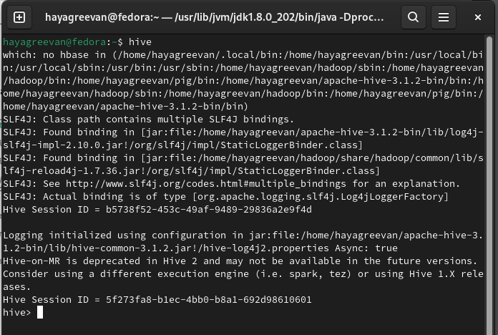

1. CREATE DATABASE financials in hive



1. Use financials database in hive



1. Create Finance_table table in hive



1. Insert records in finance_table table

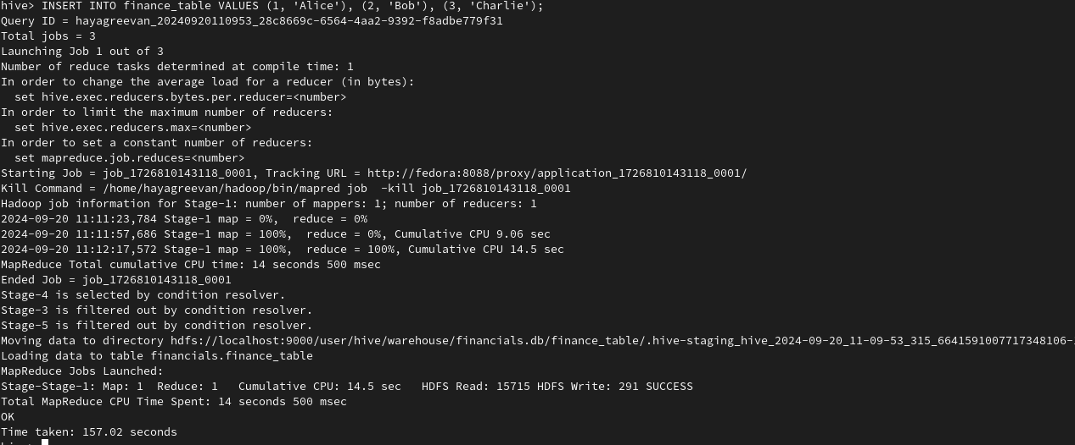

1. Creating new VIEW named myview for finance_table



1. Display myview.

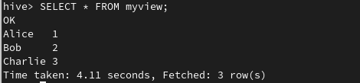

1. Describing finance_table structure.

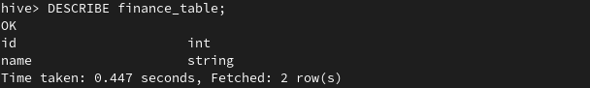

1. Add new age column to Finance_table

