SIMATS ENGINEERING ASSESSMENT TOOL 2

COURSE NAME: Cryptography and Network Security
COURSE CODE: CSA51

COURSE OUTCOME COVERED

CO1: Apply classical encryption techniques using symmetric and asymmetric ciphers to encrypt and decrypt data for the ensuring data security. (BL3, BL4)

Assessment Tool Weightage: 20%

QUESTIONS: 5 Total Marks:50

Annexure A

CONCEPT MAPPING

Code of Conduct:

I ____________________ (Name / Reg No) certify that this submission is my original work and that I have adhered to the guidelines specified for this assessment.
I understand that any violation of academic integrity rules will result in disciplinary action.

Signature of the student:

Annexure A

CONCEPT MAPPING

2.Develop a concept map comparing substitution techniques: Caesar Cipher, Monoalphabetic Cipher, Vigenère Cipher and Hill Cipher. Perform the following tasks to connect based on: Key usage, Complexity and Security strength. Analyze which technique is most secure and why.
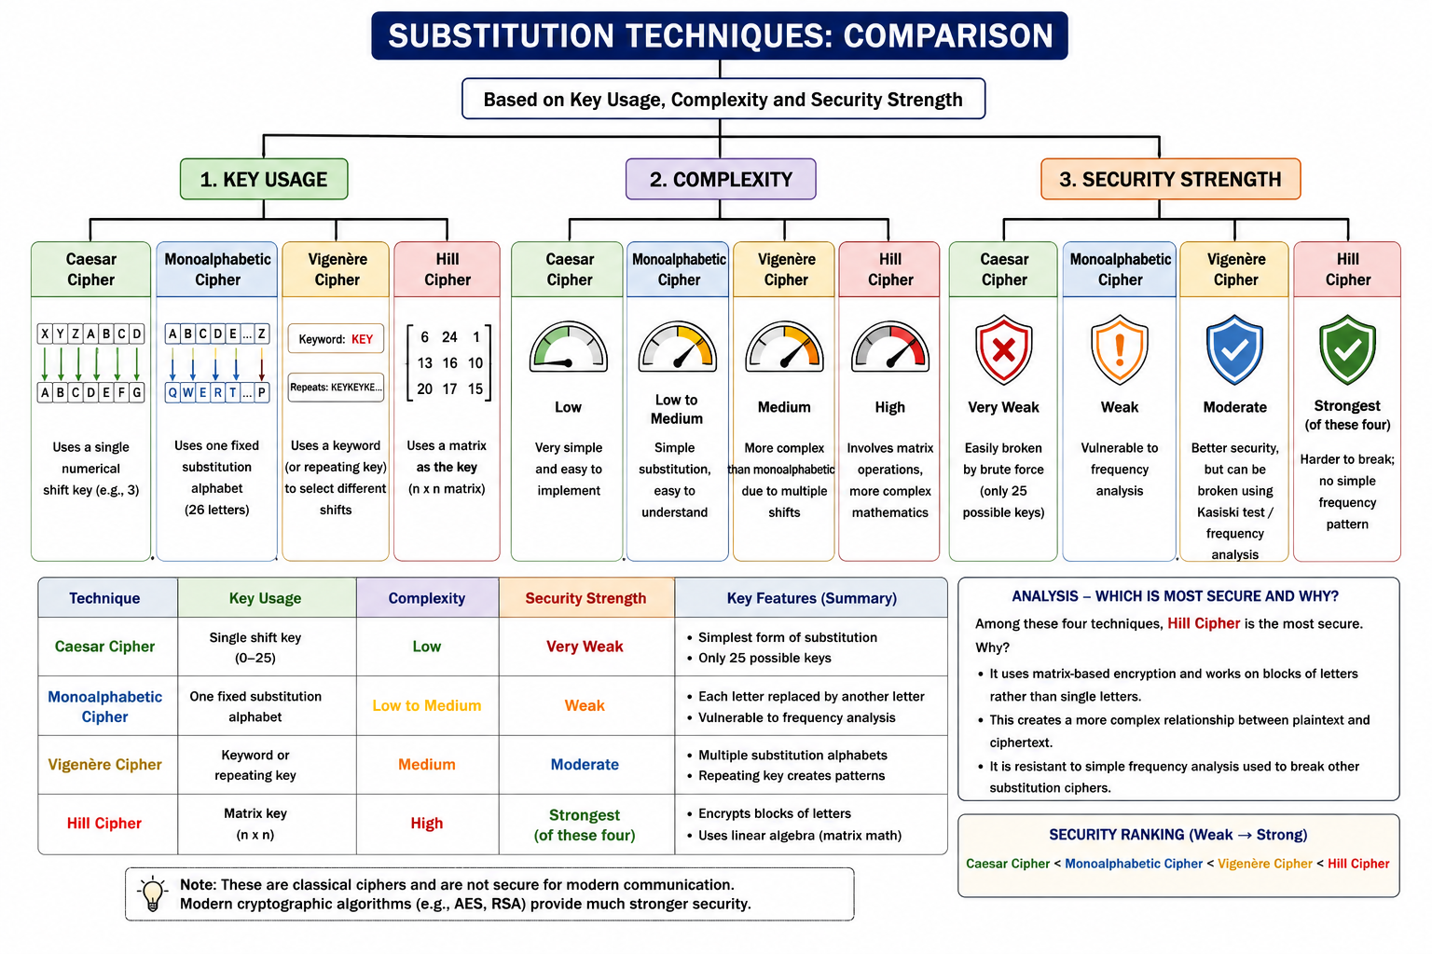

RUBRICS FOR CALCULATION:

Criteria | Weighta ge | Level 4 –  Exemplary | Level 3 –  Proficient | Level 2 –  Developing | Level 1 –  Beginning
Understandi ng of  Concepts | 25 | Demonstrates thorough understanding and effectively integrates multiple concepts/technolo gies | Good understandi ng with proper integration of most concepts | Basic  understandin g; limited or partial integration | Poor understandin g; unable to integrate concepts
Experiment al Design | 30 | Well-planned, systematic implementation with optimal solution | Correct implementat ion with minor issues | Basic implementati on with errors or  inefficiencies | Incorrect or incomplete implementati on
Use of Tools | 20 | Effective and advanced use of tools/technologies with proper configuration | Appropriate use of tools with correct execution | Limited or inconsistent use of tools | Incorrect or minimal use of tools
Analysis of Results | 15 | Insightful analysis with accurate interpretation and validation of results | Good  analysis with reasonable interpretatio n | Basic analysis with limited insights | Poor or incorrect analysis of results
Documentat  ion | 10 | Clear, wellstructured documentation with diagrams, code, and results | Organized documentati on with  necessary details | Basic documentatio n with missing details | Poor or incomplete documentatio  n

