**Concept:** Web Geo-Spectrum Management (WGSM) with all possible features and tools

User Interface*

SIPP and Spectrum Licence Search Fuctionalities

Customize Services*

Libraries

Database server (postgis)

Web Services*

Map Servers(OSM, Google)

Geoserver (WMS/WFS)

SPPlanPortal

SP+

EMC

File System

(Vector files*)

Vector files*: Canadian province, district, city, road, building vector information

Customize Services: OpenLayers, JavaScript, LS JavaScript based MapClient libraries

User Interface*:

District:

Province:

City:

Geographical Search:

Spectrum Licence Search:

Spectrum Licence’s Station Search:

Company Search:

Licensee Search:

Licence Search:

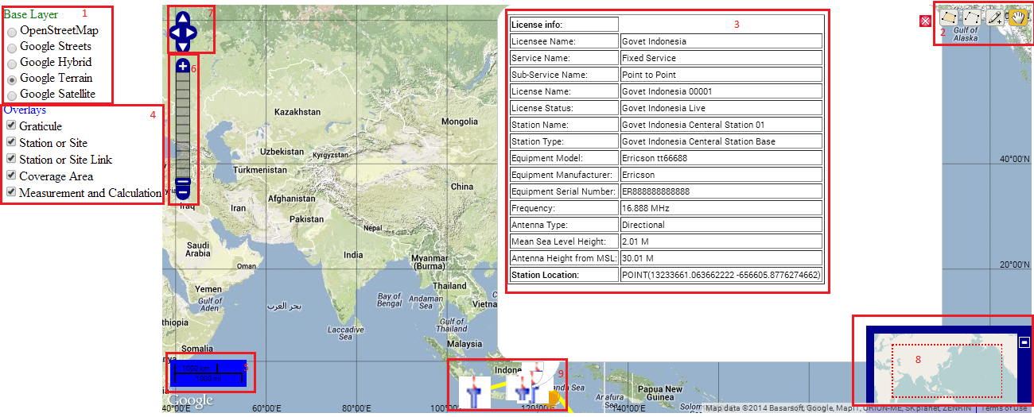

**Source:naznin/GeoSpectraManagement.png**

**a. Base Layer switcher(1):** With this functionality one can see the station on OpenStreetMap or all Google maps type. In the above screen shot it is showing in Google Terrain map.

**b. Web editing tools(2):** With this tools points, line or polygon can be drawn with measurement functionality.

**c. Popup feature(3):** This popup will give some feature information of the selected station.

**d. Overlays(4):** It is used to control the feature layers with show or hide functionality.

**e. Scale(5):** It is used to determine the real world distance.

**f. Pan zoom(6):** It is used for the zoom-in and zoom-out functionality.

**g. Navigator(7):** To control navigation with mouse and keyboard.

**h. OverMap(8):** The OverViewMap control creates a small overview map, useful to display the extent of a zoomed map and the main map and provide additional navigation options to the User.

**i. Dynamic station(9):** This will show the stations build dynamically on the base map.

**Application and technological concepts:**

**a. Open Source JavaScript Libraries:** OpenLayer.js, proj4.js, dojo.js and Google Maps API

**b. Implemented JavaScript Libraries:** WebGeoSpectrum.js based on above JavaScript Libraries

**c. Open Technologies:** HTML, HTML5, CSS, CSS3, JavaScript, JQuery.js