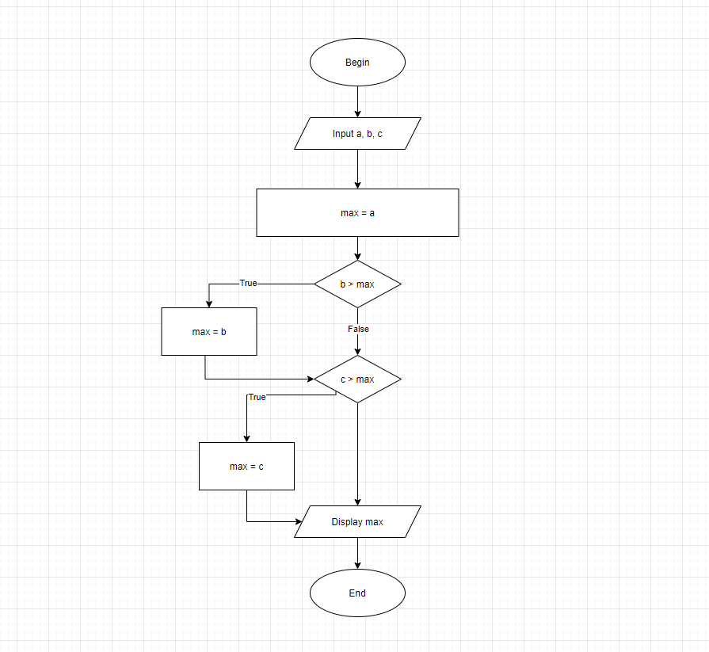BEGIN

If a > b AND a > c THEN

Max = a

Else b > a AND b > c THEN

Max = b

Else

Max = c

Display Max

END