

Kabul University
Computer Science Faculty
Software Engineering Department

SOFTWARE REQUIREMENTS SPECIFICATION
For
Vehicle Sales Management System

Prepared for: University Group Project
Prepared by: Ahmadullah ’Hayat’, Ehsanullah ‘Habib’, Hewad ‘Shams’, ‘Harron Faizi’
Date: September 2026

Document Control
Item | Value
Document Title | Software Requirements Specification – Vehicle Sales Management System
Version | 1.0
Status | Initial Baseline
Prepared By | University Project Group
Intended Audience | Project supervisor, developers, testers, designers, and stakeholders
Primary Purpose | Define the functional, non-functional, interface, data, and business requirements of the system

Revision History
Version | Date | Description | Author
1.0 | September 2026 | Initial SRS baseline | Project Group

Table of Contents
1. Introduction
1.1 Purpose
1.2 Scope
1.3 Definitions and Acronyms
2. Overall Description
2.1 Product Perspective
2.2 Product Functions
2.3 User Classes and Characteristics
2.4 Operating Environment
2.5 Design and Implementation Constraints
2.6 Assumptions and Dependencies
3. Specific Requirements
3.1 Functional Requirements
3.2 Non-Functional Requirements
3.3 External Interface Requirements
3.4 Business Rules
4. System Models
4.1 Use Case Diagram
4.2 Activity Diagrams
4.3 Class Diagram
4.4 Sequence Diagrams
4.5 ER Diagram
5. Data Requirements
6. System Constraints
7. Acceptance Criteria
8. Appendices

1. Introduction

1.1 Purpose
This Software Requirements Specification (SRS) defines the requirements for the Vehicle Sales Management System (VSMS), a computerized system intended to support the day-to-day sales and inventory operations of a vehicle dealership. The document establishes a common understanding between stakeholders and the development team and provides a baseline for system design, implementation, testing, validation, and future maintenance.
The SRS describes what the system shall do, the quality attributes it shall satisfy, the interfaces through which users and external components interact with it, the business rules governing vehicle sales, the information that must be stored, and the criteria by which the completed system will be accepted.

1.2 Scope
The Vehicle Sales Management System will provide a centralized platform for managing vehicle inventory, customer information, vehicle reservations, sales transactions, payments, employees/salespersons, authentication, and business reports. The system will allow authorized users to register and manage vehicles; search and filter inventory; register customers; reserve available vehicles; create and complete sales; record payments and balances; generate invoices and reports; and monitor key dealership information through a dashboard.
The project is focused on the internal management and sales operations of a vehicle dealership. It does not attempt to replace external government registration systems, banking systems, insurance systems, full accounting software, vehicle manufacturing systems, or real-time vehicle tracking platforms.

1.3 Definitions and Acronyms
Term / Acronym | Definition
SRS | Software Requirements Specification.
VSMS | Vehicle Sales Management System.
Administrator | User with privileges to manage system data, users, and configuration.
Manager | User who monitors dealership operations, sales, inventory, and reports.
Salesperson | Employee who manages customers, reservations, sales, and related activities.
Customer | Person who purchases or intends to purchase a vehicle from the dealership.
Vehicle | Automobile recorded and managed in the dealership inventory.
VIN | Vehicle Identification Number; a unique identifier for a vehicle.
Inventory | Collection of vehicles currently managed by the dealership.
Reservation | Temporary record indicating that a vehicle is held for a customer.
Sale | Completed transaction in which a vehicle is sold to a customer.
Invoice | Document summarizing a vehicle sale and its financial details.
GPA | Not applicable to this project; included here only to distinguish academic terminology from VSMS terminology.

1.4 References
- IEEE/ISO/IEC-style software requirements engineering principles and SRS practices.
- Project course guidelines and requirements provided by the group members.
- Applicable dealership business rules defined by the project stakeholders.
- Database, web application, and programming-language documentation selected during implementation.

1.5 Intended Audience
This document is intended for the project supervisor, dealership stakeholders, system analysts, UI/UX designers, developers, database designers, testers, and future maintainers. Readers can use the SRS to understand the system scope, verify requirements, design system components, create test cases, and evaluate whether the final implementation satisfies the project objectives.

1.6 Document Overview
Section 2 presents the overall product description. Section 3 defines detailed functional, non-functional, interface, and business requirements. Section 4 identifies the system models to be produced. Section 5 defines data requirements. Section 6 states system constraints. Section 7 provides acceptance criteria. Section 8 contains supporting appendices.

2. Overall Description

2.1 Product Perspective
VSMS is a dealership-oriented information system. It can be implemented as a web-based application with a browser-based user interface, an application/backend layer, and a relational database. Users interact with the application to perform authorized operations, while the database stores persistent vehicle, customer, employee, reservation, sale, payment, and user information.
High-level architecture:
- Presentation layer – pages, forms, tables, dashboard, search, and reports.
- Application layer – business logic, validation, authorization, sales and payment processing.
- Data layer – relational database and integrity constraints.
- Optional reporting/export layer – printable or downloadable invoices and reports.

2.2 Product Functions
- User authentication and role-based authorization.
- Vehicle registration, editing, viewing, searching, filtering, and status management.
- Inventory monitoring for available, reserved, sold, under-maintenance, and unavailable vehicles.
- Customer registration, updating, searching, and purchase-history management.
- Vehicle reservation and cancellation.
- Vehicle sales processing, discounts, invoice generation, and sale completion.
- Payment recording, balance calculation, payment-status tracking, and payment history.
- Employee/salesperson management and salesperson performance information.
- Dashboard and operational/financial reports.
- Validation, error handling, audit-oriented transaction information, and database integrity.

2.3 User Classes and Characteristics
User Class | Main Responsibilities | Typical Privileges
Administrator | System and master-data management | Manage users, employees, vehicles, customers, reservations, sales, payments, reports, and settings.
Manager | Business oversight | View inventory, sales, revenue, payments, customer information, and employee performance; approve/monitor selected operations.
Salesperson | Customer and sales operations | Search vehicles, manage customers, create reservations, create sales, record permitted payments, and view relevant sales.
The system may later support additional roles, but the initial university project baseline uses these three roles to demonstrate authentication and authorization without creating unnecessary complexity.

2.4 Operating Environment
- Client: modern web browser such as Google Chrome, Microsoft Edge, Mozilla Firefox, or equivalent.
- Server: Windows or Linux computer capable of running the selected application server/runtime.
- Database: relational database management system such as MySQL.
- Network: local network or Internet connection depending on deployment; the prototype may operate on localhost.
- Hardware: standard desktop/laptop with sufficient CPU, RAM, storage, keyboard, mouse, and display.

2.5 Design and Implementation Constraints
- The implementation shall use technologies approved by the course/instructor.
- The project shall use a relational database for persistent transactional data.
- The system shall preserve data integrity through validation and database constraints.
- Only authorized roles may perform restricted operations.
- External integrations shall not be required unless specifically approved and available for the project.

2.6 Assumptions and Dependencies
Assumptions:
- Dealership staff have basic computer and web-application skills.
- Vehicle, customer, employee, and transaction information entered into the system is sufficiently accurate.
- Each vehicle has a unique VIN or equivalent dealership identifier.
- Business rules such as discount limits, payment rules, and reservation policies are defined by management.
Dependencies:
- Availability of the application runtime/web server.
- Availability of the database server.
- A supported web browser.
- Reliable storage and backup mechanisms.
- Any approved third-party libraries used by the implementation.

3. Specific Requirements

3.1 Functional Requirements

3.1.1 Authentication and Authorization
FR-AUTH-01: The system shall provide a login function for registered users.
FR-AUTH-02: The system shall verify submitted credentials before granting access to protected functions.
FR-AUTH-03: The system shall assign each user a role such as Administrator, Manager, or Salesperson.
FR-AUTH-04: The system shall restrict functions according to the user's assigned role.
FR-AUTH-05: The system shall allow an authorized administrator to create, activate, deactivate, and update user accounts.
FR-AUTH-06: The system shall provide a logout function that terminates the current authenticated session.
FR-AUTH-07: The system shall prevent unauthenticated users from accessing protected management pages.

3.1.2 Vehicle Management
FR-VEH-01: The system shall allow authorized staff to add a vehicle to the inventory.
FR-VEH-02: The system shall store vehicle attributes including VIN, make, model, year, price, mileage, color, fuel type, transmission, category, and status.
FR-VEH-03: The system shall prevent duplicate VIN values.
FR-VEH-04: The system shall allow authorized staff to update vehicle information.
FR-VEH-05: The system shall allow authorized users to view detailed vehicle information.
FR-VEH-06: The system shall allow authorized users to remove or deactivate a vehicle according to business rules.
FR-VEH-07: The system shall maintain vehicle statuses including Available, Reserved, Sold, Under Maintenance, and Unavailable.
FR-VEH-08: The system shall maintain the date on which a vehicle record was created and, where applicable, last updated.

3.1.3 Inventory Management and Search
FR-INV-01: The system shall display current vehicle inventory to authorized users.
FR-INV-02: The system shall allow users to search vehicles by VIN, make, model, or other supported attributes.
FR-INV-03: The system shall allow users to filter vehicles by price, year, fuel type, transmission, mileage, category, color, and availability.
FR-INV-04: The system shall provide an inventory summary showing counts by relevant vehicle status.
FR-INV-05: The system shall prevent a vehicle marked Sold from being selected for a new reservation or sale.

3.1.4 Customer Requirements
FR-CUS-01: The system shall allow authorized staff to register a new customer.
FR-CUS-02: The system shall store customer information such as customer ID, name, contact information, and address where required.
FR-CUS-03: The system shall allow authorized staff to update customer information.
FR-CUS-04: The system shall allow authorized users to search for customers.
FR-CUS-05: The system shall display a customer's completed purchases and related transaction history.
FR-CUS-06: The system shall validate required customer fields before saving a customer record.

3.1.5 Reservation Requirements
FR-RES-01: The system shall allow authorized sales staff to reserve an available vehicle for a customer.
FR-RES-02: The system shall record the customer, vehicle, salesperson, reservation date, expiration date where applicable, and reservation status.
FR-RES-03: The system shall change the vehicle status to Reserved when a valid reservation is created.
FR-RES-04: The system shall allow authorized staff to cancel a reservation.
FR-RES-05: The system shall return a vehicle to Available status when its active reservation is cancelled, provided that no other business rule prevents this change.
FR-RES-06: The system shall prevent simultaneous active reservations for the same vehicle unless explicitly allowed by management.

3.1.6 Sales Requirements
FR-SAL-01: The system shall allow authorized staff to create a sale for an eligible vehicle and customer.
FR-SAL-02: The system shall allow the salesperson to select a customer and an available or validly reserved vehicle.
FR-SAL-03: The system shall calculate the sale amount from the vehicle price, applicable discount, and other configured charges.
FR-SAL-04: The system shall record the salesperson responsible for the sale.
FR-SAL-05: The system shall record the sale date and transaction status.
FR-SAL-06: The system shall require confirmation before finalizing a sale.
FR-SAL-07: The system shall change the vehicle status to Sold when the sale is successfully completed.
FR-SAL-08: The system shall prevent a completed sale from being duplicated for the same vehicle.
FR-SAL-09: The system shall generate a sale invoice or printable sales record for a completed transaction.

3.1.7 Payment Requirements
FR-PAY-01: The system shall allow authorized staff to record a payment against a sale.
FR-PAY-02: The system shall record payment amount, date, method, reference where applicable, and the associated sale.
FR-PAY-03: The system shall calculate the total amount paid for a sale.
FR-PAY-04: The system shall calculate the remaining balance as applicable.
FR-PAY-05: The system shall determine a payment status such as Unpaid, Partially Paid, or Fully Paid.
FR-PAY-06: The system shall prevent a payment from causing the recorded paid amount to exceed the permitted outstanding amount unless an authorized business rule explicitly allows it.
FR-PAY-07: The system shall display payment history for a selected sale.

3.1.8 Employee Requirements
FR-EMP-01: The system shall allow authorized administrators to register employees.
FR-EMP-02: The system shall store employee information including employee ID, name, contact information, position, and status where applicable.
FR-EMP-03: The system shall allow authorized administrators to update employee information.
FR-EMP-04: The system shall associate eligible sales with the responsible salesperson.
FR-EMP-05: The system shall provide sales information by salesperson.

3.1.9 Reporting Requirements
FR-REP-01: The system shall provide a vehicle inventory report.
FR-REP-02: The system shall provide a vehicle sales report.
FR-REP-03: The system shall provide a revenue report based on completed sales and recorded payments as defined by the reporting rules.
FR-REP-04: The system shall provide a customer purchase-history report.
FR-REP-05: The system shall provide an outstanding-payment report.
FR-REP-06: The system shall provide salesperson performance information based on recorded sales.
FR-REP-07: The system shall allow authorized users to filter supported reports by date or relevant criteria.
FR-REP-08: The system shall display dashboard summaries such as total vehicles, available vehicles, reserved vehicles, sold vehicles, customers, sales, and revenue.

3.1.10 General Validation and Error Handling
FR-GEN-01: The system shall validate required fields before creating or updating records.
FR-GEN-02: The system shall display understandable error messages when an operation fails.
FR-GEN-03: The system shall request confirmation before destructive or irreversible operations where appropriate.
FR-GEN-04: The system shall preserve database consistency when a transaction fails.
FR-GEN-05: The system shall record sufficient transaction information to support troubleshooting and reporting.

3.2 Non-Functional Requirements

3.2.1 Performance
NFR-PERF-01: The system should return ordinary search results within approximately 3 seconds under normal project workload and network conditions.
NFR-PERF-02: Common dashboard and list pages should load within an acceptable time under normal conditions.
NFR-PERF-03: Database queries shall be designed to avoid unnecessary retrieval of large amounts of data.

3.2.2 Security
NFR-SEC-01: Protected functions shall require authentication.
NFR-SEC-02: Authorization shall be enforced on the server/application side and shall not rely only on hidden UI controls.
NFR-SEC-03: Passwords shall be stored using secure password hashing rather than plain text.
NFR-SEC-04: The system shall validate and sanitize user input and use parameterized database operations to reduce injection risks.
NFR-SEC-05: Users shall be prevented from accessing records or operations outside their permissions.

3.2.3 Usability
NFR-USE-01: The user interface shall use consistent navigation, terminology, buttons, forms, and page layouts.
NFR-USE-02: Forms shall clearly identify required fields and validation errors.
NFR-USE-03: Important actions such as completing a sale or deleting a record shall provide clear confirmation or warning messages.
NFR-USE-04: The system shall be usable on standard desktop/laptop screen sizes and reasonably responsive where supported.

3.2.4 Reliability and Data Integrity
NFR-REL-01: The system shall maintain consistent relationships among vehicles, customers, reservations, sales, and payments.
NFR-REL-02: A failed transaction shall not leave partial or contradictory transactional data.
NFR-REL-03: The database shall enforce uniqueness and referential-integrity constraints where appropriate.
NFR-REL-04: The system shall support regular database backup as part of operational procedures.

3.2.5 Maintainability
NFR-MNT-01: The system shall use modular components so that individual modules can be modified without unnecessary changes to unrelated modules.
NFR-MNT-02: Source code shall follow consistent naming, formatting, and documentation conventions.
NFR-MNT-03: Database tables and important business rules shall be documented.

3.2.6 Scalability
NFR-SCL-01: The system should support growth in the number of vehicles, customers, employees, sales, and payments without requiring a complete redesign.
NFR-SCL-02: The database design should permit future addition of modules such as maintenance or advanced accounting without breaking the core sales model.

3.2.7 Availability and Portability
NFR-AVL-01: The system shall be available whenever the required application and database services are operational.
NFR-PORT-01: The web application should operate on major modern browsers without requiring a proprietary desktop client.

3.3 External Interface Requirements

3.3.1 User Interface
- Login page with username/email and password fields.
- Dashboard with inventory, sales, customer, and payment summaries.
- Vehicle management pages with forms, tables, search, and filtering.
- Customer management pages with registration, editing, search, and history.
- Reservation pages showing active and completed/cancelled reservations.
- Sales pages with customer/vehicle selection, price calculation, discount, payment information, and confirmation.
- Payment pages with payment entry, history, and balance information.
- Employee/user administration pages restricted to authorized roles.
- Reports page with filters and printable/exportable results where implemented.

3.3.2 Software Interfaces
- Web browser interface for end users.
- Relational database management system, such as MySQL.
- Optional PDF/printing library for invoices and reports.

3.3.3 Hardware Interfaces
No specialized hardware is required for the baseline system. The application shall operate using standard desktop or laptop input/output devices. If a printer is available, invoices and reports may be printed through normal operating-system/browser facilities.

3.3.4 Communication Interfaces
For a web deployment, the client and server shall communicate using standard HTTP/HTTPS mechanisms. HTTPS should be used in any real deployment involving sensitive customer or financial information. The university prototype may use localhost or a controlled local network.

3.4 Business Rules
Rule ID | Business Rule
BR-01 | Each vehicle shall have a unique VIN or dealership vehicle identifier.
BR-02 | A sold vehicle shall not be available for a new reservation or sale.
BR-03 | Only eligible vehicles may be reserved.
BR-04 | A vehicle shall not have more than one active reservation unless management explicitly defines a different policy.
BR-05 | A sale shall reference one valid customer and one eligible vehicle.
BR-06 | A completed sale shall change the associated vehicle status to Sold.
BR-07 | A payment shall be associated with a valid sale.
BR-08 | The total recorded payments shall follow the configured rules for the sale amount.
BR-09 | Discounts shall be subject to authorization and any configured maximum or approval rule.
BR-10 | Only authorized roles may modify sensitive sales and payment information.
BR-11 | Cancelled reservations shall not remain active.
BR-12 | Deactivated employees/users shall not be allowed to perform new transactions.
BR-13 | Reports shall use the same authoritative transaction data stored by the system.

4. System Models

4.1 Use Case Diagram

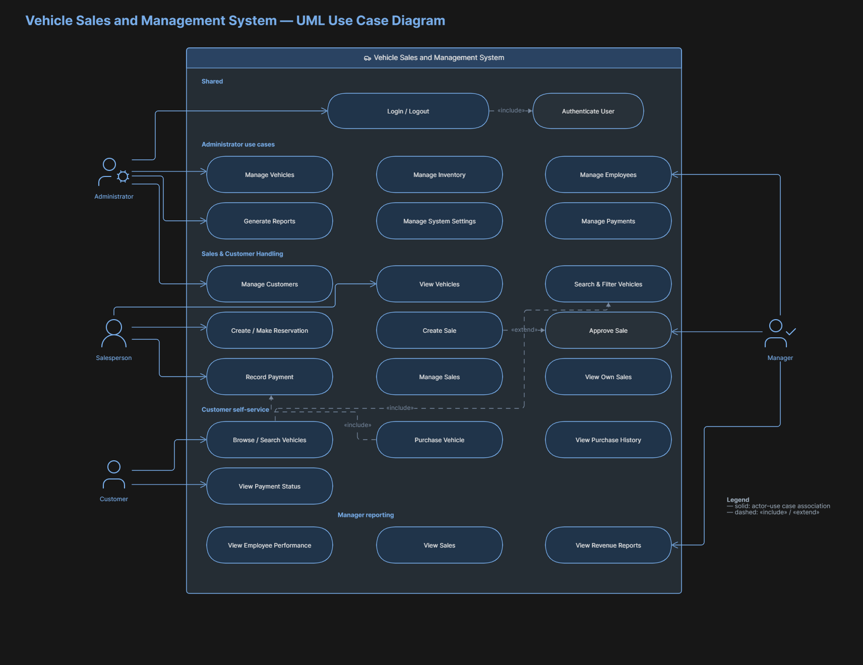

4.2 Activity Diagrams

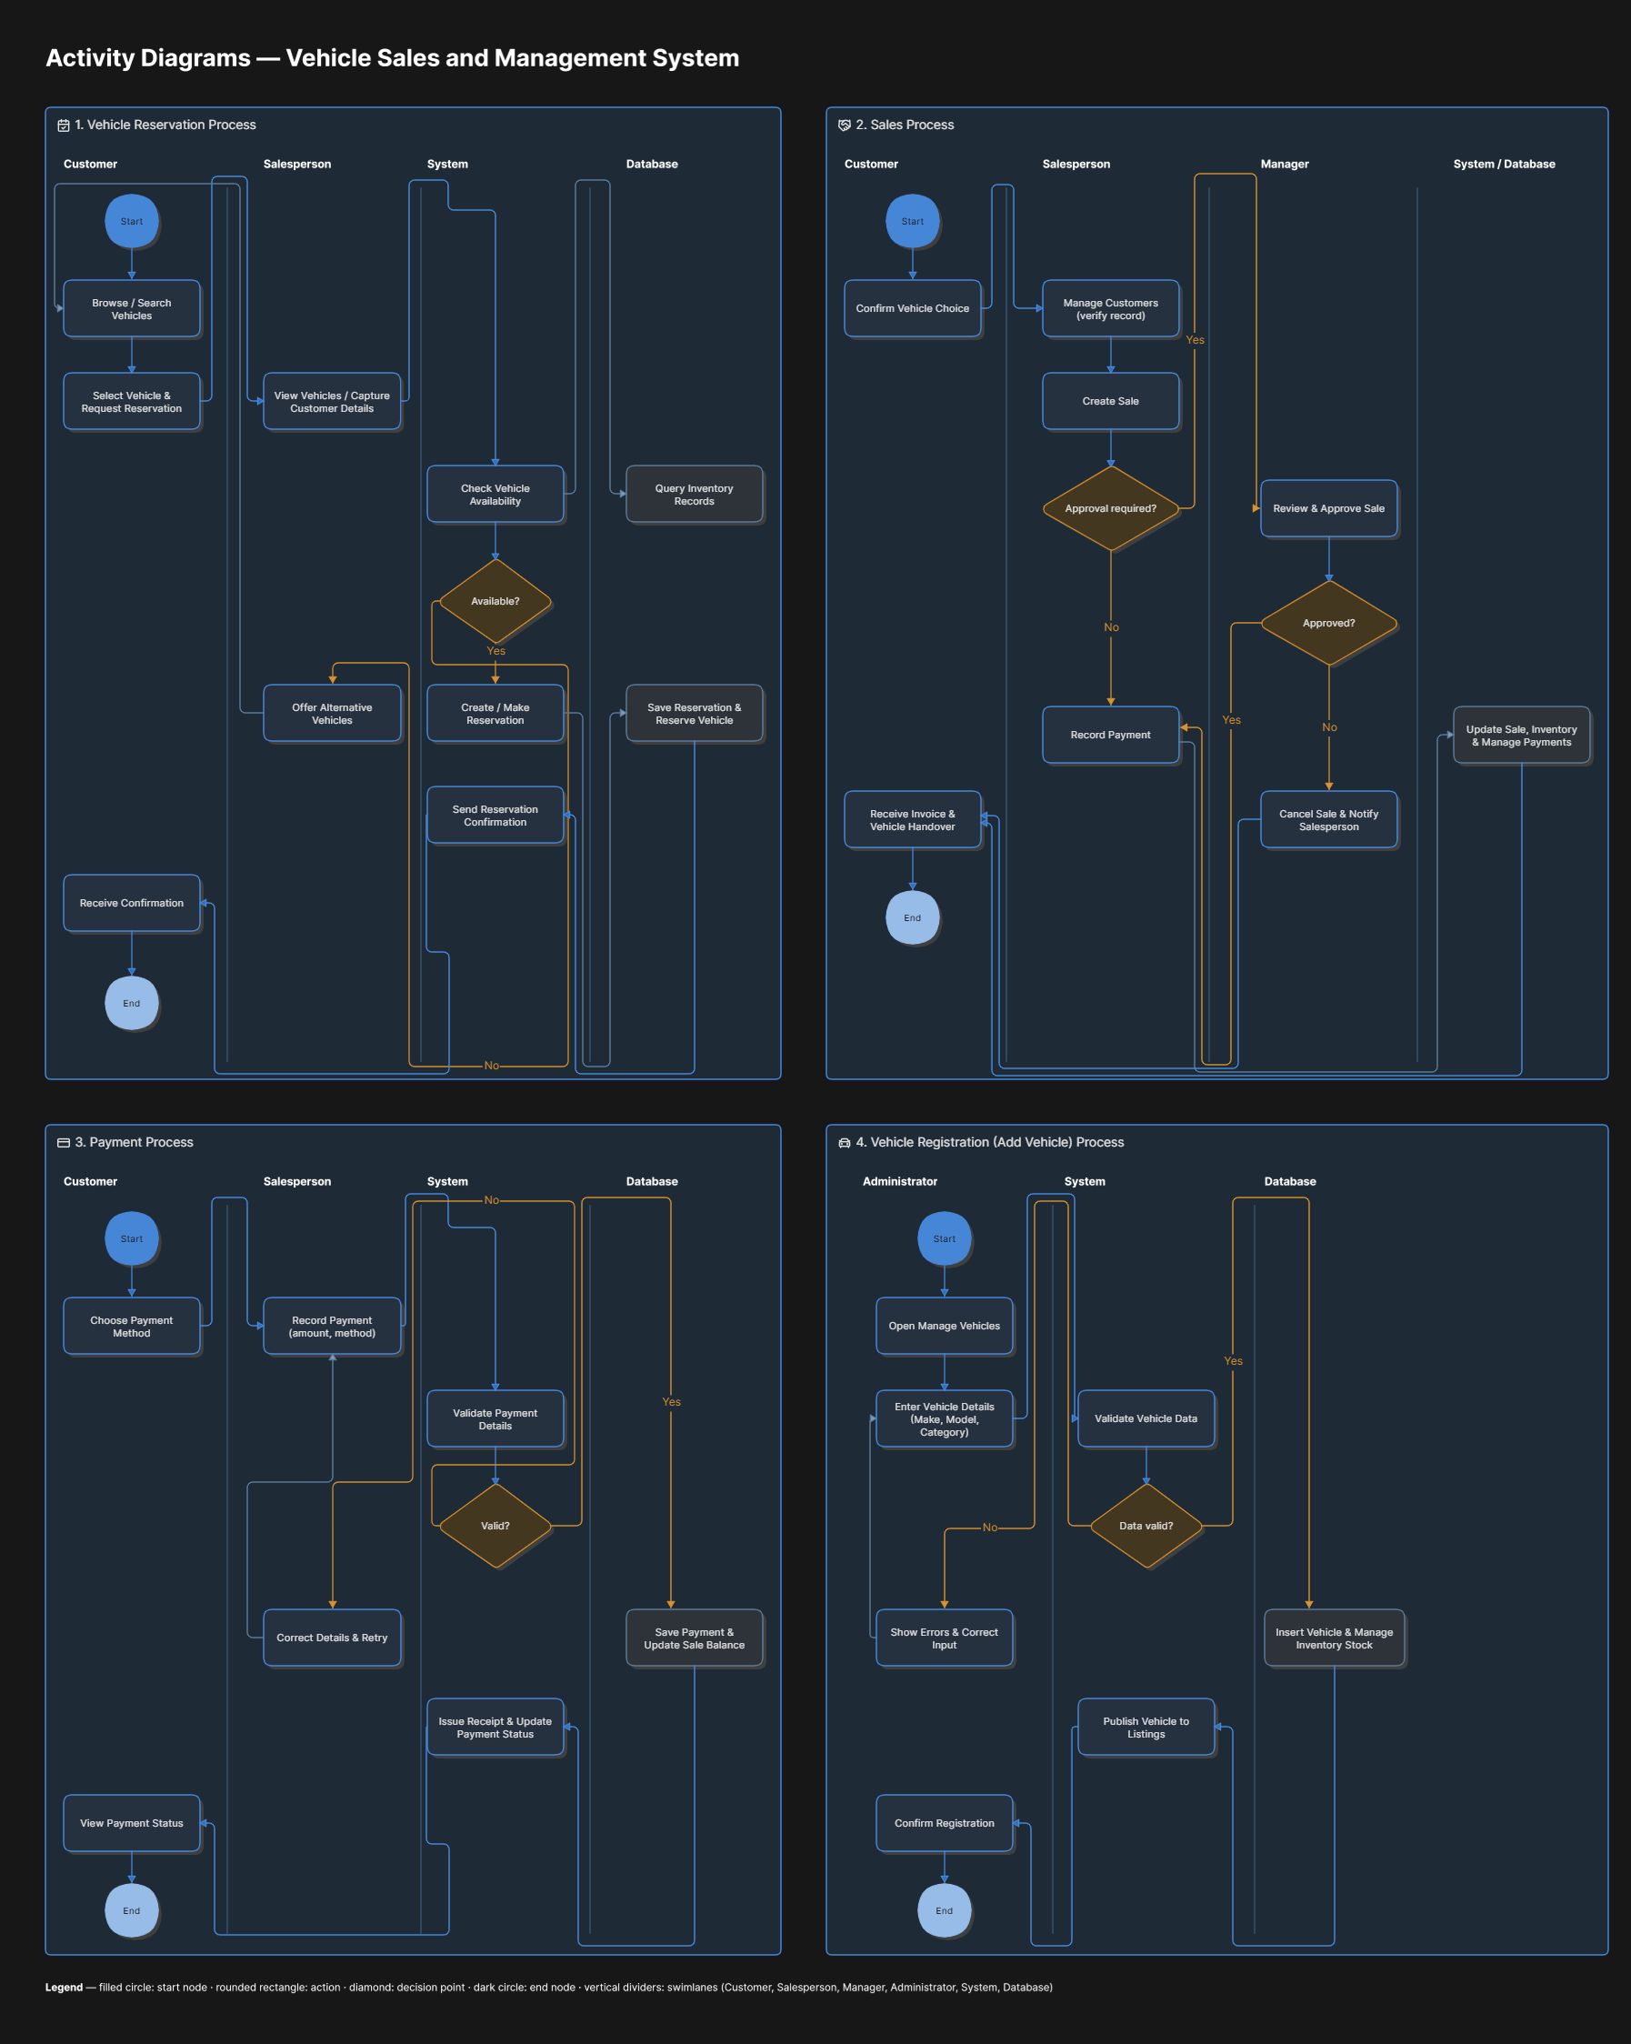

4.3 Class Diagram
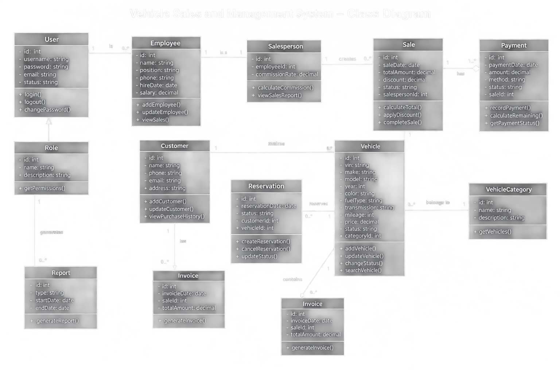

4.4 Sequence Diagrams
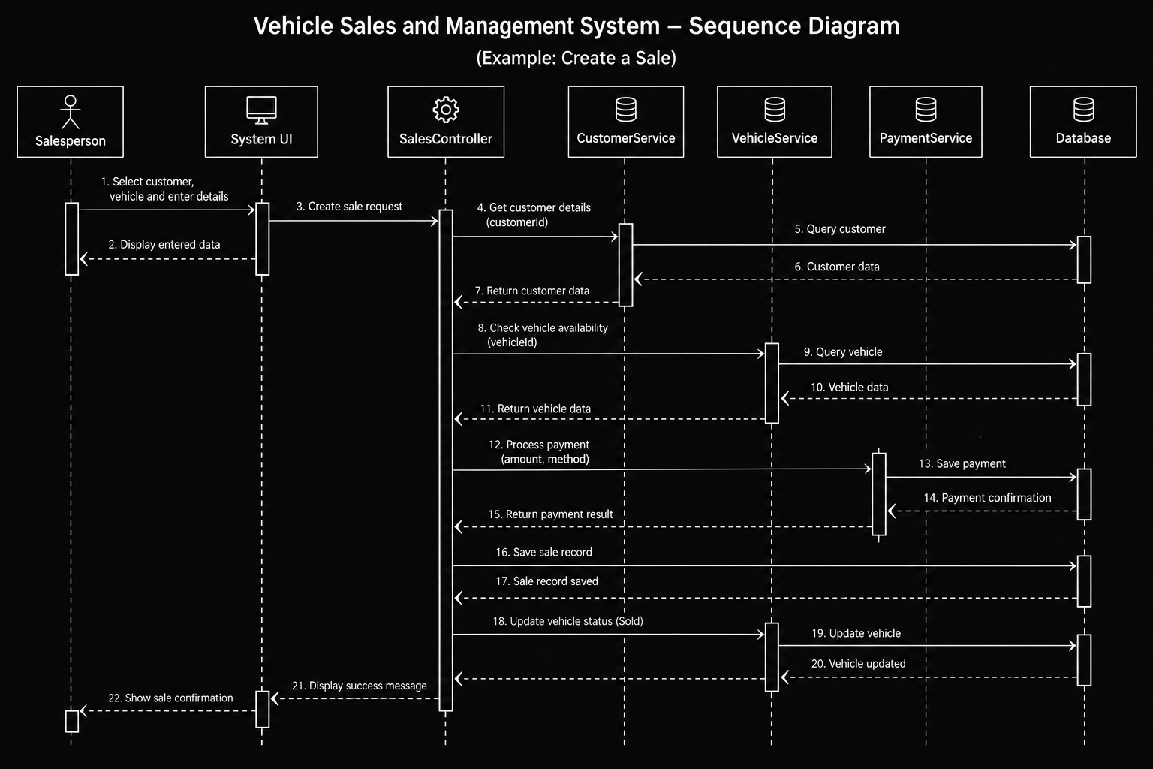

4.5 ER Diagram
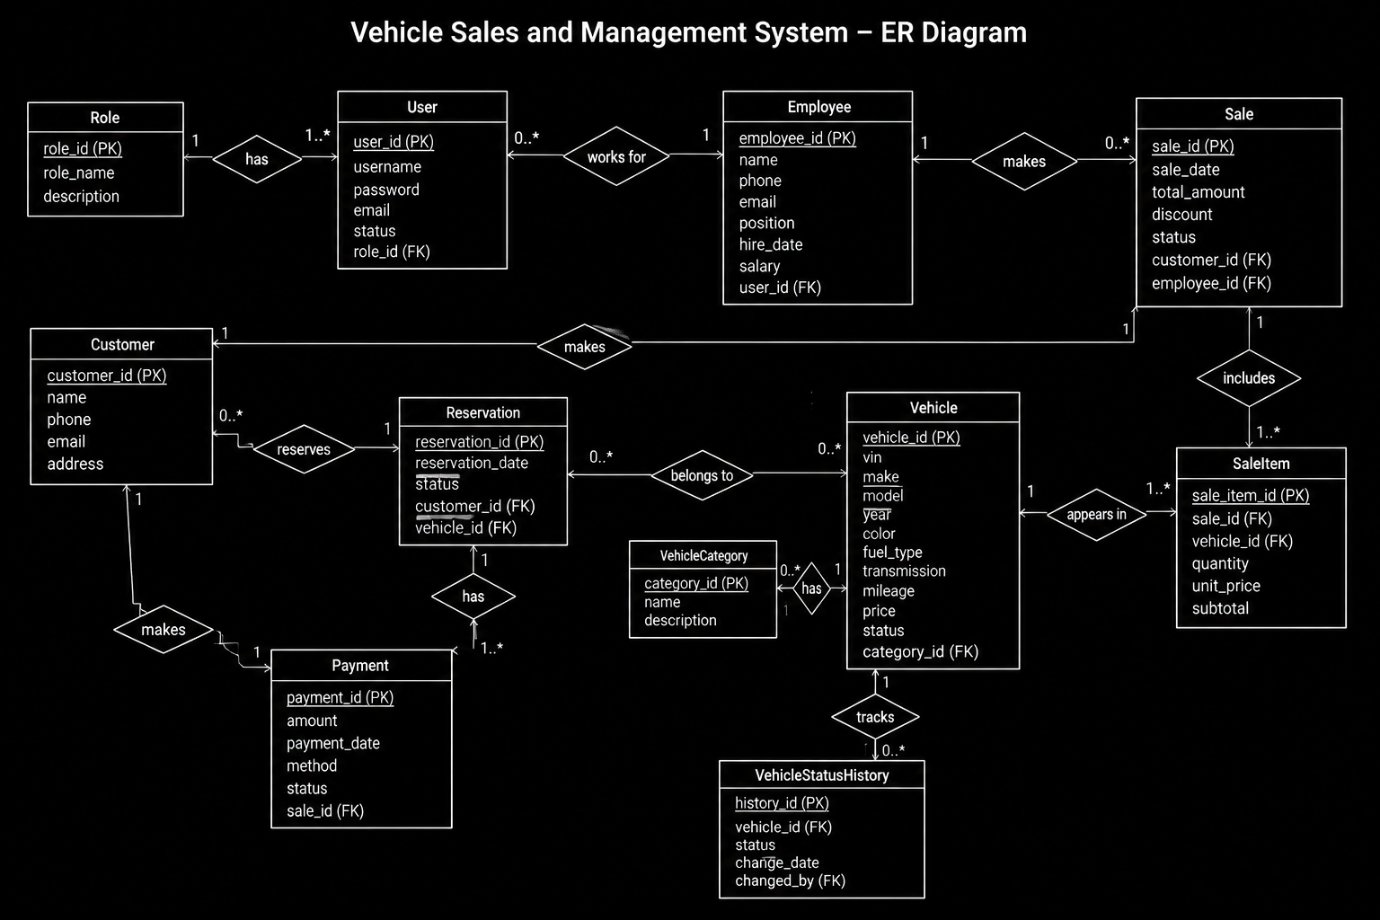

5. Data Requirements

5.1 Core Data Entities
Entity | Key Information
User | User ID, username/email, password hash, role, account status, timestamps.
Role | Role ID, role name, description/permissions.
Employee | Employee ID, name, contact details, position, status.
Customer | Customer ID, name, contact details, address, registration date.
Vehicle | Vehicle ID, VIN, make, model, year, price, mileage, color, fuel type, transmission, category, status, timestamps.
Reservation | Reservation ID, vehicle ID, customer ID, employee ID, reservation date, expiration date, status.
Sale | Sale ID, vehicle ID, customer ID, salesperson ID, sale date, price, discount, final amount, status.
Payment | Payment ID, sale ID, amount, payment date, method, reference, notes.
Invoice | Invoice ID, sale ID, invoice number, issue date, total, payment summary.

5.2 Data Validation
- Required fields shall not be empty.
- VIN shall be unique.
- Numeric values such as price, mileage, and payment amounts shall be validated as non-negative where appropriate.
- Dates shall use valid formats and shall satisfy applicable business rules.
- Foreign-key references shall point to valid records.
- Vehicle status transitions shall follow the defined business rules.

5.3 Data Retention and Backup
The system should retain completed sales and payment records for the period required by the project/business policy. The database should be backed up regularly. Backup frequency, retention duration, and restoration procedures should be defined by the deployment owner if the system is moved beyond the university prototype.

6. System Constraints
- The system is limited to vehicle dealership sales and related management functions defined in this SRS.
- The baseline system does not directly integrate with government vehicle-registration systems.
- The baseline system does not directly process bank transfers, card payments, or online financial transactions.
- The baseline system does not perform insurance underwriting or insurance claims processing.
- The baseline system does not provide real-time GPS tracking.
- The baseline system does not implement full accounting, payroll, taxation, or enterprise resource planning.
- The baseline system depends on the availability of its application server, database, and supported client environment.
- The project schedule and team capacity may limit advanced features and external integrations.

6.1 Project Boundaries
Included:
- Vehicle registration and management
- Vehicle inventory and availability management
- Vehicle search and filtering
- Customer management and purchase history
- Reservations
- Vehicle sales
- Payments and balances
- Employee/salesperson management
- Authentication and role-based authorization
- Invoices
- Dashboard and reports
Excluded:
- Vehicle manufacturing management
- Full repair/workshop management
- Insurance processing
- Government registration and ownership transfer
- Direct bank/payment-gateway integration
- Loan approval by financial institutions
- Real-time GPS tracking
- Spare-parts inventory
- Payroll
- Full accounting/tax system
- Auction management
- Vehicle transportation/logistics management
- External marketplace synchronization

7. Acceptance Criteria
The system shall be considered acceptable for the university project when the implemented baseline satisfies the approved requirements and passes functional and non-functional verification. The following criteria provide a practical acceptance checklist.
Criterion | Acceptance Condition
AC-01 | Users can log in and log out, and protected functions are inaccessible without authentication.
AC-02 | Role-based permissions prevent users from performing operations outside their assigned privileges.
AC-03 | Authorized users can add, edit, view, search, and filter vehicles.
AC-04 | The system prevents duplicate VINs and maintains valid vehicle statuses.
AC-05 | Authorized users can register and update customers and view purchase history.
AC-06 | An eligible vehicle can be reserved and its status changes appropriately.
AC-07 | A reservation can be cancelled and the vehicle status is restored according to business rules.
AC-08 | A valid sale can be created, finalized, and associated with the correct customer, vehicle, and salesperson.
AC-09 | A completed sale changes the vehicle status to Sold and prevents another sale of the same vehicle.
AC-10 | Payments can be recorded and the system calculates paid amount, balance, and payment status correctly.
AC-11 | Invoices/sales records can be generated for completed sales.
AC-12 | Inventory, sales, revenue, payment, customer, and salesperson reports produce results consistent with database transactions.
AC-13 | The interface provides clear validation, error, and confirmation messages.
AC-14 | Core operations meet the agreed performance expectations under normal project workload.
AC-15 | Database relationships and transactional data remain consistent after successful and failed operations.

8. Appendices

Appendix A – Suggested Navigation Structure
Menu | Suggested Pages
Dashboard | Overview, key statistics, recent sales, inventory summary
Vehicles | All Vehicles, Add Vehicle, Search/Filter, Vehicle Details
Inventory | Available, Reserved, Sold, Maintenance/Unavailable
Customers | All Customers, Add Customer, Customer Details, Purchase History
Reservations | Active Reservations, Reservation History
Sales | New Sale, Sales History, Sale Details, Invoice
Payments | Record Payment, Payment History, Outstanding Balances
Employees | Employee List, Add/Edit Employee, Sales Performance
Reports | Inventory, Sales, Revenue, Customers, Payments, Salesperson Performance
Administration | Users, Roles, Settings

Appendix B – Suggested Vehicle Fields
Field | Example / Description
Vehicle ID | Internal unique database identifier
VIN | Unique vehicle identification number
Make | Toyota, Honda, Ford, etc.
Model | Corolla, Civic, Mustang, etc.
Year | Manufacturing/model year
Category | Sedan, SUV, Truck, Hatchback, etc.
Price | Current dealership selling price
Mileage | Current mileage
Fuel Type | Petrol, Diesel, Hybrid, Electric, etc.
Transmission | Manual, Automatic, etc.
Color | Exterior color
Status | Available, Reserved, Sold, Under Maintenance, Unavailable

Appendix C – Suggested Vehicle Status Lifecycle
A typical lifecycle is: Available → Reserved → Available (if cancelled) OR Sold (if sale completed). A vehicle may also move between Available and Under Maintenance/Unavailable according to authorized inventory operations.

Appendix D – Suggested Future Enhancements
- Online customer-facing vehicle catalog.
- Email/SMS notifications for reservations or payment reminders.
- Online payment gateway integration.
- Government registration integration where legally and technically available.
- Insurance integration.
- Vehicle maintenance/workshop module.
- Advanced accounting and taxation.
- Mobile application.
- Advanced analytics and forecasting.
- Integration with external vehicle marketplaces.

Appendix E – Requirements Traceability Matrix (Initial)
Business Area | Primary Requirements | Verification
Authentication | FR-AUTH-01 to FR-AUTH-07 | Login/authorization tests
Vehicles | FR-VEH-01 to FR-VEH-08 | CRUD, validation, uniqueness tests
Inventory | FR-INV-01 to FR-INV-05 | Search/filter/status tests
Customers | FR-CUS-01 to FR-CUS-06 | Customer management tests
Reservations | FR-RES-01 to FR-RES-06 | Reservation lifecycle tests
Sales | FR-SAL-01 to FR-SAL-09 | End-to-end sales tests
Payments | FR-PAY-01 to FR-PAY-07 | Payment/balance tests
Employees | FR-EMP-01 to FR-EMP-05 | Employee and performance tests
Reports | FR-REP-01 to FR-REP-08 | Report accuracy tests
Quality | NFR-PERF through NFR-PORT | Performance, security, usability, integrity checks

Appendix F – Out-of-Scope Boundary Statement
For the university project, any feature not explicitly included in Sections 1.2, 3.1, or 6.1 shall be considered outside the baseline scope unless the project team and supervisor formally approve a change. This prevents uncontrolled expansion of the project.

