

Air University - Islamabad
Islamabad, Pakistan

Final Term Project CRM
Full Stack Programming Lab (B)

Hayat Ishfaq - 231994
Semester: Spring 2026

Submission Date: June 7, 2026

Github URL: https://github.com/hayat-ishfaq/uni-full-stack-programming-lab/tree/5d1573dea6213c8913ac9f56d016c734be312eee/Lab_10full_Stack_Node_Express

Output Screenshots
Sign-in:
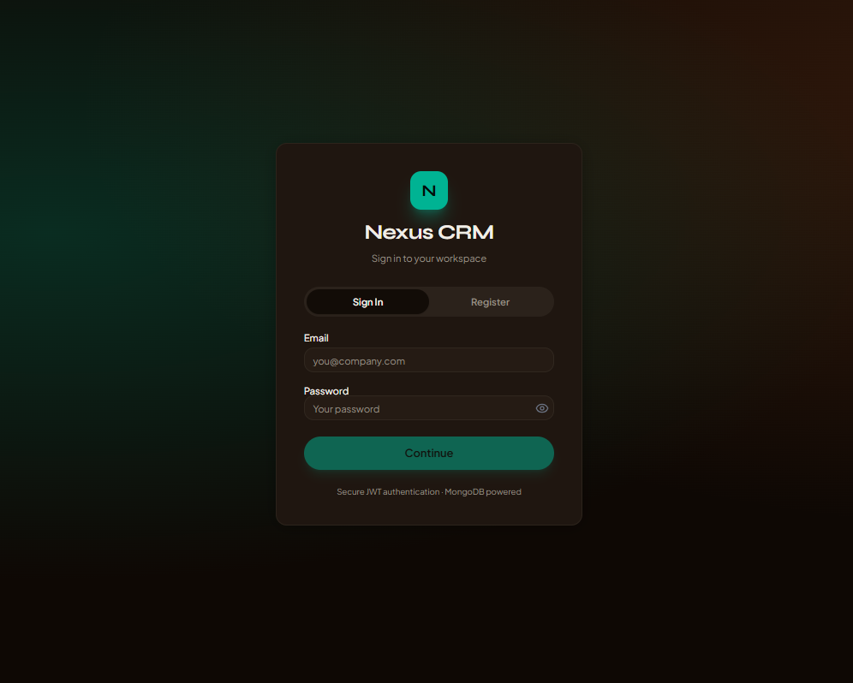

Register:
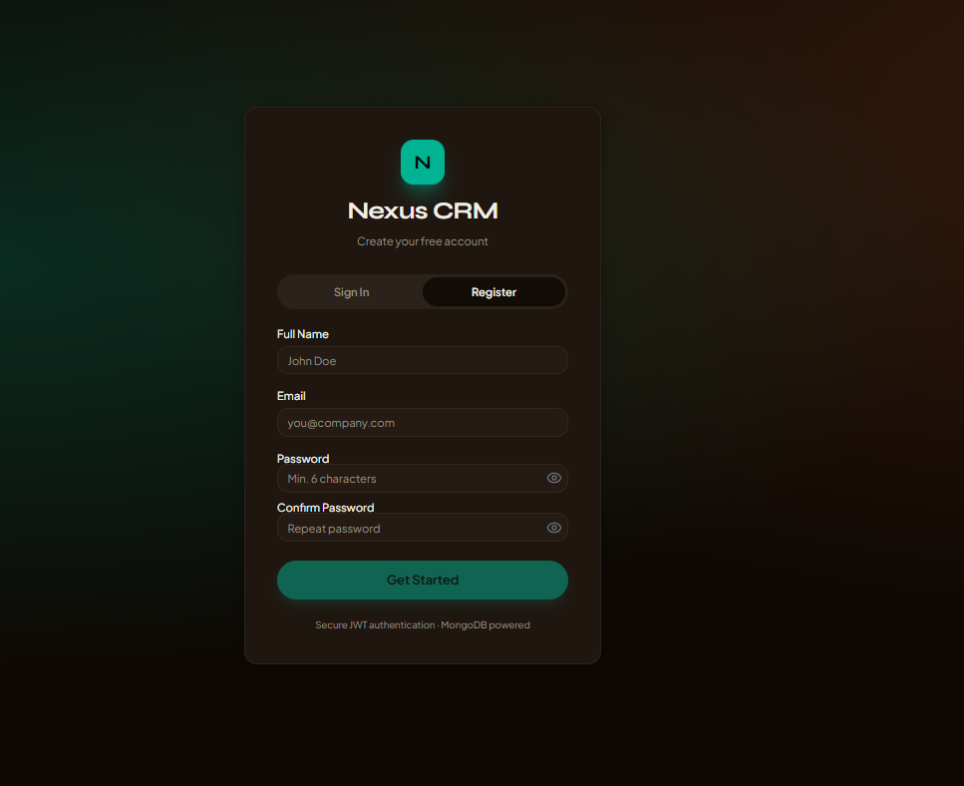
Dashboard:
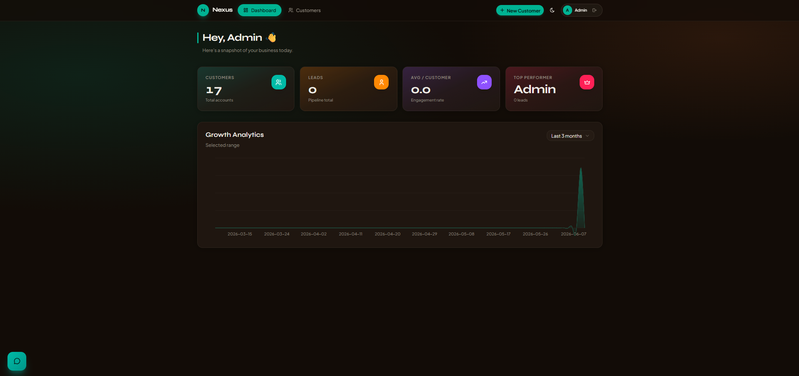

Add customers:
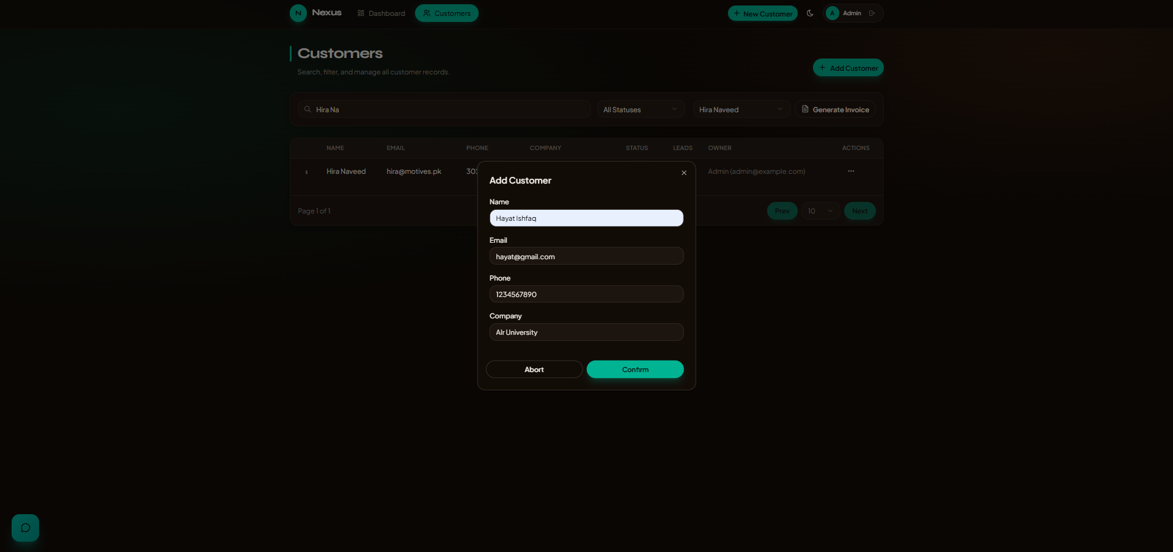

Customers-list:
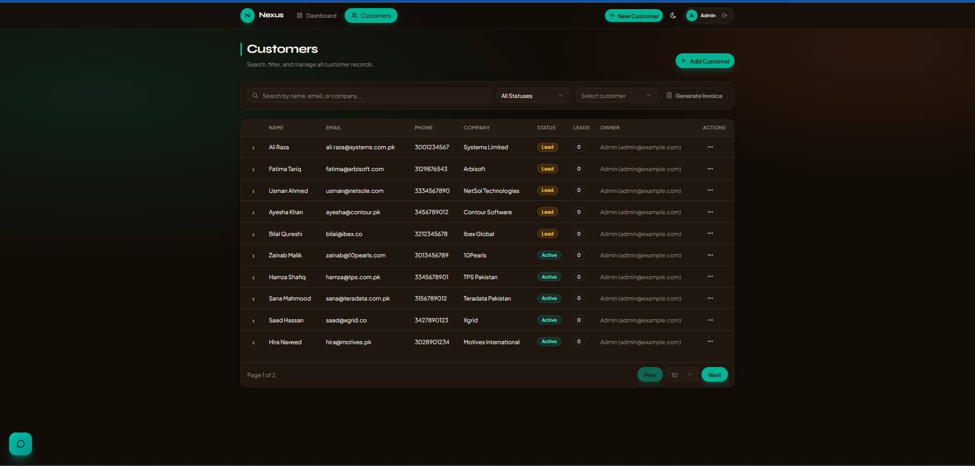

Search-customer-by-name:
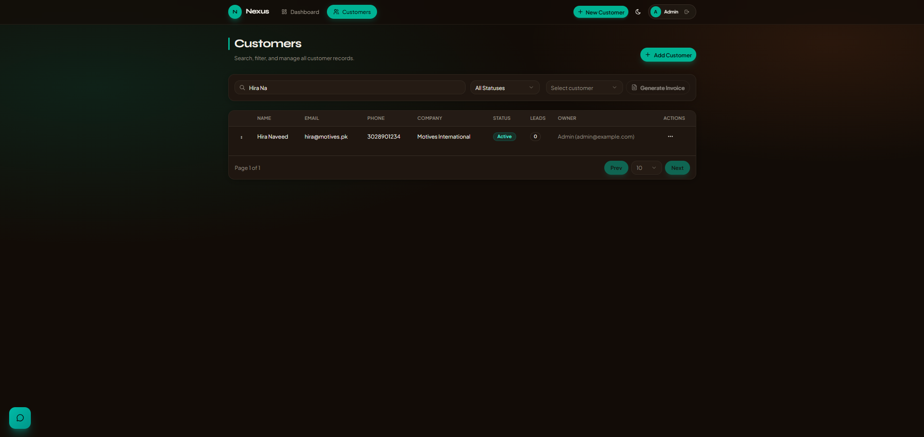
Invoice-generation:
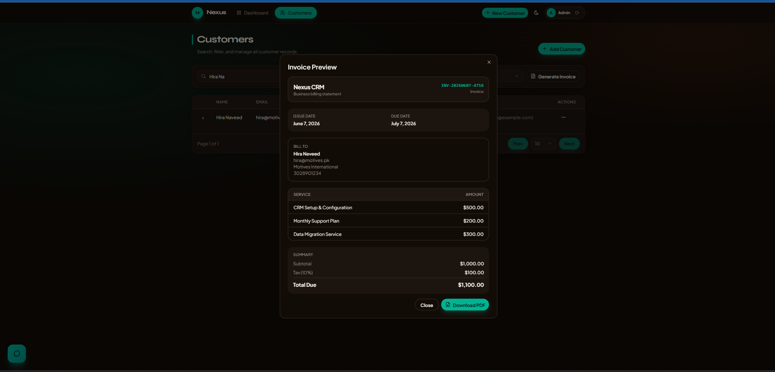

Invoice-pdf:
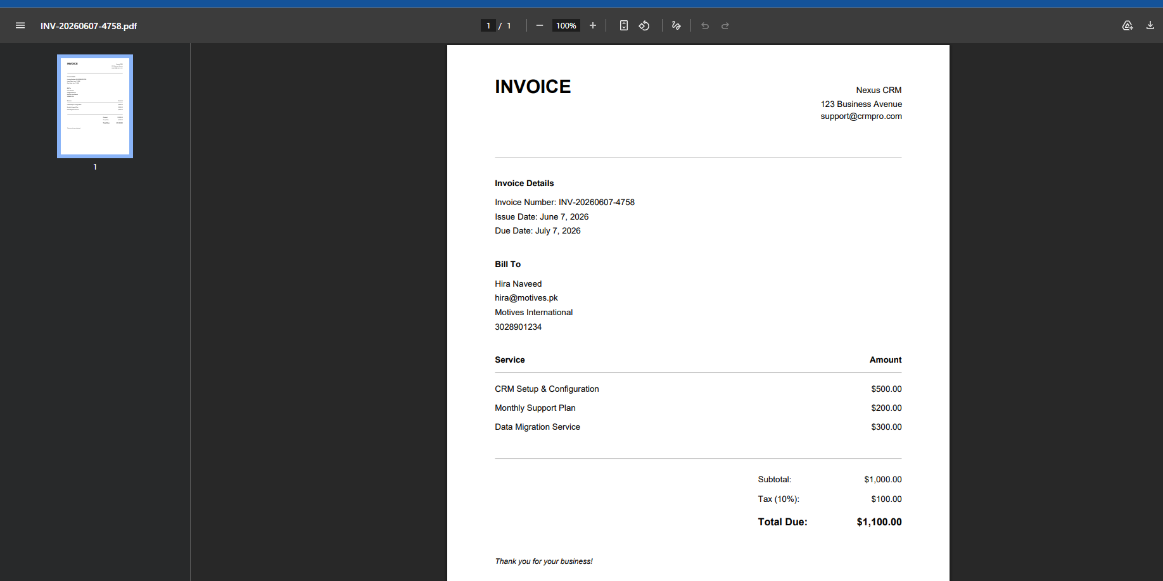

Chatbot:
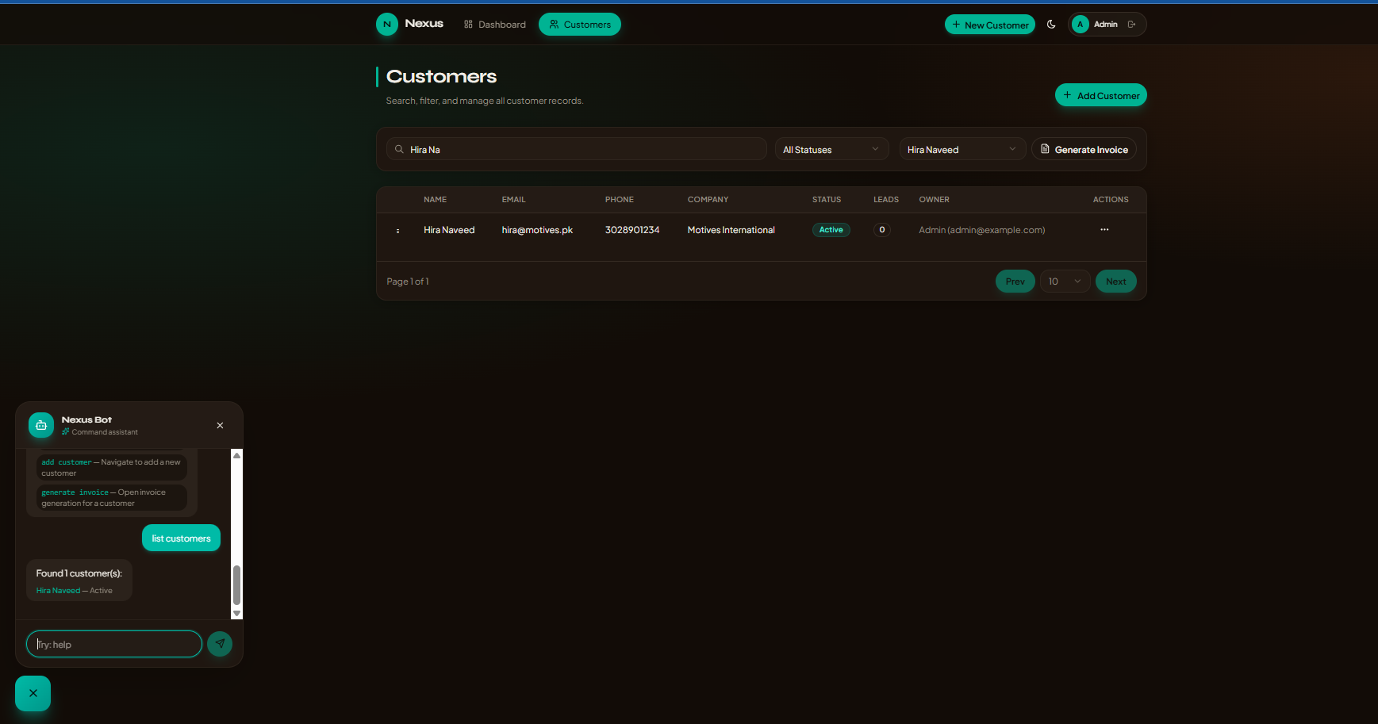

Light-mode:
