

Air University - Islamabad
Islamabad, Pakistan

Lab 02
Full Stack Programming Lab (B)

Hayat Ishfaq - 231994
Semester: Spring 2026

Submission Date: February 18, 2026

(Task#1)
html-code:
<!DOCTYPE html>
<html lang="en">
<head>
<meta charset="UTF-8">
<meta name="viewport" content="width=device-width, initial-scale=1.0">
<title>Dynamic Quiz</title>
<link rel="stylesheet" href="style.css">
</head>
<body>
<header>
<h1> Dynamic Quiz </h1>
</header>

<section class="container">
<div class="question">
<h2>1. Who is creator of JavaScript?</h2>
<div class="answer">
<label class="option">
<input type="radio" name="question1" value="Brendan Eich">
<span>Brendan Eich</span>
</label>
<label class="option">
<input type="radio" name="question1" value="James Gosling">
<span>James Gosling</span>
</label>
<label class="option">
<input type="radio" name="question1" value="Guido van Rossum">
<span>Guido van Rossum</span>
</label>
<label class="option">
<input type="radio" name="question1" value="Dennis Ritchie">
<span>Dennis Ritchie</span>
</label>
</div>
</div>
<div class="question">
<h2>2. HTML stands for:</h2>
<div class="answer">
<label class="option">
<input type="radio" name="question2" value="HyperText Markup Language">
<span>HyperText Markup Language</span>
</label>
<label class="option">
<input type="radio" name="question2" value="High Tech Modern Language">
<span>High Tech Modern Language</span>
</label>
<label class="option">
<input type="radio" name="question2" value="Home Tool Markup Language">
<span>Home Tool Markup Language</span>
</label>
<label class="option">
<input type="radio" name="question2" value="Hyperlinks and Text Markup Language">
<span>Hyperlinks and Text Markup Language</span>
</label>
</div>
</div>
<div class="question">
<h2>3. CSS stands for:</h2>
<div class="answer">
<label class="option">
<input type="radio" name="question3" value="Cascading Style Sheets">
<span>Cascading Style Sheets</span>
</label>
<label class="option">
<input type="radio" name="question3" value="Creative Style Sheets">
<span>Creative Style Sheets</span>
</label>
<label class="option">
<input type="radio" name="question3" value="Computer Style Sheets">
<span>Computer Style Sheets</span>
</label>
<label class="option">
<input type="radio" name="question3" value="Colorful Style Sheets">
<span>Colorful Style Sheets</span>
</label>
</div>
</div>
<div class="question">
<h2>4. What is capital of Pakistan?</h2>
<div class="answer">
<label class="option">
<input type="radio" name="question4" value="Islamabad">
<span>Islamabad</span>
</label>
<label class="option">
<input type="radio" name="question4" value="Karachi">
<span>Karachi</span>
</label>
<label class="option">
<input type="radio" name="question4" value="Lahore">
<span>Lahore</span>
</label>
<label class="option">
<input type="radio" name="question4" value="Peshawar">
<span>Peshawar</span>
</label>
</div>
</div>
<div class="question">
<h2>5. What is the largest planet in our solar system?</h2>
<div class="answer">
<label class="option">
<input type="radio" name="question5" value="Jupiter">
<span>Jupiter</span>
</label>
<label class="option">
<input type="radio" name="question5" value="Saturn">
<span>Saturn</span>
</label>
<label class="option">
<input type="radio" name="question5" value="Earth">
<span>Earth</span>
</label>
<label class="option">
<input type="radio" name="question5" value="Mars">
<span>Mars</span>
</label>
</div>
</div>
</section>

<button id="submit-btn">Submit Quiz</button>
<button id="reset-btn">Reset Quiz</button>

<div id="result-container"></div>

<script src="scripts.js"></script>
</body>
</html>

Css-code:

* {
margin: 0;
padding: 0;
box-sizing: border-box;
}

body {
font-family: 'Segoe UI', Tahoma, Geneva, Verdana, sans-serif;
background: linear-gradient(135deg, #667eea 0%, #764ba2 100%);
min-height: 100vh;
padding: 20px;
color: #333;
}

header {
text-align: center;
margin-bottom: 40px;
padding: 20px;
}

header h1 {
color: white;
font-size: 3em;
text-shadow: 2px 2px 4px rgba(0, 0, 0, 0.3);
letter-spacing: 2px;
animation: fadeInDown 0.8s ease;
}

@keyframes fadeInDown {
from {
opacity: 0;
transform: translateY(-30px);
}
to {
opacity: 1;
transform: translateY(0);
}
}

@keyframes fadeInUp {
from {
opacity: 0;
transform: translateY(30px);
}
to {
opacity: 1;
transform: translateY(0);
}
}

.container {
max-width: 900px;
margin: 0 auto 30px;
background: white;
padding: 40px;
border-radius: 15px;
box-shadow: 0 10px 40px rgba(0, 0, 0, 0.2);
animation: fadeInUp 0.8s ease;
}

.question {
background: linear-gradient(135deg, #f5f7fa 0%, #c3cfe2 100%);
padding: 25px;
margin-bottom: 25px;
border-radius: 12px;
border-left: 5px solid #667eea;
transition: all 0.3s ease;
box-shadow: 0 3px 10px rgba(0, 0, 0, 0.1);
}

.question:hover {
transform: translateX(10px);
box-shadow: 0 5px 20px rgba(102, 126, 234, 0.3);
}

.question h2 {
color: #333;
font-size: 1.3em;
margin-bottom: 15px;
font-weight: 600;
}

.answer {
margin-top: 10px;
}

/* Multiple Choice Option Styles */
.option {
display: block;
padding: 15px 20px;
margin: 10px 0;
background: white;
border: 2px solid #ddd;
border-radius: 8px;
cursor: pointer;
transition: all 0.3s ease;
position: relative;
font-size: 1.05em;
}

.option:hover {
background: #f0f4ff;
border-color: #667eea;
transform: translateX(5px);
box-shadow: 0 2px 10px rgba(102, 126, 234, 0.2);
}

.option input[type="radio"] {
margin-right: 12px;
cursor: pointer;
width: 20px;
height: 20px;
accent-color: #667eea;
}

.option input[type="radio"]:checked + span {
font-weight: 600;
color: #667eea;
}

.option:has(input[type="radio"]:checked) {
background: #e8f0fe;
border-color: #667eea;
border-width: 3px;
}

.option span {
vertical-align: middle;
}

.answer-input {
width: 100%;
padding: 15px;
font-size: 1.1em;
border: 2px solid #ddd;
border-radius: 8px;
transition: all 0.3s ease;
outline: none;
background: white;
}

.answer-input:focus {
border-color: #667eea;
box-shadow: 0 0 0 4px rgba(102, 126, 234, 0.1);
transform: scale(1.02);
}

.answer-input::placeholder {
color: #999;
font-style: italic;
}

button {
padding: 15px 50px;
font-size: 1.2em;
font-weight: 700;
border: none;
border-radius: 10px;
cursor: pointer;
transition: all 0.3s ease;
text-transform: uppercase;
letter-spacing: 1.5px;
margin: 10px;
box-shadow: 0 4px 15px rgba(0, 0, 0, 0.2);
}

#submit-btn {
background: linear-gradient(135deg, #667eea 0%, #764ba2 100%);
color: white;
display: block;
margin: 20px auto;
}

#submit-btn:hover {
transform: translateY(-3px);
box-shadow: 0 6px 25px rgba(102, 126, 234, 0.4);
}

#submit-btn:active {
transform: translateY(-1px);
}

#reset-btn {
background: linear-gradient(135deg, #f85032 0%, #e73827 100%);
color: white;
display: block;
margin: 10px auto;
}

#reset-btn:hover {
transform: translateY(-3px);
box-shadow: 0 6px 25px rgba(248, 80, 50, 0.4);
}

#reset-btn:active {
transform: translateY(-1px);
}

#result-container {
max-width: 900px;
margin: 30px auto;
background: white;
padding: 30px;
border-radius: 15px;
box-shadow: 0 10px 40px rgba(0, 0, 0, 0.2);
display: none;
animation: slideIn 0.5s ease;
}

@keyframes slideIn {
from {
opacity: 0;
transform: scale(0.9);
}
to {
opacity: 1;
transform: scale(1);
}
}

#result-container.show {
display: block;
}

.result-title {
color: #667eea;
font-size: 2.5em;
text-align: center;
margin-bottom: 20px;
font-weight: bold;
}

.score-display {
font-size: 1.8em;
text-align: center;
color: #333;
margin-bottom: 20px;
font-weight: bold;
padding: 20px;
background: linear-gradient(135deg, #f5f7fa 0%, #c3cfe2 100%);
border-radius: 10px;
}

.message-display {
font-size: 1.3em;
text-align: center;
color: #555;
margin-bottom: 30px;
padding: 20px;
background: #fff3cd;
border-left: 5px solid #ffc107;
border-radius: 8px;
font-style: italic;
}

.details-title {
color: #333;
font-size: 1.5em;
margin-bottom: 20px;
border-bottom: 3px solid #667eea;
padding-bottom: 10px;
}

.details-list {
list-style: none;
}

.details-list li {
padding: 20px;
margin-bottom: 15px;
border-radius: 10px;
background: #f8f9fa;
box-shadow: 0 2px 8px rgba(0, 0, 0, 0.1);
transition: transform 0.2s ease;
}

.details-list li:hover {
transform: translateX(5px);
}

.correct-answer {
border-left: 5px solid #28a745;
background: linear-gradient(135deg, #d4edda 0%, #c3e6cb 100%);
}

.incorrect-answer {
border-left: 5px solid #dc3545;
background: linear-gradient(135deg, #f8d7da 0%, #f5c6cb 100%);
}

.answer-detail {
color: #666;
font-size: 1em;
display: block;
margin-top: 8px;
}

.correct-answer-text {
color: #28a745;
font-weight: 700;
font-size: 1em;
display: block;
margin-top: 8px;
}

@media (max-width: 768px) {
header h1 {
font-size: 2em;
}

.container {
padding: 20px;
}

.question h2 {
font-size: 1.1em;
}

.option {
padding: 12px 15px;
font-size: 1em;
}

button {
width: 80%;
padding: 12px 30px;
font-size: 1em;
}

.result-title {
font-size: 1.8em;
}

.score-display {
font-size: 1.3em;
}
}

@media (max-width: 480px) {
body {
padding: 10px;
}

header h1 {
font-size: 1.5em;
}

.container {
padding: 15px;
}

.question {
padding: 15px;
}

.question h2 {
font-size: 1em;
}

.option {
padding: 10px 12px;
font-size: 0.95em;
margin: 8px 0;
}

.option input[type="radio"] {
width: 18px;
height: 18px;
}

button {
width: 95%;
padding: 10px 20px;
font-size: 0.9em;
margin: 5px;
}
}

Js-code:
// Store each question and answer in separate variables
const question1 = "Who is creator of JavaScript?";
const answer1 = "Brendan Eich";

const question2 = "HTML stands for:";
const answer2 = "HyperText Markup Language";

const question3 = "CSS stands for:";
const answer3 = "Cascading Style Sheets";

const question4 = "What is capital of Pakistan?";
const answer4 = "Islamabad";

const question5 = "What is the largest planet in our solar system?";
const answer5 = "Jupiter";

// Function to get selected answer for a question
function getSelectedAnswer(questionName) {
const selectedOption = document.querySelector(`input[name="${questionName}"]:checked`);
return selectedOption ? selectedOption.value : null;
}

// Function to check answer 1 individually
function checkAnswer1() {
const userAnswer = getSelectedAnswer('question1');
return userAnswer === answer1;
}

// Function to check answer 2 individually
function checkAnswer2() {
const userAnswer = getSelectedAnswer('question2');
return userAnswer === answer2;
}

// Function to check answer 3 individually
function checkAnswer3() {
const userAnswer = getSelectedAnswer('question3');
return userAnswer === answer3;
}

// Function to check answer 4 individually
function checkAnswer4() {
const userAnswer = getSelectedAnswer('question4');
return userAnswer === answer4;
}

// Function to check answer 5 individually
function checkAnswer5() {
const userAnswer = getSelectedAnswer('question5');
return userAnswer === answer5;
}

// Function to calculate total score
function calculateTotalScore() {
let totalScore = 0;

if (checkAnswer1()) totalScore++;
if (checkAnswer2()) totalScore++;
if (checkAnswer3()) totalScore++;
if (checkAnswer4()) totalScore++;
if (checkAnswer5()) totalScore++;

return totalScore;
}

// Function to get message based on score using conditional statements
function getScoreMessage(score, total) {
const percentage = (score / total) * 100;

if (percentage === 100) {
return "🎉 Perfect Score! You're a genius!";
} else if (percentage >= 80) {
return "🌟 Excellent! You have great knowledge!";
} else if (percentage >= 60) {
return "👍 Good job! Keep up the good work!";
} else if (percentage >= 40) {
return "📚 Not bad! A little more study will help!";
} else {
return "💪 Keep learning! Practice makes perfect!";
}
}

// Function to display results dynamically using DOM manipulation
function displayResults() {
// Validate that all answers are selected
const answer1Input = getSelectedAnswer('question1');
const answer2Input = getSelectedAnswer('question2');
const answer3Input = getSelectedAnswer('question3');
const answer4Input = getSelectedAnswer('question4');
const answer5Input = getSelectedAnswer('question5');

if (!answer1Input || !answer2Input || !answer3Input || !answer4Input || !answer5Input) {
alert('⚠️ Please answer all questions before submitting!');
return;
}

// Calculate score
const totalScore = calculateTotalScore();
const totalQuestions = 5;
const percentage = ((totalScore / totalQuestions) * 100).toFixed(0);

// Get the result container
const resultContainer = document.getElementById('result-container');

// Clear previous results
resultContainer.innerHTML = '';

// Create result title
const resultTitle = document.createElement('h2');
resultTitle.className = 'result-title';
resultTitle.textContent = '📊 Quiz Results';

// Create score display
const scoreDisplay = document.createElement('div');
scoreDisplay.className = 'score-display';
scoreDisplay.textContent = `Your Score: ${totalScore} / ${totalQuestions} (${percentage}%)`;

// Create message display using conditional statements
const messageDisplay = document.createElement('div');
messageDisplay.className = 'message-display';
messageDisplay.textContent = getScoreMessage(totalScore, totalQuestions);

// Create details title
const detailsTitle = document.createElement('h3');
detailsTitle.className = 'details-title';
detailsTitle.textContent = 'Answer Breakdown:';

// Create details list
const detailsList = document.createElement('ul');
detailsList.className = 'details-list';

// Array of question details for easier iteration
const questionDetails = [
{ num: 1, check: checkAnswer1(), userAnswer: answer1Input, correctAnswer: answer1, question: question1 },
{ num: 2, check: checkAnswer2(), userAnswer: answer2Input, correctAnswer: answer2, question: question2 },
{ num: 3, check: checkAnswer3(), userAnswer: answer3Input, correctAnswer: answer3, question: question3 },
{ num: 4, check: checkAnswer4(), userAnswer: answer4Input, correctAnswer: answer4, question: question4 },
{ num: 5, check: checkAnswer5(), userAnswer: answer5Input, correctAnswer: answer5, question: question5 }
];

// Create list items for each question
questionDetails.forEach(detail => {
const listItem = document.createElement('li');
listItem.className = detail.check ? 'correct-answer' : 'incorrect-answer';

const statusIcon = detail.check ? '✓' : '✗';
const statusText = detail.check ? 'Correct' : 'Incorrect';

listItem.innerHTML = `
<strong>Question ${detail.num}:</strong> ${statusIcon} ${statusText}<br>
<span class="answer-detail">Your answer: "${detail.userAnswer}"</span><br>
${!detail.check ? `<span class="correct-answer-text">Correct answer: "${detail.correctAnswer}"</span>` : ''}
`;

detailsList.appendChild(listItem);
});

// Append all elements to result container using DOM manipulation
resultContainer.appendChild(resultTitle);
resultContainer.appendChild(scoreDisplay);
resultContainer.appendChild(messageDisplay);
resultContainer.appendChild(detailsTitle);
resultContainer.appendChild(detailsList);

// Show result container
resultContainer.classList.add('show');
resultContainer.style.display = 'block';

// Scroll to results
resultContainer.scrollIntoView({ behavior: 'smooth', block: 'nearest' });
}

// Function to reset quiz - clears all inputs and results
function resetQuiz() {
// Clear all radio button selections
const allRadioButtons = document.querySelectorAll('input[type="radio"]');
allRadioButtons.forEach(radio => {
radio.checked = false;
});

// Clear result container using DOM manipulation
const resultContainer = document.getElementById('result-container');
resultContainer.innerHTML = '';
resultContainer.style.display = 'none';
resultContainer.classList.remove('show');

// Scroll to top
window.scrollTo({ top: 0, behavior: 'smooth' });

// Show confirmation
console.log('Quiz has been reset!');
}

// Event listeners
document.getElementById('submit-btn').addEventListener('click', displayResults);

document.getElementById('reset-btn').addEventListener('click', resetQuiz);

// Log initialization
console.log('Multiple Choice Quiz initialized successfully!');
console.log('Total questions:', 5);

Output:
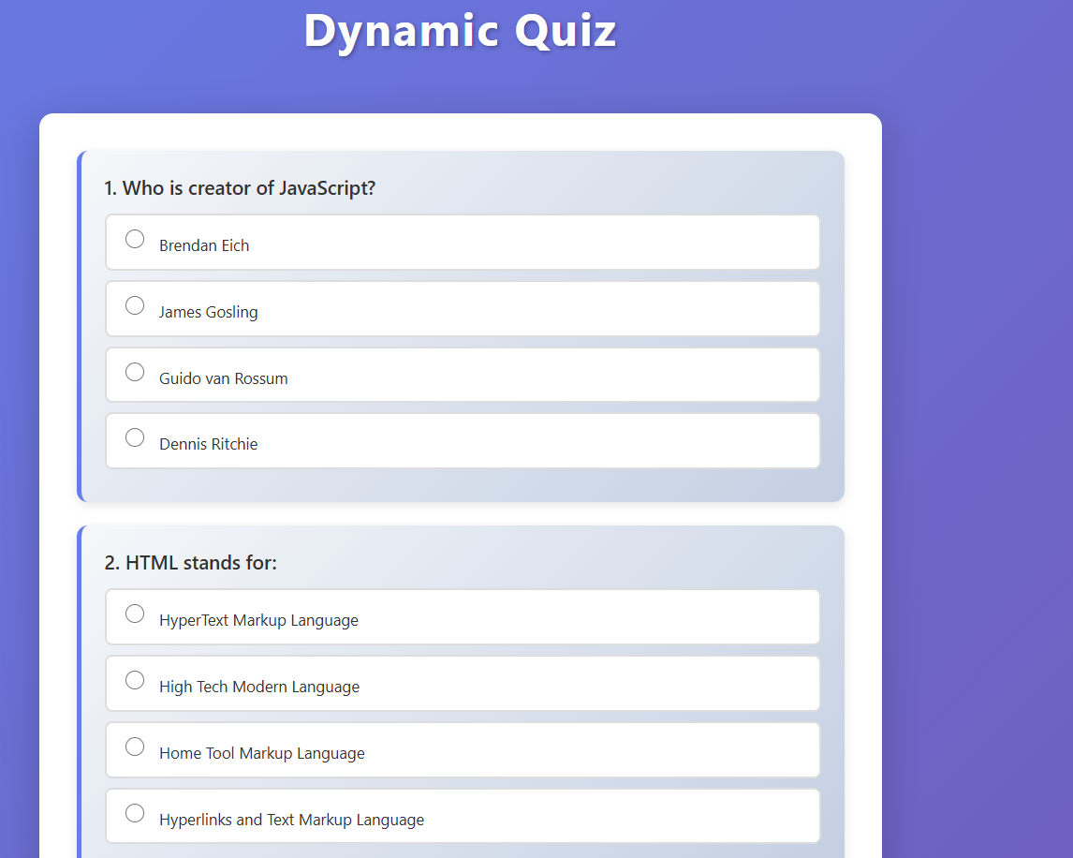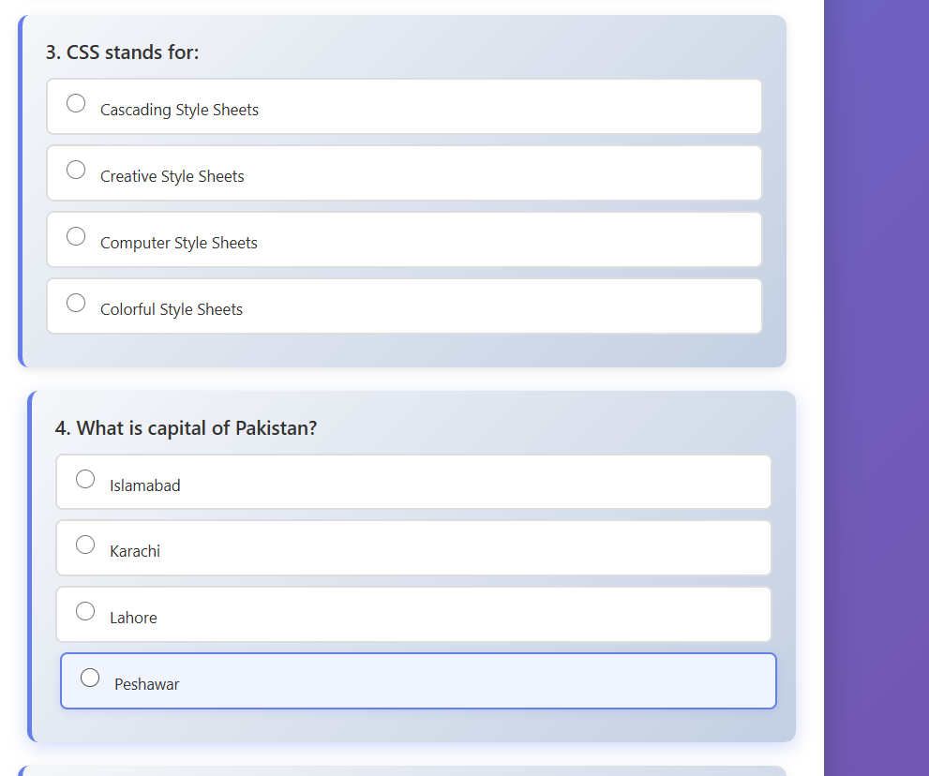
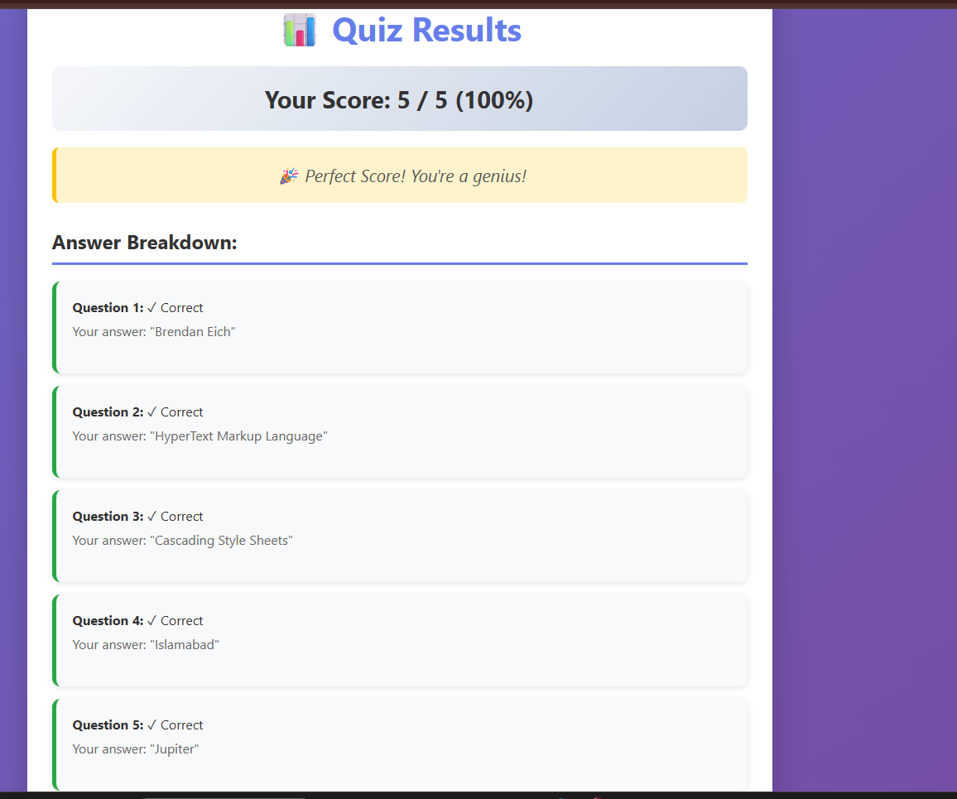

(Task#2)
Html-code:
<!DOCTYPE html>
<html lang="en">
<head>
<meta charset="UTF-8">
<meta name="viewport" content="width=device-width, initial-scale=1.0">
<title>Interactive Calculator</title>
<link rel="stylesheet" href="style.css">
</head>
<body>
<div class="container">
<header>
<h1>Interactive Calculator</h1>
</header>

<div class="calculator">
<div class="input-section">
<div class="input-group">
<label for="number1">First Number:</label>
<input type="number" id="number1" class="number-input" placeholder="Enter first number" step="any">
</div>

<div class="input-group">
<label for="operation">Operation:</label>
<select id="operation" class="operation-select">
<option value="">-- Select Operation --</option>
<option value="add">+ Addition</option>
<option value="subtract">- Subtraction</option>
<option value="multiply">× Multiplication</option>
<option value="divide">÷ Division</option>
</select>
</div>

<div class="input-group">
<label for="number2">Second Number:</label>
<input type="number" id="number2" class="number-input" placeholder="Enter second number" step="any">
</div>
</div>

<div class="button-group">
<button id="calculate-btn" class="btn calculate-btn">Calculate</button>
<button id="clear-btn" class="btn clear-btn">Clear</button>
</div>

<div id="result-container" class="result-container">
<h2>Result</h2>
<div id="result-display" class="result-display">
<span class="result-text">--</span>
</div>
<div id="operation-details" class="operation-details"></div>
</div>
</div>
</div>

<script src="scripts.js"></script>
</body>
</html>

Css-code:
/* Reset and Base Styles */
* {
margin: 0;
padding: 0;
box-sizing: border-box;
}

body {
font-family: 'Segoe UI', Tahoma, Geneva, Verdana, sans-serif;
background: linear-gradient(135deg, #1e3c72 0%, #2a5298 100%);
min-height: 100vh;
display: flex;
justify-content: center;
align-items: center;
padding: 20px;
}

.container {
width: 100%;
max-width: 600px;
}

/* Header Styles */
header {
text-align: center;
margin-bottom: 30px;
}

header h1 {
color: white;
font-size: 2.5em;
text-shadow: 2px 2px 4px rgba(0, 0, 0, 0.3);
letter-spacing: 1px;
animation: fadeInDown 0.8s ease;
}

@keyframes fadeInDown {
from {
opacity: 0;
transform: translateY(-30px);
}
to {
opacity: 1;
transform: translateY(0);
}
}

/* Calculator Container */
.calculator {
background: white;
border-radius: 20px;
padding: 40px;
box-shadow: 0 15px 50px rgba(0, 0, 0, 0.3);
animation: fadeInUp 0.8s ease;
}

@keyframes fadeInUp {
from {
opacity: 0;
transform: translateY(30px);
}
to {
opacity: 1;
transform: translateY(0);
}
}

/* Input Section */
.input-section {
margin-bottom: 30px;
}

.input-group {
margin-bottom: 25px;
}

.input-group label {
display: block;
color: #333;
font-size: 1.1em;
font-weight: 600;
margin-bottom: 10px;
}

.number-input,
.operation-select {
width: 100%;
padding: 15px;
font-size: 1.1em;
border: 2px solid #ddd;
border-radius: 10px;
transition: all 0.3s ease;
outline: none;
background: #f8f9fa;
}

.number-input:focus,
.operation-select:focus {
border-color: #1e3c72;
box-shadow: 0 0 0 4px rgba(30, 60, 114, 0.1);
background: white;
}

.operation-select {
cursor: pointer;
appearance: none;
background-image: url("data:image/svg+xml,%3Csvg xmlns='http://www.w3.org/2000/svg' width='12' height='12' viewBox='0 0 12 12'%3E%3Cpath fill='%23333' d='M10.293 3.293L6 7.586 1.707 3.293A1 1 0 00.293 4.707l5 5a1 1 0 001.414 0l5-5a1 1 0 10-1.414-1.414z'/%3E%3C/svg%3E");
background-repeat: no-repeat;
background-position: right 15px center;
padding-right: 45px;
}

/* Button Group */
.button-group {
display: flex;
gap: 15px;
margin-bottom: 30px;
}

.btn {
flex: 1;
padding: 15px 30px;
font-size: 1.2em;
font-weight: 700;
border: none;
border-radius: 10px;
cursor: pointer;
transition: all 0.3s ease;
text-transform: uppercase;
letter-spacing: 1px;
}

.calculate-btn {
background: linear-gradient(135deg, #1e3c72 0%, #2a5298 100%);
color: white;
}

.calculate-btn:hover {
transform: translateY(-3px);
box-shadow: 0 6px 25px rgba(30, 60, 114, 0.4);
}

.calculate-btn:active {
transform: translateY(-1px);
}

.clear-btn {
background: linear-gradient(135deg, #dc3545 0%, #c82333 100%);
color: white;
}

.clear-btn:hover {
transform: translateY(-3px);
box-shadow: 0 6px 25px rgba(220, 53, 69, 0.4);
}

.clear-btn:active {
transform: translateY(-1px);
}

/* Result Container */
.result-container {
background: #f8f9fa;
border-radius: 15px;
padding: 25px;
text-align: center;
opacity: 0.5;
transition: all 0.3s ease;
}

.result-container.show {
opacity: 1;
animation: pulse 0.5s ease;
}

@keyframes pulse {
0% {
transform: scale(1);
}
50% {
transform: scale(1.05);
}
100% {
transform: scale(1);
}
}

.result-container h2 {
color: #333;
font-size: 1.5em;
margin-bottom: 20px;
}

/* Result Display with Dynamic Background Colors (BONUS) */
.result-display {
padding: 30px;
border-radius: 12px;
margin-bottom: 15px;
transition: all 0.4s ease;
border: 3px solid transparent;
}

/* Positive Result - Green Background */
.result-display.positive {
background: linear-gradient(135deg, #d4edda 0%, #c3e6cb 100%);
border-color: #28a745;
box-shadow: 0 5px 20px rgba(40, 167, 69, 0.3);
}

/* Negative Result - Red Background */
.result-display.negative {
background: linear-gradient(135deg, #f8d7da 0%, #f5c6cb 100%);
border-color: #dc3545;
box-shadow: 0 5px 20px rgba(220, 53, 69, 0.3);
}

/* Neutral Result (Zero) - Blue Background */
.result-display.neutral {
background: linear-gradient(135deg, #d1ecf1 0%, #bee5eb 100%);
border-color: #17a2b8;
box-shadow: 0 5px 20px rgba(23, 162, 184, 0.3);
}

.result-text {
font-size: 3em;
font-weight: bold;
color: #333;
display: block;
}

.operation-details {
font-size: 1.2em;
color: #555;
font-weight: 600;
}

/* Responsive Design */
@media (max-width: 768px) {
header h1 {
font-size: 2em;
}

.calculator {
padding: 25px;
}

.button-group {
flex-direction: column;
}

.result-text {
font-size: 2.5em;
}
}

@media (max-width: 480px) {
body {
padding: 10px;
}

header h1 {
font-size: 1.5em;
}

.calculator {
padding: 20px;
}

.input-group label {
font-size: 1em;
}

.number-input,
.operation-select {
padding: 12px;
font-size: 1em;
}

.btn {
padding: 12px 20px;
font-size: 1em;
}

.result-text {
font-size: 2em;
}

.operation-details {
font-size: 1em;
}
}

Js-code:
// Function to validate inputs using conditional statements
function validateInputs(num1, num2, operation) {
// Check if numbers are valid
if (isNaN(num1) || num1 === '') {
return { valid: false, message: 'Please enter a valid first number!' };
}

if (isNaN(num2) || num2 === '') {
return { valid: false, message: 'Please enter a valid second number!' };
}

// Check if operation is selected
if (!operation || operation === '') {
return { valid: false, message: 'Please select an operation!' };
}

// Prevent division by zero
if (operation === 'divide' && parseFloat(num2) === 0) {
return { valid: false, message: '⚠️ Cannot divide by zero!' };
}

return { valid: true, message: 'Valid inputs' };
}

// Function to calculate result based on operation
function calculate(num1, num2, operation) {
const number1 = parseFloat(num1);
const number2 = parseFloat(num2);
let result;
let operationSymbol;

// Use conditional statements to determine operation
if (operation === 'add') {
result = number1 + number2;
operationSymbol = '+';
} else if (operation === 'subtract') {
result = number1 - number2;
operationSymbol = '-';
} else if (operation === 'multiply') {
result = number1 * number2;
operationSymbol = '×';
} else if (operation === 'divide') {
result = number1 / number2;
operationSymbol = '÷';
}

return {
result: result,
operation: operationSymbol,
num1: number1,
num2: number2
};
}

// Function to display result dynamically using DOM manipulation
function displayResult() {
// Get input values
const num1Input = document.getElementById('number1').value;
const num2Input = document.getElementById('number2').value;
const operation = document.getElementById('operation').value;

// Validate inputs
const validation = validateInputs(num1Input, num2Input, operation);

if (!validation.valid) {
alert(validation.message);
return;
}

// Calculate result
const calculationResult = calculate(num1Input, num2Input, operation);

// Get result container and display elements
const resultContainer = document.getElementById('result-container');
const resultDisplay = document.getElementById('result-display');
const operationDetails = document.getElementById('operation-details');

// Clear existing content
resultDisplay.innerHTML = '';
operationDetails.innerHTML = '';

// Create result text element
const resultText = document.createElement('span');
resultText.className = 'result-text';
resultText.textContent = calculationResult.result.toFixed(2);

// Change background color based on positive or negative value (BONUS)
if (calculationResult.result > 0) {
resultDisplay.className = 'result-display positive';
} else if (calculationResult.result < 0) {
resultDisplay.className = 'result-display negative';
} else {
resultDisplay.className = 'result-display neutral';
}

// Create operation details
const detailsParagraph = document.createElement('p');
detailsParagraph.textContent = `${calculationResult.num1} ${calculationResult.operation} ${calculationResult.num2} = ${calculationResult.result.toFixed(2)}`;

// Append elements to DOM
resultDisplay.appendChild(resultText);
operationDetails.appendChild(detailsParagraph);

// Show result container with animation
resultContainer.classList.add('show');
}

// Function to clear calculator
function clearCalculator() {
// Clear input fields
document.getElementById('number1').value = '';
document.getElementById('number2').value = '';
document.getElementById('operation').value = '';

// Reset result display using DOM manipulation
const resultDisplay = document.getElementById('result-display');
const operationDetails = document.getElementById('operation-details');

resultDisplay.innerHTML = '<span class="result-text">--</span>';
resultDisplay.className = 'result-display';
operationDetails.innerHTML = '';

// Hide result container
const resultContainer = document.getElementById('result-container');
resultContainer.classList.remove('show');

// Focus on first input
document.getElementById('number1').focus();
}

// Event listeners
document.getElementById('calculate-btn').addEventListener('click', displayResult);
document.getElementById('clear-btn').addEventListener('click', clearCalculator);

// Allow Enter key to calculate
document.getElementById('number1').addEventListener('keypress', function(event) {
if (event.key === 'Enter') {
displayResult();
}
});

document.getElementById('number2').addEventListener('keypress', function(event) {
if (event.key === 'Enter') {
displayResult();
}
});

// Log initialization
console.log('Interactive Calculator initialized successfully!');

Output:

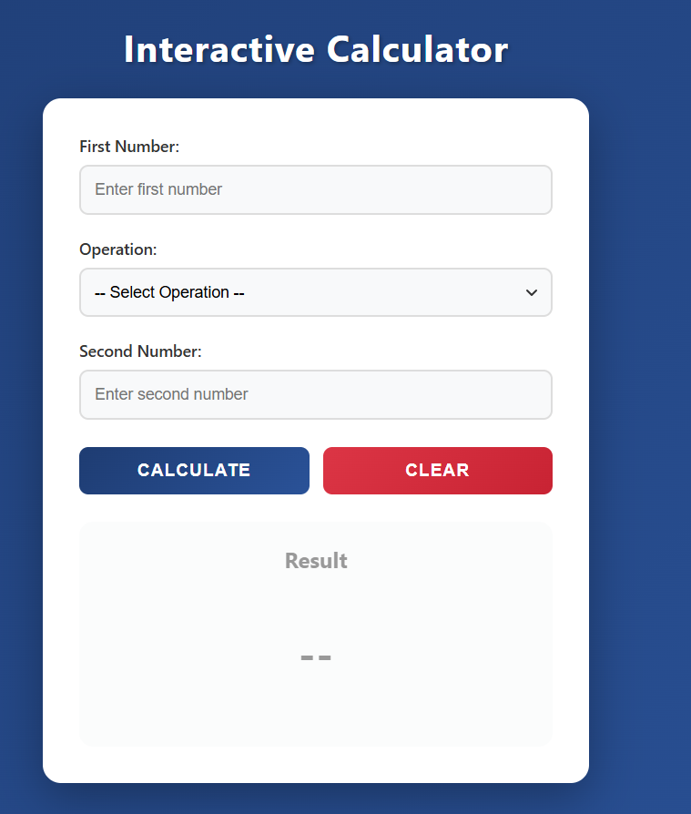
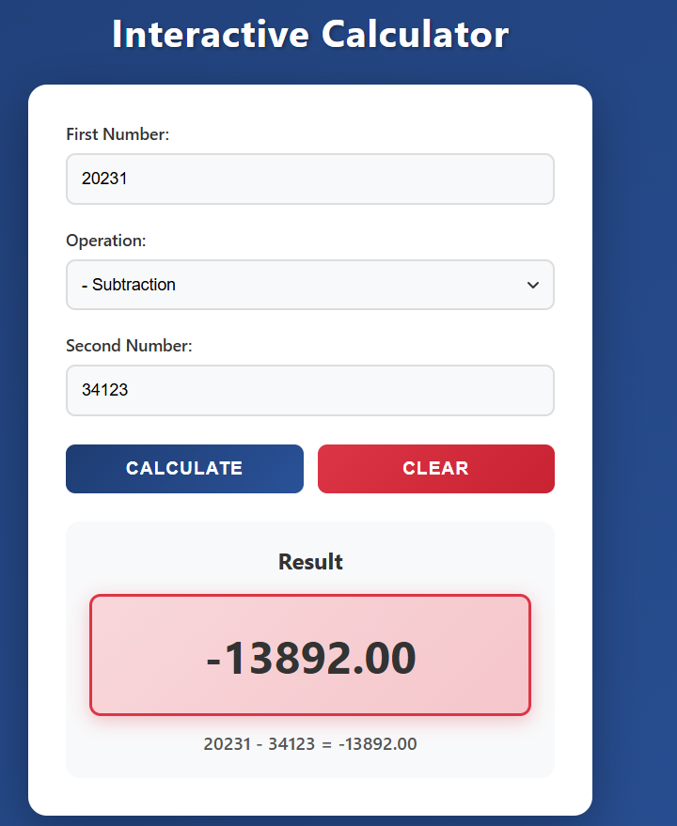

(Task#3)

Html-code:
<!DOCTYPE html>
<html lang="en">
<head>
<meta charset="UTF-8">
<meta name="viewport" content="width=device-width, initial-scale=1.0">
<title>Simple To-Do List</title>
<link rel="stylesheet" href="style.css">
</head>
<body>
<div class="container">
<header>
<h1>My To-Do List</h1>
</header>

<div class="todo-container">
<div class="task-item" id="task1">
<input type="text" class="task-input" value="Complete JavaScript Assignment" readonly>
<div class="task-buttons">
<button class="btn complete-btn" onclick="toggleComplete(1)">✓ Complete</button>
<button class="btn remove-btn" onclick="removeTask(1)">✗ Remove</button>
</div>
</div>

<div class="task-item" id="task2">
<input type="text" class="task-input" value="Study for Math Exam" readonly>
<div class="task-buttons">
<button class="btn complete-btn" onclick="toggleComplete(2)">✓ Complete</button>
<button class="btn remove-btn" onclick="removeTask(2)">✗ Remove</button>
</div>
</div>

<div class="task-item" id="task3">
<input type="text" class="task-input" value="Read Chapter 5 of Textbook" readonly>
<div class="task-buttons">
<button class="btn complete-btn" onclick="toggleComplete(3)">✓ Complete</button>
<button class="btn remove-btn" onclick="removeTask(3)">✗ Remove</button>
</div>
</div>
</div>

<div class="stats-container">
<p id="stats">Total Tasks: 3 | Completed: 0 | Remaining: 3</p>
</div>

<button class="btn reset-btn" onclick="resetAll()">Reset All Tasks</button>
</div>

<script src="scripts.js"></script>
</body>
</html>

Css-code:
* {
margin: 0;
padding: 0;
box-sizing: border-box;
}

body {
font-family: 'Segoe UI', Tahoma, Geneva, Verdana, sans-serif;
background: linear-gradient(135deg, #667eea 0%, #764ba2 100%);
min-height: 100vh;
display: flex;
justify-content: center;
align-items: center;
padding: 20px;
}

.container {
width: 100%;
max-width: 700px;
background: white;
border-radius: 20px;
padding: 40px;
box-shadow: 0 15px 50px rgba(0, 0, 0, 0.3);
animation: fadeIn 0.8s ease;
}

@keyframes fadeIn {
from {
opacity: 0;
transform: translateY(30px);
}
to {
opacity: 1;
transform: translateY(0);
}
}

header {
text-align: center;
margin-bottom: 40px;
}

header h1 {
color: #667eea;
font-size: 2.5em;
letter-spacing: 1px;
}

.todo-container {
margin-bottom: 30px;
}

.task-item {
display: flex;
align-items: center;
justify-content: space-between;
background: #f8f9fa;
padding: 20px;
margin-bottom: 20px;
border-radius: 12px;
border-left: 5px solid #667eea;
transition: all 0.3s ease;
box-shadow: 0 3px 10px rgba(0, 0, 0, 0.1);
}

.task-item:hover {
transform: translateX(5px);
box-shadow: 0 5px 15px rgba(0, 0, 0, 0.15);
}

.task-item.completed {
border-left-color: #28a745;
background: #e8f5e9;
}

.task-input {
flex: 1;
padding: 12px;
font-size: 1.1em;
border: none;
background: transparent;
color: #333;
font-weight: 500;
outline: none;
cursor: default;
}

.task-input.completed {
text-decoration: line-through;
color: #6c757d;
opacity: 0.7;
}

.task-buttons {
display: flex;
gap: 10px;
}

.btn {
padding: 10px 20px;
font-size: 0.95em;
font-weight: 600;
border: none;
border-radius: 8px;
cursor: pointer;
transition: all 0.3s ease;
text-transform: uppercase;
letter-spacing: 0.5px;
}

.complete-btn {
background: linear-gradient(135deg, #28a745 0%, #20c997 100%);
color: white;
}

.complete-btn:hover {
transform: translateY(-2px);
box-shadow: 0 4px 15px rgba(40, 167, 69, 0.4);
}

.uncomplete-btn {
background: linear-gradient(135deg, #ffc107 0%, #ff9800 100%);
}

.uncomplete-btn:hover {
transform: translateY(-2px);
box-shadow: 0 4px 15px rgba(255, 193, 7, 0.4);
}

.remove-btn {
background: linear-gradient(135deg, #dc3545 0%, #c82333 100%);
color: white;
}

.remove-btn:hover {
transform: translateY(-2px);
box-shadow: 0 4px 15px rgba(220, 53, 69, 0.4);
}

.btn:active {
transform: translateY(0);
}

.stats-container {
background: linear-gradient(135deg, #e3f2fd 0%, #bbdefb 100%);
padding: 20px;
border-radius: 12px;
text-align: center;
margin-bottom: 20px;
border: 2px solid #2196f3;
}

.stats-container p {
font-size: 1.2em;
font-weight: 600;
color: #1976d2;
}

.reset-btn {
width: 100%;
padding: 15px;
font-size: 1.1em;
background: linear-gradient(135deg, #6c757d 0%, #495057 100%);
color: white;
}

.reset-btn:hover {
transform: translateY(-3px);
box-shadow: 0 6px 20px rgba(108, 117, 125, 0.4);
}

@media (max-width: 768px) {
.container {
padding: 25px;
}

header h1 {
font-size: 2em;
}

.task-item {
flex-direction: column;
gap: 15px;
}

.task-input {
width: 100%;
text-align: center;
}

.task-buttons {
width: 100%;
justify-content: center;
}

.btn {
flex: 1;
}
}

@media (max-width: 480px) {
body {
padding: 10px;
}

.container {
padding: 20px;
}

header h1 {
font-size: 1.5em;
}

.task-item {
padding: 15px;
}

.task-input {
font-size: 1em;
}

.btn {
padding: 8px 15px;
font-size: 0.85em;
}

.stats-container p {
font-size: 1em;
}
}

Js-code:
function toggleComplete(taskNumber) {
const taskElement = document.getElementById(`task${taskNumber}`);
const taskInput = taskElement.querySelector('.task-input');
const completeBtn = taskElement.querySelector('.complete-btn');

if (taskElement.classList.contains('completed')) {
taskElement.classList.remove('completed');
taskInput.classList.remove('completed');
completeBtn.textContent = '✓ Complete';
completeBtn.classList.remove('uncomplete-btn');
} else {
taskElement.classList.add('completed');
taskInput.classList.add('completed');
completeBtn.textContent = '↺ Undo';
completeBtn.classList.add('uncomplete-btn');
}

updateStyles();
updateStats();
}

function removeTask(taskNumber) {
const taskElement = document.getElementById(`task${taskNumber}`);
taskElement.style.display = 'none';
updateStats();
}

function updateStyles() {
const allTasks = document.querySelectorAll('.task-item');

for (let i = 0; i < allTasks.length; i++) {
const task = allTasks[i];
const input = task.querySelector('.task-input');

if (task.classList.contains('completed')) {
input.style.textDecoration = 'line-through';
input.style.color = '#6c757d';
input.style.opacity = '0.7';
} else {
input.style.textDecoration = 'none';
input.style.color = '#333';
input.style.opacity = '1';
}
}
}

function updateStats() {
const allTasks = document.querySelectorAll('.task-item');
let totalVisible = 0;
let completed = 0;

for (let i = 0; i < allTasks.length; i++) {
if (allTasks[i].style.display !== 'none') {
totalVisible++;
if (allTasks[i].classList.contains('completed')) {
completed++;
}
}
}

const remaining = totalVisible - completed;
const statsElement = document.getElementById('stats');
statsElement.textContent = `Total Tasks: ${totalVisible} | Completed: ${completed} | Remaining: ${remaining}`;
}

function resetAll() {
const allTasks = document.querySelectorAll('.task-item');

for (let i = 0; i < allTasks.length; i++) {
const task = allTasks[i];
const input = task.querySelector('.task-input');
const completeBtn = task.querySelector('.complete-btn');

task.style.display = 'flex';
task.classList.remove('completed');
input.classList.remove('completed');
input.style.textDecoration = 'none';
input.style.color = '#333';
input.style.opacity = '1';
completeBtn.textContent = '✓ Complete';
completeBtn.classList.remove('uncomplete-btn');
}

updateStats();
}

window.onload = function() {
updateStats();
};

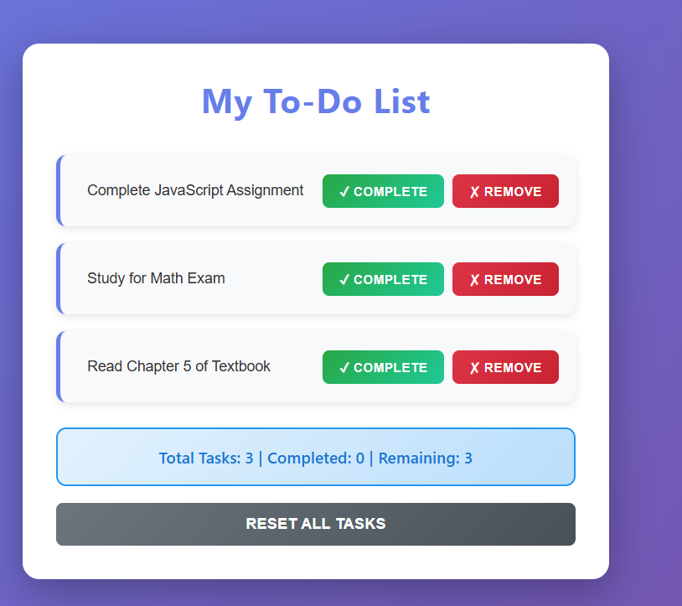
Output:
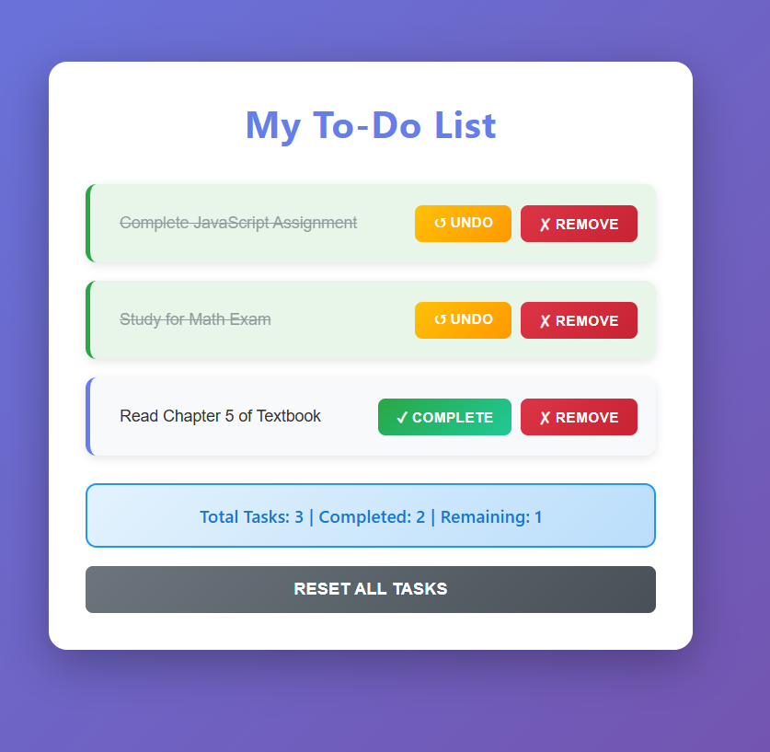

(Task#4)
Html-code:
<!DOCTYPE html>
<html lang="en">
<head>
<meta charset="UTF-8">
<meta name="viewport" content="width=device-width, initial-scale=1.0">
<title>Color Box Generator</title>
<link rel="stylesheet" href="style.css">
</head>
<body>
<div class="container">
<header>
<h1>Color Box Generator</h1>
</header>

<div class="input-section">
<div class="color-input-group">
<label for="color1">Color 1:</label>
<input type="text" id="color1" class="color-input" placeholder="e.g., red, #ff0000, rgb(255,0,0)">
<button class="btn add-btn" onclick="addColorBox(1)">Add Box 1</button>
</div>

<div class="color-input-group">
<label for="color2">Color 2:</label>
<input type="text" id="color2" class="color-input" placeholder="e.g., blue, #0000ff, rgb(0,0,255)">
<button class="btn add-btn" onclick="addColorBox(2)">Add Box 2</button>
</div>

<div class="color-input-group">
<label for="color3">Color 3:</label>
<input type="text" id="color3" class="color-input" placeholder="e.g., green, #00ff00, rgb(0,255,0)">
<button class="btn add-btn" onclick="addColorBox(3)">Add Box 3</button>
</div>
</div>

<div class="control-buttons">
<button class="btn clear-btn" onclick="clearAllBoxes()">Clear All Boxes</button>
</div>

<div class="bom-info-section">
<h2>Browser & Window Information (BOM)</h2>
<div class="info-grid">
<div class="info-item">
<span class="info-label">Window Width:</span>
<span class="info-value" id="window-width">--</span>
</div>
<div class="info-item">
<span class="info-label">Window Height:</span>
<span class="info-value" id="window-height">--</span>
</div>
<div class="info-item">
<span class="info-label">Screen Width:</span>
<span class="info-value" id="screen-width">--</span>
</div>
<div class="info-item">
<span class="info-label">Screen Height:</span>
<span class="info-value" id="screen-height">--</span>
</div>
<div class="info-item">
<span class="info-label">Browser:</span>
<span class="info-value" id="browser-name">--</span>
</div>
<div class="info-item">
<span class="info-label">Platform:</span>
<span class="info-value" id="platform">--</span>
</div>
<div class="info-item">
<span class="info-label">Language:</span>
<span class="info-value" id="language">--</span>
</div>
<div class="info-item">
<span class="info-label">Online Status:</span>
<span class="info-value" id="online-status">--</span>
</div>
</div>
</div>

<div class="display-section">
<h2>Color Boxes</h2>
<div id="boxes-container" class="boxes-container"></div>
<p id="box-count" class="box-count">Total Boxes: 0</p>
</div>
</div>

<script src="scripts.js"></script>
</body>
</html>

Css-code:
* {
margin: 0;
padding: 0;
box-sizing: border-box;
}

body {
font-family: 'Segoe UI', Tahoma, Geneva, Verdana, sans-serif;
background: linear-gradient(135deg, #667eea 0%, #764ba2 100%);
min-height: 100vh;
padding: 20px;
}

.container {
max-width: 1000px;
margin: 0 auto;
background: white;
border-radius: 20px;
padding: 40px;
box-shadow: 0 15px 50px rgba(0, 0, 0, 0.3);
animation: fadeIn 0.8s ease;
}

@keyframes fadeIn {
from {
opacity: 0;
transform: translateY(30px);
}
to {
opacity: 1;
transform: translateY(0);
}
}

header {
text-align: center;
margin-bottom: 40px;
}

header h1 {
color: #667eea;
font-size: 2.8em;
letter-spacing: 1px;
}

.input-section {
background: #f8f9fa;
padding: 30px;
border-radius: 15px;
margin-bottom: 30px;
}

.color-input-group {
display: flex;
align-items: center;
gap: 15px;
margin-bottom: 20px;
}

.color-input-group:last-child {
margin-bottom: 0;
}

.color-input-group label {
font-weight: 600;
color: #333;
font-size: 1.1em;
min-width: 80px;
}

.color-input {
flex: 1;
padding: 12px;
font-size: 1em;
border: 2px solid #ddd;
border-radius: 8px;
transition: all 0.3s ease;
outline: none;
}

.color-input:focus {
border-color: #667eea;
box-shadow: 0 0 0 3px rgba(102, 126, 234, 0.1);
}

.btn {
padding: 12px 25px;
font-size: 1em;
font-weight: 600;
border: none;
border-radius: 8px;
cursor: pointer;
transition: all 0.3s ease;
text-transform: uppercase;
letter-spacing: 0.5px;
}

.add-btn {
background: linear-gradient(135deg, #667eea 0%, #764ba2 100%);
color: white;
min-width: 120px;
}

.add-btn:hover {
transform: translateY(-2px);
box-shadow: 0 5px 20px rgba(102, 126, 234, 0.4);
}

.control-buttons {
text-align: center;
margin-bottom: 30px;
}

.clear-btn {
background: linear-gradient(135deg, #dc3545 0%, #c82333 100%);
color: white;
padding: 15px 50px;
font-size: 1.1em;
}

.clear-btn:hover {
transform: translateY(-3px);
box-shadow: 0 6px 25px rgba(220, 53, 69, 0.4);
}

.bom-info-section {
background: linear-gradient(135deg, #e3f2fd 0%, #bbdefb 100%);
padding: 30px;
border-radius: 15px;
margin-bottom: 30px;
border: 3px solid #2196f3;
}

.bom-info-section h2 {
color: #1976d2;
font-size: 1.8em;
margin-bottom: 20px;
text-align: center;
}

.info-grid {
display: grid;
grid-template-columns: repeat(auto-fit, minmax(250px, 1fr));
gap: 15px;
}

.info-item {
background: white;
padding: 15px 20px;
border-radius: 10px;
display: flex;
justify-content: space-between;
align-items: center;
box-shadow: 0 3px 10px rgba(0, 0, 0, 0.1);
transition: all 0.3s ease;
}

.info-item:hover {
transform: translateY(-3px);
box-shadow: 0 5px 15px rgba(0, 0, 0, 0.15);
}

.info-label {
font-weight: 600;
color: #555;
font-size: 1em;
}

.info-value {
font-weight: 700;
color: #1976d2;
font-size: 1.1em;
}

.display-section {
background: #f8f9fa;
padding: 30px;
border-radius: 15px;
min-height: 300px;
}

.display-section h2 {
color: #333;
font-size: 1.8em;
margin-bottom: 20px;
text-align: center;
}

.boxes-container {
display: grid;
grid-template-columns: repeat(auto-fill, minmax(150px, 1fr));
gap: 20px;
margin-bottom: 20px;
min-height: 200px;
}

.box-wrapper {
display: flex;
flex-direction: column;
align-items: center;
gap: 10px;
}

.color-box {
width: 150px;
height: 150px;
border-radius: 15px;
box-shadow: 0 5px 20px rgba(0, 0, 0, 0.2);
transition: all 0.3s ease;
position: relative;
border: 3px solid white;
}

.color-box:hover {
transform: scale(1.1) rotate(5deg);
box-shadow: 0 8px 30px rgba(0, 0, 0, 0.3);
}

.remove-box-btn {
position: absolute;
top: -10px;
right: -10px;
width: 35px;
height: 35px;
background: #dc3545;
color: white;
border: 3px solid white;
border-radius: 50%;
font-size: 1.5em;
font-weight: bold;
cursor: pointer;
display: flex;
align-items: center;
justify-content: center;
transition: all 0.3s ease;
box-shadow: 0 3px 10px rgba(0, 0, 0, 0.3);
}

.remove-box-btn:hover {
background: #c82333;
transform: scale(1.2);
}

.color-label {
font-size: 0.95em;
font-weight: 600;
color: #555;
background: white;
padding: 8px 15px;
border-radius: 20px;
box-shadow: 0 2px 8px rgba(0, 0, 0, 0.1);
text-align: center;
word-break: break-all;
}

.input-label {
font-size: 0.85em;
font-weight: 500;
color: #888;
font-style: italic;
}

.box-count {
text-align: center;
font-size: 1.3em;
font-weight: 700;
color: #667eea;
background: white;
padding: 15px;
border-radius: 10px;
box-shadow: 0 3px 10px rgba(0, 0, 0, 0.1);
}

@keyframes slideIn {
from {
opacity: 0;
transform: scale(0.5) rotate(-10deg);
}
to {
opacity: 1;
transform: scale(1) rotate(0deg);
}
}

@keyframes slideOut {
from {
opacity: 1;
transform: scale(1);
}
to {
opacity: 0;
transform: scale(0.3);
}
}

@media (max-width: 768px) {
.container {
padding: 25px;
}

header h1 {
font-size: 2em;
}

.color-input-group {
flex-wrap: wrap;
}

.color-input-group label {
width: 100%;
}

.color-input {
width: 100%;
}

.add-btn {
width: 100%;
}

.info-grid {
grid-template-columns: 1fr;
}

.boxes-container {
grid-template-columns: repeat(auto-fill, minmax(120px, 1fr));
gap: 15px;
}

.color-box {
width: 120px;
height: 120px;
}
}

@media (max-width: 480px) {
body {
padding: 10px;
}

.container {
padding: 20px;
}

header h1 {
font-size: 1.6em;
}

.input-section {
padding: 20px;
}

.bom-info-section {
padding: 20px;
}

.bom-info-section h2 {
font-size: 1.4em;
}

.info-item {
flex-direction: column;
align-items: flex-start;
gap: 5px;
}

.boxes-container {
grid-template-columns: repeat(auto-fill, minmax(100px, 1fr));
gap: 10px;
}

.color-box {
width: 100px;
height: 100px;
}

.color-label {
font-size: 0.8em;
padding: 5px 10px;
}
}

Js-code:
function addColorBox(inputNumber) {
const colorInput = document.getElementById(`color${inputNumber}`);
const colorValue = colorInput.value.trim();

if (!colorValue) {
alert('Please enter a color!');
return;
}

if (!isValidColor(colorValue)) {
alert('Invalid color! Use color names (red, blue), hex (#ff0000), or rgb(255,0,0)');
return;
}

createBox(colorValue, inputNumber);
colorInput.value = '';
updateBoxCount();
}

function isValidColor(color) {
const tempElement = document.createElement('div');
tempElement.style.color = color;
return tempElement.style.color !== '';
}

function createBox(color, inputNumber) {
const boxesContainer = document.getElementById('boxes-container');

const boxWrapper = document.createElement('div');
boxWrapper.className = 'box-wrapper';

const colorBox = document.createElement('div');
colorBox.className = 'color-box';
colorBox.style.backgroundColor = color;

const colorLabel = document.createElement('div');
colorLabel.className = 'color-label';
colorLabel.textContent = color;

const inputLabel = document.createElement('div');
inputLabel.className = 'input-label';
inputLabel.textContent = `From Input ${inputNumber}`;

const removeBtn = document.createElement('button');
removeBtn.className = 'remove-box-btn';
removeBtn.textContent = '×';
removeBtn.onclick = function() {
removeBox(boxWrapper);
};

colorBox.appendChild(removeBtn);
boxWrapper.appendChild(colorBox);
boxWrapper.appendChild(colorLabel);
boxWrapper.appendChild(inputLabel);

boxesContainer.appendChild(boxWrapper);

boxWrapper.style.animation = 'slideIn 0.4s ease';
}

function removeBox(boxElement) {
boxElement.style.animation = 'slideOut 0.3s ease';
setTimeout(() => {
boxElement.remove();
updateBoxCount();
}, 300);
}

function clearAllBoxes() {
const boxesContainer = document.getElementById('boxes-container');
const allBoxes = boxesContainer.querySelectorAll('.box-wrapper');

if (allBoxes.length === 0) {
alert('No boxes to clear!');
return;
}

for (let i = 0; i < allBoxes.length; i++) {
allBoxes[i].style.animation = 'slideOut 0.3s ease';
}

setTimeout(() => {
boxesContainer.innerHTML = '';
updateBoxCount();
}, 300);
}

function updateBoxCount() {
const boxesContainer = document.getElementById('boxes-container');
const boxCount = boxesContainer.querySelectorAll('.box-wrapper').length;
const boxCountElement = document.getElementById('box-count');
boxCountElement.textContent = `Total Boxes: ${boxCount}`;
}

function updateBOMInfo() {
document.getElementById('window-width').textContent = window.innerWidth + 'px';
document.getElementById('window-height').textContent = window.innerHeight + 'px';
document.getElementById('screen-width').textContent = window.screen.width + 'px';
document.getElementById('screen-height').textContent = window.screen.height + 'px';

const userAgent = navigator.userAgent;
let browserName = 'Unknown';

if (userAgent.indexOf('Firefox') > -1) {
browserName = 'Mozilla Firefox';
} else if (userAgent.indexOf('Chrome') > -1) {
browserName = 'Google Chrome';
} else if (userAgent.indexOf('Safari') > -1) {
browserName = 'Safari';
} else if (userAgent.indexOf('Edge') > -1) {
browserName = 'Microsoft Edge';
} else if (userAgent.indexOf('MSIE') > -1 || userAgent.indexOf('Trident') > -1) {
browserName = 'Internet Explorer';
}

document.getElementById('browser-name').textContent = browserName;
document.getElementById('platform').textContent = navigator.platform;
document.getElementById('language').textContent = navigator.language;
document.getElementById('online-status').textContent = navigator.onLine ? 'Online ✓' : 'Offline ✗';
}

document.getElementById('color1').addEventListener('keypress', function(event) {
if (event.key === 'Enter') {
addColorBox(1);
}
});

document.getElementById('color2').addEventListener('keypress', function(event) {
if (event.key === 'Enter') {
addColorBox(2);
}
});

document.getElementById('color3').addEventListener('keypress', function(event) {
if (event.key === 'Enter') {
addColorBox(3);
}
});

window.onload = function() {
updateBoxCount();
updateBOMInfo();
};

window.onresize = function() {
updateBOMInfo();
};

Output:
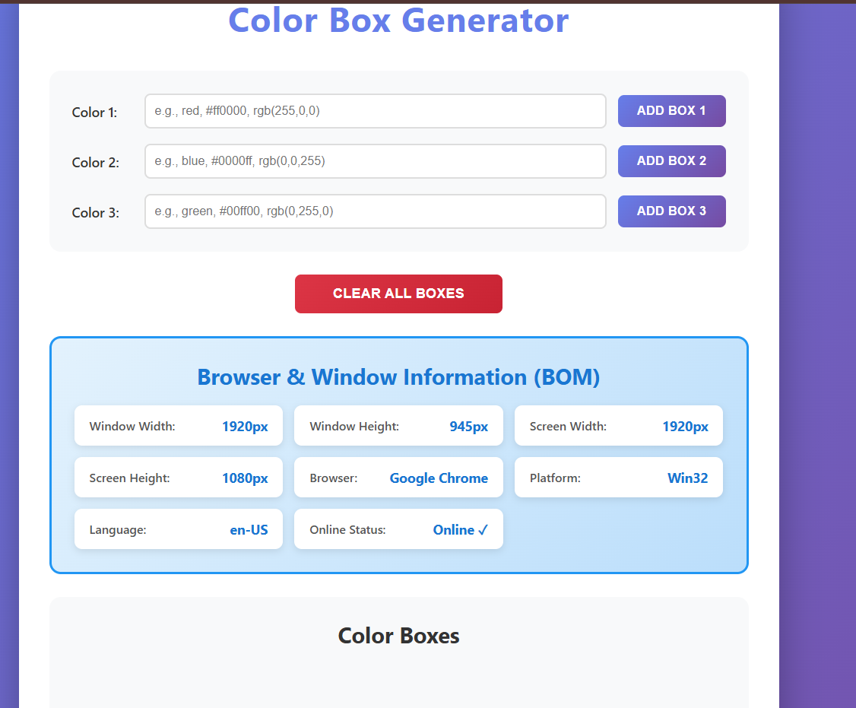
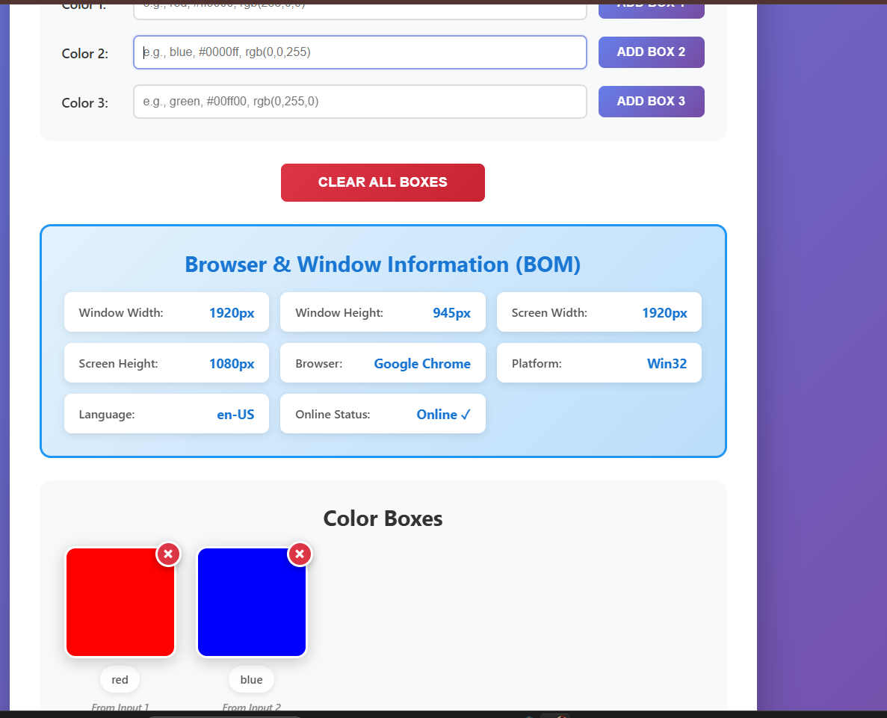

(Task#5)
Html-code:
<!DOCTYPE html>
<html lang="en">
<head>
<meta charset="UTF-8">
<meta name="viewport" content="width=device-width, initial-scale=1.0">
<title>Form Validation</title>
<link rel="stylesheet" href="style.css">
</head>
<body>
<div class="container">
<header>
<h1>Registration Form</h1>
<p>Please fill in all fields correctly</p>
</header>

<form id="registration-form" onsubmit="return handleSubmit(event)">
<div class="form-group">
<label for="name">Full Name:</label>
<input type="text" id="name" class="form-input" placeholder="Enter your full name">
<span class="error-message" id="name-error"></span>
</div>

<div class="form-group">
<label for="email">Email Address:</label>
<input type="text" id="email" class="form-input" placeholder="Enter your email">
<span class="error-message" id="email-error"></span>
</div>

<div class="form-group">
<label for="age">Age:</label>
<input type="number" id="age" class="form-input" placeholder="Enter your age">
<span class="error-message" id="age-error"></span>
</div>

<div class="form-group">
<label for="password">Password:</label>
<input type="password" id="password" class="form-input" placeholder="Enter password (min 6 characters)">
<span class="error-message" id="password-error"></span>
</div>

<div class="button-group">
<button type="submit" class="btn submit-btn">Register</button>
<button type="button" class="btn reset-btn" onclick="resetForm()">Reset</button>
</div>
</form>

<div id="success-message" class="success-message">
<h2>✓ Registration Successful!</h2>
<p id="success-details"></p>
</div>
</div>

<script src="scripts.js"></script>
</body>
</html>

Css-code:
* {
margin: 0;
padding: 0;
box-sizing: border-box;
}

body {
font-family: 'Segoe UI', Tahoma, Geneva, Verdana, sans-serif;
background: linear-gradient(135deg, #667eea 0%, #764ba2 100%);
min-height: 100vh;
display: flex;
justify-content: center;
align-items: center;
padding: 20px;
}

.container {
max-width: 600px;
width: 100%;
background: white;
border-radius: 20px;
padding: 40px;
box-shadow: 0 15px 50px rgba(0, 0, 0, 0.3);
animation: fadeIn 0.8s ease;
}

@keyframes fadeIn {
from {
opacity: 0;
transform: translateY(30px);
}
to {
opacity: 1;
transform: translateY(0);
}
}

header {
text-align: center;
margin-bottom: 40px;
}

header h1 {
color: #667eea;
font-size: 2.5em;
margin-bottom: 10px;
}

header p {
color: #666;
font-size: 1.1em;
}

.form-group {
margin-bottom: 25px;
}

.form-group label {
display: block;
color: #333;
font-size: 1.1em;
font-weight: 600;
margin-bottom: 8px;
}

.form-input {
width: 100%;
padding: 15px;
font-size: 1em;
border: 2px solid #ddd;
border-radius: 10px;
transition: all 0.3s ease;
outline: none;
background: #f8f9fa;
}

.form-input:focus {
border-color: #667eea;
box-shadow: 0 0 0 4px rgba(102, 126, 234, 0.1);
background: white;
}

.form-input.valid {
border-color: #28a745;
background: #f0fff4;
}

.form-input.invalid {
border-color: #dc3545;
background: #fff5f5;
}

.error-message {
display: none;
color: #dc3545;
font-size: 0.9em;
margin-top: 5px;
font-weight: 600;
animation: shake 0.3s ease;
}

@keyframes shake {
0%, 100% { transform: translateX(0); }
25% { transform: translateX(-5px); }
75% { transform: translateX(5px); }
}

.button-group {
display: flex;
gap: 15px;
margin-top: 30px;
}

.btn {
flex: 1;
padding: 15px 30px;
font-size: 1.1em;
font-weight: 700;
border: none;
border-radius: 10px;
cursor: pointer;
transition: all 0.3s ease;
text-transform: uppercase;
letter-spacing: 1px;
}

.submit-btn {
background: linear-gradient(135deg, #28a745 0%, #20c997 100%);
color: white;
}

.submit-btn:hover {
transform: translateY(-3px);
box-shadow: 0 6px 25px rgba(40, 167, 69, 0.4);
}

.submit-btn:active {
transform: translateY(-1px);
}

.reset-btn {
background: linear-gradient(135deg, #6c757d 0%, #495057 100%);
color: white;
}

.reset-btn:hover {
transform: translateY(-3px);
box-shadow: 0 6px 25px rgba(108, 117, 125, 0.4);
}

.reset-btn:active {
transform: translateY(-1px);
}

.success-message {
display: none;
background: linear-gradient(135deg, #d4edda 0%, #c3e6cb 100%);
padding: 30px;
border-radius: 15px;
margin-top: 30px;
border: 3px solid #28a745;
text-align: center;
}

.success-message.show {
display: block;
animation: slideIn 0.5s ease;
}

@keyframes slideIn {
from {
opacity: 0;
transform: translateY(20px);
}
to {
opacity: 1;
transform: translateY(0);
}
}

.success-message h2 {
color: #28a745;
font-size: 2em;
margin-bottom: 15px;
}

.success-message p {
color: #155724;
font-size: 1.1em;
line-height: 1.8;
}

@media (max-width: 768px) {
.container {
padding: 30px;
}

header h1 {
font-size: 2em;
}

.button-group {
flex-direction: column;
}
}

@media (max-width: 480px) {
body {
padding: 10px;
}

.container {
padding: 20px;
}

header h1 {
font-size: 1.6em;
}

header p {
font-size: 1em;
}

.form-input {
padding: 12px;
font-size: 0.95em;
}

.btn {
padding: 12px 20px;
font-size: 1em;
}

.success-message h2 {
font-size: 1.5em;
}

.success-message p {
font-size: 1em;
}
}

Js-code:
function validateName() {
const nameInput = document.getElementById('name');
const nameError = document.getElementById('name-error');
const name = nameInput.value.trim();

if (name === '') {
displayError(nameError, 'Name cannot be empty!');
markFieldInvalid(nameInput);
return false;
} else {
clearError(nameError);
markFieldValid(nameInput);
return true;
}
}

function validateEmail() {
const emailInput = document.getElementById('email');
const emailError = document.getElementById('email-error');
const email = emailInput.value.trim();

if (email === '') {
displayError(emailError, 'Email cannot be empty!');
markFieldInvalid(emailInput);
return false;
} else if (!email.includes('@')) {
displayError(emailError, 'Email must contain @ symbol!');
markFieldInvalid(emailInput);
return false;
} else {
clearError(emailError);
markFieldValid(emailInput);
return true;
}
}

function validateAge() {
const ageInput = document.getElementById('age');
const ageError = document.getElementById('age-error');
const age = parseInt(ageInput.value);

if (isNaN(age) || ageInput.value.trim() === '') {
displayError(ageError, 'Age is required!');
markFieldInvalid(ageInput);
return false;
} else if (age < 18) {
displayError(ageError, 'Age must be at least 18!');
markFieldInvalid(ageInput);
return false;
} else if (age > 60) {
displayError(ageError, 'Age must be 60 or below!');
markFieldInvalid(ageInput);
return false;
} else {
clearError(ageError);
markFieldValid(ageInput);
return true;
}
}

function validatePassword() {
const passwordInput = document.getElementById('password');
const passwordError = document.getElementById('password-error');
const password = passwordInput.value;

if (password === '') {
displayError(passwordError, 'Password cannot be empty!');
markFieldInvalid(passwordInput);
return false;
} else if (password.length < 6) {
displayError(passwordError, 'Password must be at least 6 characters!');
markFieldInvalid(passwordInput);
return false;
} else {
clearError(passwordError);
markFieldValid(passwordInput);
return true;
}
}

function displayError(errorElement, message) {
errorElement.textContent = message;
errorElement.style.display = 'block';
}

function clearError(errorElement) {
errorElement.textContent = '';
errorElement.style.display = 'none';
}

function markFieldInvalid(inputElement) {
inputElement.classList.add('invalid');
inputElement.classList.remove('valid');
}

function markFieldValid(inputElement) {
inputElement.classList.add('valid');
inputElement.classList.remove('invalid');
}

function handleSubmit(event) {
event.preventDefault();

const isNameValid = validateName();
const isEmailValid = validateEmail();
const isAgeValid = validateAge();
const isPasswordValid = validatePassword();

if (isNameValid && isEmailValid && isAgeValid && isPasswordValid) {
const name = document.getElementById('name').value.trim();
const email = document.getElementById('email').value.trim();
const age = document.getElementById('age').value;

const confirmSubmission = confirm('Do you want to submit the registration form?');

if (confirmSubmission) {
showSuccessMessage(name, email, age);

alert('Thank you for registering! Your account has been created successfully.');

const additionalInfo = prompt('Would you like to add a phone number? (Optional)');

if (additionalInfo && additionalInfo.trim() !== '') {
alert(`Phone number "${additionalInfo}" has been saved to your profile!`);
}

setTimeout(() => {
resetForm();
}, 5000);
}
} else {
alert('Please fix all errors before submitting!');
}

return false;
}

function showSuccessMessage(name, email, age) {
const successMessage = document.getElementById('success-message');
const successDetails = document.getElementById('success-details');

successDetails.innerHTML = `
<strong>Name:</strong> ${name}<br>
<strong>Email:</strong> ${email}<br>
<strong>Age:</strong> ${age}
`;

successMessage.style.display = 'block';
successMessage.classList.add('show');
}

function resetForm() {
document.getElementById('registration-form').reset();

const errorMessages = document.querySelectorAll('.error-message');
for (let i = 0; i < errorMessages.length; i++) {
clearError(errorMessages[i]);
}

const inputs = document.querySelectorAll('.form-input');
for (let i = 0; i < inputs.length; i++) {
inputs[i].classList.remove('valid', 'invalid');
}

const successMessage = document.getElementById('success-message');
successMessage.style.display = 'none';
successMessage.classList.remove('show');

document.getElementById('name').focus();
}

document.getElementById('name').addEventListener('blur', validateName);
document.getElementById('email').addEventListener('blur', validateEmail);
document.getElementById('age').addEventListener('blur', validateAge);
document.getElementById('password').addEventListener('blur', validatePassword);

window.onload = function() {
document.getElementById('name').focus();
};

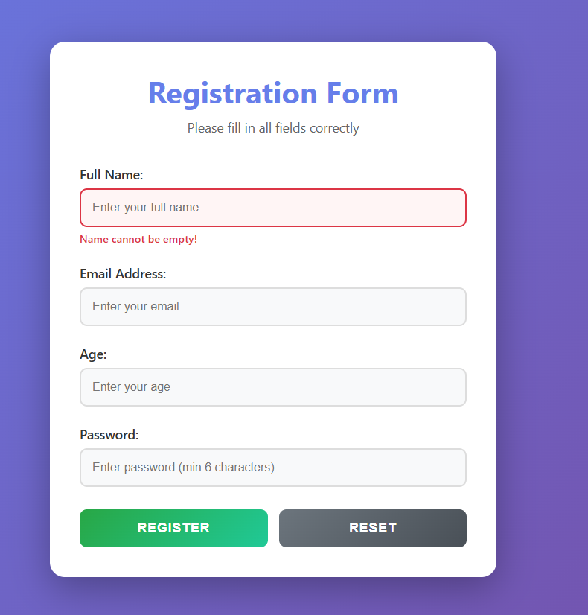
Output:
