

Air University - Islamabad
Islamabad, Pakistan

Lab 03
Full Stack Programming Lab (B)

Hayat Ishfaq - 231994
Semester: Spring 2026

Submission Date: February 24, 2026

(Task#1)

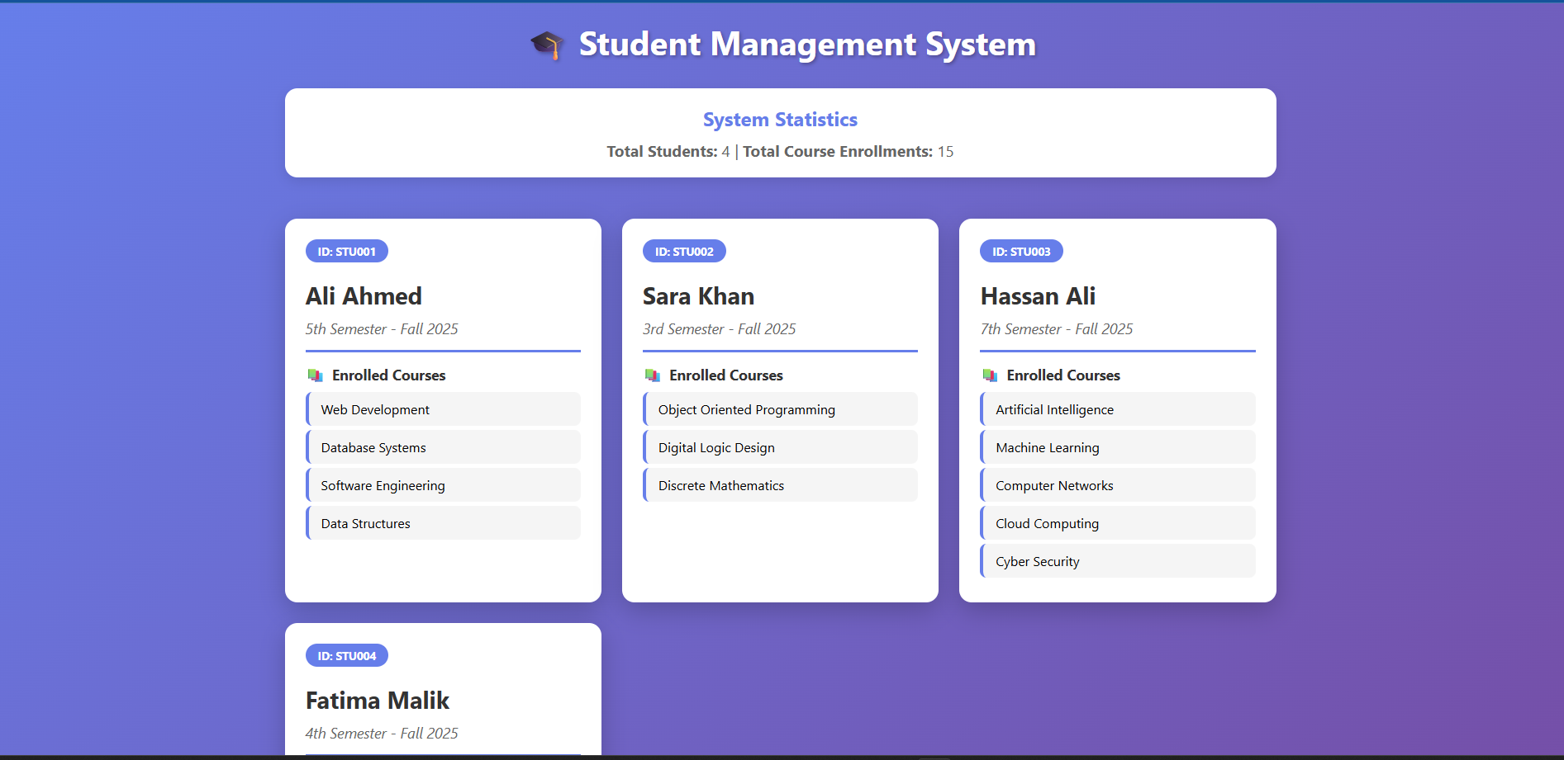
(Task#2)
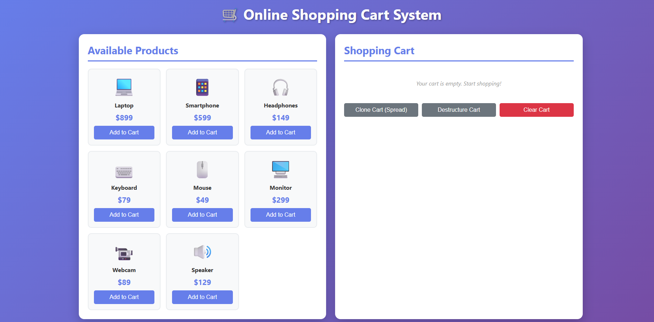

(Task#3)
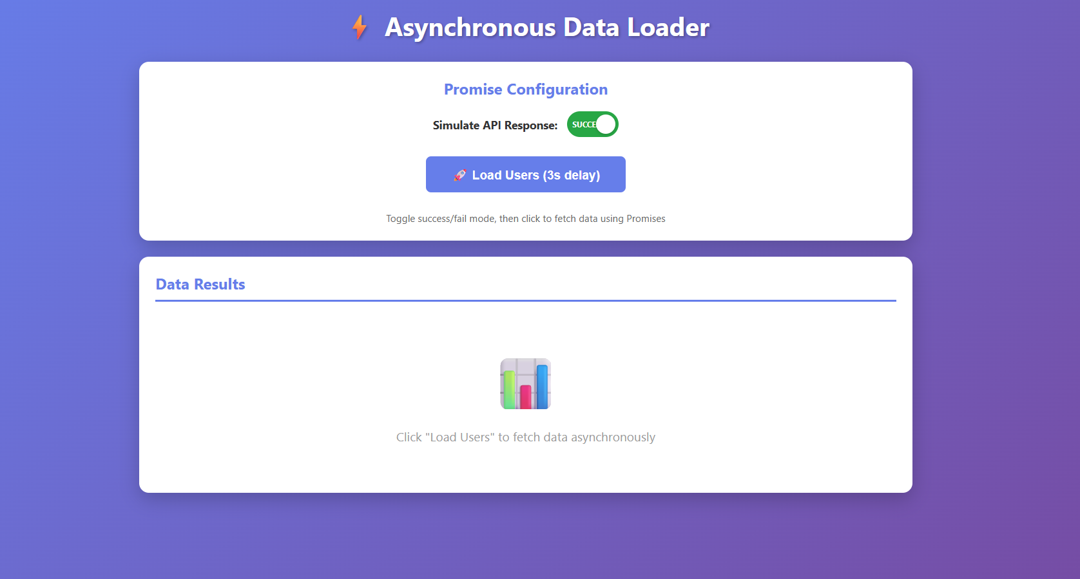
(Task#4)
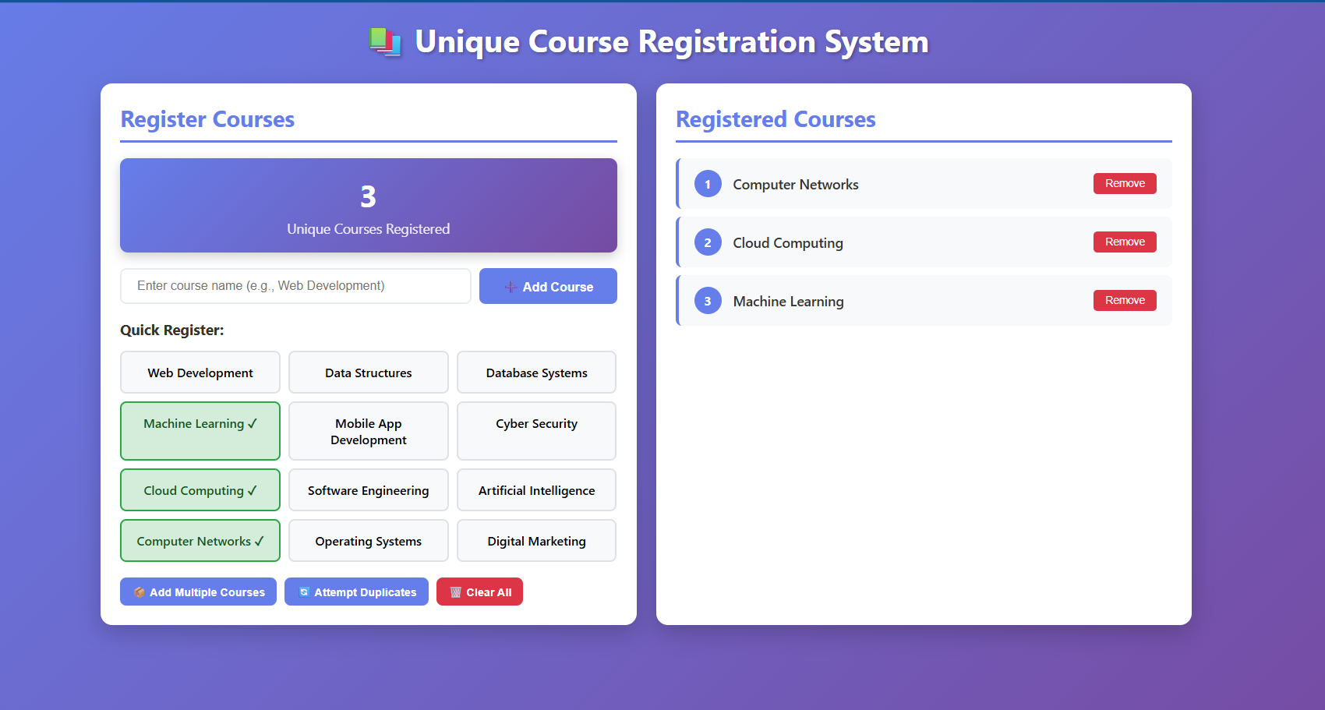

(Task#5)
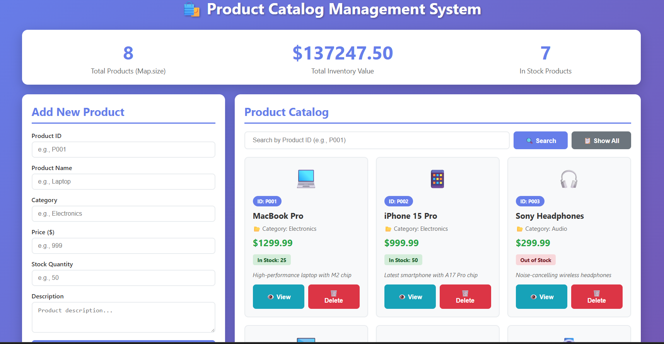
(Task#6)
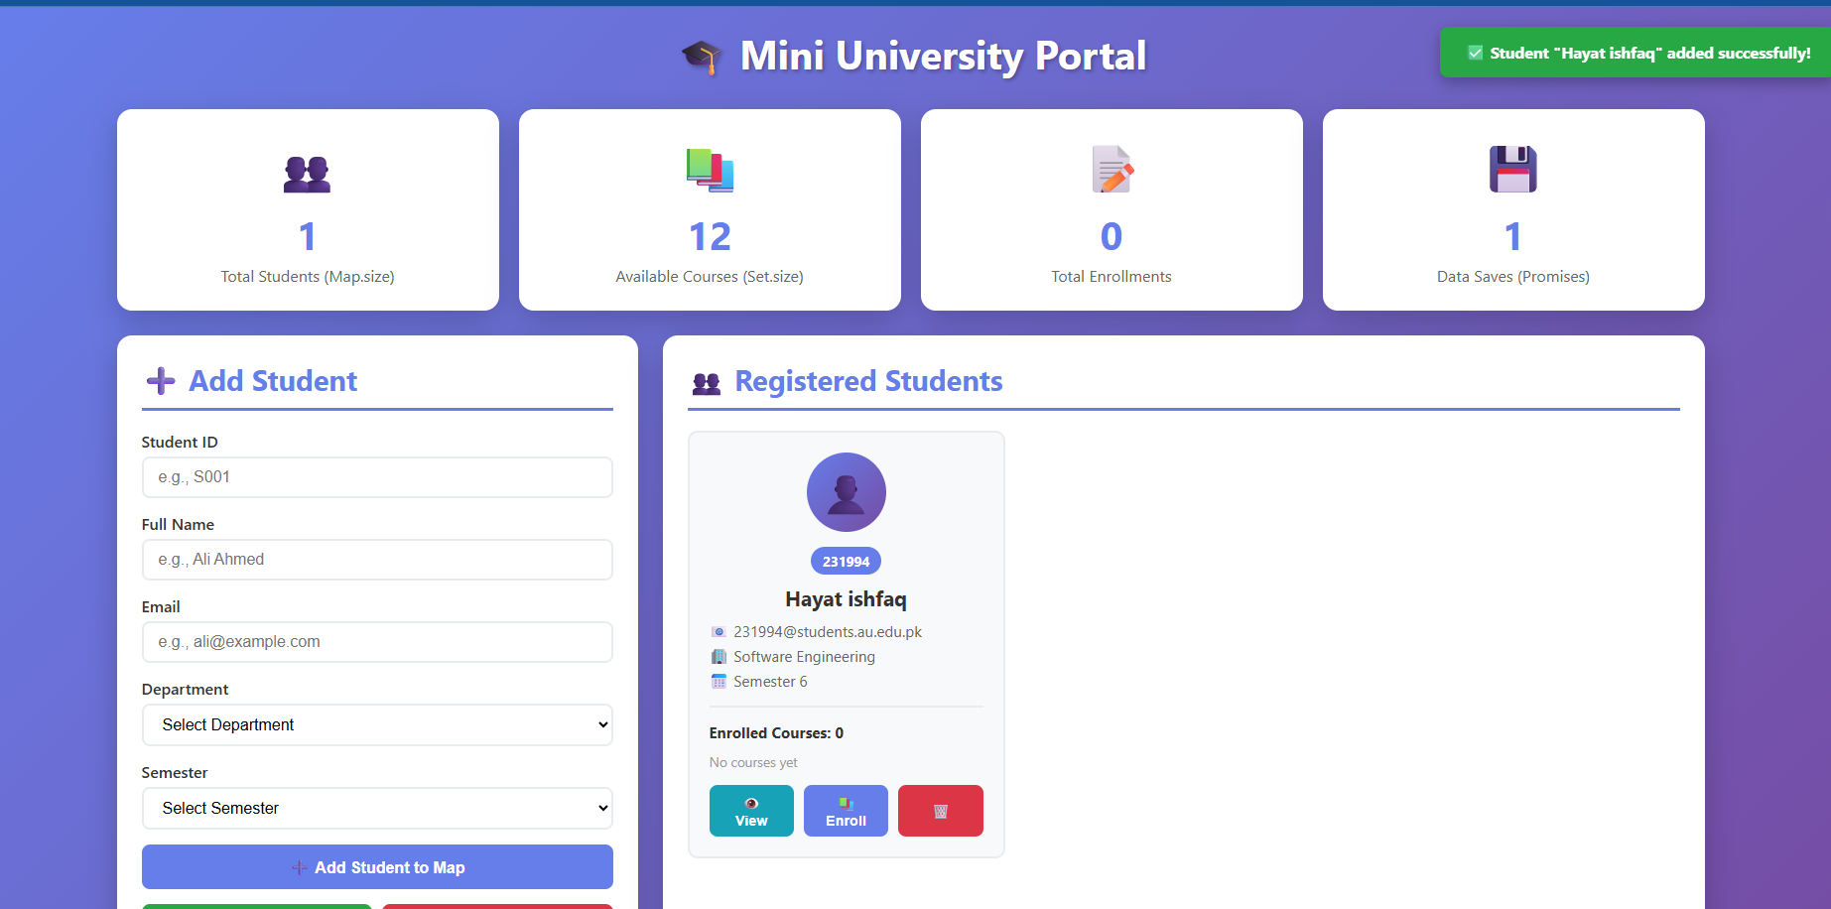

(Task#7)
