

Air University - Islamabad
Islamabad, Pakistan

Lab 08
Full Stack Programming Lab (B)

Hayat Ishfaq - 231994
Semester: Spring 2026

Submission Date: April 22, 2026

Github URL: https://github.com/hayat-ishfaq/uni-full-stack-programming-lab/tree/f9253df3f1baf194a3fda381200b9cbe335453ef/Lab_08_NEXTjsApp
Task1 Screenshots:
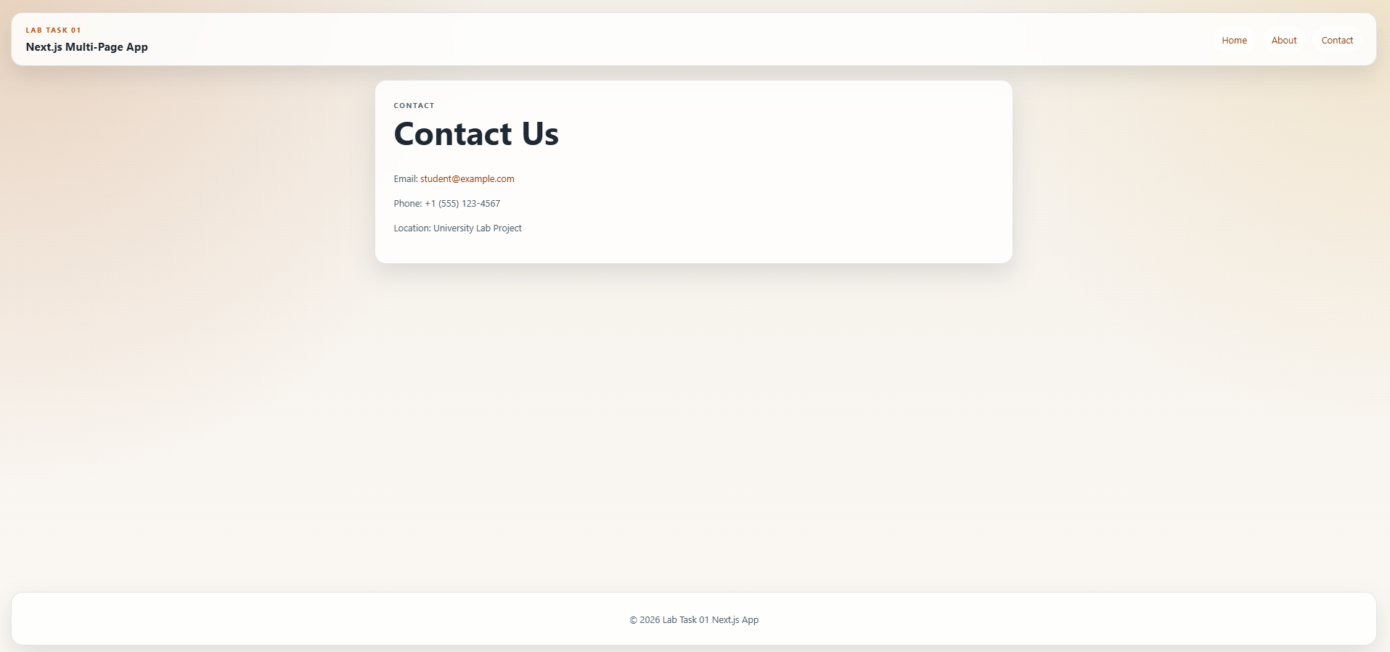
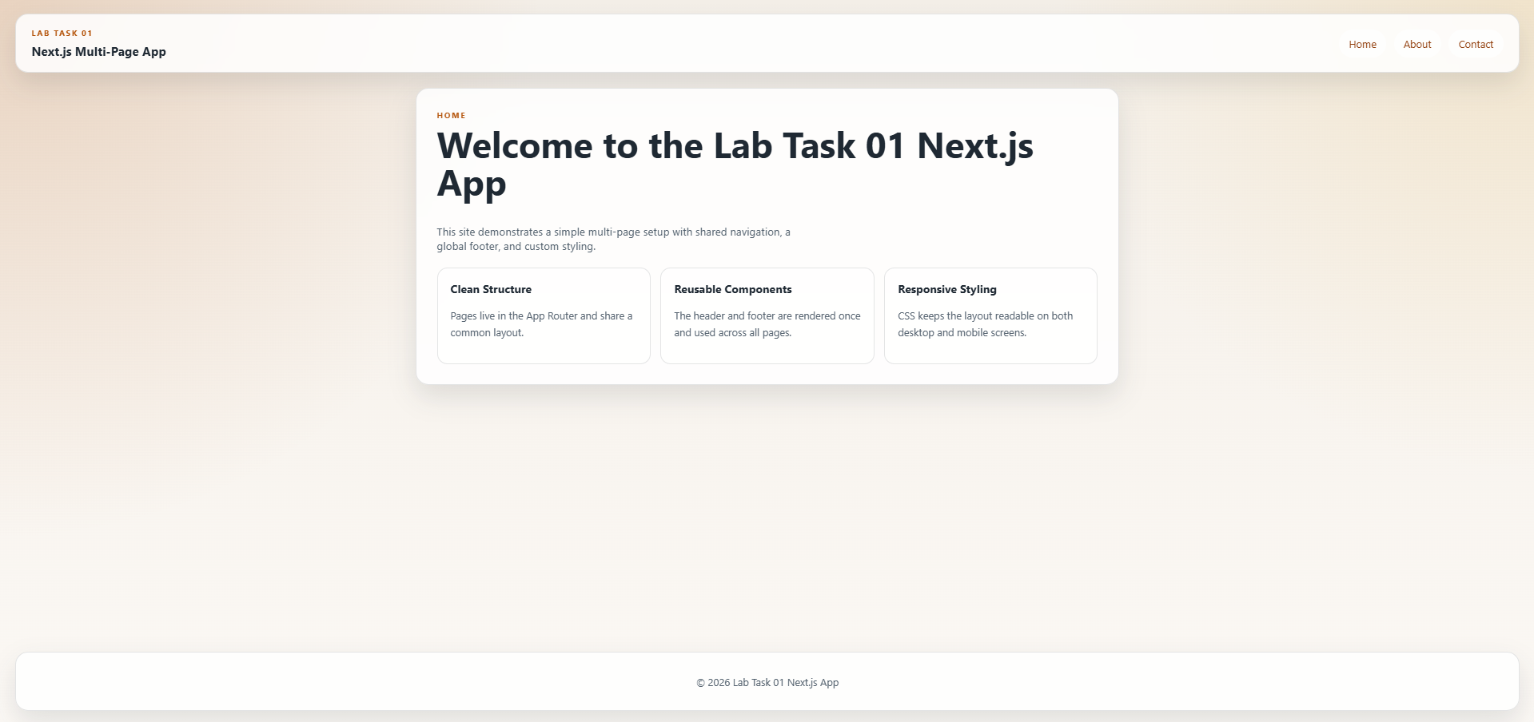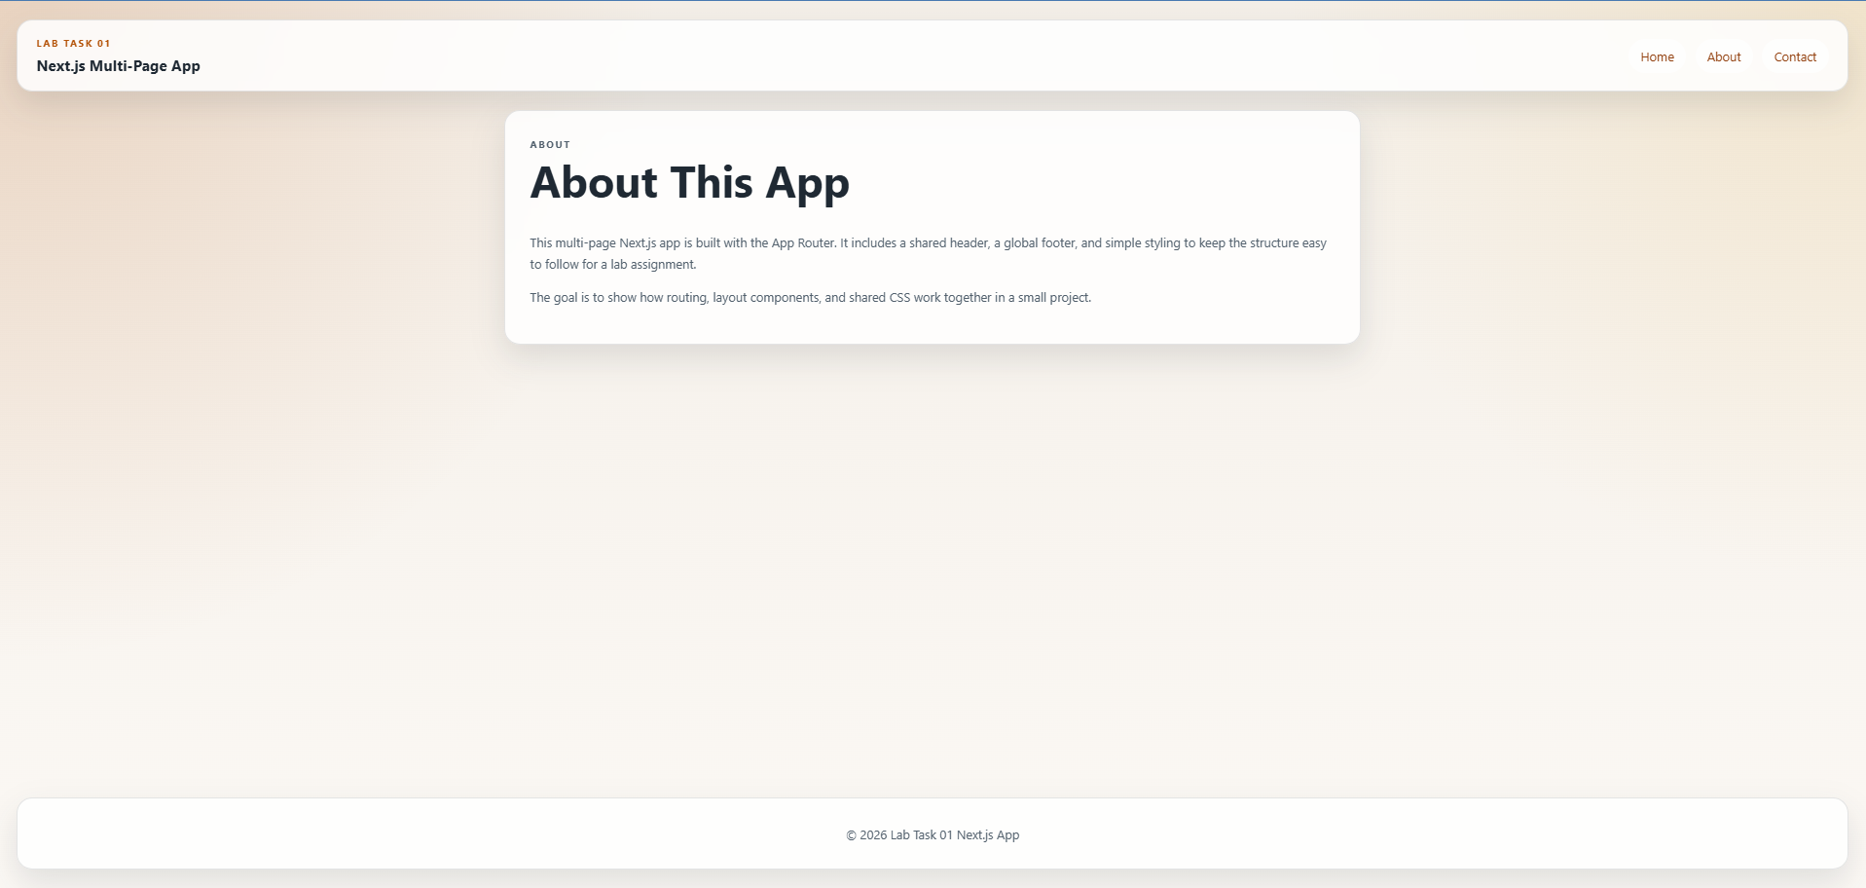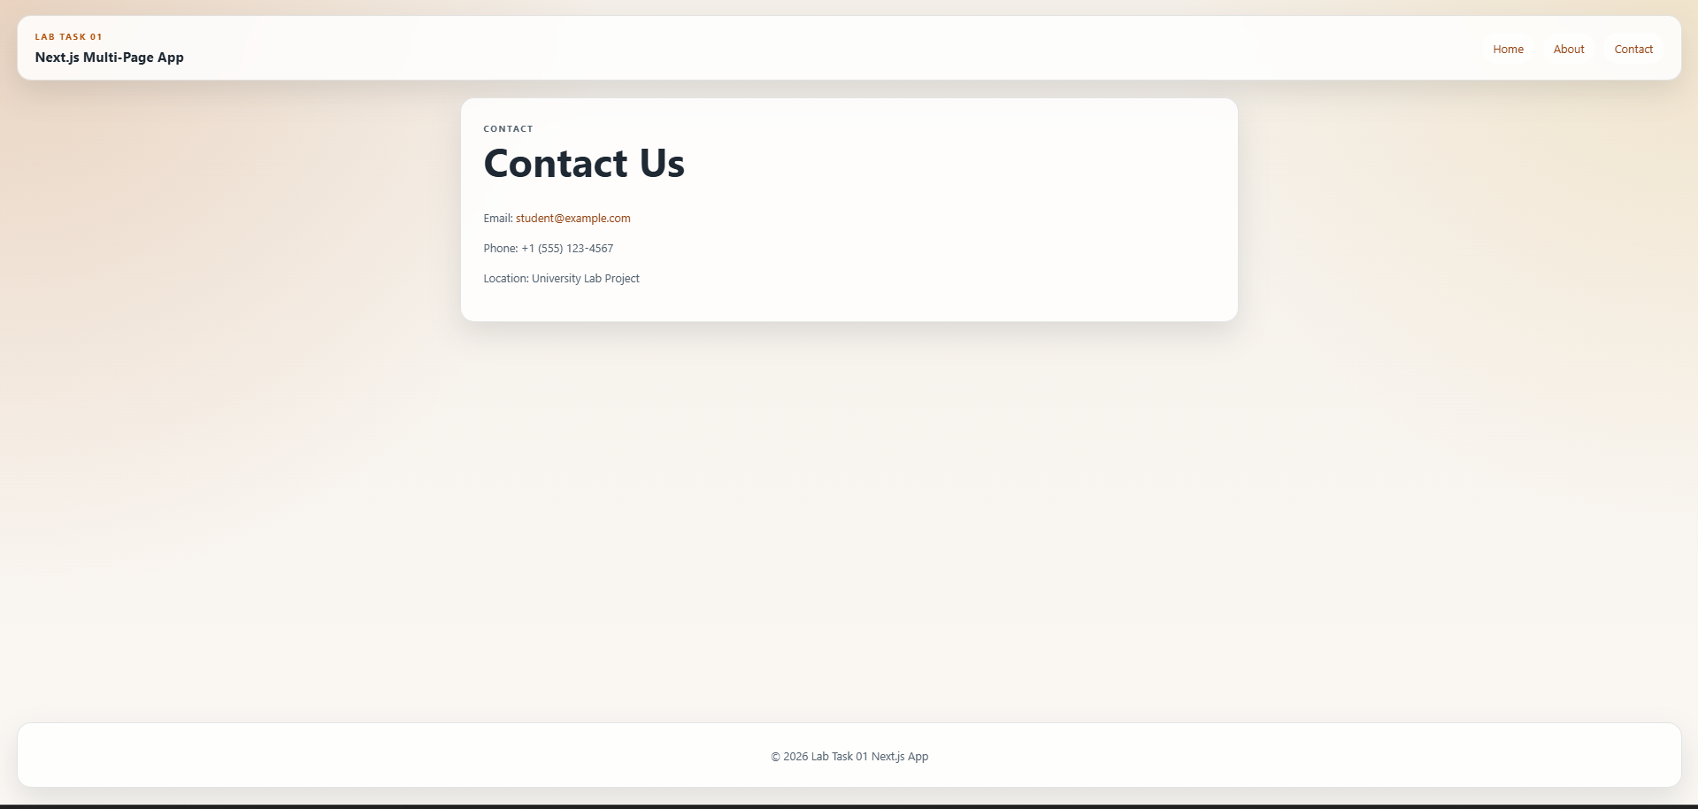
Task2 Screenshots:
