

Air University - Islamabad
Islamabad, Pakistan

Lab 10
Full Stack Programming Lab (B)

Hayat Ishfaq - 231994
Semester: Spring 2026

Submission Date: April 28, 2026

Github URL: https://github.com/hayat-ishfaq/uni-full-stack-programming-lab/tree/5d1573dea6213c8913ac9f56d016c734be312eee/Lab_10full_Stack_Node_Express

Task1 Screenshots:
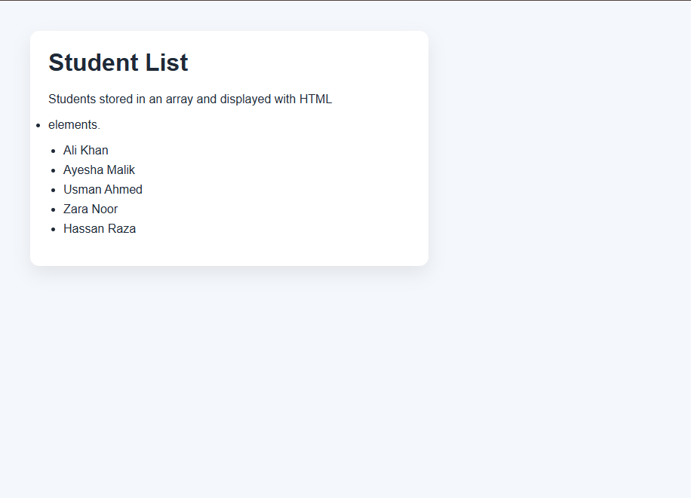

Task2 Screenshots:

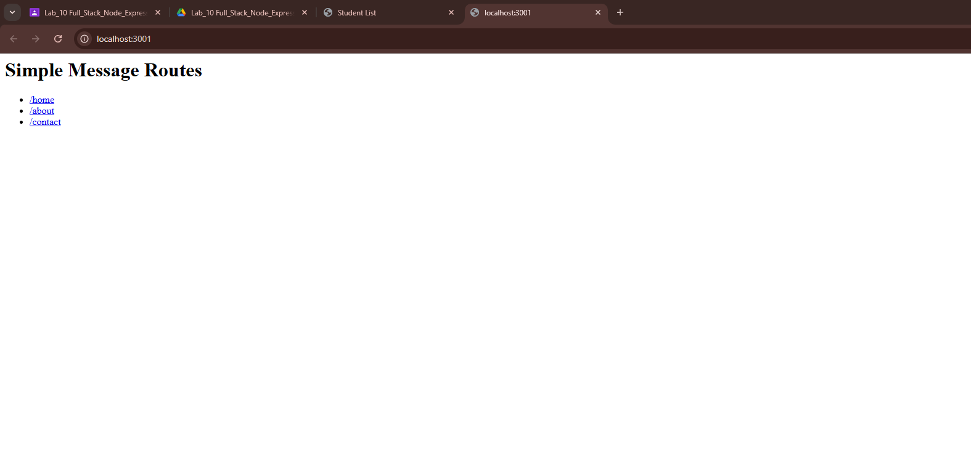
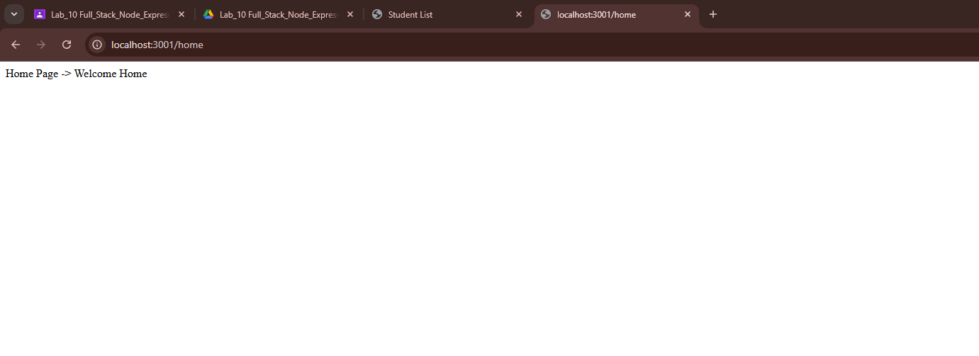
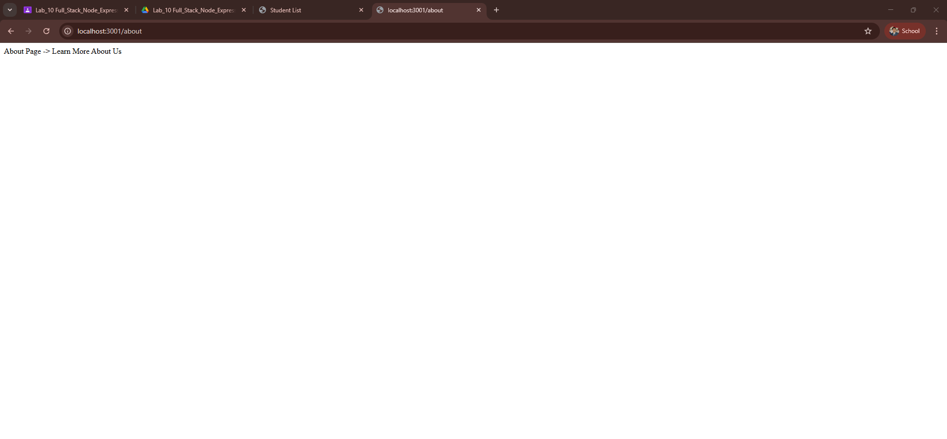
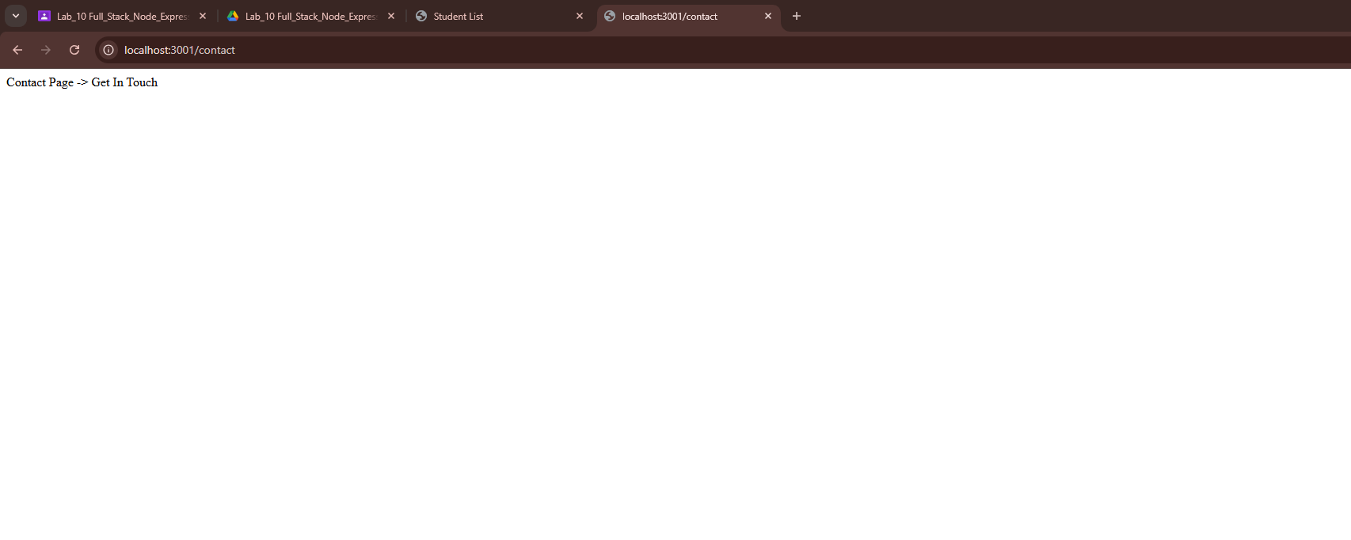

Task 3 screenshots:
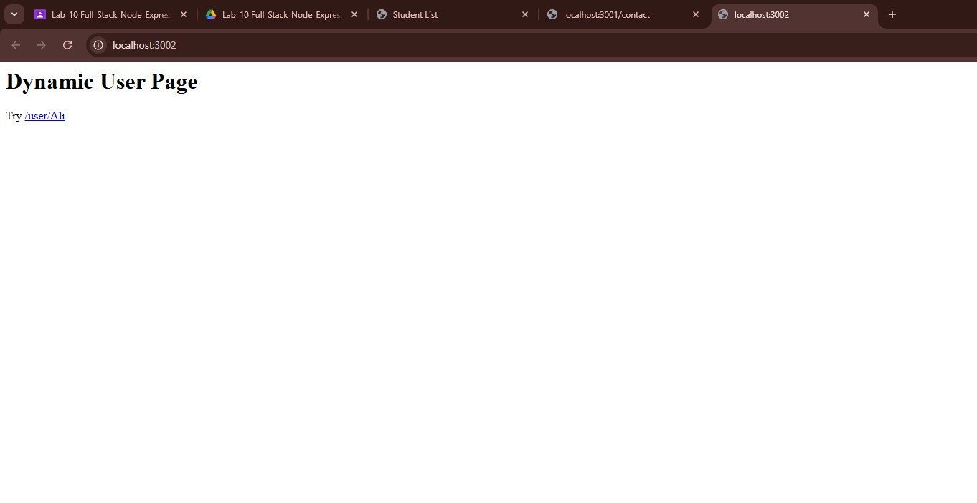
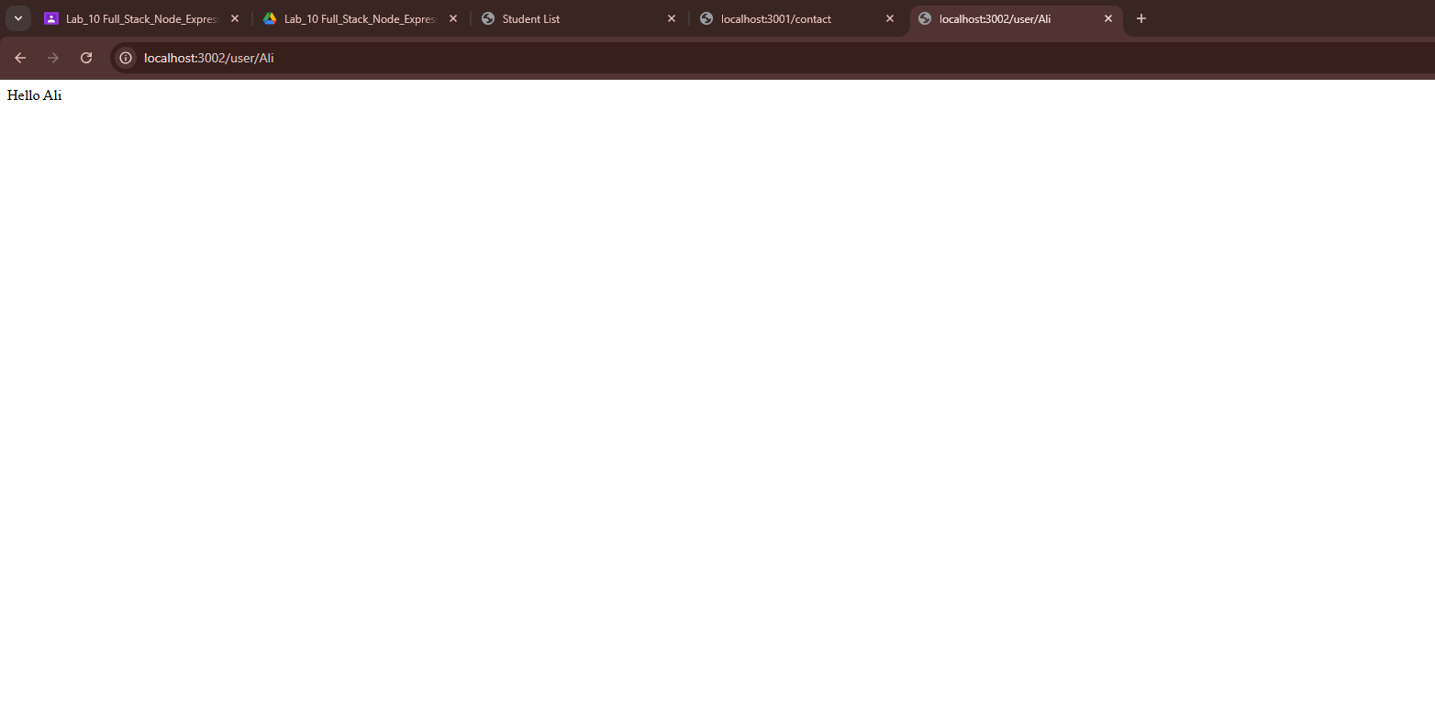

Task 4 screenshots:
